
A CELEBRATION OF WORSHIP
EASTER SUNDAY
APRIL 5TH, 2026

GOD’S PEOPLE GATHER TOGETHER IN FELLOWSHIP
PRELUDE Jacob Baker
CHIMING OF THE HOUR
SPECIAL MUSIC “Then Came the Morning” WC CHOIR

EASTER MEDLEY THE MUSICIANS

THE TOMB IS EMPTY!!!

CALL TO WORSHIP – Matthew 28:2-4
L: There was a Violent Earthquake
P: For an angel of the Lord came down from Heaven, rolled back the stone, and sat on it!
L: His appearance was like lightning, and his cloths white as snow. I was afraid, I shook and became like dead
P: The stone was not rolled aside so that Jesus could get out, but so others could get in and see that Jesus has risen, HE HAS RISEN INDEED!

+THE LIGHT RETURNS!!!

+OPENING HYMN “Christ the Lord is Risen Today” UMH302

Wesley Chapel
United Methodist Church

LIFE OF THE CONGREGATION
LORD’S PRAYER
Our Father, who art in heaven, hallowed be thy name. Thy kingdom come, thy will be done on earth as it is in heaven. Give us this day our daily bread. And forgive us our trespasses as we forgive those who trespass against us. And lead us not into temptation, but deliver us from evil. For thine is the kingdom, and the power, and the glory forever. AMEN.
OFFERTORY The Holy City Steve Wilson

DOXOLOGY
Praise God from whom all blessings flow; praise him, all creatures here below; praise him above ye heavenly hosts; praise Father, Son and Holy Ghost Amen

PROCLAMATION AND RESPONSE
HYMN OF PREPARATION “In the Garden” UMH 314

GOSPEL LESSON JOHN 20:1-18 pg. 768

HYMN “Because He Lives” UMH 635

SERMON “Through the eyes of a…” Pastor Glenn Riggs

RESPONSE TO THE WORD
“Up From The Grave He Arose!” UMH 322

SENDING FORTH

Holy Communion

+CLOSING HYMN “He Lives” UMH 310
+DISMISSAL WITH BLESSING
+THE LIGHT RETURNS TO THE WORLD
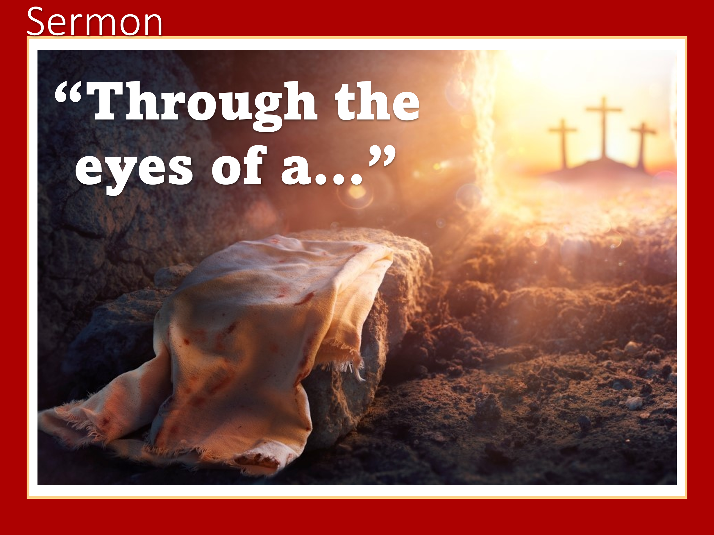
+CHORAL BENEDICTION THE CHANCEL CHIOR
+POSTLUDE THE ORGANIST

+please stand as you are able

Wesley Chapel United Methodist Church
9227 River Road
Easter Sunday
South Chesterfield, VA 23803
804-590-1837
Pastor Glenn Riggs
Sunday School - 8:45 a.m.
Wesley Chapel
Worship – 10:00 a.m.
Email: Wesleychapelumc.va@gmail.com
Website: wesleychapelumcva.org
United Methodist Church
Facebook: Wesley Chapel UMC – Matoaca, VA

April 5th, 2026
Donate from your smartphone. Scan this image using your phone’s camera or QR app.

WELCOME!

