HOODIE ORDER FORM

Church of the Cross Hoodies & Posters
Youth group fundraiser Easter 2026
Deadline April 26 – hoodies available May 17
Complete one form per hoodie.

NAME:__________________________

E-MAIL:_________________________

STYLE (circle one): ANIMAL or FLOWER

SIZE (circle on):

Youth: S, M, L, XL

Adult: S, M, L, XL, 2XL, 3XL

COLOUR: SAND (available in one colour)

Hoodie cost: $55 (incl. taxes)

FORM OF PAYMENT:______________

Forms of payment: e-transfer sent to lutheranchurchofthecross@shaw.ca

Cheque made out to “Lutheran Church of the Cross” with “hoodie” or “poster” in memo.

Cash is also accepted. Visit: lutheranvictoria.ca
POSTER ORDER FORM

Church of the Cross Hoodies & Posters
Youth group fundraiser Easter 2026
Deadline April 26 – posters available May 3

NAME:__________________________

E-MAIL:_________________________

QUANTITY ANIMAL POSTERS: _____

QUANTITY FLOWER POSTERS: _____

POSTER COST: $8 per poster (incl. taxes)
Posters are 11” X 17”

TOTAL: QUANTITY X $8:___________

FORM OF PAYMENT:______________

Forms of payment: e-transfer sent to lutheranchurchofthecross@shaw.ca

Cheque made out to “Lutheran Church of the Cross” with “hoodie” or “poster” in memo.

Cash is also accepted. Visit: lutheranvictoria.ca


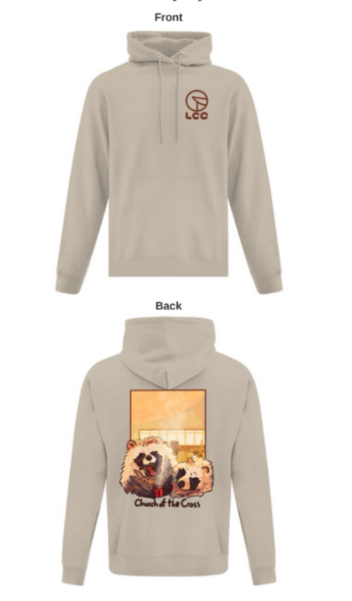
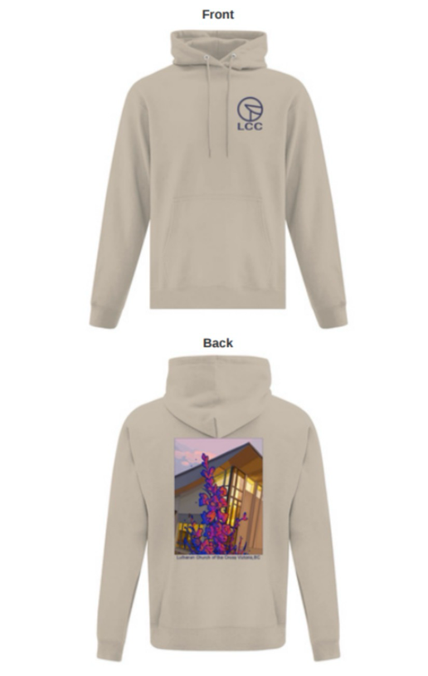

Youth group fundraiser: a portion of the sales will go toward youth group activities.

These are original designs by Sam, member of the high youth group. They were hand drawn on a digital tablet, images inspired by his interests and experience of the church space. The tanuki image, a popular Japanese animal, includes a visual of the sanctuary. While the flower image includes the church exterior. The smaller logo on the front of the hoodies reflects the distinctive peak of the church roof.

Lutheran Church of the Cross
3787 Cedar Hill Road, Victoria, BC, V8P 3Z4

Youth group fundraiser: a portion of the sales will go toward youth group activities.

These are original designs by Sam, member of the high youth group. They were hand drawn on a digital tablet, images inspired by his interests and experience of the church space. The tanuki image, a popular Japanese animal, includes a visual of the sanctuary. While the flower image includes the church exterior. The smaller logo on the front of the hoodies reflects the distinctive peak of the church roof.
Lutheran Church of the Cross
3787 Cedar Hill Road, Victoria, BC, V8P 3Z4

