GOOD FRIDAY - APRIL 3, 2026
FINAL WORDS FROM THE CROSS

ENTRANCE
PRELUDE
*OPENING HYMN “Spirit Song” #347

THE LIGHT ENTERS
CALL TO WORSHIP
L: Why are we here tonight?
P: To tell what Jesus did in the midst of our brokenness.
L: Why are we here tonight?
P: To give our praise in the midst of our pain.
L: Why are we here tonight?
P: To seek the Lord and give God our praise.
L: Why are we here tonight?
P: To join with the families of the earth as we worship
Our Lord and Savior

Luke 23:32-34 Father, forgive them.

OPENING PRAYER
Merciful Father, In your great love you sent your son Jesus Christ To suffer and die on the cross. We gather to reflect upon his crucifixion this day: May we find consolation in our suffering. May we find healing in our sickness and clinging to the hope that we have in Christ, may we find salvation in your promise. We pray in the name of Jesus the Lord. Amen.
Luke 23:40-43 Today you will be with me in Paradise.

GLORY BE TO THE FATHER #70
Glory be to the Father; and to the Son and to the Holy Ghost; as it was in the beginning, is now, and ever shall be, world without end Amen. Amen.

John 19:26-27 Woman, here is your son.

Vs. 1 Were You There When They Crucified My Lord on back

Mark 15:33-34 My God, why have you forsaken me?

Vs. 2 Were You There When They Nailed Him to the Tree

John 19:28 I am Thirsty.

Vs. 3 Were You There When They Pierced Him in the Side

John 19:29-30 It is Finished
Vs. 4 Were You There When the Sun Refused to Shine

PROCLAMATION AND RESPONSE
Luke 23:44-49 Into your hands I commend my spirit

“Surrounded by Darkness”
LORD’S PRAYER
Our Father, who art in heaven, hallowed be thy name. Thy kingdom come, thy will be done on earth as it is in heaven. Give us this day our daily bread. And forgive us our trespasses as we forgive those who trespass against us. And lead us not into temptation, but deliver us from evil. For thine is the kingdom, and the power, and the glory, forever. AMEN.

Vs. 5 Were You There When They Laid Him in the Tomb

SENDING FORTH
WERE YOU THERE? SOLO
*THE LIGHT IS EXTINGUISHED
* POSTLUDE – PLEASE EXIT THE SANCTUARY IN SILENCE
*Please stand as you are able.

1 - Were you there when they crucified my Lord?
Were you there when they crucified my Lord?
Oh! Sometimes it causes me to tremble, tremble, tremble.
Were you there when they crucified my Lord?
2 - Were you there when they nailed him to the tree?
Were you there when they nailed him to the tree?
Oh! Sometimes it causes me to tremble, tremble, tremble.
Were you there when they nailed him to the tree?
3 - Were you there when they pierced him in the side?
Were you there when they pierced him in the side?
Oh! Sometimes it causes me to tremble, tremble, tremble.
Were you there when they pierced him in the side?
4 - Were you there when the sun refused to shine?
Were you there when the sun refused to shine?
Oh! Sometimes it causes me to tremble, tremble, tremble.
Were you there when they pierced him in the side?
5 - Were you there when they laid him in the tomb?
Were you there when they laid him in the tomb?
Oh! Sometimes it causes me to tremble, tremble, tremble.
Were you there when they laid him in the tomb?
Wesley Chapel

Wesley Chapel United Methodist Church

9227 River Road
South Chesterfield, VA 23803
United Methodist Church
804-590-1837
Pastor Glenn Riggs
April 3rd, 2026
Sunday School - 8:45 a.m.
Worship – 10:00 a.m.
Email: Wesleychapelumc.va@gmail.com
Facebook: Wesley Chapel UMC – Matoaca, VA

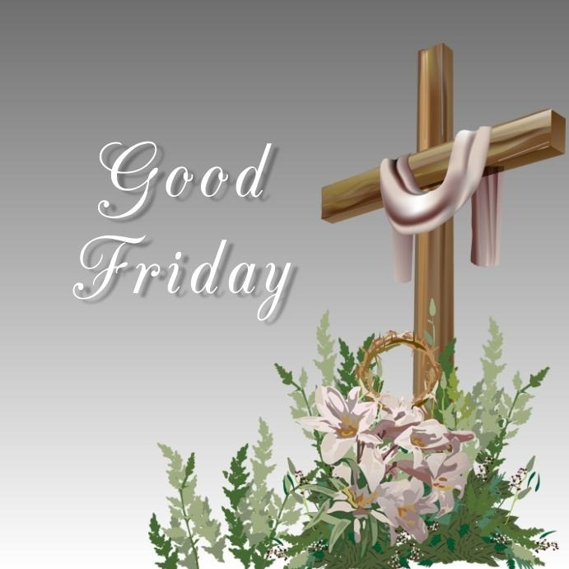
Welcome!

