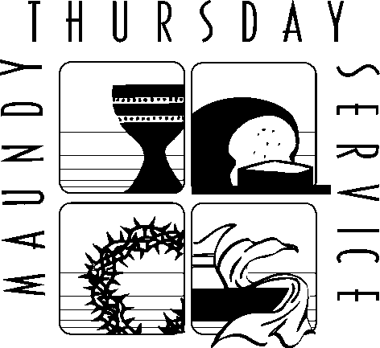

THE FEAST OF VICTORY
April 2, 2026
7:00pm

This evening our Lenten observance comes to an end, and we gather with Christians around the world to celebrate the Three Days of Jesus’ death and resurrection. Tonight we remember Christ’s last meal with his disciples, but the central focus is his commandment that we live out the promise embodied in this meal. As Jesus washed his disciples’ feet, so we are called to give and receive love in humble service to one another. Formed into a new body in Christ through this holy meal, we are transformed by the mercy we have received and carry it into the world. Departing worship in solemn silence, we anticipate the coming days.

Pastor Christian McMullan

Daniel S. Bower, Music Director

Craig Miller, Director of Youth & Family Ministries

SAINT MATTHEW’S LUTHERAN CHURCH
2440 Conestoga Road
Chester Springs, Pennsylvania 19425
610-458-5675
www.stmatthews-church.org

Images, texts and music reprinted under One License A-701213 and/or CCLI License 1029780

WELCOME
Please stand

GREETING

P: Blessed be the holy Trinity, one God, who brings us out of captivity into freedom,
out of the wilderness into the promised land, out of death into life.
C: Amen.

HYMN Will You Let Me Be Your Servant ELW 659
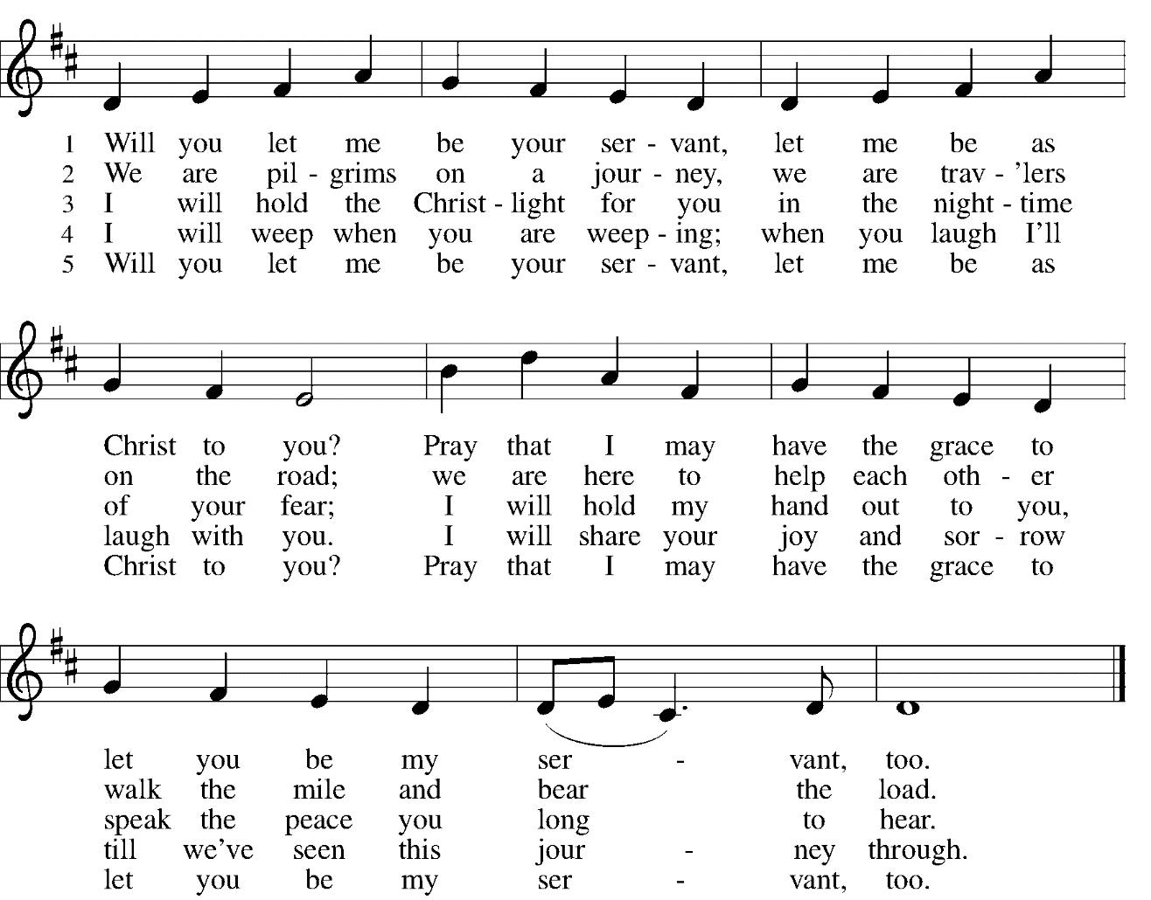

PRAYER OF THE DAY

C: Holy God, source of all love, on the night of his betrayal, Jesus gave us a new commandment, to love one another as he loves us. Write this commandment in our hearts, and give us the will to serve others as he was the servant of all, your Son, Jesus Christ, our Savior and Lord, who lives and reigns with you and the Holy Spirit, one God, now and forever. Amen.

READING Exodus 12:1-4 [5-10] 11-14

A: A reading from Exodus, the twelfth chapter.

¹The Lord said to Moses and Aaron in the land of Egypt: ²This month shall mark for you the beginning of months; it shall be the first month of the year for you. ³Tell the whole congregation of Israel that on the tenth of this month they are to take a lamb for each family, a lamb for each household. ⁴If a household is too small for a whole lamb, it shall join its closest neighbor in obtaining one; the lamb shall be divided in proportion to the number of people who eat of it.
⁵Your lamb shall be without blemish, a year-old male; you may take it from the sheep or from the goats. ⁶You shall keep it until the fourteenth day of this month; then the whole assembled congregation of Israel shall slaughter it at twilight. ⁷They shall take some of the blood and put it on the two doorposts and the lintel of the houses in which they eat it. ⁸They shall eat the lamb that same night; they shall eat it roasted over the fire with unleavened bread and bitter herbs. ⁹Do not eat any of it raw or boiled in water, but roasted over the fire, with its head, legs, and inner organs. ¹⁰You shall let none of it remain until the morning; anything that remains until the morning you shall burn.
¹¹This is how you shall eat it: your loins girded, your sandals on your feet, and your staff in your hand; and you shall eat it hurriedly. It is the passover of the Lord. ¹²For I will pass through the land of Egypt that night, and I will strike down every firstborn in the land of Egypt, both human beings and animals; on all the gods of Egypt I will execute judgments: I am the Lord. ¹³The blood shall be a sign for you on the houses where you live: when I see the blood, I will pass over you, and no plague shall destroy you when I strike the land of Egypt. ¹⁴This day shall be a day of remembrance for you. You shall celebrate it as a festival to the Lord; throughout your generations you shall observe it as a perpetual ordinance.

P: The Word of the Lord.
C: Thanks be to God.

GOSPEL John 13:1-17; 31b-35
P: The holy gospel according to St. John, the thirteenth chapter.
C: Glory to you, O Lord.

¹Now before the festival of the Passover, Jesus knew that his hour had come to depart from this world and go to the Father. Having loved his own who were in the world, he loved them to the end. ²The devil had already put it into the heart of Judas son of Simon Iscariot to betray him. And during supper ³Jesus, knowing that the Father had given all things into his hands, and that he had come from God and was going to God, ⁴got up from the table, took off his outer robe, and tied a towel around himself. ⁵Then he poured water into a basin and began to wash the disciples' feet and to wipe them with the towel that was tied around him.
⁶He came to Simon Peter, who said to him, "Lord, are you going to wash my feet?" ⁷Jesus answered, "You do not know now what I am doing, but later you will understand." ⁸Peter said to him, "You will never wash my feet." Jesus answered, "Unless I wash you, you have no share with me." ⁹Simon Peter said to him, "Lord, not my feet only but also my hands and my head!" ¹⁰Jesus said to him, "One who has bathed does not need to wash, except for the feet, but is entirely clean. And you are clean, though not all of you." ¹¹For he knew who was to betray him; for this reason he said, "Not all of you are clean."
¹²After he had washed their feet, had put on his robe, and had returned to the table, he said to them, "Do you know what I have done to you? ¹³You call me Teacher and Lord and you are right, for that is what I am. ¹⁴So if I, your Lord and Teacher, have washed your feet, you also ought to wash one another's feet. ¹⁵For I have set you an example, that you also should do as I have done to you. ¹⁶Very truly, I tell you, servants are not greater than their master, nor are messengers greater than the one who sent them. ¹⁷If you know these things, you are blessed if you do them.

^{31b}"Now the Son of Man has been glorified, and God has been glorified in him. ³²If God has been glorified in him, God will also glorify him in himself and will glorify him at once. ³³Little children, I am with you only a little longer. You will look for me; and as I said to the Jews so now I say to you, 'Where I am going, you cannot come.' ³⁴I give you a new commandment, that you love one another. Just as I have loved you, you also should love one another. ³⁵By this everyone will know that you are my disciples, if you have love for one another."

P: The Gospel of the Lord.
C: Praise to you, O Christ.

Please be seated

HOMILY

Please stand

HYMN Will You Come and Follow Me ELW 798
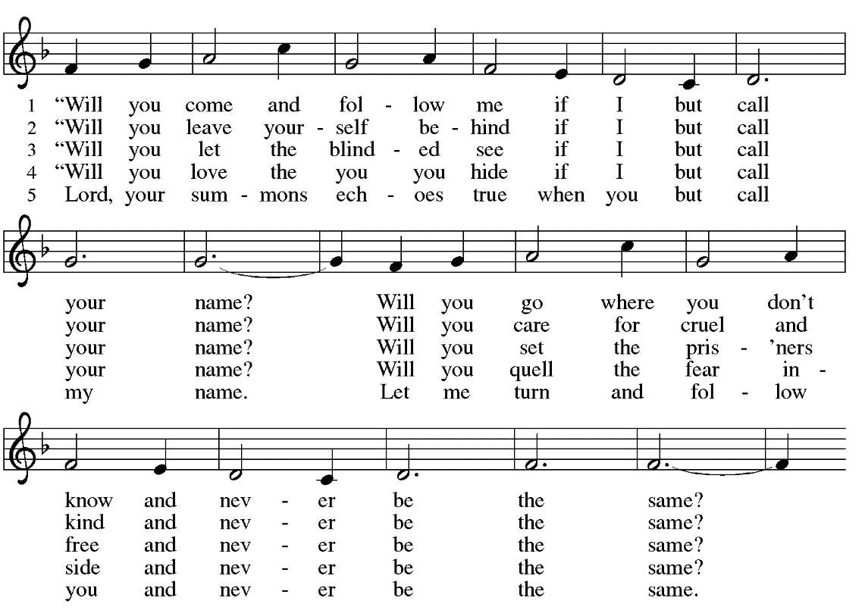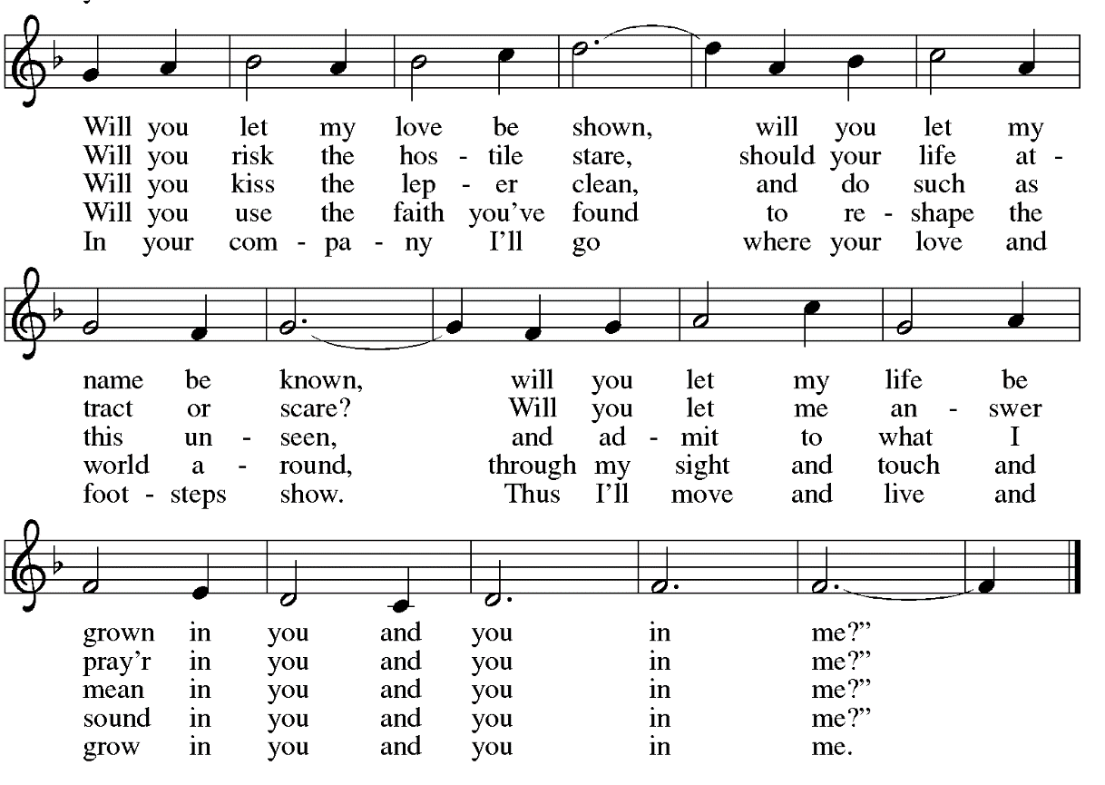

PRAYERS

P: Holy God, we come to you in prayer for the church, your good creation, and all who are in need.

P: God of grace,
C: Hear our prayer.

P: Receive the prayers of your people and draw all things together in your love, in the name of Jesus, who leads us from death to life.
C: Amen.

Please be seated

OFFERTORY MUSIC

Please stand

CONFESSION OF SIN

P: Friends in Christ, in this Lenten season we have heard our Lord’s call to struggle against sin, death, and the devil—all that keeps us from loving God and each other. This is the struggle to which we were called at baptism. We have also heard our Lord’s promise of the Holy Spirit that cleanses our hearts and births us as children born from above
God never wearies of giving the peace of reconciliation and offering a welcome of love.
On this night let us confess our sin against God and our neighbor and enter the celebration of the great Three Days reconciled with God and with one another.

Silence is kept for reflection.

P: Most merciful God,
C: we confess that we are captive to sin and cannot free ourselves. We have sinned against you in thought, word, and deed, by what we have done and by what we have left undone. We have not loved you with our whole heart; we have not loved our neighbors as ourselves.

P: Holy God, have mercy on us:
C: For self-centered living, and for failing to walk with humility and gentleness.

P: Holy God, have mercy on us:
C: For longing to have what is not ours, and for hearts that are not at rest with ourselves.

P: Holy God, have mercy on us:
C: For unwillingness to see the image of God in others, and for jealousies and rivalries that create strife and warfare.

P: Holy God, have mercy on us:
C: For reluctance in sharing the gifts of God, and for carelessness with the fruits of creation.

C: Holy God, have mercy on us:
P: For holding on to our regrets and shame, for not entering into more fully your grace, mercy and forgiveness.

P: Holy God, holy and mighty, have mercy on us:
C: For idleness in witnessing to Jesus Christ, and for squandering the gifts of love and grace.
For the sake of your Son, Jesus Christ, have mercy on us. Forgive us, renew us, and lead us, so that we may delight in your will and walk in your ways, to the glory of your holy name. Amen.

P: God, who is rich in mercy, loved us even when we were dead in sin, and made us alive together with Christ. By grace you have been saved.
In the name of ☩ Jesus Christ, your sins are forgiven.
Almighty God strengthen you with power through the Holy Spirit that Christ may live in your hearts through faith.
C: Amen.

THE SHARING OF THE PEACE

P: The Peace of the Lord be with you always.
C: And also with you.

THE GREAT THANKSGIVING

P: The Lord be with you.
C: And also with you.
P: Lift up your hearts.
C: We lift them to the Lord.
P: Let us give thanks to the Lord our God.
C: It is right to give our thanks and praise.

P: We give you thanks, Almighty God,
through Jesus Christ, your beloved Son,
whom you sent in this end of the ages
to save and redeem us and to proclaim to us your will.
You so loved the world that you gave your only Son,
so that everyone who believes in him may not perish
but have eternal life.
We give you thanks for his coming into the world
to fulfill for us your holy will
and to accomplish all things for our salvation.

In the night in which he was betrayed,
our Lord Jesus took bread, and gave thanks;
broke it, and gave it to his disciples, saying:
Take and eat; this is my body, given for you.
Do this for the remembrance of me.
Again, after supper, he took the cup, gave thanks,
and gave it for all to drink, saying:
This cup is the new covenant in my blood,
shed for you and for all people for the forgiveness of sin.
Do this for the remembrance of me.
For as often as we eat of this bread and drink from this cup,
we proclaim the Lord’s death until he comes.
Remembering, therefore, his life-giving command,
his passion and death, his glorious resurrection and ascension,
and the promise of his coming again, we give thanks to you, O Lord God Almighty, and offer our praise and thanksgiving.
With your Word and Holy Spirit bless us, your servants,
and these your own gifts of bread and wine,
so that we and all who share in the body and blood of Christ
may be filled with grace and peace,
and be formed to live as your holy people
To you, O God, Father, Son, and Holy Spirit,
be all honor and glory now and forever
C: Amen

P: Lord remember us in your kingdom and teach us to pray:
C: Our Father, who art in heaven, hallowed be thy name, thy kingdom come, thy will be done, on earth as it is in heaven. Give us this day our daily bread; and forgive us our trespasses, as we forgive those who trespass against us; and lead us not into temptation, but deliver us from evil. For thine is the kingdom, and the power, and the glory, forever and ever. Amen.

Please be seated

COMMUNION

This is God’s table so all are welcome to join the feast.
Grape juice and gluten free wafers are available.

Please stand

P: The body and blood of our Lord Jesus Christ strengthen you and keep you in his grace.
C: Amen.

PRAYER AFTER COMMUNION

P: Lord Jesus, in this wonderful gift from your altar you strengthen us with the saving power of your suffering, death, and resurrection. May your body and blood so work in us that the fruits of your redemption will show forth in the way we live, for you live and reign with the Father and the Holy Spirit, one God, now and forever.
C: Amen.

Please be seated

PSALM 22

STRIPPING OF THE ALTAR

CLOSING HYMN Go to Dark Gethsemane ELW 347
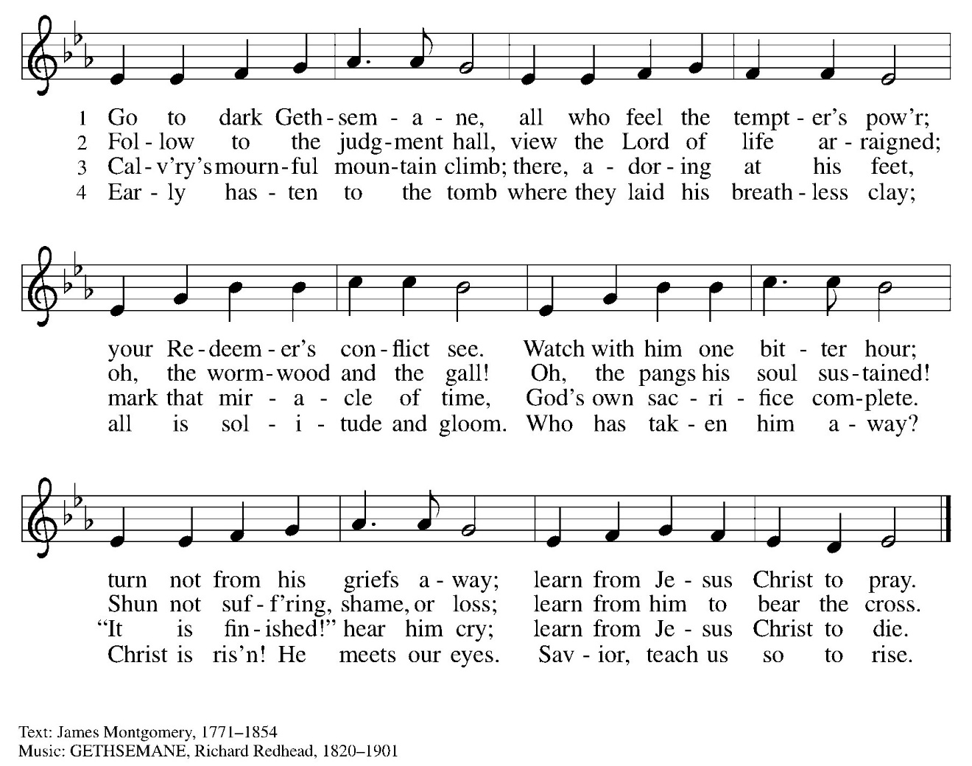

This service ends in silence.
You are welcome to stay FOR as long as you wish.



Good Friday
April 3, 7:00pm

Holy Saturday, Children’s Easter Egg Hunt
April 4, 10:00am

Easter Sunday Worship
April 5, 7:30am & 9:30am

Easter Congregational Breakfast
April 5, 8:30am

St. Matthew’s Staff
Pastor Christian McMullan cmcmullan71@gmail.com
Daniel Bower, Music Director worship@stmatthews-church.org
Craig Miller, Director of Youth and Family Ministries 484-320-0785
Sandy Elkins, Director St. Matthew’s School 610-458-3381
Sara Richardson, Church Administrator 610-458-5675
Sandy Dewees, Cemetery Operations Coordinator 610-458-8121

