This Week at PPBC
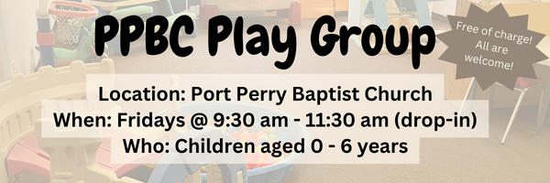




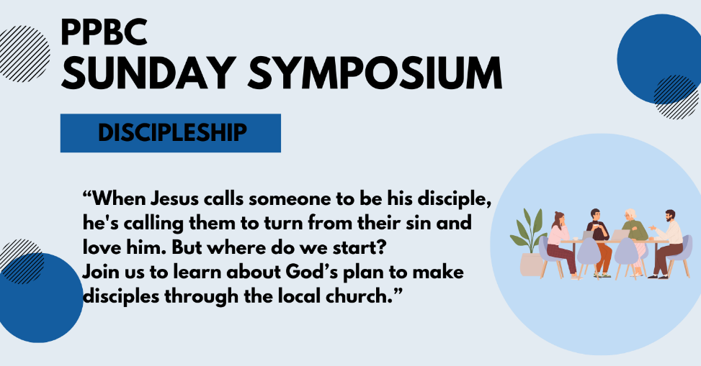
April 19th, 2026
April 11th, 2026



Sunday Ministry Schedules
Nursery
April 5: Jen Werner, Hannah Colwell
April 12: Jan Gerrow, Audrianna Angrove
Infant Nursery
April 5: Lisa Dallas, Elise Anderson
April 12: Stephanie Anderson, Karis Henkelman
Jr. Church; ages 3 to grade 1
April 5: Deb Brown, Hailey Ferguson
April 12: Christine McLaren, Grace Brown
Jr. Church; Grades 2 to 6
April 5: Miriam Bolsonello, Lena Sammut
April 12: Tracy Ballanger, Tiffany Green
Greeters
Good Friday: Mark & Christine McLaren
April 5: Paul & Helen Jones
April 12: Graeme & Barb Foster
Ushers
Good Friday: Gregg Anderson, Roy Wilson
April 5: Joe Colwell, Matt Saunders
April 12: Nick Woytowich, Mark McLaren
Sound & Video
Good Friday: Sound: Wyatt Werner | Video: William Conley
April 5: Sound: Eric Duchesne | Video: Josh Bolsonello
April 12: Sound: Wyatt Werner | Video: Josh Myers

Sunday Service
Song – Christ the Lord is Risen Today
Welcome
Song – Rejoice the Lord is King
Scripture
Song – How Deep the Father’s Love for Us
Song – Turn Your Eyes
Prayer
Message – Pastor Jim Clemens
Song – O Church Arise


A Prayer Request from Arms of Jesus: Praise for the finances at AOJ Guatemala – despite another year of very high government mandated salary increases, and general cost increases experienced by everyone everywhere, God continues to provide in generous and surprising ways. We are very grateful and humbled.

Praise & Prayer Highlights
PRAY for Joan Mabley who has been moved to Glen Hill Strathaven in Bowmanville. Please PRAY for Joan’s comfort and peace.
PRAY for John & Joan Mank and their ongoing health concerns.
PRAY for Martin & Tina McCurley and their ongoing health concerns. PRAY for them as they prepare to move the end of April.
PRAY for the community of Tumbler Ridge BC. PRAY for Pastor George Rowe and Tumbler Ridge Baptist Church as they care for their community.
PRAY for Jordan & Stephanie Anderson. PRAY for Jordan as he undergoes training in Quebec.
PRAY for Laurie Buismans sister Debbie and their family. Debbie is in Lakeridge health Hospital under observation. PRAY for the family and the doctors who are caring for them.
PRAY for Darren & Brooke VanUden. They are expecting a baby in May 2026. PRAY for Brooke and the little ones health as they approach the due date and delivery.
PRAY for Betty Collins cousin Pat and her ongoing concerns. PRAY for her healing for her neck and that the docors and nurses would have wisdom in caring for her.

Giving
Just as a reminder, there are several ways you can give:
In Person using the offering box located on the back wall of the sanctuary. Donation envelopes are available at the Welcome Centre. Please contact the church office if you would like a box of donation envelopes (office@portperrybaptist.ca)
Through your online banking, you may send electronic transfers to ppbcdonations@gmail.com.
You can also give through Canada Helps. Donation receipts will be provided by Canada Helps, and transaction fees apply.
***********************************************************************
Weekly Newsletter
The PPBC Newsletter is emailed to the church family every Friday. If you would like to be added to the weekly email list, please contact the office by phone: 905-985-8681 or by email: office@portperrybaptist.ca.
*****************************************************************
Church Information:
Location:
2210 Hwy 7A
Port Perry, ON
L9L 1B4
Office Hours:
Monday: 8:30am – 4:00pm
Tuesday: 8:30am – 4:00pm
Wednesday: Closed
Thursday: 8:30am – 4:00pm
Friday: 8:30 am - 3:00 pm
Contact:
Phone: 905.985.8681
Email: office@portperrybaptist.ca
Website: www.portperrybaptist.ca
Staff:
Sr. Pastor – Rev. Jim Clemens
Administrative Assistant – Madeline Werner
Family Ministries Director – Josh Anderson
Pastoral Intern – Scott McKenzie

PPBC Newsletter
Sunday, April 5, 2026


Sunday Starting Point
Sunday, April 5, 2026 - 9:30 am
“Beginning the day with the Word and prayer”
Adults:
Adults will meet in the sanctuary for a time of study and prayer.
Youth:
Jr High (Grades 7-8) will meet in room 18 with Kate Anderson to study Thessalonians.
Children:
Children ages 3 - grade 6 will meet in room 26.
(Please note nursery is unavailable during Starting Point)
Sunday Morning Worship
Sunday, April 5, 2026 - 10:30 am
We are meeting in the sanctuary and will continue to live-stream for those who are unable to attend.
Message: Seeing Jesus
Scripture: John 11-21
Pastor Jim Clemens

