St. Matthew’s Lutheran Church



GOOD FRIDAY SERVICE
April 3, 2026
7:00pm

WELCOME
Welcome to worship!

Please stand

GREETING

P: The boundless grace of our Lord Jesus Christ, the wisdom of God, and the light of the
Holy Spirit be with you all.
C: And also with you.

PRAYER OF THE DAY

P: Almighty God, look with loving mercy on your family, for whom our Lord Jesus Christ was willing to be betrayed, to be given over to the hands of sinners, and to suffer death on the cross; who now lives and reigns with you and the Holy Spirit, one God, forever and ever.
C: Amen.

OPENING HYMN What Wondrous Love Is This ELW 666
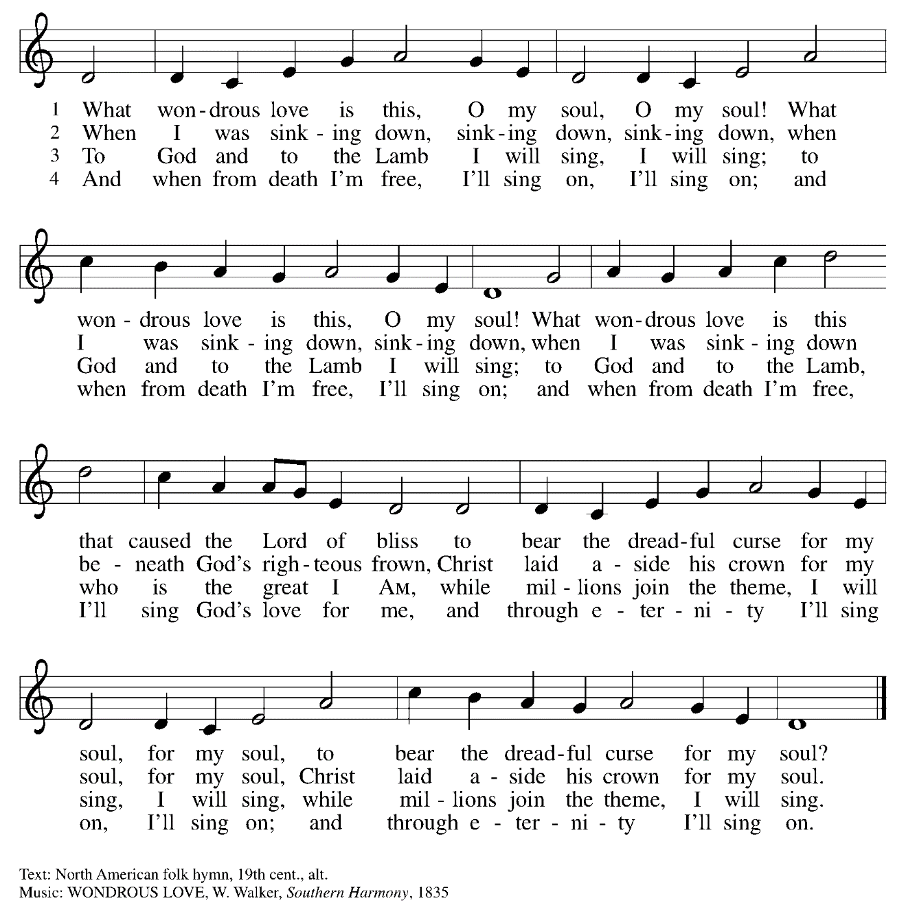

OPENING WORDS

P: Jesus told his disciples, “If any want to become my followers, let them deny themselves and take up their cross and follow me. For those who want to save their life will lose it and those who lose their life for my sake and the sake of the gospel will save it” (Mark 8:34-35).

C: On this day we gather to remember Jesus our Savior who loved us and gave himself
for us. Let us draw near in full assurance of God’s endless love and mercy.

P: Jesus said, “The hour has come for the Son of Man to be glorified. Very truly I tell you, unless a grain of wheat falls into the earth and dies, it remains just a single grain, but if it dies it bears much fruit” (John 12:24).

C: We give our thanks and praise to Jesus Christ who carries our sorrows, heals
our wounds, and redeems us from sin and death.

Please be seated

Jesus Before Pilate

It is Friday early in the morning. Jesus was brought from Caiaphas the High Priest to Pontius Pilate, the Governor, on charges of treason. Pilate sat on the judge's bench and cynically interrogated Jesus.

READING John 18:28-38

²⁸ Then [the chief priests and elders] took Jesus from Caiaphas to Pilate’s headquarters. It was early in the morning. They themselves did not enter the headquarters, so as to avoid ritual defilement and to be able to eat the Passover. ²⁹So Pilate went out to them and said, ‘What accusation do you bring against this man?’ ³⁰They answered, ‘If this man were not a criminal, we would not have handed him over to you.’ ³¹Pilate said to them, ‘Take him yourselves and judge him according to your law.’ The Jews replied, ‘We are not permitted to put anyone to death.’ ³²(This was to fulfil what Jesus had said when he indicated the kind of death he was to die.)
³³ Then Pilate entered the headquarters again, summoned Jesus, and asked him, ‘Are you the King of the Jews?’ ³⁴Jesus answered, ‘Do you ask this on your own, or did others tell you about me?’ ³⁵Pilate replied, ‘I am not a Jew, am I? Your own nation and the chief priests have handed you over to me. What have you done?’ ³⁶Jesus answered, ‘My kingdom is not from this world. If my kingdom were from this world, my followers would be fighting to keep me from being handed over to the Jews. But as it is, my kingdom is not from here.’ ³⁷Pilate asked him, ‘So you are a king?’ Jesus answered, ‘You say that I am a king. For this I was born, and for this I came into the world, to testify to the truth. Everyone who belongs to the truth listens to my voice.’ ³⁸Pilate asked him, ‘What is truth?’

PRAYER

HYMN Lamb of God ELW 336

Your only Son no sin to hide
But You have sent Him from Your side
To walk upon this guilty sod
And to become the Lamb of God

Oh Lamb of God sweet Lamb of God
I love the holy Lamb of God
Oh wash me in His precious blood
My Jesus Christ the Lamb of God

Your gift of love we crucified
We laughed and scorned Him as He died
The humble King we named a fraud
And sacrificed the Lamb of God

Oh Lamb of God sweet Lamb of God
I love the holy Lamb of God
Oh wash me in His precious blood
My Jesus Christ the Lamb of God

I was so lost I should have died
But You have brought me to Your side
To be led by Your staff and rod
And to be called a lamb of God

Oh Lamb of God sweet Lamb of God
I love the holy Lamb of God
Oh wash me in His precious blood
My Jesus Christ the Lamb of God

Jesus Is Condemned

Jesus is condemned by the very people he came to save and will die innocently for a criminal deserving death. He hears them shout their rejection of who he is and all he meant to do and his heart breaks. Not just mental anguish but horrible physical suffering will be his. He will carry a cross.

READING Mark 15:6-15

⁶ Now at the festival Pilate used to release a prisoner for them, anyone for whom they asked. ⁷Now a man called Barabbas was in prison with the rebels who had committed murder during the insurrection. ⁸So the crowd came and began to ask Pilate to do for them according to his custom. ⁹Then he answered them, ‘Do you want me to release for you the King of the Jews?’ ¹⁰For he realized that it was out of jealousy that the chief priests had handed him over. ¹¹But the chief priests stirred up the crowd to have him release Barabbas for them instead. ¹²Pilate spoke to them again, ‘Then what do you wish me to do with the man you call the King of the Jews?’ ¹³They shouted back, ‘Crucify him!’ ¹⁴Pilate asked them, ‘Why, what evil has he done?’ But they shouted all the more, ‘Crucify him!’ ¹⁵So Pilate, wishing to satisfy the crowd, released Barabbas for them; and after flogging Jesus, he handed him over to be crucified.

PRAYER

Please stand

PROCESSION

P: Behold, the life-giving cross on which was hung the salvation of the whole world.
C: Oh, come, let us worship him.

P: Behold, the life-giving cross on which was hung the salvation of the whole world.
C: Oh, come, let us worship him.

P: Behold, the life-giving cross on which was hung the salvation of the whole world.
C: Oh, come, let us worship him.

Jesus Is Beaten and Mocked

A heavy cross is thrust into Jesus' arms. He is ordered to carry it to the site of His execution. Jesus accepts the cross. Carrying it by himself, he goes out to the Place of the Skull Golgotha - to be crucified with two other men. He went out carrying his cross....beaten, mocked, bleeding, carrying the burden that he did not earn. Without a word. In silence.

READING Matthew 27:27-31

²⁷ Then the soldiers of the governor took Jesus into the governor’s headquarters, and they gathered the whole cohort around him. ²⁸They stripped him and put a scarlet robe on him, ²⁹and after twisting some thorns into a crown, they put it on his head. They put a reed in his right hand and knelt before him and mocked him, saying, ‘Hail, King of the Jews!’ ³⁰They spat on him, and took the reed and struck him on the head. ³¹After mocking him, they stripped him of the robe and put his own clothes on him. Then they led him away to crucify him.

PRAYER

HYMN The Old Rugged Cross (On a Hill Far Away)

On a hill far away stood an old rugged cross,
the emblem of suff’ring and shame;
and I love that old cross where the dearest and best
for a world of lost sinners was slain.

Refrain
So I’ll cherish the old rugged cross,
till my trophies at last I lay down;
I will cling to the old rugged cross,
and exchange it some day for a crown.

Oh, that old rugged cross so despised by the world,
has a wondrous attraction for me;
for the dear Lamb of God left his glory above,
to bear it to dark Calvary. Refrain

To the old rugged cross I will ever be true,
its shame and reproach gladly bear;
Christ will call me some day to my home far away,
where his glory forever I’ll share. Refrain Text: George Bennard, 1873-1958
Simon of Cyrene Helps Jesus Carry the Cross

The soldiers seized Simon of Cyrene, put the cross on his shoulders as he stood behind Jesus and made him shoulder the load. Jesus fell in the dirt, sweat beading on his face, mingling with the blood from the cuts on his forehead and the dust of those well-traveled streets. The soldiers, impatient and anxious to be finished, roughly dragged him to his feet again, cursing him.

READING Luke 23:26-31

²⁶ As they led him away, they seized a man, Simon of Cyrene, who was coming from the country, and they laid the cross on him, and made him carry it behind Jesus. ²⁷A great number of the people followed him, and among them were women who were beating their breasts and wailing for him. ²⁸But Jesus turned to them and said, ‘Daughters of Jerusalem, do not weep for me, but weep for yourselves and for your children. ²⁹For the days are surely coming when they will say, “Blessed are the barren, and the wombs that never bore, and the breasts that never nursed.” ³⁰Then they will begin to say to the mountains, “Fall on us”; and to the hills, “Cover us.” ³¹For if they do this when the wood is green, what will happen when it is dry?’

PRAYER

SPECIAL MUSIC

Jesus is Stripped of His Garments

Finally they arrived at the God-forsaken place where Jesus was to be crucified. People dumped their garbage very near the place known as Golgatha. Hurriedly, roughly, his clothes are stripped from his back leaving him naked in front of the crowd, exhausted and humiliated. There was nothing left him as a man.

READING John 19:19-27

¹⁹Pilate also had an inscription written and put on the cross. It read, ‘Jesus of Nazareth, the King of the Jews.’ ²⁰Many of the Jews read this inscription, because the place where Jesus was crucified was near the city; and it was written in Hebrew, in Latin, and in Greek. ²¹Then the chief priests of the Jews said to Pilate, ‘Do not write, “The King of the Jews”, but, “This man said, I am King of the Jews.” ’ ²²Pilate answered, ‘What I have written I have written.’
²³When the soldiers had crucified Jesus, they took his clothes and divided them into four parts, one for each soldier. They also took his tunic; now the tunic was seamless, woven in one piece from the top. ²⁴So they said to one another, ‘Let us not tear it, but cast lots for it to see who will get it.’ This was to fulfil what the scripture says,
‘They divided my clothes among themselves,
and for my clothing they cast lots.’
²⁵And that is what the soldiers did.
Meanwhile, standing near the cross of Jesus were his mother, and his mother’s sister, Mary the wife of Clopas, and Mary Magdalene. ²⁶When Jesus saw his mother and the disciple whom he loved standing beside her, he said to his mother, ‘Woman, here is your son.’ ²⁷Then he said to the disciple, ‘Here is your mother.’ And from that hour the disciple took her into his own home.

PRAYER

HYMN Alas! And Did My Savior Bleed? ELW 337
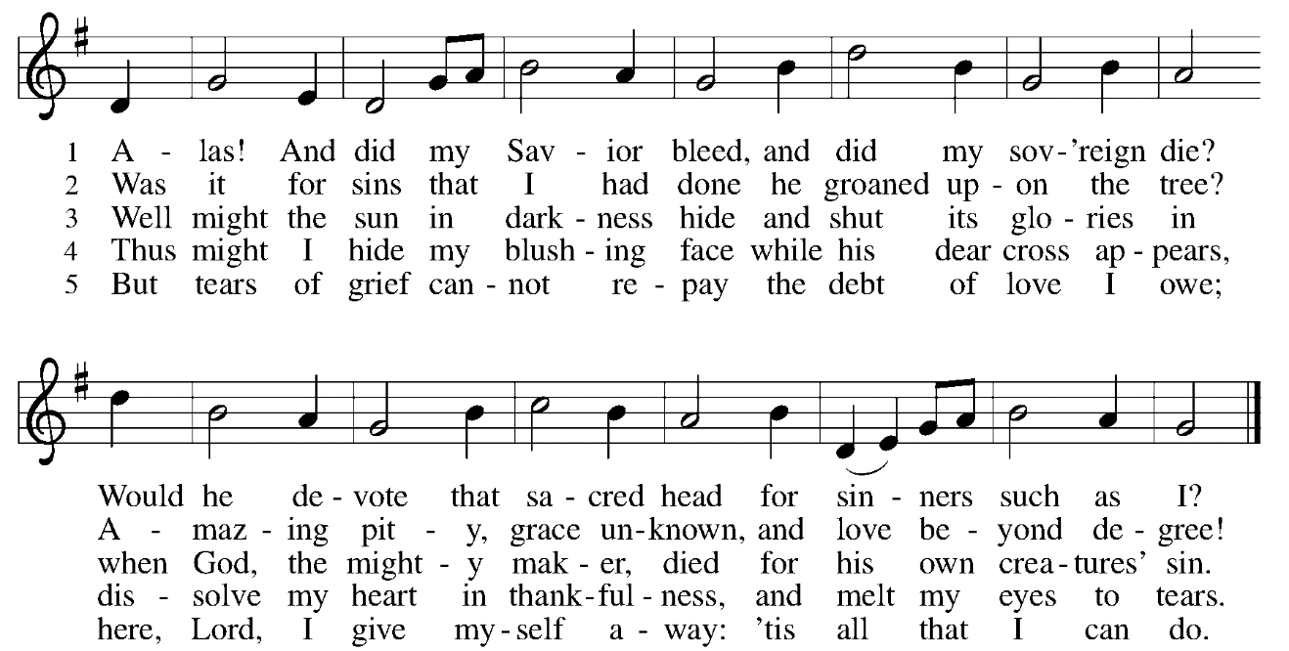

Please stand

Jesus is Nailed to the Cross

Roughly, contemptuously, the soldiers thrust Jesus down onto his cross. Holding him down they pounded the nails through his hands and feet. Lifting him up, all his weight in his pierced hands, he sagged forward. Arms wide he struggled to breathe. And yet Jesus still had love in his heart.

READING Luke 23:32-43

³² Two others also, who were criminals, were led away to be put to death with him. ³³When they came to the place that is called The Skull, they crucified Jesus there with the criminals, one on his right and one on his left. ³⁴Then Jesus said, ‘Father, forgive them; for they do not know what they are doing.’ And they cast lots to divide his clothing. ³⁵And the people stood by, watching; but the leaders scoffed at him, saying, ‘He saved others; let him save himself if he is the Messiah of God, his chosen one!’ ³⁶The soldiers also mocked him, coming up and offering him sour wine, ³⁷and saying, ‘If you are the King of the Jews, save yourself!’ ³⁸There was also an inscription over him, ‘This is the King of the Jews.’
³⁹ One of the criminals who were hanged there kept deriding him and saying, ‘Are you not the Messiah? Save yourself and us!’ ⁴⁰But the other rebuked him, saying, ‘Do you not fear God, since you are under the same sentence of condemnation? ⁴¹And we indeed have been condemned justly, for we are getting what we deserve for our deeds, but this man has done nothing wrong.’ ⁴²Then he said, ‘Jesus, remember me when you come into your kingdom.’ ⁴³He replied, ‘Truly I tell you, today you will be with me in Paradise.’

PRAYER

HYMN Were You There ELW 353 (verses 1 & 2)

Were you there when they crucified my Lord? Were you there when they crucified my Lord? Oh! Sometimes it causes me to tremble, tremble, tremble. Were you there when they crucified my Lord?

Were you there when they nailed Him to the tree? Were you there when they nailed Him to the tree? Oh! Sometimes it causes me to tremble, tremble, tremble. Were you there when they nailed Him to the tree?

Please be seated

Jesus Dies on the Cross

PRAYER

READING Mark 15:33-39

³³When it was noon, darkness came over the whole land until three in the afternoon. ³⁴At three o’clock Jesus cried out with a loud voice, ‘Eloi, Eloi, lema sabachthani?’ which means, ‘My God, my God, why have you forsaken me?’ ³⁵When some of the bystanders heard it, they said, ‘Listen, he is calling for Elijah.’ ³⁶And someone ran, filled a sponge with sour wine, put it on a stick, and gave it to him to drink, saying, ‘Wait, let us see whether Elijah will come to take him down.’ ³⁷Then Jesus gave a loud cry and breathed his last. ³⁸And the curtain of the temple was torn in two, from top to bottom. ³⁹Now when the centurion, who stood facing him, saw that in this way he breathed his last, he said, ‘Truly this man was God’s Son!’

Silence

HYMN Were You There ELW 353 (verses 3 & 4)

Were you there when the sun refused to shine? Were you there when the sun refused to shine? Oh, sometimes it causes me to tremble, tremble, tremble. Were you there when the sun refused to shine?

Were you there when they laid him in the tomb? Were you there when they laid him in the tomb? Oh, sometimes it causes me to tremble, tremble, tremble, Were you there when they laid him in the tomb?

Jesus is dead…

The tomb is sealed…

It is finished.

This service ends in silence. Stay as long as you wish.
Please leave your offering in the back of the sanctuary.

Holy Saturday, Children’s Easter Egg Hunt
April 4, 10:00am

Easter Sunday Worship
April 5, 7:30am & 9:30am

Easter Congregational Breakfast
April 5, 8:30am

St. Matthew’s Staff
Pastor Christian McMullan cmcmullan71@gmail.com
Daniel Bower, Music Director worship@stmatthews-church.org
Craig Miller, Director of Youth and Family Ministries 484-320-0785
Sandy Elkins, Director St. Matthew’s School 610-458-3381
Sara Richardson, Church Administrator 610-458-5675
Sandy Dewees, Cemetery Operations Coordinator 610-458-8121

