Thursday, April 2, 2026 ~ Maundy Thursday

Prayer of the Day
Let us pray. Eternal God, in the sharing of a meal your Son established a new covenant for all people, and in the washing of feet he showed us the dignity of service. Grant that by the power of your Holy Spirit these signs of our life in faith may speak again to our hearts, feed our spirits, and refresh our bodies, through Jesus Christ, our Savior and Lord, who lives and reigns with you and the Holy Spirit, one God, now and forever. Amen.

First Reading: Exodus 12:1-14

The Lord said to Moses and Aaron in the land of Egypt, “This month shall mark for you the beginning of months; it shall be the first month of the year for you. Tell the whole congregation of Israel that on the tenth of this month they are to take a lamb for each family, a lamb for each household. If a household is too small for a whole lamb, it shall join its closest neighbor in obtaining one; the lamb shall be divided in proportion to the number of people who eat of it. Your lamb shall be without blemish, a year-old male; you may take it from the sheep or from the goats. You shall keep it until the fourteenth day of this month; then the whole assembled congregation of Israel shall slaughter it at twilight. They shall take some of the blood and put it on the two doorposts and the lintel of the houses in which they eat it. They shall eat the lamb that same night; they shall eat it roasted over the fire with unleavened bread and bitter herbs. Do not eat any of it raw or boiled in water but roasted over the fire, with its head, legs, and inner organs. You shall let none of it remain until the morning; anything that remains until the morning you shall burn with fire. This is how you shall eat it: your loins girded, your sandals on your feet, and your staff in your hand, and you shall eat it hurriedly. It is the Passover of the Lord. I will pass through the land of Egypt that night, and I will strike down every firstborn in the land of Egypt, from human to animal, and on all the gods of Egypt I will execute judgments: I am the Lord. The blood shall be a sign for you on the houses where you live: when I see the blood, I will pass over you, and no plague shall destroy you when I strike the land of Egypt. “This day shall be a day of remembrance for you. You shall celebrate it as a festival to the Lord; throughout your generations you shall observe it as a perpetual ordinance.

Psalm 116:1-2, 12-19
¹I love the Lord, who has heard my voice, and listened to my supplication,
²for the Lord has given ear to me whenever I called.
¹²How shall I repay the Lord for all the good things God has done for me?
¹³I will lift the cup of salvation and call on the name of the Lord.
¹⁴I will fulfill my vows to the Lord in the presence of all God’s people.
¹⁵Precious in your sight, O Lord, is the death of your servants.
¹⁶O Lord, truly I am your servant; I am your servant, the child of your handmaid; you have freed me from my bonds.
¹⁷I will offer you the sacrifice of thanksgiving and call upon the name of the Lord.
¹⁸I will fulfill my vows to the Lord in the presence of all God’s people,
¹⁹in the courts of the Lord’s house, in the midst of you, O Jerusalem. Hallelujah!

Second Reading: 1 Corinthians 11:23-26

For I received from the Lord what I also handed on to you, that the Lord Jesus on the night when he was betrayed took a loaf of bread, and when he had given thanks, he broke it and said, “This is my body that is for you. Do this in remembrance of me.” In the same way he took the cup also, after supper, saying, “This cup is the new covenant in my blood. Do this, as often as you drink it, in remembrance of me.” For as often as you eat this bread and drink the cup, you proclaim the Lord’s death until he comes.

Gospel: John 13:1-17, 31b-35
Now before the festival of the Passover, Jesus knew that his hour had come to depart from this world and go to the Father. Having loved his own who were in the world, he loved them to the end. The devil had already decided that Judas son of Simon Iscariot would betray Jesus. And during supper Jesus, knowing that the Father had given all things into his hands and that he had come from God and was going to God, got up from supper, took off his outer robe, and tied a towel around himself. Then he poured water into a basin and began to wash the disciples’ feet and to wipe them with the towel that was tied around him. He came to Simon Peter, who said to him, “Lord, are you going to wash my feet?” Jesus answered, “You do not know now what I am doing, but later you will understand.” Peter said to him, “You will never wash my feet.” Jesus answered, “Unless I wash you, you have no share with me.” Simon Peter said to him, “Lord, not my feet only but also my hands and my head!” Jesus said to him, “One who has bathed does not need to wash, except for the feet, but is entirely clean. And you are clean, though not all of you.” For he knew who was to betray him; for this reason he said, “Not all of you are clean.”
After he had washed their feet, had put on his robe, and had reclined again, he said to them, “Do you know what I have done to you? You call me Teacher and Lord, and you are right, for that is what I am. So if I, your Lord and Teacher, have washed your feet, you also ought to wash one another’s feet. For I have set you an example, that you also should do as I have done to you. Very truly, I tell you, slaves are not greater than their master, nor are messengers greater than the one who sent them. If you know these things, you are blessed if you do them. “Now the Son of Man has been glorified, and God has been glorified in him. If God has been glorified in him, God will also glorify him in himself and will glorify him at once. Little children, I am with you only a little longer. You will look for me, and as I said to the Jews so now I say to you, ‘Where I am going, you cannot come.’ I give you a new commandment, that you love one another. Just as I have loved you, you also should love one another. By this everyone will know that you are my disciples, if you have love for one another.”
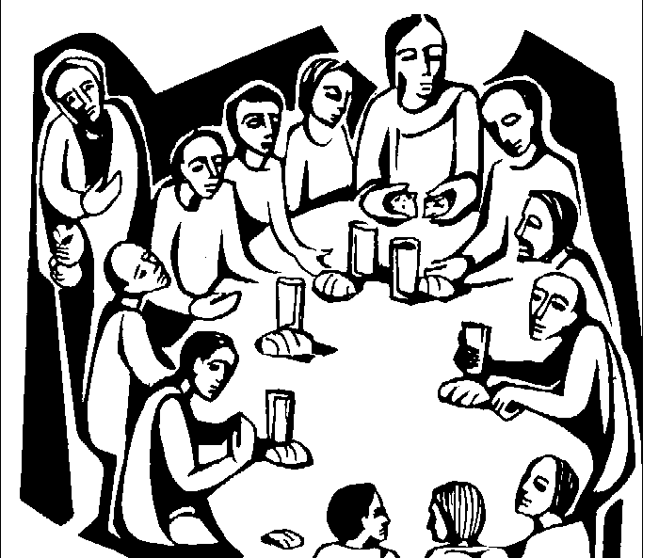

Prayers of Intercession – Maundy Thursday, 4/2
On this night when Jesus gave us a new commandment to love one another, let us bring our prayers before the One whose love knows no bounds.
A brief silence.
Gracious host, you knelt to wash your disciples’ feet. Cleanse us from pride and self-centeredness, and teach us to love one another as you have loved us. Receive our prayers, O God.
Your mercy is great.
Creator God, the earth is yours and everything in it. Awaken us to care for all you have made and conserve the rich diversity of your good creation. Receive our prayers, O God.
Your mercy is great.
God of the nations, guide the world’s leaders in the ways of justice and peace. Where they wield power unjustly, confront them. Where they are indifferent to suffering, awaken their conscience. Receive our prayers, O God.
Your mercy is great.
Compassionate One, embrace all who are lonely or in captivity, comfort the grieving, and relieve those in pain. Draw near to all who suffer ( especially [names].…and all other people or concerns we now name aloud on our lips or in the silence of our hearts.) Receive our prayers, O God.
Your mercy is great.
Blessed redeemer, we give you thanks for this community of faith, and for all who gather around your table of grace. Unite us in love for you and for one another. Receive our prayers, O God.
Your mercy is great.
Eternal God, we praise you for the great cloud of witnesses who now rest from their labors. At the last, gather us with them at your heavenly banquet. Receive our prayers, O God.
Your mercy is great.
We entrust these prayers to you, O God, confident that you will strengthen us by your Spirit to love one another as Christ has loved us. We ask this in Jesus’ name.
Amen.

