
Easter Sunday
April 5, 2026
10 AM
Holy Eucharist

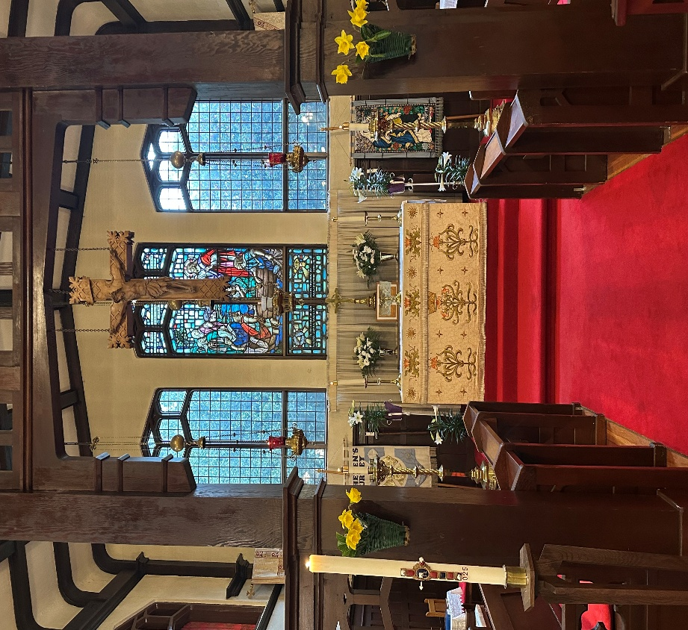

This service is Livestreamed via Facebook and the Parish website.
We welcome everyone worshipping with us today whether in person or online.

The Gathering of the Community

Words of Welcome and Acknowledgment
We give thanks that we live, work, play, and worship on the traditional and unceded territory of the Coast Salish peoples including the Katzee, Tsawwassen, Semiahmoo and Kwantlen Nations. May our words and our actions reflect our awareness and appreciation.

Processional Hymn: CP 203 Jesus Christ is Risen Today

The Gathering of the Community

Alleluia! Christ is risen.
The Lord is risen indeed. Alleluia!

May his grace and peace be with you.
May he fill our hearts with joy.

Children’s Focus

Gloria: CP 366
All stand for the singing of the Gloria

Glory in the highest glory, peace to all, in all their days.
Worship, thanks, and praise unceasing to the source of all we raise:
reigning in the sapphire height, hidden from our mortal sight,
now receive our adoration, as we make our supplication.

Jesus Christ, the world’s redeemer, Lamb of God, for sinners given,
Word eternal, born of Mary, Word made flesh, the face of heaven:
holy one, to you we pray, hear us in the realms of day,
with the Spirit there united, and the God-head high exulted.
Kyrie Confessions

Like Mary at the empty tomb,
we fail to grasp the wonder of your presence.
Lord, have mercy.
Lord, have mercy.

Like the disciples behind locked doors,
we are afraid to be seen as your followers.
Christ, have mercy.
Christ, have mercy.

Like Thomas in the upper room,
we are slow to believe.
Lord, have mercy.
Lord, have mercy

Collect of the Day

Creator God,
from you every family in heaven and on earth takes its name.
You have grounded us in your covenant love,
and empowered us by your Spirit to speak the truth in love,
and to walk in your way towards justice and wholeness.
Mercifully grant that your people,
journeying together in partnership,
may be strengthened and guided
to help one another grow into the full stature of Christ,
who is our light and our life. Amen

The Proclamation of the Word

First Reading: Acts 10: 34-43
A reading from the book of Acts
Then Peter began to speak to the Gentiles: "I truly understand that God shows no partiality, but in every nation anyone who fears him and does what is right is acceptable to him. You know the message he sent to the people of Israel, preaching peace by Jesus Christ - he is Lord of all. That message spread throughout Judea, beginning in Galilee after the baptism that John announced: how God anointed Jesus of Nazareth with the Holy Spirit and with power; how he went about doing good and healing all who were oppressed by the devil, for God was with him. We are witnesses to all that he did both in Judea and in Jerusalem. They put him to death by hanging him on a tree; but God raised him on the third day and allowed him to appear, not to all the people but to us who were chosen by God as witnesses, and who ate and drank with him after he rose from the dead. He commanded us to preach to the people and to testify that he is the one ordained by God as judge of the living and the dead. All the prophets testify about him that everyone who believes in him receives forgiveness of sins through his name."
Listen to what the spirit is saying to the Church.
Thanks be to God

Psalm: 118: 1-2, 14-24

Give thanks to the Lord, for he is good; his mercy endures for ever.
Let Israel now proclaim, "His mercy endures for ever."

The Lord is my strength and my song, and he has become my salvation. There is a sound of exultation and victory in the tents of the righteous:
"The right hand of the Lord has triumphed! the right hand of the Lord is exalted! The right hand of the Lord has triumphed!"

I shall not die, but live, and declare the works of the Lord.
The Lord has punished me sorely, but he did not hand me over to death.

Open for me the gates of righteousness; I will enter them; I will offer thanks to the Lord.
"This is the gate of the Lord; he who is righteous may enter."

I will give thanks to you, for you answered me and have become my salvation.
The same stone which the builders rejected has become the chief cornerstone.

This is the Lord's doing, and it is marvellous in our eyes.
On this day the Lord has acted; we will rejoice and be glad in it.

Glory to God, Source of all Being, Eternal Word, and Holy Spirit:
As it was in the beginning, is now and ever shall be. Amen

Second Reading: Colossians 3: 1-4

A Reading from the letter of Paul to the Colossians
So if you have been raised with Christ, seek the things that are above, where Christ is, seated at the right hand of God. Set your minds on things that are above, not on things that are on earth, for you have died, and your life is hid-den with Christ in God. When Christ who is your life is revealed, then you also will be revealed with him in glory.
Listen to what the spirit is saying to the Church.
Thanks be to God
Gradual Hymn: CP 212 Alleluia! The Strife is O’er

Gospel: John 20: 1-18

The Lord be with you.
And also with you.
The holy Gospel of our Lord Jesus Christ, according to John
Glory to you Lord Jesus Christ

Early on the first day of the week, while it was still dark, Mary Magdalene came to the tomb and saw that the stone had been removed from the tomb. So she ran and went to Simon Peter and the other disciple, the one whom Jesus loved, and said to them, "They have taken the Lord out of the tomb, and we do not know where they have laid him." Then Peter and the other disciple set out and went toward the tomb. The two were running together, but the other disciple outran Peter and reached the tomb first. He bent down to look in and saw the linen wrappings lying there, but he did not go in. Then Simon Peter came, following him, and went into the tomb. He saw the linen wrappings lying there, and the cloth that had been on Jesus' head, not lying with the linen wrappings but rolled up in a place by itself. Then the other disciple, who reached the tomb first, also went in, and he saw and believed; for as yet they did not understand the scripture, that he must rise from the dead. Then the disciples returned to their homes. But Mary stood weeping outside the tomb. As she wept, she bent over to look into the tomb; and she saw two angels in white, sitting where the body of Jesus had been lying, one at the head and the other at the feet. They said to her, "Woman, why are you weeping?" She said to them, "They have taken away my Lord, and I do not know where they have laid him." When she had said this, she turned around and saw Jesus standing there, but she did not know that it was Jesus. Jesus said to her, "Woman, why are you weeping? Whom are you looking for?" Supposing him to be the gardener, she said to him, "Sir, if you have carried him away, tell me where you have laid him, and I will take him away." Jesus said to her, "Mary!" She turned and said to him in Hebrew, "Rabbouni!" (which means Teacher). Jesus said to her, "Do not hold on to me, because I have not yet ascended to the Father. But go to my brothers and say to them, 'I am ascending to my Father and your Father, to my god and your God.'" Mary Magdalene went and announced to the disciples, "I have seen the Lord"; and she told them that he had said these things to her.
The Gospel of Christ
Praise to you Lord Jesus Christ.

Homily: Reverend Dr. Robin Ruder Celiz

Hymn: CP 205 The Day of Resurrection

Renewal of Baptismal Vows

Let us give thanks to the Lord our God.
It is right to give our thanks and praise.

We thank you, Almighty God, for the gift of water.
Over water the Holy Spirit moved in the beginning
of creation. Through water you led the children of
Israel out of their bondage in Egypt into the land of
promise. In water your Son Jesus received the
baptism of John and was anointed by the Holy
Spirit as the Messiah, the Christ, to lead us,
through his death and resurrection, from the
bondage of sin into everlasting life.

We thank you, Father, for the water of baptism. In
it we are buried with Christ in his death. By it we
share in his resurrection. Through it we are reborn
by the Holy Spirit. Therefore in joyful obedience to
your Son, we celebrate our fellowship in him in faith.

We pray that all who have passed through the water
of baptism may continue for ever in the risen life of
Jesus Christ our Saviour.
To him, to you, and to the Holy Spirit, be all honour
and glory, now and for ever. Amen.

Dear friends,
through the paschal mystery
we have been buried with Christ in baptism,
so that we may rise with him to a new life.
Now that our Lenten observance is ended,
let us renew the promises we made in baptism,
when we rejected Satan and all his works,
and promised to serve God faithfully
in his holy catholic Church.

Do you reaffirm your renunciation of evil
and renew your commitment to Jesus Christ?
I do.

Do you believe in God the Father?
I believe in God,
the Father almighty,
creator of heaven and earth.

Do you believe in Jesus Christ, the Son of God?
I believe in Jesus Christ,
his only Son, our Lord.
He was conceived by the power of the Holy Spirit
and born of the Virgin Mary.
He suffered under Pontius Pilate,
was crucified, died, and was buried.
He descended to the dead.
On the third day he rose again.
He ascended into heaven,
and is seated at the right hand of the Father.
He will come again
to judge the living and the dead.

Do you believe in God the Holy Spirit?
I believe in the Holy Spirit,
the holy catholic Church,
the communion of saints,
the forgiveness of sins,
the resurrection of the body,
and the life everlasting.

Will you continue in the apostles’ teaching and
fellowship, in the breaking of bread, and in the
prayers?
I will, with God’s help.

Will you persevere in resisting evil and, whenever
you fall into sin, repent and return to the Lord?
I will, with God’s help.

Will you proclaim by word and example the good
news of God in Christ?
I will, with God’s help.

Will you seek and serve Christ in all persons, loving
your neighbour as yourself?
I will, with God’s help.

Will you strive for justice and peace among all
people, and respect the dignity of every human being?
I will, with God’s help.

Will you strive to safeguard the integrity of God’s
creation, and respect, sustain and renew the life of
the Earth?
I will, with God’s help.

God the creator, the rock of our salvation,
has given us new birth by water and the Holy Spirit,
and bestowed upon us the forgiveness of sins,
through our Lord Jesus Christ.
May he keep us faithful to our calling,
now and for ever. Amen.

Hymn: CP 216 Ye Choirs of New Jerusalem
During the singing of this hymn, the congregation is springled with the newly blessed waters of baptism.

The Peace
Please rise as you are able

The Risen Christ came and stood among his disciples.
And said “Peace be with you”
Then they were glad they had seen the Lord.
The peace of the Lord be always with you
And also with you.

The Celebration of the Eucharist

Offertory Hymn: CP 232: Jesus is Risen from the Grave

Prayers over the Gifts
Please Remain Standing
Creator God,
accept all we offer you this day
as you accepted us as your children
and bring us into covenant love.
May we who receive these holy things
be found reconciling with each other
and come to maturity in you
through our brother Jesus Christ our Lord. Amen

The Great Thanksgiving

The Lord is here.
His Spirit is with us.
Lift up your hearts.
We lift them to the Lord.
Let us give thanks to the Lord our God.
It is right to give thanks and praise.

It is indeed right, our duty and our joy,
always and everywhere to give you thanks,
almighty and eternal Father,
and in these days of Easter
to celebrate with joyful hearts
the memory of your wonderful works.
For by the mystery of his passion
Jesus Christ, your risen Son,
has conquered the powers of death and hell
and restored in men and women the image of your glory.
He has placed them once more in paradise
and opened to them the gate of life eternal.
And so, in the joy of this Passover,
earth and heaven resound with gladness,
while angels and archangels and the powers of all creation
sing for ever the hymn of your glory.

Holy, holy, holy Lord,
God of power and might,
heaven and earth are full of your glory.
Hosanna in the highest.
Blessed is he who comes in the name of the Lord.
Hosanna in the highest.

Lord, you are holy indeed, the source of all holiness;
grant that by the power of your Holy Spirit,
and according to your holy will,
these gifts of bread and wine
may be to us the body and blood of our Lord Jesus Christ;
who, in the same night that he was betrayed,
took bread and gave you thanks;
he broke it and gave it to his disciples, saying:
Take, eat; this is my body which is given for you;
do this in remembrance of me.
In the same way, after supper
he took the cup and gave you thanks;
he gave it to them, saying:
Drink this, all of you;
this is my blood of the new covenant,
which is shed for you and for many for the forgiveness of sins.
Do this, as often as you drink it,
in remembrance of me.

Lord, by your cross and resurrection
you have set us free.
You are the Saviour of the world.

And so, Father, calling to mind his death on the cross,
his perfect sacrifice made once for the sins of the whole world;
rejoicing in his mighty resurrection and glorious ascension,
and looking for his coming in glory,
we celebrate this memorial of our redemption.
As we offer you this our sacrifice of praise and thanksgiving,
we bring before you this bread and this cup
and we thank you for counting us worthy
to stand in your presence and serve you.
Send the Holy Spirit on your people
and gather into one in your kingdom
all who share this one bread and one cup,
so that we, in the company of St.Helen and all the saints,
may praise and glorify you for ever,
through Jesus Christ our Lord;
by whom, and with whom, and in whom,
in the unity of the Holy Spirit,
all honour and glory be yours, almighty Father,
for ever and ever. Amen

The Lord’s Prayer

Alleluia, as the Risen Lord taught, so we pray .
Our Father in heaven, hallowed be your name,
your kingdom come, your will be done, on earth as in heaven.
Give us today our daily bread.
Forgive us our sins as we forgive those who sin against us.
Save us from the time of trial and deliver us from evil.
For the kingdom, the power,
and the glory are yours now and for ever. Amen.

The Communion
The gifts of God for the people of God.
Thanks be to God
Please proceed to the altar for communion as directed. Communion is offered in both bread and wine. If you only wish to receive the bread, you may touch the base of the chalice or give a slight bow in reverence to the Sacrament after receiving the bread.

Prayer after Communion
Please Rise as you are able

Reconciling and loving Creator,
you bring new life to all who accept your call.
May we who receive these holy things
respond to your call by loving one another and growing in faith.
This we ask on the name of our brother, Jesus Christ our Lord. Amen

The Doxology
Glory to God
whose power working in us can do infinitely more than we can ask or imagine. Glory to God from generation to generation in the church and in Christ Jesus for ever and ever. Amen.

Community Announcements

The Blessing
All stand as you are able for the blessing.

God the Father,
by whose love Christ was raised from the dead,
open to you who believe the gates of everlasting life.
Amen.

God the Son,
who in bursting from the grave has won a glorious victory,
give you joy as you share the Easter faith.
Amen.

God the Holy Spirit,
who filled the disciples with the life of the risen Lord,
empower you and fill you with Christ’s peace.
Amen.

Recessional Hymn: CP 210: Yours be the Glory

Dismissal
Go in peace to love and serve the Lord. Alleluia! Alleluia!
Thanks be to God. Alleluia! Alleluia!

Notices and Prayer List for the week beginning April 5, 2026
To assist the office, please ensure that any items for the Notices are received
before Noon on Thursday.

The flowers at the altar this morning are given to the glory of God by Heather Herd in celebration of her birthday and, also Ken and Marion O’Byrne in loving memory of parents Hurbert and Elsie Ampleford, brother-in-law David and Carol Ampleford and brother-in-law David Ager.
We pray for the whole Anglican Church of Canada. We pray especially for our interim.
Anglican Communion – we pray for the peace of Jerusalem.
In our Diocesan Cycle: We pray for Rt. Rev’d. John Stephens, Archbishop, Robin our Rector, Rev. Paula Porter Leggett and Stephen our Deacon. Thanksgiving for our life together in Christ.
.
We pray for our companion diocese of Northern Philippines.
We pray for our own twinned parish of Holy Apostles, Abatan, and their priest, Father Joey Napat-a.
In all these prayers for the church near and far, we pray for the people and clergy and for the ministries flowing from these places into the communities.
In our Parish Cycle we pray for Craig & Paulette Smith & Sybil Smith . We pray for their work, ministry, and families here and away.

Notices

Easter Sunday: There will be an Easter Egg hunt for the Sunday School following the service.

Lunch Bunch is on Thursday, April 29 in the Upper Hall at 11:45 am. The cost is now $10.00. Your friends and family are welcome.
COME TO THE MUSIC with the Kent Street Choristers, a fun Spring afternoon concert right here at St. Helen’s at 2:00 p.m. SATURDAY, APRIL 18,2026 has been postponed .

SAVE THE DATE- JUNE 13 Our STRAWBERRY TEA is back bigger and better than ever. Enjoy a lovely time over strawberry dessert, a fashion show, bake table, previously loved jewellery - all sorts of fun things will be happening. Let your friends and family know, bring them with you for a lovely afternoon. More information re tickets etc. in the coming weeks.
Rector’s Absence
Father Robin will be away from April 6 until Monday the13th of April. Father Neil Fernyhough will cover services on Sunday April 12.
This Week’s Ministry Team
Officiant/Preacher The Rev. Dr. Robin Ruder Celiz
Honorary Assistant …………The Rev. Paula Porter Leggett
Deacon The Rev. Stephen Thompson
Music Joel Adimathra
Crucifer/Servers/Psalmist Darrel & Jaden Shaw
Prayers of the Community John Palmer
Readers Catherine Hall and Janette Bulkan
Lay Administration Cathy Anderson & Angelita Sotana
Greeters Glenda Colquhoun
Livestream Tec Zoltan B, Tom B. S. Lee, Ronit V., Ike N,A Sillah
Altar Guild J. Francis, H.Herd ,Kelly Foulds
Fellowship Servers …………. Sarah Vinu & Venu Jacob

Next Week’s Ministry Team
Officiant/Preacher The Rev. Neil Fernyhough
Honorary Assistant …………..The Rev.Paula Porter Leggett
Deacon The Rev. Stephen Thompson
Music Joel Adimathra
Crucifer/Server and Psalmist Wendy Russell
Prayers of the Community Jennfer Semenoff
Readers Jayden Shaw & Jane Denton
Lay Administration Ian Mulcaster & Cathy Anderson
Greeters Abdul Sillah & Judy Nicholson
Livestream Tech ……Zoltan B, Tom B. S. Lee, Ronit V., Ike N ,A.Sillah
Altar Guild Sarah Vinu & Carol Young
Fellowship Servers .Cynthia & Anil Richards, Catherine Hall& D .Dronsfield

Copyright Info
  - Christ the Lord is Risen Today : Public Domain
  - Yours Be the Glory. Public Domain
  - Alleluia the Strife is over No 1: Public Domain
  - Day of Resurrection Public Domain
  - Jesus is Risen from the Grave: Public Domain
  - Ye Choirs of New Jerusalem : Public Domain
  - Lord’s prayer SFAGP1987 International Committee on English on the Liturgy
  - Common Worship: Common Worship Communion The Archbishops' Council 2006 and published by Church House Publishing
  - Common Worship: Times and Seasons The Archbishops' Council 2006 and published by Church House Publishing.
  - CCLI License number 20316737 ONE LICENSE number :734895-A

