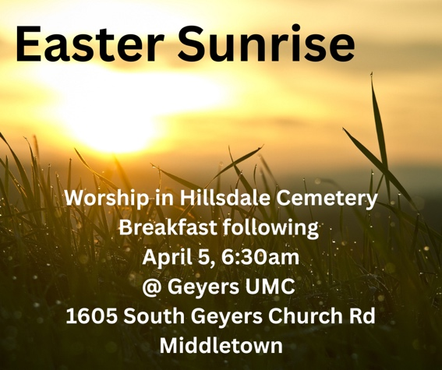
Faith Communities Participating Tonight
Chambers Hill UMC
The Reverend Heather Wurst, pastor
6300 Chambers Hill RD, Harrisburg PA
Sunday morning worship: 10:00 AM
chambershillumc.org

Evangelical UMC
The Reverend Andrew Burd-Harris, pastor
The Reverend Megan Burd-Harris, deacon
157 E Water ST, Middletown PA
Sunday morning worship: 10:15 AM
eumch.org

Geyers UMC
The Reverend Amy Raser, pastor
1605 S Geyers Church RD, Middletown PA
Sunday morning worship: 9 AM
geyersumc.org

Neidig UMC
The Reverend Amy Raser, pastor
1251 Highland St, Oberlin PA 17113
Sunday morning worship: 10:45 AM
sites.google.com/view/neidigmemorialunitedmethodistc/home
Faith Communities Participating Tonight
Chambers Hill UMC
The Reverend Heather Wurst, pastor
6300 Chambers Hill RD, Harrisburg PA
Sunday morning worship: 10:00 AM
chambershillumc.org

Evangelical UMC
The Reverend Andrew Burd-Harris, pastor
The Reverend Megan Burd-Harris, deacon
157 E Water ST, Middletown PA
Sunday morning worship: 10:15 AM
eumch.org

Geyers UMC
The Reverend Amy Raser, pastor
1605 S Geyers Church RD, Middletown PA
Sunday morning worship: 9 AM
geyersumc.org

Neidig UMC
The Reverend Amy Raser, pastor
1251 Highland St, Oberlin PA 17113
Sunday morning worship: 10:45 AM
sites.google.com/view/neidigmemorialunitedmethodistc/home

