Cover image: James Tissot’s “What Our Lord Saw from the Cross.” In the public domain.
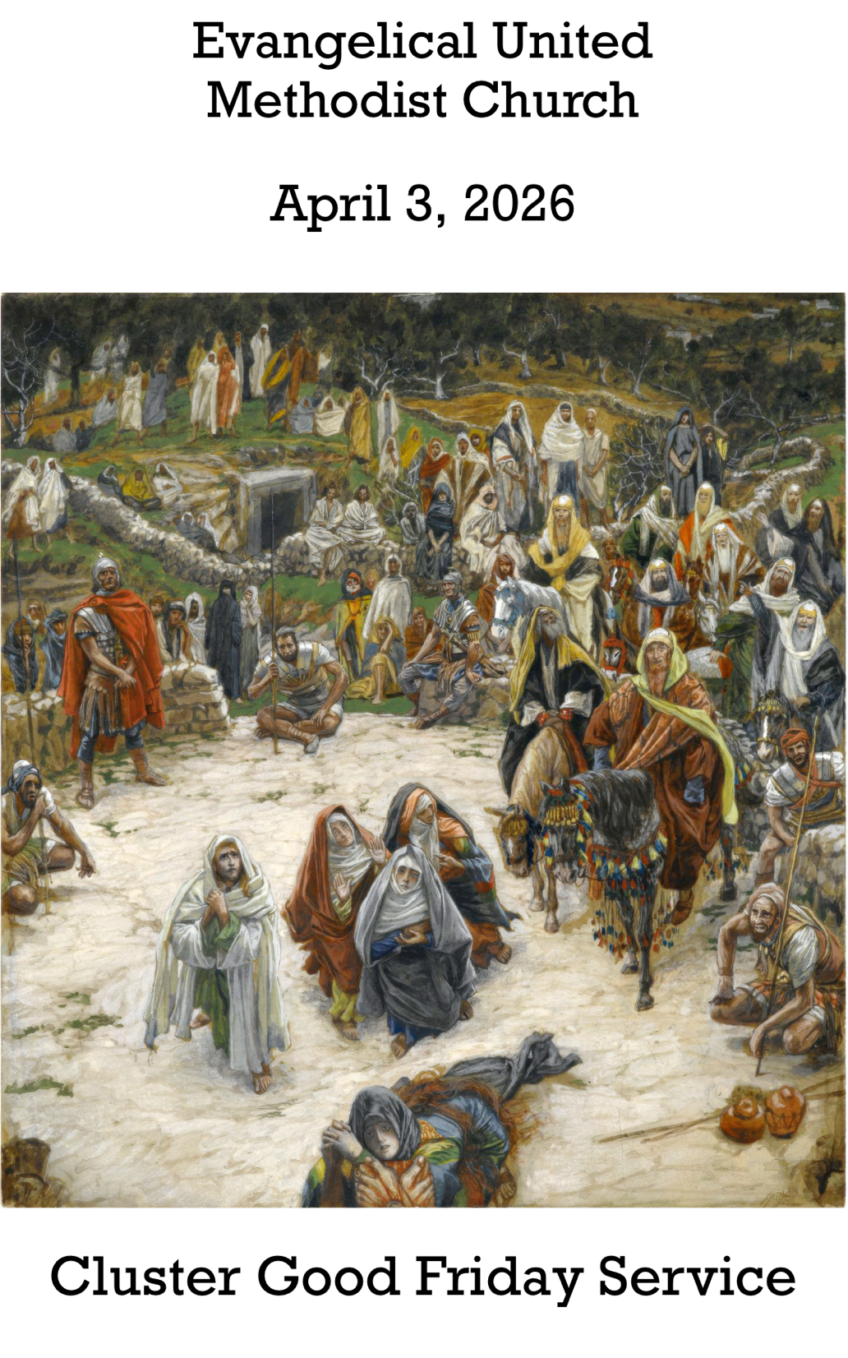

Cluster Worship at Evangelical United Methodist Church
157 East Water Street, Middletown, Pa. 17057
eumch.org; 717-944-6181; office@eumch.org
April 3, 2026
Good Friday
10:15AM Service
Bold & Italicized print – All in unison l *Please stand if able.
UMH: United Methodist Hymnal l TFWS: The Faith We Sing l W&S: Worship & Song
~Start Live Stream
Gathering
Announcements
Worship video
*DIRECTING OUR ATTENTION TOWARD GOD:
“The Old Rugged Cross” (verse 3) UMH 504
Introduction (Philippians 2: 5-11)
Leader: Though Christ was by nature divine,
he did not cling to equality with God,
but emptied himself, took the form of a slave,
and was born as a human.
All: Lord have mercy.
Leader: Appearing in human form,
he humbled himself,
and became obedient to death,
even death on a cross.
All: Christ have mercy.
Therefore God has highly exalted him,
and given him the name above all others,
that every knee should bend, and every tongue confess
that Jesus Christ is Lord, to the glory of God the Giver of Life.
Leader: Lord have mercy, and grant us your peace.
Copyright ©2026 Steve Garnaas-Holmes. From Unfolding Light. Used by permission.)

Opening Hymn “What Wonderous Love is This” UMH 292
Prayer
ATTENDING TO GOD’S WORD:
First Scripture Lesson: Isaiah 52:13-53:12
Second Scripture Lesson: Psalm 22 (UMH 752 with response 1)
Third Scripture Lesson: Hebrews 10: 16-25
*Hymn “And Can It Be That I Should Gain” UMH 363
Proclamation of the Passion Story (John 18-19)

RESPONSES TO GOD’S WORD:
Intercessory Prayer (After each petition there will be a time of silence.)
Silent Prayer
The Reproaches: Christ’s Lament Against His Faithless Church
For the responses (R) after each lament, we will sing “Jesus, Remember Me” UMH 488).
Leader: O my people, O my Church, what have I done to you, or in what have I offended you? I led you forth from the land of Egypt and delivered you by waters of baptism, but you have prepared a cross for your Savior.
People: Holy God, holy and mighty, holy and immortal One, have mercy upon us. R.
The Laments continue, after each lament, the congregation sings the response R.
(© Copyright 1992 the United Methodist Publishing House. Used by permission.)
Silent Prayer
The Lord’s Prayer (UMH 894)

GOING FORTH TO SHARE THE LIGHT OF CHRIST:
*Closing Hymn “Were You There” UMH 288
Dismissal
Going Forth in Silence
~End Live Stream~

