HOLY COMMUNION:
A service of Word and Table III (UMH 15-16)
The Lord’s Prayer
Prayer After Communion

GOING FORTH TO SHARE THE LIGHT OF CHRIST:
*Hymn “Up From the Grave He Arose” UMH 322
Reaffirming God’s Presence
Choral Benediction “He Lives” (verse 3) UMH 31
Postlude
~End Live Stream~

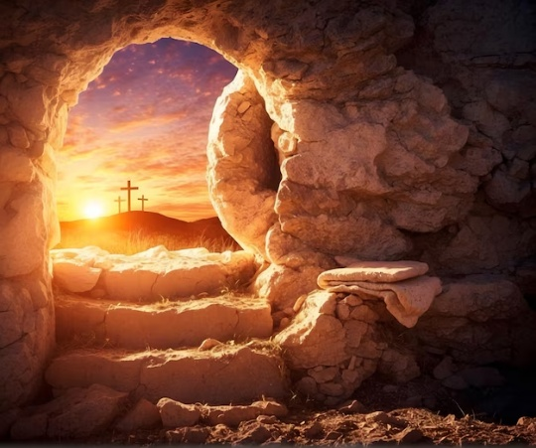

TODAY’S WORSHIP TEAM MEMBERS
Pastor Andrew Burd-Harris
Accompanist Andrew Martin
Audio Visual Team Justin Hahn, Steve Moyer, Mike Harris
Children’s Sermon Andrew Burd-Harris
Choir Director Erich Schlicher
Deacon Megan Burd-Harris
Greeter ---
Head Usher Lori Keller
Liturgist Megan Burd-Harris
Cover image: Rembrandt’s “Supper at Emmaus.” In the public domain.

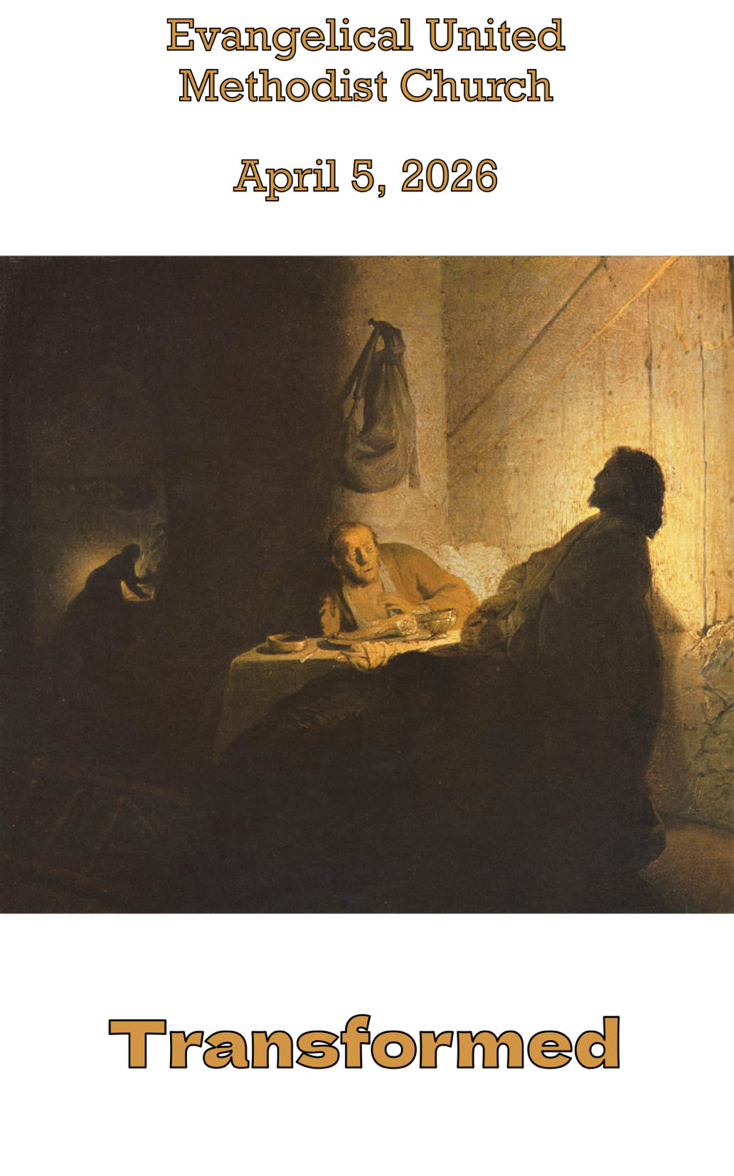

Evangelical United Methodist Church
157 East Water Street, Middletown, Pa. 17057
www.eumch.org; 717.944.6181; office@eumch.org
April 5, 2026
Easter Sunday
10:15 AM Service
Bold & Italicized print – All in unison l *Please stand if able.
UMH: United Methodist Hymnal l TFWS: The Faith We Sing l W&S: Worship & Song
~Start Live Stream~
Announcements
Worship video
*DIRECTING OUR ATTENTION TOWARD GOD:
*“Christ is Alive” (verse one) UMH 318

Opening Prayer
Gracious God, Christ is the light of the World, and so we come to walk in his light. Christ is the resurrection and the life, and so we come to enter into his life. Christ raises us to new life, and so we come to surrender our lives to you, and be raised anew. Speak to us now, that we may hear the word of life. Amen.
(©2026 Steve Garnaas-Holmes. From Unfolding Light. Used by permission.)

*Hymn of Praise “Christ the Lord is Risen Today” UMH 302
(Verses 1-3, 6)
JOYS AND CONCERNS:
We will pass around the microphone. Please remember we are livestreaming the service. Consider not using last names and please do not share concerns that a person would not want widely known. If you would like to add a joy or concern to our “Compassion for the Brethren” list please call our office at 717.944.6181, email the office at office@eumch.org, or fill out a prayer card and drop it in an offering plate.
Intercessory Prayer (After each intercession the leader will say, “God of Resurrection,” and the congregation will respond by saying, “hear our prayer.”)
Prayer Chorus “Sweet Hour of Prayer” (Verse one) UMH 496

ATTENDING TO GOD’S WORD:
Scripture Lessons Colossians 3:: 1-4, John 20: 1-18
This is God’s Word for everyone. Thanks be to God.
Children’s Sermon Andrew Burd-Harris

*Hymn “The Easter Song” W&S 3090
Message: “Transformed”

RESPONSES TO GOD’S WORD:
Sharing Our Gifts and Offering
Please put your offering in the offering plates located near the entrance(s) before the service starts. You can also give online using the link or QR code below. https://www.eumch.org/give

*Doxology “Praise God, from Whom All Blessings Flow” UMH 95
Choir Anthem “Lift High the Cross” arr. Tom Fettke

Deacon Megan: Christ our Lord invites to his table all who love him, who earnestly repent of their sin and seek to live in peace with one another. Therefore, let us confess our sin before God and one another.
All: Merciful God, we confess that we have not loved you with our whole heart. We have failed to be an obedient church. We have not done your will, we have broken your law, we have rebelled against your love, we have not loved our neighbors, and we have not heard the cry of the needy. Forgive us we pray. Free us for joyful obedience, through Jesus Christ our Lord, Amen.
All offer prayers of confession in silence.
Deacon Megan: Hear the good news, Christ died for us, while we were yet sinners; that proves God’s love towards us. In the name of Jesus Christ, you are forgiven!
People: In the name of Jesus Christ, you are forgiven!
All: Glory to God. Amen. © Copyright 1992 the United Methodist Publishing House. Used by permission.)

