
Good Friday
April 3, 2026
10 AM

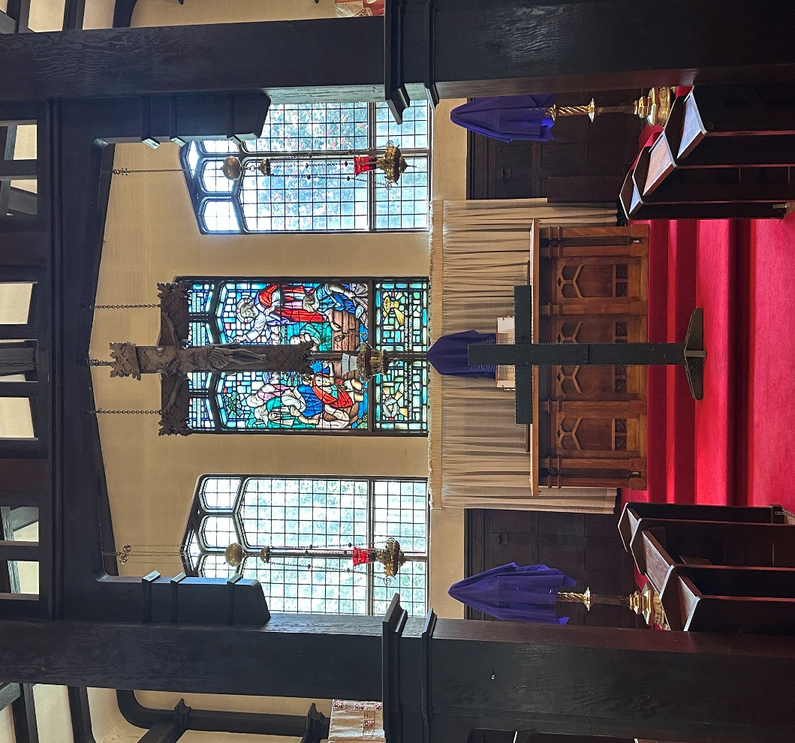

This service is Livestreamed via Facebook and the Parish website.
We welcome everyone worshipping with us today whether in person or online. www.sthelensurrey.ca
www.facebook.com/sainthelensurrey
The Gathering of the Community

Words of Welcome and Acknowledgment
We give thanks that we live, work, play, and worship on the traditional and unceded territory of the Coast Salish peoples including the Katzee, Tsawwassen, Semiahmoo and Kwantlen Nations. May our words and our actions reflect our awareness and appreciation.

The Ministry of the Word

Throughout this week we follow Christ
from his triumphal entry into Jerusalem,
to his cross and resurrection.
Last night we gathered with his disciples in the upper room,
and received bread and wine as signs of his self-giving for our sake.
We watched with him in the garden and shared his agony of soul.
Today we have arrived at the dark and holy heart of this week:
we will see him condemned by the religious and civil authorities,
stripped, mocked, beaten, and nailed to a cross to die.
We have come to hear this story anew,
to be with him in imagination and prayer and love,
to let our hearts be broken again
by the cruelty of humans
and by the tender love of God,
manifested in the self-giving of Christ.

Let us pray:

Christ, strengthen us, we pray, with your Spirit,
that we may watch with you this dark hour,
with our eyes fixed firmly on your agony on the cross.
Break our hearts, and mould them again
in the image of your compassion and courage,
in the image of your faithful love. Amen
All we like sheep have gone astray.
we have turned everyone to their own way,
And the Lord has laid on him the iniquity of us all.

Christ the Lord became obedient unto death,
Even death on a cross.

Silence

A General Confession

Almighty God,
Our heavenly Father, we have sinned in thought and word and deed.
We have failed to continue in the apostles’ teaching and fellowship.
We have allowed enmity and evil to grow in our hearts and have been embarrassed or neglectful in seeking repentance and in returning to the Lord.
We have shied away from proclaiming by word and example the good news of God in Christ.
We have neglected to seek and to serve Christ in all persons.
We have fallen short of your call to justice and peace among all people.
We have not respected the dignity of all human life.
We have been complicit in the neglect and decline of the created order and have failed to safeguard the integrity of creation.
Lift us up O Son of God, that we may be restored to our common work of justice and mercy as we approach the foot of the cross.
Amen.

Hymn: CP 378 Crown Him with Many Crowns

Collect of the Day
The Lord be with you.
And also with you.

Let us pray.

O Holy and Immortal One, we veil our faces before your glory, and bow before the cross of your wounded Christ. With angels and archangels we praise you, our Mercy, and we bless you, our Compassion, for in our brokenness you have not abandoned us. Amen

Invitation to the Passion

Since, then, we have a great high priest who has passed through the heavens, Jesus, the Son of God, let us hold fast to our confession For we do not have a high priest who is unable to sympathize with our weaknesses, but we have one who in every respect has been tested as we are, yet without sin. Let us therefore approach the throne of grace with boldness, so that we may receive mercy and find grace to help in time of need. Hebrews 4: 14-16

The Passion narrative

The Lord be with you
And also with you
The Passion of our Lord Jesus Christ according to John
Thanks be to God.

^{18:1} After Jesus had spoken these words, he went out with his disciples across the Kidron valley to a place where there was a garden, which he and his disciples entered. ² Now Judas, who betrayed him, also knew the place, because Jesus often met there with his disciples. 3 So Judas brought a detachment of soldiers together with guards from the chief priests and the Pharisees, and they came there with lanterns and torches and weapons. ⁴ Then Jesus, knowing all that was to happen to him, came forward and asked them, “Whom are you looking for?” ⁵ They answered, “Jesus of Nazareth.” Jesus replied, “I am he.” Judas, who betrayed him, was standing with them. ⁶ When Jesus said to them, “I am he,” they stepped back and fell to the ground. ⁷ Again he asked them, “Whom are you looking for?” And they said, “Jesus of Nazareth.” ⁸ Jesus answered, “I told you that I am he. So if you are looking for me, let these men go.” [⁹ This was to fulfill the word that he had spoken, “I did not lose a single one of those whom you gave me.”] ¹⁰ Then Simon Peter, who had a sword, drew it, struck the high priest’s slave, and cut off his right ear. The slave’s name was Malchus. ¹¹ Jesus said to Peter, “Put your sword back into its sheath. Am I not to drink the cup that the Father has given me?”
¹² So the soldiers, their officer, and the Judean guards arrested Jesus and bound him. ¹³ First they took him to Annas, who was the father-in-law of Caiaphas, the high priest that year. ¹⁴ Caiaphas was the one who had advised the Judean leaders that it was better to have one person die for the people.
¹⁵ Simon Peter and another disciple followed Jesus. Since that disciple was known to the high priest, he went with Jesus into the courtyard of the high priest, ¹⁶ but Peter was standing outside at the gate. So the other disciple, who was known to the high priest, went out, spoke to the woman who guarded the gate, and brought Peter in. ¹⁷ The woman said to Peter, “You are not also one of this man’s disciples, are you?” He said, “I am not.” ¹⁸ Now the slaves and the guards had made a charcoal fire because it was cold, and they were standing around it and warming themselves. Peter also was standing with them and warming himself.
¹⁹ Then the high priest questioned Jesus about his disciples and about his teaching. ²⁰ Jesus answered, “I have spoken openly to the world; I have always taught in synagogues and in the temple, where all the Judeans come together. I have said nothing in secret. ²¹ Why do you ask me? Ask those who heard what I said to them; they know what I said.” ²² When he had said this, one of the guards standing nearby struck Jesus on the face, saying, “Is that how you answer the high priest?” ²³ Jesus answered, “If I have spoken wrongly, testify to the wrong. But if I have spoken rightly, why do you strike me?” ²⁴ Then Annas sent him bound to Caiaphas the high priest.
²⁵ Now Simon Peter was standing and warming himself. They asked him, “You are not also one of his disciples, are you?” He denied it and said, “I am not.” ²⁶ One of the slaves of the high priest, a relative of the man whose ear Peter had cut off, asked, “Did I not see you in the garden with him?” ²⁷ Again Peter denied it, and at that moment the cock crowed.
²⁸ Then they took Jesus from Caiaphas to Pilate’s headquarters. It was early in the morning. They themselves did not enter the headquarters, so as to avoid ritual defilement and to be able to eat the Passover. ²⁹ So Pilate went out to them and said, “What accusation do you bring against this man?” ³⁰ They answered, “If this man were not a criminal, we would not have handed him over to you.” ³¹ Pilate said to them, “Take him yourselves and judge him according to your law.” The Judean leaders replied, “We are not permitted to put anyone to death.” ³² (This was to fulfill what Jesus had said when he indicated the kind of death he was to die.)
³³ Then Pilate entered the headquarters again, summoned Jesus, and asked him, “Are you the King of the Judeans?” ³⁴ Jesus answered, “Do you ask this on your own, or did others tell you about me?” ³⁵ Pilate replied, “I am not a Judean, am I? Your own nation and the chief priests have handed you over to me. What have you done?” ³⁶ Jesus answered, “My kingdom is not from this world. If my kingdom were from this world, my followers would be fighting to keep me from being handed over to the Judeans. But as it is, my kingdom is not from here.” ³⁷ Pilate asked him, “So you are a king?” Jesus answered, “You say that I am a king. For this I was born, and for this I came into the world, to testify to the truth. Everyone who belongs to the truth listens to my voice.” ³⁸ Pilate asked him, “What is truth?”
After he had said this, he went out to the Judean leaders again and told them, “I find no case against him. ³⁹ But you have a custom that I release someone for you at the Passover. Do you want me to release for you the King of the Judeans?” ⁴⁰ They shouted in reply, “Not this man, but Barabbas!” Now Barabbas was a bandit.
^{19:1} Then Pilate took Jesus and had him flogged. ² And the soldiers wove a crown of thorns and put it on his head, and they dressed him in a purple robe. ³ They kept coming up to him, saying, “Hail, King of the Judeans!” and striking him on the face. ⁴ Pilate went out again and said to them, “Look, I am bringing him out to you to let you know that I find no case against him.” ⁵ So Jesus came out, wearing the crown of thorns and the purple robe. Pilate said to them, “Here is the man!” ⁶ When the chief priests and the guards saw him, they shouted, “Crucify him! Crucify him!” Pilate said to them, “Take him yourselves and crucify him; I find no case against him.” ⁷ The Judean leaders answered him, “We have a law, and according to that law he ought to die because he has claimed to be the Son of God.”
⁸ Now when Pilate heard this, he was more afraid than ever. ⁹ He entered his headquarters again and asked Jesus, “Where are you from?” But Jesus gave him no answer. ¹⁰ Pilate therefore said to him, “Do you refuse to speak to me? Do you not know that I have power to release you, and power to crucify you?” ¹¹ Jesus answered him, “You would have no power over me unless it had been given you from above; therefore the one who handed me over to you is guilty of a greater sin.” ¹² From then on Pilate tried to release him, but the Judean leaders cried out, “If you release this man, you are no friend of the emperor. Everyone who claims to be a king sets himself against the emperor.”
¹³ When Pilate heard these words, he brought Jesus outside and sat on the judge’s bench at a place called The Stone Pavement, or in Hebrew Gabbatha. ¹⁴ Now it was the day of Preparation for the Passover; and it was about noon. He said to the Judean leaders, “Here is your King!” ¹⁵ They cried out, “Away with him! Away with him! Crucify him!” Pilate asked them, “Shall I crucify your King?” The chief priests answered, “We have no king but the emperor.” ¹⁶ Then he handed him over to them to be crucified.
So they took Jesus; ¹⁷ and carrying the cross by himself, he went out to what is called The Place of the Skull, which in Hebrew is called Golgotha. ¹⁸ There they crucified him, and with him two others, one on either side, with Jesus between them. ¹⁹ Pilate also had an inscription written and put on the cross. It read, “Jesus of Nazareth, the King of the Judeans.” ²⁰ Many of the Judeans read this inscription, because the place where Jesus was crucified was near the city; and it was written in Hebrew, in Latin, and in Greek. ²¹ Then the chief priests of the Judeans said to Pilate, “Do not write, ‘The King of the Judeans,’ but, ‘This man said, I am King of the Judeans.’” ²² Pilate answered, “What I have written I have written.” ²³ When the soldiers had crucified Jesus, they took his clothes and divided them into four parts, one for each soldier. They also took his tunic; (now the tunic was seamless, woven in one piece from the top). ²⁴ So they said to one another, “Let us not tear it, but cast lots for it to see who will get it.” (This was to fulfill what the scripture says,
“They divided my clothes among themselves,
and for my clothing they cast lots.”)
²⁵ And that is what the soldiers did.
Meanwhile, standing near the cross of Jesus were his mother, and his mother’s sister, Mary the wife of Clopas, and Mary Magdalene. ²⁶ When Jesus saw his mother and the disciple whom he loved standing beside her, he said to his mother, “Woman, here is your son.” ²⁷ Then he said to the disciple, “Here is your mother.” And from that hour the disciple took her into his own home.
²⁸ After this, when Jesus knew that all was now finished, he said (in order to fulfill the scripture), “I am thirsty.” ²⁹ A jar full of sour wine was standing there. So they put a sponge full of the wine on a branch of hyssop and held it to his mouth. ³⁰ When Jesus had received the wine, he said, “It is finished.” Then he bowed his head and gave up his spirit.
³¹ Since it was the day of Preparation, the Judean leaders did not want the bodies left on the cross during the sabbath, especially because that sabbath was a day of great solemnity. So they asked Pilate to have the legs of the crucified men broken and the bodies removed. ³² Then the soldiers came and broke the legs of the first and of the other who had been crucified with him. ³³ But when they came to Jesus and saw that he was already dead, they did not break his legs. ³⁴ Instead, one of the soldiers pierced his side with a spear, and at once blood and water came out. ³⁵ (He who saw this has testified so that you also may believe. His testimony is true, and he knows that he tells the truth.) ³⁶ These things occurred so that the scripture might be fulfilled, “None of his bones shall be broken.” ³⁷ And again another passage of scripture says, “They will look on the one whom they have pierced.”
³⁸ After these things, Joseph of Arimathea, who was a disciple of Jesus, though a secret one because of his fear of the Judean leaders, asked Pilate to let him take away the body of Jesus. Pilate gave him permission; so he came and removed his body. ³⁹ Nicodemus, who had at first come to Jesus by night, also came, bringing a mixture of myrrh and aloes, weighing about a hundred pounds. ⁴⁰ They took the body of Jesus and wrapped it with the spices in linen cloths, according to the burial custom of the Jews. ⁴¹ Now there was a garden in the place where he was crucified, and in the garden there was a new tomb in which no one had ever been laid. ⁴² And so, because it was the Jewish day of Preparation, and the tomb was nearby, they laid Jesus there.
Silence
Psalm 22
Psalm 22 is chanted by the Cantor. The Congregation joins in with the Refrain where indicated.

Refrain: My God, my God why have you forgotten me
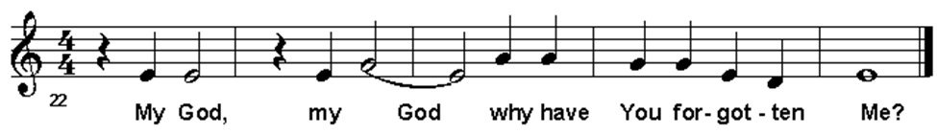
- My God, my God, why have you forsaken me *
and are so far from my cry and from the words of my distress?
- O my God, I cry in the daytime, but you do not answer; *
by night as well, but I find no rest.
- Yet you are the Holy One, *
enthroned upon the praises of Israel.
- Our ancestors put their trust in you; *
they trusted, and you delivered them.
- They cried out to you and were delivered; *
they trusted in you and were not put to shame.
Refrain

- But as for me, I am a worm and not human, *
scorned by all and despised by the people.
- All who see me laugh me to scorn; *
they curl their lips and wag their heads, saying,
- “You trusted in the Lord; let the Lord deliver you; *
let God rescue you, if God delights in you.”
Refrain
- Yet you are the one who took me out of the womb, *
and kept me safe upon my mother’s breast.
- I have been entrusted to you ever since I was born; *
you were my God when I was still in my mother’s womb.
- Be not far from me, for trouble is near, *
and there is none to help.
Refrain

- Many young bulls encircle me; *
strong bulls of Bashan surround me.
- They open wide their jaws at me, *
like a ravening and a roaring lion.
- I am poured out like water; all my bones are out of joint; *
my heart within my breast is melting wax.
- My mouth is dried out like a potsherd; my tongue sticks to the roof of my mouth; *
you have laid me in the dust of the grave.
- Packs of dogs close me in and gangs of evildoers circle around me; *
they pierce my hands and my feet.
- I can count all my bones *
while they stare and gloat over me.
- They divide my garments among them; *
they cast lots for my clothing.
Refrain

- Be not far away, O Lord; *
you are my strength; hasten to help me.
- Save me from the sword, *
my life from the power of the dog.
- Save me from the lion’s mouth, *
my wretched body from the horns of wild bulls.
- I will declare your name to my kindred; *
in the midst of the congregation I will praise you.
Refrain

Part II

Refrain: All the ends of the earth shall remember and turn to the Lord.
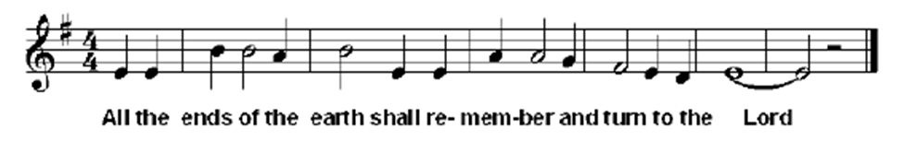

- Praise the Lord, you that fear God; *
stand in awe of God, O offspring of Israel;
all you of Jacob’s line, give glory.
- For God does not despise nor abhor the poor in their poverty;
neither turns away from them; *
when they cry to the Lord, they are heard.
- My praise is of God in the great assembly; *
I will perform my vows in the presence of those who worship the Lord.
Refrain

- The poor shall eat and be satisfied,
and those who seek the Lord shall give praise: *
“May your heart live for ever!”
- All the ends of the earth shall remember and turn to the Lord, *
and all the families of the nations shall bow before God.
- For sovereignty belongs to the Lord, *
who rules over the nations.
Refrain

- To God alone all who sleep in the earth bow down in worship; *
all who go down to the dust fall before God.
- My soul shall live for God;
my descendants shall serve God; *
they shall be known as the Lord’s for ever.
- They shall come and make known to a people yet unborn *
the saving deeds that God has done.
Refrain

Silence

Meditation on the Cross of Jesus

This is the wood of the cross, on which hung the Saviour of the world.
Come let us worship.

The Congregation is invited to come forward to the foot of the cross and offer a prayer or meditation before returning to their place. The following hymns are sung as people approach the cross.

CP 634: Jesus, Remember Me
SNC 51: Senzeni ma

Good Friday Reproaches

Holy God,
holy and strange,
holy and intimate,
have mercy on us.

O my people, what have I done to you?
How have I offended you?
Answer me.

I brooded over the abyss,
with my words I called forth creation:
by your have brooded on destruction,
and manufactured the means of chaos.

O my people, what have I done to you?
How have I offended you?
Answer me.

I made the desert bloom before you,
I fed you with an open hand:
but you have grasped the children’s food,
and laid waste fertile lands.

O my people, what have I done to you?
How have I offended you?
Answer me.

I abandoned my power like a garment,
choosing your unprotected flesh:
but you have robed yourselves in privilege,
and chosen to despise the abandoned.

O my people, what have I done to you?
How have I offended you?
Answer me.

Holy God,
holy and strange,
holy and intimate,
have mercy on us.

I would have gathered you to me as a lover,
and shown you the ways of peace:
but you have desired security,
and you would not surrender your self.

O my people, what have I done to you?
How have I offended you?
Answer me.

I have torn the veil of my glory,
transfiguring the earth:
but you have disfigured my beauty,
and turned away your face.

O my people, what have I done to you?
How have I offended you?
Answer me.

I have laboured to deliver you,
as a woman delights to give life:
but you have delighted in bloodshed,
and laboured to bereave the world.

O my people, what have I done to you?
How have I offended you?
Answer me.

I have followed you with the power of my spirit,
to seek truth and heal the oppressed:
but you have been following a lie,
and returned to your own comfort.

O my people, what have I done to you?
How have I offended you?
Answer me.

Holy God,
holy and strange,
holy and intimate,
have mercy on us.

Hymn: CP 198 O Sacred Head Surrounded

The Intercessions
We stand at the foot of the cross,
moved by grief, fear, and compassion,
but most of all by the great love Jesus showed for the world
in sharing our suffering even to death,
let us reach out in prayer with God’s compassion for all who face suffering,
and for ourselves, the Church, whose call is to healing, justice, and reconciliation.

At the foot of your cross, O God, we lament with you the suffering unleashed in the world by human greed and hardened hearts. We pray for all who suffer:

for the victims of violence and injustice.
for those exploited and abused by the misuse of power.
for the victims of war.
for those exploited and abused by the misuse of power.
for all who are enslaved by their own cruelty and violence.
for those burdened with guilt for the things they have done.
for all who suffer in the captivity of poverty.

Other biddings may be added as appropriate to the local community and current world events.

God of all compassion, on the cross you told the truth of the depths of human sin. Open our hearts to the realities of cruelty and fill us with your compassionate care for all who suffer abuse, exploitation, and violence. Make the dignity of your light to shine on all who are downtrodden. Lead those who harm to repentance and healing, that they may know the new life that comes through your way of forgiveness. Stir us to work for peace, justice, and right relationships, that all may find wholeness in you and rejoice in peace. Amen.

At the foot of your cross, O God, we lament the suffering endured through the difficult and the incomprehensible journeys of life. We pray for all who suffer:

for those struggling with mental illness, depression, or addiction.
for those who suffer in physical pain, for the injured, the sick and the aging.
for those overwhelmed by sorrow and loss.
for those living with the fear of death.

Other biddings may be added as appropriate to the local community and current world events.

God of all healing, from the cross you reach out to all who carry burdens of pain in their minds and bodies. Gift medical and social healers with skill and kind-heartedness that all may find liberation. Open our minds to ever new ways to lift the burdens of suffering. Bring comfort, courage, and hope to all who grieve, and to all who are confined in pain. Grace us with your healing presence that we may be strengthened to console and to offer a compassionate witness to your abundant hope. Amen.

At the foot of your cross, O God, we lament the suffering of your whole creation at the hands of human arrogance and exploitation. We pray for all of God’s creation:

for a battered and exploited creation
for a world fallen amongst thieves
for all who pray and work to heal and restore ecosystems

Other biddings may be added as appropriate to the local community and current world events.

God of all you have created, by the cross you reveal your glory within the fragility of this world. Continue your new creation in our midst, that the whole world may find the glorious liberty of your original intention for your beloved cosmos. Embolden us to tell the truth of this world’s captivity and suffering, and to pray and to work for restoration, that the trees of the hills, the birds of the fields, and the creatures of the oceans may live anew to sing your praises in the perfect harmony of your new creation. Amen.
At the foot of your cross, O God, we lament with you the failings of your church to live fully in the way of your compassionate love. We pray for all who seek to serve your good purposes, who stumble and fall, and yet whom you continue to call to new life:

For the Church of Christ
that we may know the way of the cross as the way of new life.

For all who bear responsibilities in ministry and mission,
for clergy and lay leaders,
that they may offer the struggles and the joys in their ministries at the foot of the cross and be renewed in faith, hope, and love as compassionate and humble servants.

For all who have been harmed through actions of Christians. May their witness to our wrongdoings provoke us to remorse and true repentance, knowing that God’s forgiveness is an invitation to walk in newness of life.

For the Jewish people, your beloved covenant children, who have so often faced contempt, persecution, and violence at the hands of Christians. Strengthen them in their vocation to be a light to the nations, and keep us grafted into their witness to your faithfulness and justice:

O God, who has chosen Israel to be your inheritance: Have mercy on us and forgive us for violence and wickedness against our brother Jacob; the arrogance of our hearts and minds has deceived us, and shame has covered our face. Take away all pride and prejudice in us, and grant that we, together with the people you first made your own, may attain to the fullness of redemption which you have promised; to the honour and glory of your most holy Name. Amen.

We pray for ourselves,
with our hopes, doubts, and dejection, our gifts, and our failings,
that we may find renewed faith and commitment to Christ’s way of self-giving love.

Other prayers may be added as appropriate to the local community and current world events.

At the foot of your cross, O God, we entrust our laments and prayers to you. May we be Christ’s body, broken in sorrow and poured out in love for the world, that through us the power of his cross may bring healing and reconciliation. Amen.

Hymn: CP 189 Alone Thou Goest Forth, O Lord

A Final Prayer
The presider moves to stand or kneel in front of and facing the cross.

Send down your abundant blessing, Lord, upon your people who have devoutly recalled the death of your Son in the sure and certain hope of the resurrection. Grant us pardon; bring us comfort. May our faith grow stronger, and our eternal salvation be assured. We ask this through Christ our Lord. Amen.

There is no Dismissal. All Leave in Silence

Good Friday Ministry Team

Officiant………………………………………. The Rev. Dr. Robin Ruder Celiz
Honorary Assistant ……………………………The Rev. Paula Porter Leggett
Deacon…………………………………………The Rev. Stephen Thompson
Musician…….………………………………….Joel Adimathra
Cantor…………………………………………..James Gifford
Crucifer/Servers/Psalmist………………………Wendy Russell
Prayers of the Community……………………. John Palmer
Readers……. ...Jacquie Stinson & Catherine Hall
Greeters…… .. Patricia &Tom Beneteau
Livestream Tech………………………………..Z. Barabas, T Beneteau, S Lee, R. V. .Nwaogu, A.Sillah
Altar Guild……………….……………. ……… J.Francis, H.Herd & K.Foulds

Copyright Information
  - Crown Him wit Many Crowns: Public Domain
  - Jesus Remember Me. Public Domain
  - O Sacred Head Surrounded :Public Domain
  - Alone thou Goest Forth O Lord : Public Domain
  - Lord’s prayer SFAGP1987 International Committee on English on the Liturgy
  - Common Worship: Common Worship Communion The Archbishops' Council 2006 and published by Church House Publishing
  - Common Worship: Times and Seasons The Archbishops' Council 2006 and published by Church House Publishing.
  - CCLI License number 20316737 ONE LICENSE number :734895-A

Acknowledgments

Musical refrains to Psalms are by George Black ©

The Passion Narrative is a version created within The Episcopal Church (USA) and approved for trial use in that Province. ©Standing Commission on Liturgy and Music, The Episcopal Church https://www.episcopalarchives.org/files/gc_resolutions/2022-D058.pdf

The readings from Hebrews are from the New Revised Standard Version – Updated Edition of the Bible ©The National Council of Churches of Christ in the USA, 2021, used by permission. All rights reserved worldwide.

The Psalm is from The Inclusive Language Liturgical Psalter. ©The General Synod of The Anglican Church of Canada, 2019.

The Good Friday Reproaches are from Janet Morley, All Desires Known. London: SPCK, ©1992.
Additional Canticles are from The Book of Alternative Services ©The General Synod of The Anglican Church of Canada, 1985.

The Opening address and responsories, General Confession, Intercessions, and the explanatory prose are original writings by the Task Group on Holy Week Liturgies.

For any errors or omissions in source acknowledgement, we offer our apologies.

Members of the Task Group on Holy Week Liturgies (a Task Group of the Liturgical Advisory Committee of the Faith, Worship, and Ministry Committee):

The Reverend Alvardo Adderley (Toronto)
The Reverend Walter Kagura (Yukon)
The Reverend Canon Paul Jennings (Nova Scotia and Prince Edward Island)
The Reverend Canon Jeffrey Petten (Western Newfoundland)
The Reverend Dr. Robin Ruder-Celiz (New Westminster)
Jordan Sandrock (Huron)
The Reverend Dr. Eileen Scully (Staff)
Notices

New Email Address: The new e-mail addresses for the Rector and Parish Office are now in effect. They are:
Parish Office: Office@StHelenSurrey.ca
The Rector: Rector@StHelenSurrey.ca

HOLY WEEK

Good Friday APRIL 3, Worship service at 10:00 a.m. is a solemn day that commemorates Jesus’ crucifixion and His ultimate sacrifice for our sins. Despite its sorrowful events, it’s called “Good” because of the redemption Jesus secured for us.

Holy Saturday APRIL 4 Please arrive for a 5:30 p.m. pot-luck dinner. Bring a dish that might serve 6 to 8 people, and we’ll share a meal together prior to the Worship service at7:00 p.m. this is a day of quiet reflection, as we remember Jesus’ time in the tomb and anticipate the joy of what’s to come. We will light the fire outdoors, to symbolize the light of Christ, his resurrection and our salvation. In those moments of darkness in our lives let us look to the light of the Resurrection, and we will certainly realize that God truly can bring us from darkness and suffering to joy and light. When the wait is long and we feel that we are losing hope let’s keep our eyes fixed on the Lord for he will bring us His Holy Fire.

Finally, EASTER SUNDAY bursts forth with celebration: Jesus is alive! His resurrection offers us hope, new life, and the promise of eternity with Him. Worship Service at 10:00 a.m. And here is something fun, joyful and takes a step back to remember the ones who gave so much to St. Helen’s. On this EASTER DAY, we are asked to dress up – how dressy were the Easter Sundays of your youth? Ladies, make or wear an Easter bonnet, – a nice, simple hat - dig out the white gloves (maybe) you don’t have to take part in this ,but what a great picture we could take and post to Facebook and the Diocesan page – It is fun to be part of St. Helen’s 115th Anniversary celebrations!

Easter Sunday: There will be an Easter Egg hunt for the Sunday School following the service.

NOTE : With regret, the choir concert, scheduled for April 18, will have to be postponed due to the hospitalization of the Choir Director. Hopefully a date in the near future will see this event happening as a fundraiser for St. Helen’s renovation project.

SAVE THE DATE- JUNE 13 Our STRAWBERRY TEA is back bigger and better than ever. Enjoy a lovely time over strawberry dessert, a fashion show, bake table, previously loved jewellery - all sorts of fun things will be happening. Let your friends and family know, bring them with you for a lovely afternoon. More information re tickets etc. in the coming weeks.

Rector’s Schedule

Father Robin will be away from April 6 until Monday April 13. Father Neil Fernyhough will cover services on Sunday April 12.

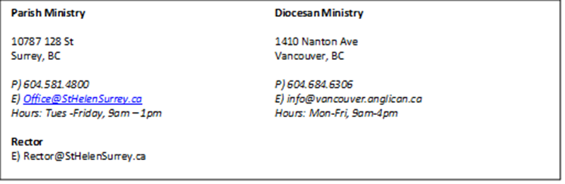

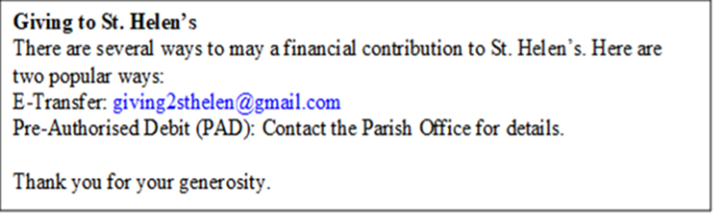

Good Friday Reproaches author: Janet Morley, All Desires Known. London: SPCK, 1992 – include Scripture reference. See C of E (Common Worship?) for their possible adaptation of Janet Morley’s piece, and other anthems/canticles.
Prayer for Reconciliation with the Jewish People, authorized by General Synod 2023

