
Maundy Thursday
April 2, 2026
7:00 PM
Holy Eucharist

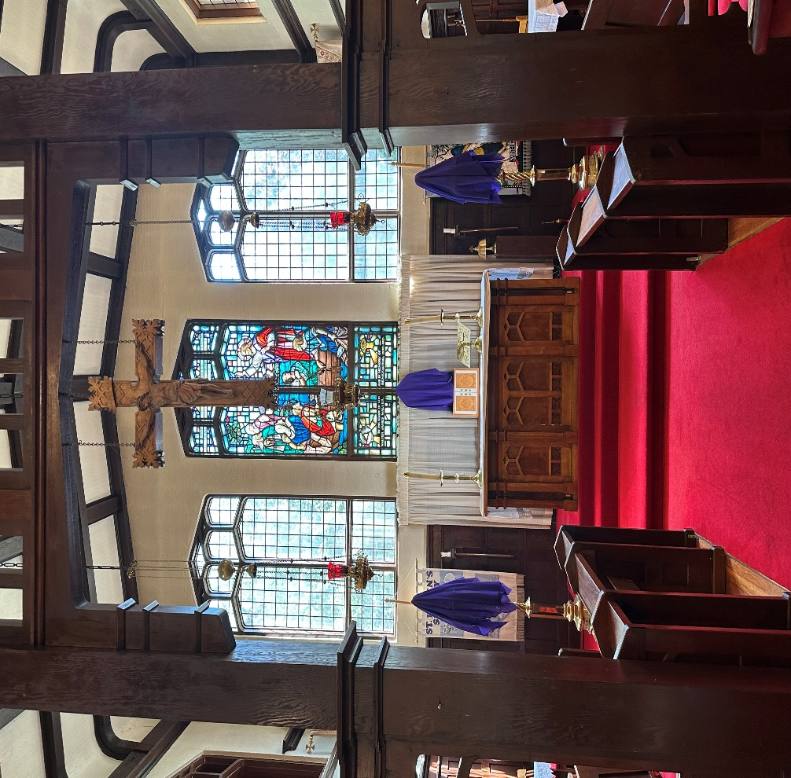

This service is Livestreamed via Facebook and the Parish website.
We welcome everyone worshipping with us today whether in person or online. www.sthelensurrey.ca
www.facebook.com/sainthelensurrey
The Gathering of the Community

Words of Welcome and Acknowledgment
We give thanks that we live, work, play, and worship on the traditional and unceded territory of the Coast Salish peoples including the Katzee, Tsawwassen, Semiahmoo and Kwantlen Nations. May our words and our actions reflect our awareness and appreciation.

Processional Hymn: CP 184: My Song is Love Unknown

The Gathering of the Community

This is the day
that Christ the Lamb of God
gave himself into the hands of those who would slay him.

This is the day
that Christ gathered with his disciples in the upper room.

This is the day
that Christ took a towel
and washed the disciples’ feet,
giving us an example that we should do to others
as he has done to us.

This is the day
that Christ our God gave us this holy feast,
that we who eat this bread
and drink this cup
may here proclaim his Holy Sacrifice
and be partakers of his resurrection,
and at the last day may reign with him in heaven.
Kyrie Confessions

Oh God, you know my foolishness
And my sins are not hidden from you:
Lord, have mercy.
Lord, have mercy.

Let not the flood overwhelm me
Nor the depths swallow me up;
Let not the pit shut its mouth upon me :
Christ, have mercy.
Christ, have mercy.

Hear me O Lord, as your loving kindness is good;
Turn to me as your compassion is great:
Lord, have mercy.
Lord, have mercy.

Collect of the Day

O God,
your Son Jesus Christ
has left to us this meal of bread and wine
in which we share his body and his blood.
May we who celebrate this sign of his great love
show in our lives the fruits of his redemption;
through Jesus Christ our Lord,
who lives and reigns with you and the Holy Spirit,
one God, now and for ever. Amen.

The Proclamation of the Word

First Reading: Exodus 12:1-4, 11-14
A reading from the book of Exodus,
The Lord said to Moses and Aaron in the land of Egypt: This month shall mark for you the beginning of months; it shall be the first month of the year for you. Tell the whole congregation of Israel that on the tenth of this month they are to take a lamb for each family, a lamb for each household. If a household is too small for a whole lamb, it shall join its closest neighbour in obtaining one; the lamb shall be divided in proportion to the number of people who eat it.
This is how you shall eat it: your loins girded, your sandals on your feet, and your staff in your hand; and you shall eat it hurriedly. It is the Passover of the Lord. For I will pass through the land of Egypt that night, and I will strike down every firstborn in the land of Egypt, both human beings and animals; on all the gods of Egypt I will execute judgements: I am the Lord. The blood shall be a sign for you on the houses where you live: when I see the blood, I will pass over you, and no plague shall destroy you when I strike the land of Egypt. This day shall be a day of remembrance for you. You shall celebrate it as a festival to the Lord; throughout your generations you shall observe it as a perpetual ordinance.
Listen to what the spirit is saying to the church.
Thanks be to God

Psalm: 116: 1, 10-17

I love the Lord, because he has heard the voice of my supplication, because he has inclined his ear to me whenever I called upon him.
How shall I repay the Lord for all the good things he has done for me?

I will lift up the cup of salvation and call upon the name of the Lord.
I will fulfil my vows to the Lord in the presence of all his people.

Precious in the sight of the Lord is the death of his servants.
O Lord, I am your servant; I am your servant and the child of your handmaid; you have freed me from my bonds.

I will offer you the sacrifice of thanksgiving and call upon the name of the Lord
I will fulfil my vows to the Lord in the presence of all his people,
In the courts of the Lord's house, in the midst of you, O Jerusalem. Hallelujah!

Glory to God, Source of all Being, Eternal Word, and Holy Spirit:
As it was in the beginning, is now and ever shall be. Amen

Second Reading: 1 Corinthians 11: 23-26

A Reading from Paul’s first letter to the Corinthians,
For I received from the Lord what I also handed on to you, that the Lord Jesus on the night when he was betrayed took a loaf of bread, and when he had given thanks, he broke it and said, "This is my body that is for you. Do this in remembrance of me." In the same way he took the cup also, after supper, saying, "This cup is the new covenant in my blood. Do this, as often as you drink it, in remembrance of me." For as often as you eat this bread and drink the cup, you proclaim the Lord's death until he comes.
Listen to what the spirit is saying to the Church.
Thanks be to God

Gradual Hymn: CP 180 Giver of the Perfect Gift

Gospel: John 13: 1-17, 31b-35

The Lord be with you.
And also with you.
The holy Gospel of our Lord Jesus Christ, according to John
Glory to you Lord Jesus Christ

Now before the festival of the Passover, Jesus knew that his hour had come to depart from this world and go to the Father. Having loved his own who were in the world, he loved them to the end. The devil had already put it into the heart of Judas, son of Simon Iscariot, to betray him. And during supper Jesus, knowing that the Father had given all things into his hands, and that he had come from God and was going to God, got up from the table, took off his outer robe, and tied a towel around himself. Then he poured water into a basin and began to wash the disciples' feet and to wipe them with the towel that was tied around him. He came to Simon Peter, who said to him, "Lord, are you going to wash my feet?" Jesus answered, "You do not know now what I am doing, but later you will understand." Peter said to him, "You will never wash my feet." Jesus answered, "Unless I wash you, you have no share with me." Simon Peter said to him, "Lord, not my feet only but also my hands and my head!" Jesus said to him, "One who has bathed does not need to wash, except for the feet, but is entirely clean. And you are clean, though not all of you." For he knew who was to betray him; for this reason he said, "Not all of you are clean."

After he had washed their feet, had put on his robe, and had returned to the table, he said to them, "Do you know what I have done to you? You call me Teacher and Lord - and you are right, for that is what I am. So if I, your Lord and Teacher, have washed your feet, you also ought to wash one another's feet. For I have set you an example, that you also should do as I have done to you. Very truly, I tell you, servants are not greater than their master, nor are messengers greater than the one who sent them. If you know these things, you are blessed if you do them. Now the Son of Man has been glorified, and God has been glorified in him. If God has been glorified in him, God will also glorify him in himself and will glorify him at once. Little children, I am with you only a little longer. You will look for me; and as I said to the Jews so now, I say to you, 'Where I am going, you cannot come.' I give you a new commandment, that you love one another. Just as I have loved you, you also should love one another. By this everyone will know that you are my disciples, if you have love for one another."
The Gospel of Christ
Praise to you Lord Jesus Christ

Homily: Reverend Dr. Robin Ruder Celiz

Washing of feet

Fellow servants of our Lord Jesus Christ,
on the night before his death,
Jesus set an example for his disciples
by washing their feet, an act of humble service.
He taught that strength and growth
in the life of the kingdom of God
come not by power, authority, or even miracle,
but by such lowly service.

Therefore, I invite you who share in the royal
priesthood of Christ to come forward,
that I may recall whose servant I am
by following the example of my Master. But come
remembering his admonition that what will be
done for you is also to be done by you to others,
for “a servant is not greater than his master, nor
is one who is sent greater than the one who sent
him. If you know these things, blessed are you if
you do them.”

A basin of water is placed at the chancel step. Members of the congregation, or their representatives, are seated on chairs near the front of the assembly. The celebrant, carrying a towel, proceeds to wash the feet of those seated before him.

Hymns During Foot washing
During the foot washing, the following hymns are sung

CP 189 Alone Thou Goest Forth, O Lord
CP 442 Great God, Your Love Has Called us Here

Prayers of the People

Confession & Absolution

Lord Jesus Christ
We confess we have failed you as did your first disciples
We ask for your mercy and your help

When we take our ease
rather than watch with you
Lord forgive us.
Christ have mercy.

When we bestow a kiss of peace
Yet nurse enmity in our hearts
Lord forgive us
Christ have mercy.
When we strike at those who hurt us
Rather than stretch out our hands to bless
Lord forgive us
Christ have mercy.

When we deny that we know you
For fear of the world and its scorn
Lord forgive us
Christ have mercy.

Almighty God have mercy upon you,
pardon and deliver you from all your sins,
confirm and strengthen you in all goodness,
and keep you in eternal life.
through Jesus Christ our Lord. Amen

The Peace
Please rise as you are able

Christ is our peace.
He has reconciled us to God
In one body by the cross
We meet in his name and share his peace.
The peace of the Lord be always with you
And also with you.

The Celebration of the Eucharist

Offertory Hymn: CP 64 Author of Life Divine

Prayer over the Gifts
Please Remain Standing

Holy God,
we spread this table to remember the loving sacrifice of Jesus Christ, your Son. Accept all we offer you this day. Bind us together in his love
and in the love he has commanded us to bring one another;
through Jesus Christ our Lord.
Amen.

The Great Thanksgiving

The Lord is here.
His Spirit is with us.
Lift up your hearts.
We lift them to the Lord.
Let us give thanks to the Lord our God.
It is right to give thanks and praise.

Almighty God,
your face is turned towards your world.
In love you gave us Jesus your Son
to rescue us from sin and death.
Your Word goes out to call us home
to the city where angels sing your praise.
We join with them in heaven’s song:

Holy, holy, holy Lord,
God of power and might,
heaven and earth are full of your glory.
Hosanna in the highest.
Blessed is he who comes in the name of the Lord.
Hosanna in the highest.

Father of all, we give you thanks for every gift that comes from heaven.
To the darkness Jesus came as your light.
With signs of faith and words of hope
he touched untouchables with love and washed the guilty clean.

This is his story.
This is our song:
Hosanna in the highest.

The crowds came out to see your Son,
yet at the end they turned on him.
On the night he was betrayed
he came to table with his friends
to celebrate the freedom of your people.

This is his story.
This is our song:
Hosanna in the highest.

On this very night
Jesus blessed you, the God of Abundance, for the food;
he took bread, gave thanks, broke it and said:
This is my body, given for you all.
Jesus then gave thanks for the wine;
he took the cup, gave it and said:
This is my blood, shed for you all
for the forgiveness of sins.
Do this in remembrance of me.

This is our story.
This is our song:
Hosanna in the highest.

Therefore, Father, with this bread and this cup
we celebrate the cross
on which he died to set us free.
Defying death he rose again
and is alive with you to plead for us and all the world.

This is our story.
This is our song:
Hosanna in the highest.

Send your Spirit on us now
that by these gifts we may feed on Christ
with opened eyes and hearts on fire.
May we and all who share this food
offer ourselves to live for you
and be welcomed at your feast in heaven
where all creation worships you,
Father, Son and Holy Spirit:
Blessing and honour and glory and power
be yours for ever and ever. Amen.

The Lord’s Prayer

Lord Jesus remember us in your kingdom and teach us to pray:
Our Father in heaven, hallowed be your name,
your kingdom come, your will be done, on earth as in heaven.
Give us today our daily bread.
Forgive us our sins as we forgive those who sin against us.
Save us from the time of trial and deliver us from evil.
For the kingdom, the power,
and the glory are yours now and for ever. Amen.

The Communion
The gifts of God for the people of God.
Thanks be to God

Agnus Dei

O Lamb of God, you take away the sins of the world:
have mercy on us.
O Lamb of God, you take away the sins of the world:
have mercy on us.
O Lamb of God, you take away the sins of the world:
grant us peace.

Please proceed to the altar for communion as directed. Communion is offered in both bread and wine. If you only wish to receive the bread, you may touch the base of the chalice or give a slight bow in reverence to the Sacrament after receiving the bread.

Prayer after Communion
Please Rise as you are able

Holy God,
source of all love,
on the night of his betrayal
Jesus gave his disciples a new commandment,
to love one another as he loved them.
Write this commandment in our hearts;
give us the will to serve others
as he was the servant of all,
who gave his life and died for us,
yet is alive and reigns with you and the Holy Spirit,
one God, now and for ever. Amen.

Hymn: CP 190 Go to Dark Gethsemane (tune CP 522)

The Altar party process the Reserved Sacraments to the Altar of Repose in the Lady Chapel.

The Stripping of the Altar
During the Stripping of the Altar the lights to the Naïve are turned off.
As the Sanctuary elements are removed, we listen and pray in silence during the following readings:

Reading: Matthew 26: 30-46

When they had sung the hymn, they went out to the Mount of Olives. Then Jesus said to them, ‘You will all become deserters because of me this night; for it is written, “I will strike the shepherd, and the sheep of the flock will be scattered.” But after I am raised up, I will go ahead of you to Galilee.’ Peter said to him, ‘Though all become deserters because of you, I will never desert you.’ Jesus said to him, ‘Truly I tell you, this very night, before the cock crows, you will deny me three times.’ Peter said to him, ‘Even though I must die with you, I will not deny you.’ And so said all the disciples.

Then Jesus went with them to a place called Gethsemane; and he said to his disciples, ‘Sit here while I go over there and pray.’ He took with him Peter and the two sons of Zebedee and began to be grieved and agitated. Then he said to them, ‘I am deeply grieved, even to death; remain here, and stay awake with me.’ And going a little farther, he threw himself on the ground and prayed, ‘My Father, if it is possible, let this cup pass from me; yet not what I want but what you want.’ Then he came to the disciples and found them sleeping; and he said to Peter, ‘So, could you not stay awake with me one hour? Stay awake and pray that you may not come into the time of trial; the spirit indeed is willing, but the flesh is weak.’ Again, he went away for the second time and prayed, ‘My Father, if this cannot pass unless I drink it, your will be done.’ Again, he came and found them sleeping, for their eyes were heavy. So, leaving them again, he went away and prayed for the third time, saying the same words. Then he came to the disciples and said to them, ‘Are you still sleeping and taking your rest? See, the hour is at hand, and the Son of Man is betrayed into the hands of sinners. Get up, let us be going. See, my betrayer is at hand.’

Reading: Psalm 22

My God, my God, why have you forsaken me? Why are you so far from helping me, from the words of my groaning? O my God, I cry by day, but you do not answer; and by night but find no rest. Yet you are holy, enthroned on the praises of Israel.
In you our ancestors trusted; they trusted, and you delivered them. To you they cried and were saved; in you they trusted and were not put to shame.

But I am a worm, and not human; scorned by others and despised by the people.
All who see me mock at me; they make mouths at me; they shake their heads;
‘Commit your cause to the Lord; let him deliver— let him rescue the one in whom he delights!’

Yet it was you who took me from the womb; you kept me safe on my mother’s breast.
On you I was cast from my birth, and since my mother bore me you have been my God.
Do not be far from me, for trouble is near and there is no one to help.
Many bulls encircle me, strong bulls of Bashan surround me; hey open wide their mouths at me, like a ravening and roaring lion.

I am poured out like water, and all my bones are out of joint; my heart is like wax;
it is melted within my breast; my mouth is dried up like a potsherd and my tongue sticks to my jaws; you lay me in the dust of death.
For dogs are all around me; a company of evildoers encircles me. My hands and feet have shrivelled; I can count all my bones. They stare and gloat over me; they divide my clothes among themselves, and for my clothing they cast lots.
But you, O Lord, do not be far away! O my help, come quickly to my aid! Deliver my soul from the sword, my life from the power of the dog! Save me from the mouth of the lion!

From the horns of the wild oxen, you have rescued me. I will tell of your name to my brothers and sisters; in the midst of the congregation, I will praise you: You who fear the Lord, praise him! All you offspring of Jacob, glorify him; stand in awe of him, all you offspring of Israel! For he did not despise or abhor he affliction of the afflicted; he did not hide his face from me but heard when I cried to him.
From you comes my praise in the great congregation; my vows I will pay before those who fear him. The poor shall eat and be satisfied; those who seek him shall praise the Lord. May your hearts live for ever!

All the ends of the earth shall remember and turn to the Lord; and all the families of the nations shall worship before him. For dominion belongs to the Lord, and he rules over the nations.

To him, indeed, shall all who sleep in the earth bow down; before him shall bow all who go down to the dust, and I shall live for him. Posterity will serve him; future generations will be told about the Lord, and proclaim his deliverance to a people yet unborn, saying that he has done it.

There is no Dismissal. All leave in Silence

This Week’s Ministry Team
Officiant/Preacher …….The Rev. Dr. Robin Ruder Celiz
Honorary Assistant ……………………………..The Rev. Paula Porter Leggett
Deacon…………… …….The Rev. Stephen Thompson
Music……………………………………………Joel Adimathra
Crucifer/Servers/Psalmist …….John Palmer
Prayers of the Community …….Lynn Turner
Readers…………………………………………Cathy Anderson & Jacquie Stinson
Lay Administration …….Mareen Mathew & Roshan Mathew
Greeters…………………………………………Christine Lee & Wendy Russell
Livestream Tec …………………………………Zoltan B. Tom B. Simon L. Ronit V, Ike N, A. Sillah
Altar Guild………………………………………J. Francis, H.Herd, K.Foulds

Copyright Infomration
  - My song Is Love Unknown : Public Domain
  - Giver of the Perfect Gift:. Public Domain
  - Author of Life Devine PublicDomain
  - Go to Dark Geth sesame: Pu blic Domain
  - Lord’s prayer SFAGP1987 International Committee on English on the Liturgy
  - Common Worship: Common Worship Communion The Archbishops' Council 2006 and published by Church House Publishing
  - Common Worship: Times and Seasons The Archbishops' Council 2006 and published by Church House Publishing.
  - CCLI License number 20316737 ONE LICENSE number :734895-A

