City Road United Methodist Church
A Lighthouse Congregation

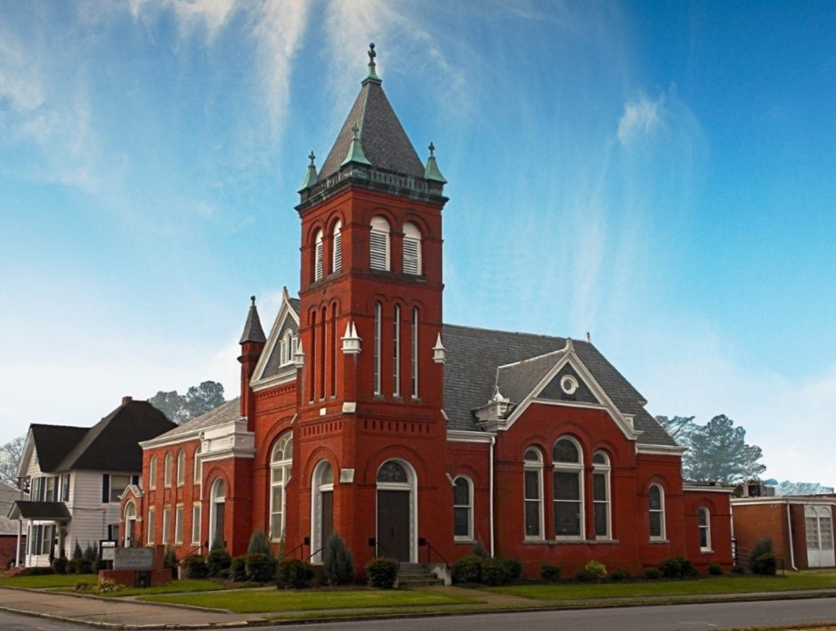
Rev. Josh Tester, Pastor

Office: (252) 335-2658
cityroadec.net crumcec@gmail.com

Facebook: https://www.facebook.com/CityRoadUMC

Sunday School: 10:00 a.m.
Sanctuary Worship: 11:00 a.m.

Tommy Venters- Organist/Choir Director
Dawn Baker- Secretary/Technology Specialist
JoAnn Herring- We Care

Service of Word
Good Friday

April 3rd, 2026 2:00 p.m.
Gathering
Words of Welcome Pastor Josh
Call to Worship Psalm 31: 9-16 UMH 765
Lighting of the Candles

Epistle lesson Philippians 2:5-11

Prayer UMH 284

Hymn “What Wonderous Love is This” UMH 292
Verse 1

Old Testament Lesson Isaiah 50:4-9a

Special Music “Your Grace Still Amazes Me”

Proclamation of the Passion Story from Matthew 26 & 27

The Reproaches
Congregational Response: Lamb of God who takes away the sins of the world have mercy on us.
CHRIST'S LAMENT AGAINST HIS FAITHLESS CHURCH

O my people, O my Church,
what have I done to you, or in what have I offended you?
I led you forth from the land of Egypt
and delivered you by the waters of baptism,
but you have prepared a cross for your Savior.
Lamb of God who takes away the sins of the world
have mercy on us.

I made you branches of my vineyard
and gave you the water of salvation,
but when I was thirsty you gave me vinegar and gall
and pierced with a spear the side of your Savior.
Lamb of God who takes away the sins of the world
have mercy on us.

I gave you a royal scepter, and bestowed the keys to the kingdom,
but you have given me a crown of thorns.
I raised you on high with great power,
but you have hanged me on the cross.
Lamb of God who takes away the sins of the world
have mercy on us.

My peace I gave, which the world cannot give,
and washed your feet as a servant,
but you draw the sword to strike in my name
and seek high places in my kingdom.
You have prepared a cross for your Savior.
Lamb of God who takes away the sins of the world
have mercy on us.

I called you to go and bring forth fruit,
but you cast lots for my clothing.
I prayed that you all may be one,
but you continue to quarrel and divide.
And you have prepared a cross for your Savior.
Lamb of God who takes away the sins of the world
have mercy on us.

I came to you as the least of your brothers and sisters.
I was hungry but you gave me no food,
thirsty but you gave me no drink.
I was a stranger but you did not welcome me,
naked but you did not clothe me,
sick and in prison but you did not visit me.
And you have prepared a cross for your Savior.
Lamb of God who takes away the sins of the world
have mercy on us.
The Lord’s Prayer
Our Father who art in heaven, hallowed be thy name. Thy kingdom come; thy will be done on earth as it is in heaven. Give us this day our daily bread, and forgive us our trespasses, as we forgive those who trespass against us; and lead us not into temptation but deliver us from evil. For thine is the kingdom, and power, and glory forever. Amen

Hymn “Jesus, Keep Me Near the Cross” UMH 301
Vs. 1,2 & 4
Stripping of the Chancel
Prayer

Reading from Prologue to John's Gospel

Dismissal with Blessing

