St. Matthew’s Lutheran Church
Resurrection of Our Lord – Easter Day
April 5, 2026

______________________________________________________
This is the day the Lord has made! Christ is risen, and through him all creation is made new! Indeed, “God shows no partiality” (Acts 10:34): Christ’s resurrection truly brings life to everyone. We sing hymns of praise, gather around sacred words, and proclaim God’s faithfulness, power, and love in the feast of holy communion. With the women at the tomb, we are astonished, elated, and grateful. We depart with joy to proclaim the good news of God’s endless love. _____________________________________________________________________

Pastor Christian McMullan
Daniel S. Bower, Music Director
Craig Miller, Director of Youth & Family Ministries

2440 Conestoga Road, Chester Springs, Pennsylvania
610-458-5675
www.stmatthews-church.org

Images, texts and music reprinted under One License A-701213 and/or CCLI License 1029780
HYMN Christ Is Risen! Alleluia! ELW 382
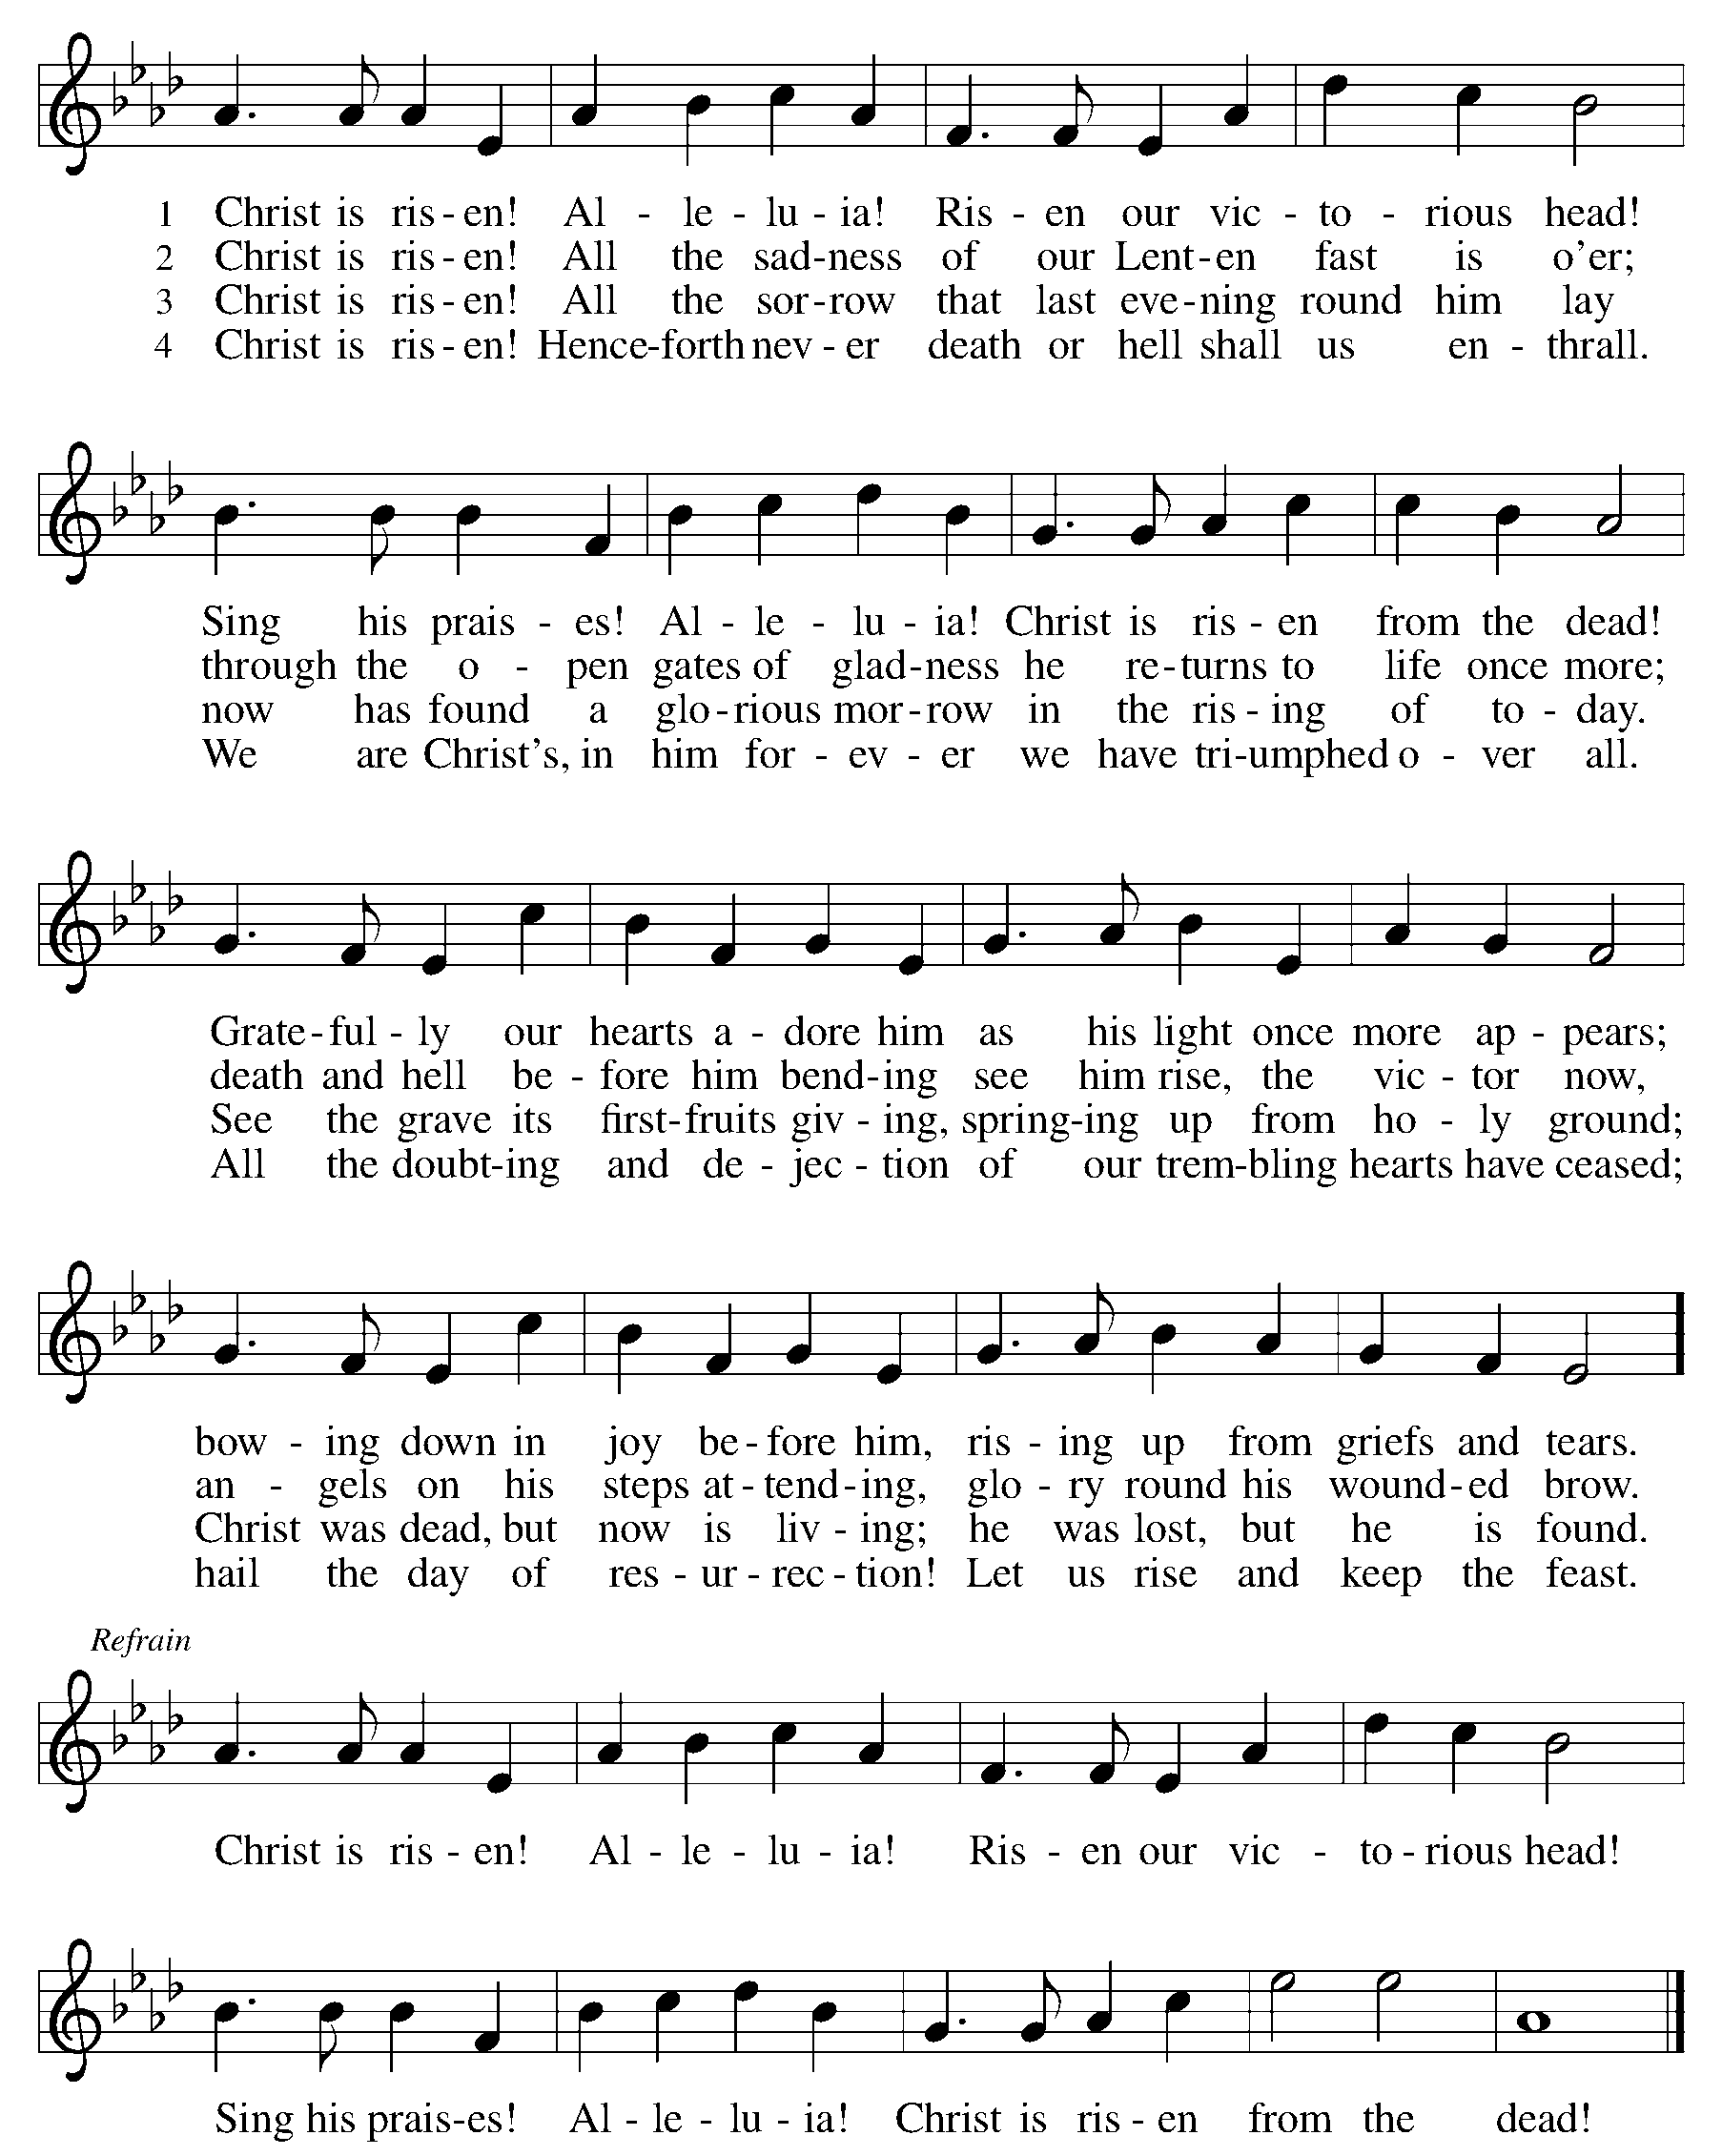

GREETING
P: Alleluia! Christ is risen!
C: Christ is risen indeed! Alleluia!
P: The grace of our Lord Jesus Christ, the love of God and the communion of the Holy Spirit be with you all.
C: And also with you.

THANKSGIVING FOR BAPTISM
All may make the sign of the cross, the sign that is marked at baptism, as the presiding minister begins.
P: In the name of ☩ the One
who was, who is, and who is to come.
C: Amen.
P:Baptized into Christ’s death and resurrection,
and called to live new life,
let us give thanks for the gifts of baptism.

Water may be poured into the font as the presiding minister continues.
Holy God,
we give you thanks for your cleansing waters,
waters that make us your own,
that restore to wholeness,
and empower us to be witnesses in your name.
Baptized into you, O Living One,
C: make us one as you are one.

P: We give you thanks for your healing waters,
waters that strengthen us in faith and trust,
and give new life to your servants;
waters that extend your boundless love
and cross barriers of our own making.
Baptized into you, O Living One,
C: make us one as you are one.

P: We give you thanks for the waters of baptism,
waters that open hearts through your Word,
and give a voice in the night to those who are burdened;
waters that set us on a new path,
rejoicing in the Holy Spirit’s power.
Baptized into you, O Living One,
C: make us one as you are one.
Grant us grace, love, and faith, O Living One,
that our every day is shaped by these waters
and your Word that makes us alive in you.
We ask this in the name of Jesus, the Crucified and Risen One.
C: Amen.

PRAYER OF THE DAY
P: God of mercy, we no longer look for Jesus among the dead, for he is alive and has become the Lord of life. Increase in our minds and hearts the risen life we share with Christ, and help us to grow as your people toward the fullness of eternal life with you, through Jesus Christ, our Savior and Lord, who lives and reigns with you and the Holy Spirit, one God, now and forever. Amen.

HYMN OF PRAISE
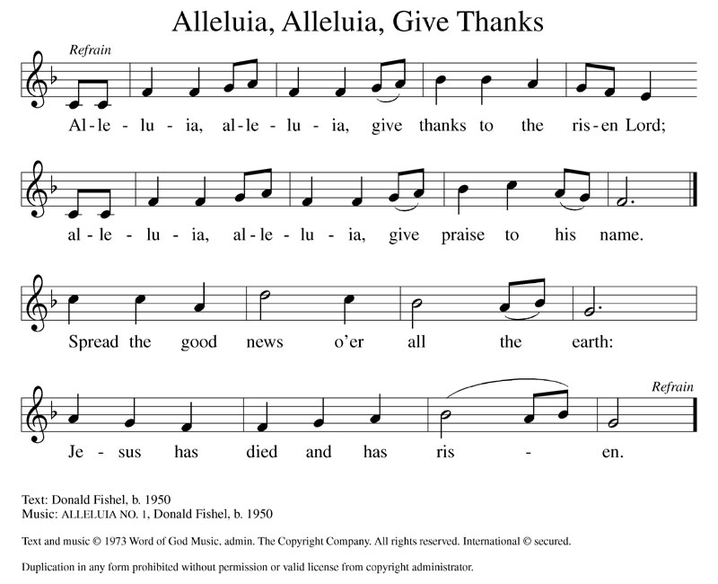

Please be seated

CHILDREN’S SERMON

FIRST READING Acts 10:34-44

A: A reading from Acts, the tenth chapter.

³⁴Then Peter began to speak to them [Cornelius and his household]: “I truly understand that God shows no partiality, ³⁵but in every nation anyone who fears him and does what is right is acceptable to him. ³⁶You know the message he sent to the people of Israel, preaching peace by Jesus Christ he is Lord of all. ³⁷That message spread throughout Judea, beginning in Galilee after the baptism that John announced: ³⁸how God anointed Jesus of Nazareth with the Holy Spirit and with power; how he went about doing good and healing all who were oppressed by the devil, for God was with him. ³⁹We are witnesses to all that he did both in Judea and in Jerusalem. They put him to death by hanging him on a tree; ⁴⁰but God raised him on the third day and allowed him to appear, ⁴¹not to all the people but to us who were chosen by God as witnesses, and who ate and drank with him after he rose from the dead. ⁴²He commanded us to preach to the people and to testify that he is the one ordained by God as judge of the living and the dead. ⁴³All the prophets testify about him that everyone who believes in him receives forgiveness of sins through his name.” ⁴⁴While Peter was still speaking, the Holy Spirit fell upon all who heard the word.

P: The Word of the Lord.
C: Thanks be to God.

SECOND READING Colossians 3:1-4

A: A reading from Colossians, the third chapter.

[St. Paul writes,] ¹ If you have been raised with Christ, seek the things that are above, where Christ is, seated at the right hand of God. ² Set your minds on the things that are above, not on the things that are on earth, ³ for you have died, and your life is hidden with Christ in God. ⁴ When Christ who is your life is revealed, then you also will be revealed with him in glory.

P: The Word of the Lord.
C: Thanks be to God.

Please stand

GOSPEL Matthew 28:1-10

P: The Holy Gospel according to St. Matthew, the twenty-eigth chapter.
C: Glory to you, O Lord.

¹ After the Sabbath, as the first day of the week was dawning, Mary Magdalene and the other Mary went to see the tomb. ² And suddenly there was a great earthquake, for an angel of the Lord, descending from heaven, came and rolled back the stone and sat on it. ³ His appearance was like lightning and his clothing white as snow. ⁴ For fear of him the guards shook and became like dead men. ⁵ But the angel said to the women, “Do not be afraid, for I know that you are looking for Jesus who was crucified. ⁶ He is not here, for he has been raised, as he said. Come, see the place where he lay. ⁷ Then go quickly and tell his disciples, ‘He has been raised from the dead, and indeed he is going ahead of you to Galilee; there you will see him.’ This is my message for you.” ⁸ So they left the tomb quickly with fear and great joy and ran to tell his disciples. ⁹ Suddenly Jesus met them and said, “Greetings!” And they came to him, took hold of his feet, and worshiped him. ¹⁰ Then Jesus said to them, “Do not be afraid; go and tell my brothers and sisters to go to Galilee; there they will see me.”

P: The Gospel of the Lord.
C: Praise to you, O Christ.

Please be seated
SERMON
Please stand

HYMN Jesus Christ is Risen Today ELW 365
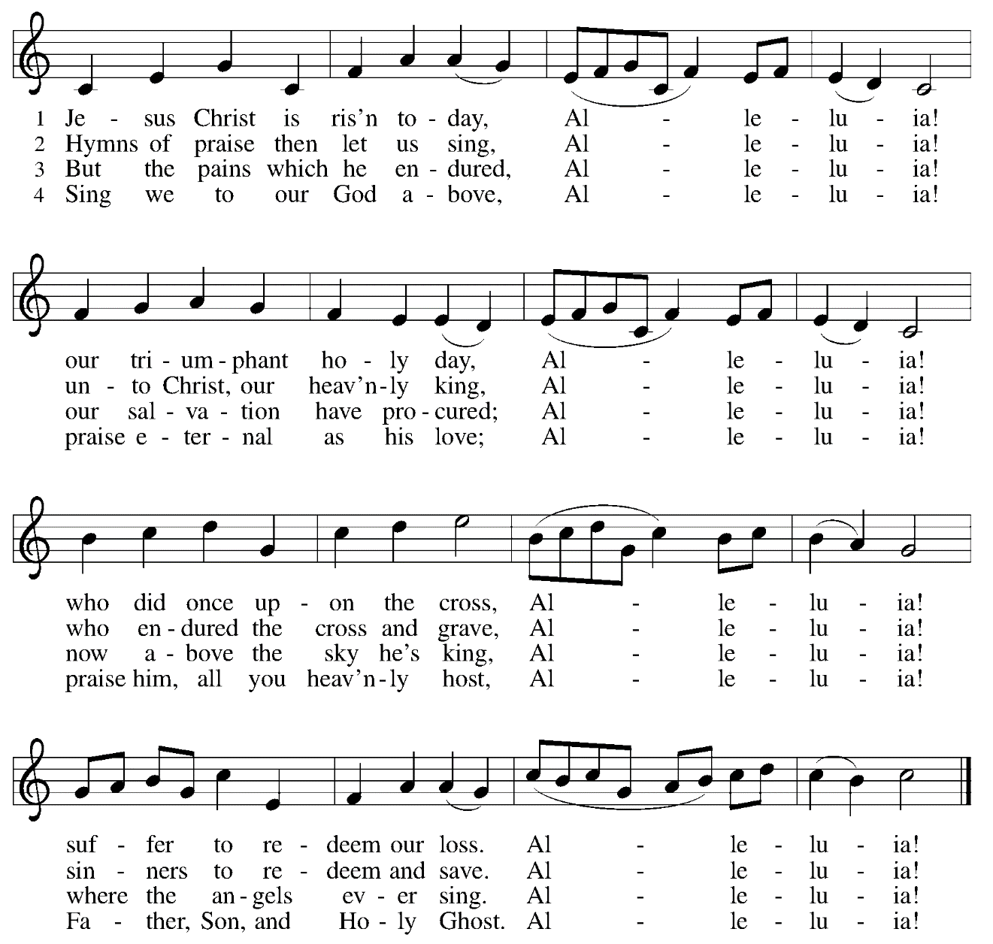

NICENE CREED

P: Living together in trust and hope, we confess our faith.
C: We believe in one God,
the Father, the Almighty,
maker of heaven and earth,
of all that is, seen and unseen.
We believe in one Lord, Jesus Christ,
the only Son of God,
eternally begotten of the Father,
God from God, Light from Light,
true God from true God,
begotten, not made,
of one Being with the Father;
through whom all things were made.
For us and for our salvation
he came down from heaven,
was incarnate of the Holy Spirit and the Virgin Mary
and became truly human.
For our sake he was crucified under Pontius Pilate;
he suffered death and was buried.
On the third day he rose again
in accordance with the Scriptures;
he ascended into heaven
and is seated at the right hand of the Father.
He will come again in glory to judge the living and the dead,
and his kingdom will have no end.
We believe in the Holy Spirit, the Lord, the giver of life,
who proceeds from the Father and the Son,
who with the Father and the Son is worshiped and glorified,
who has spoken through the prophets.
We believe in one holy catholic and apostolic church.
We acknowledge one baptism for the forgiveness of sins.
We look for the resurrection of the dead,
and the life of the world to come. Amen.

THE PRAYERS

P: Trusting in the power of Christ’s resurrection to heal and redeem our broken world, let us pray for the needs of all creation.
A brief silence.
P: Merciful God,
C: Hear our prayer.

P: God of resurrection power, use us and these prayers to proclaim the good news of new life to all the world, through Jesus Christ, our risen Savior.
C: Amen.

THE SHARING OF THE PEACE

P: The Peace of the Lord be with you always.
C: And also with you.

Please be seated

PRESENTATION OF THE GIFTS

In gratitude to God we give out of the abundance that God has given us.

Please stand

OFFERING

HYMN Joyful, Joyful We Adore Thee ELW 836

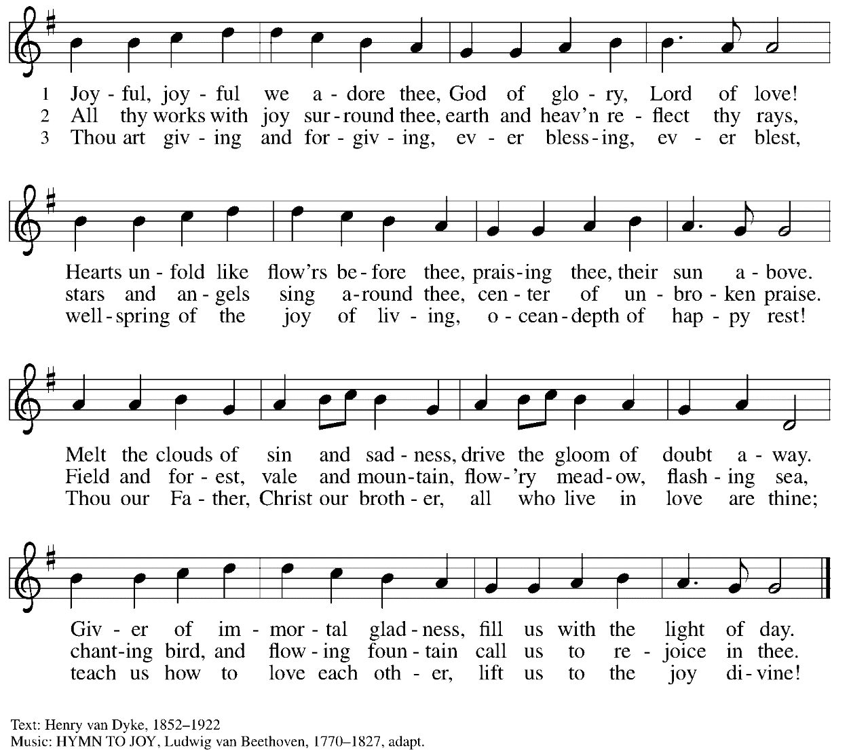

OFFERING PRAYER

P: Merciful God,
accept the fruits of our labor, gathered to give you glory.
You have set a table before us, a glimpse of that great day
when we will hunger and thirst no more.
Nourish us with the body and blood of Jesus,
that goodness and mercy may follow us
and bless the world you love.
In the name of Jesus,
C: Amen.

GREAT THANKSGIVING

P: The Lord be with you.
C: And also with you.
P: Lift up your hearts.
C: We lift them to the Lord.
P: Let us give thanks to the Lord our God.
C: It is right to give God thanks and praise.

P: Holy God, we praise you. Let the heavens be joyful, and the earth be glad. Praise to you for creating the heavens and the earth. Praise to you for saving Noah and all creatures from the waters of the flood. Praise to you for bringing the Israelites safely through the sea to a land of milk and honey. Praise to you for the words and deeds of Jesus, your anointed one. Praise to you for his death and resurrection that reconciled all things to you. Praise to you for your Holy Spirit poured out on all nations, inspiring us to love, live, and serve.
In the night in which he was betrayed, our Lord Jesus took bread, and gave thanks;
broke it, and gave it to his disciples, saying:
Take and eat; this is my body, given for you.
Do this for the remembrance of me.
Again, after supper, he took the cup, gave thanks,
and gave it for all to drink, saying:
This cup is the new covenant in my blood,
shed for you and for all people for the forgiveness of sin.
Do this for the remembrance of me.
With this bread and cup we remember our Lord's Passover from death to life as we
proclaim the mystery of faith:
C: Christ has died. Christ is risen. Christ will come again.
P: Empower our celebration with your Holy Spirit, feed us with your life, fire us with your
love, confront us with your justice, and make us one in the body of Christ. C: Amen.

P: Lord, remember us in your kingdom, and teach us to pray:
C: Our Father who art in heaven, hallowed be thy name, thy kingdom come, thy will be done, on earth as it is in heaven. Give us this day our daily bread; and forgive us our trespasses as we forgive those who trespass against us; and lead us not into temptation, but deliver us from evil. For thine is the kingdom, and the power, and the glory, forever and ever. Amen.
Please be seated
COMMUNION
This is God’s table so all are welcome to join the feast. Grape juice and gluten free wafers are available. You are invited to visit the prayer room during communion.
P: The body and blood of our Lord Jesus Christ strengthen you and keep you in his grace.
C: Amen.
PRAYER AFTER COMMUNION
P: Holy One,
through this meal you have made your home among us
and are making all things new.
Send us now to speak peace to anxious hearts,
to love our enemies,
and to bring your healing to the nations.
In the name of Jesus,
C: Amen.
Please stand

BLESSING
P: God Almighty, who is the beginning and the end,
Jesus Christ, the firstborn of the dead,
and the Spirit, our advocate and peace,
☩ bless you now and forever.
C: Amen.

SENDING HYMN Now All the Vault of Heaven Resounds ELW 367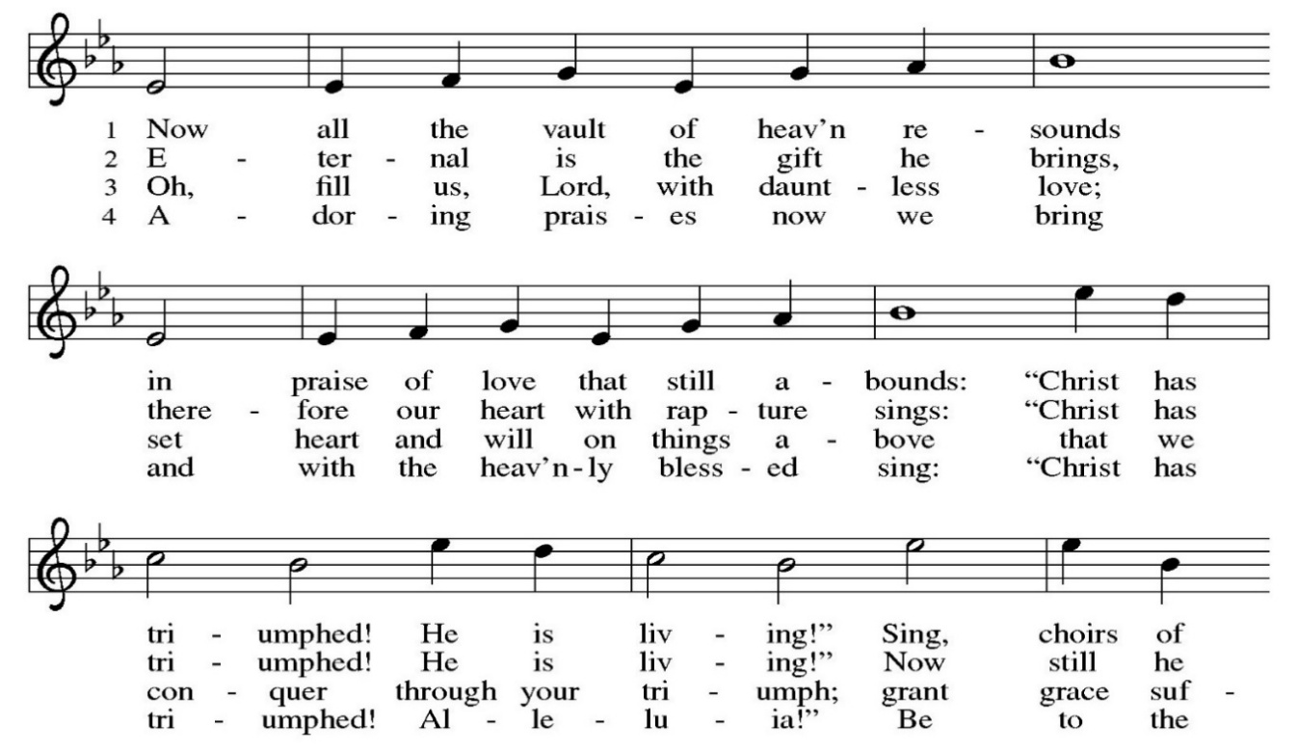
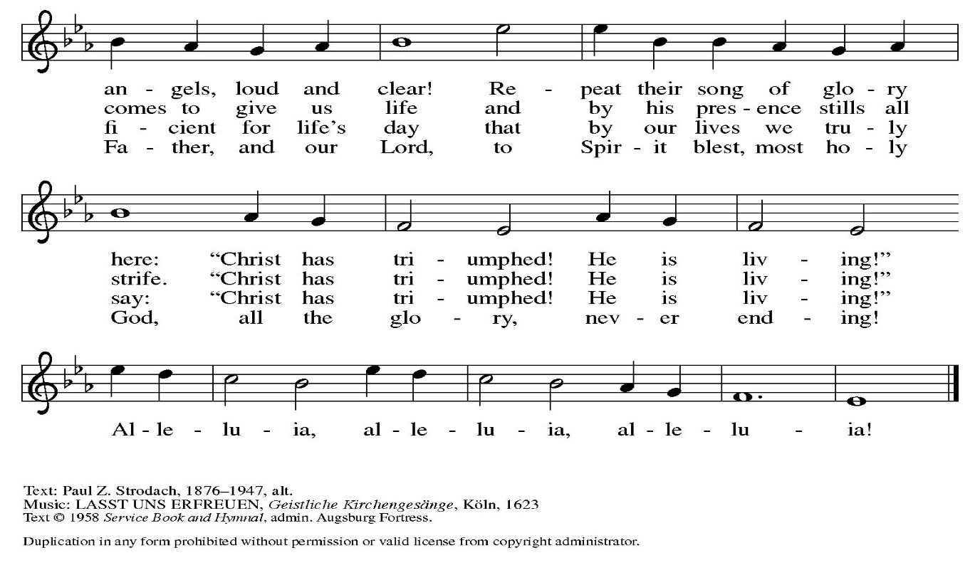
DISMISSAL
P: Alleluia! Christ is risen.
C: Christ is risen indeed. Alleluia!
P: Go in peace. Praise the Lord! Alleluia!
C: Thanks be to God. Alleluia!



Thank you to members and friends of St. Matthew’s Lutheran Church for contributing
to the beauty of the sanctuary this Easter by purchasing the Altar tulips.
Madison Cabot: In memory of Harold Derrick, in honor of James Cabot.
Brian and Kristen Delin: In memory of Edwin Jensen.
Randy and Kathryn Endsley: In memory of our loved ones, in honor of God's glory.
Vicki and Al Hanna: In memory of Samuel Marks, in honor of our children and grandchildren: Josh, Matthew, Brett, Eric, Michelle, Sarah, Alex, Collin, Dylan, Luke and Hunter.
Erich and Kim Hild: In memory of our mothers, Margaret Hild and Sharron Ressler.
Bob and Harriet Johnston: In memory of Stephanie Johnston, in honor of our grandchildren.
Lydia Lieb
Kathy and Ed Meltzer: In memory of our Dads, Hugh McCann and Ben Meltzer.
Meridith Hurd Robinson: In memory of Tyler Hurd.
Chris Schiavino and Melinda Weisgal
Mark Shanely: In memory of Warren and Ruth Shanely.
John and Peggy Smith: In honor of our children and grandchildren.

