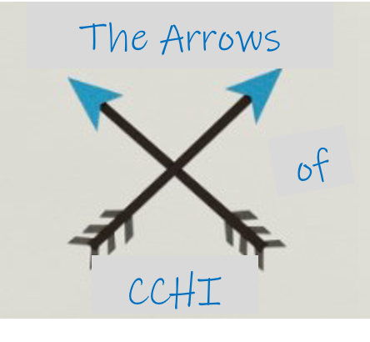  Like arrows in the hands of a warrior are children born in one’s youth.  Psalm 127:4 |  | 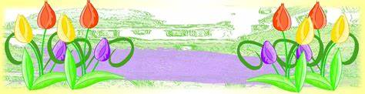  April News
April Teachers  Sunday  Juniors: Ms. Karrie  Seniors: Ms. Shannah  Wednesday  Juniors: Ms. Jamie  Seniors: Ms. Erin |  | We are wrapping up unit 11 in April after a pause for 2 Easter lessons Palm Sunday and Easter.  This month’s lesson topics are:  - Easter: Jesus Rose from the Dead  - God Defends His Glory  - Daniel Serves Faithfully  - Unit 11 Review  March Memory Verse Madness:  Sunday Juniors continue with Ephesians 2:4-5  Sunday Seniors will continue to work on Isaiah 30:18 after Easter  Easter Memory Verse: 1 Peter 2:24
This month’s Jr helpers:  4/5 Zeke  4/12 Quinn  4/19 Isaiah  4/26 Gary  Upcoming Events:  4/4 Easter Brunch & egg hunt (church wide)  4/29 Bingo Review (with prizes) |  | ARROWS updates  - Easter memory verse challenge is still going strong! Bring your card by 4/5 for a prize. If we have 14 memory verse cards turned in from the Weds. Night crew by 4/5, we’ll have an ice cream party 4/15!  - Unit 11 Review is at the end of the month!  - We’ll have a break from memory verse games after our Easter one until we start our new unit in May with a new verse  - Level up is coming up in June! Those finishing 1st grade will move up to the seniors class, and those transitioning into youth group from elementary school will officially move up!
Nursery Volunteers:  4/5 Ms. Ann & Isaiah  4/12 Ms. Nicola & Paizley  4/19 Mr. Wayne & Adalyn  4/26 Ms. Erin & Saylor |  | Nursery Reminders  - 1 background checked adult must be present at all times.  - Only 1 teenager should stay in the nursery unless there is an unusually large group.  - If you are unable to serve on your date, please swap with someone else on the schedule or one of the back up workers listed to the left (Sunday school teachers have also been background checked and can fill in as needed).  - Upcoming May schedule:  - 5/3 Ms. Ann & Isaiah  - 5/10 Ms. Nicola & Paizley  - 5/17 Mr. Wayne & Adalyn  - 5/24 Ms. Erin & Saylor  - 5/31 M. Karla & Quinn
**Easter Brunch & Egg Hunt**
Saturday, 4/4 10:30 at the Fountains
Details and sign up are posted on the church web site under events!
**National Bible Bee Summer Study**
Study the book of James this summer! We’ll have a couple meetings and some quick Sunday check ins with prizes, Proclaim! Day, and our BIG DAY OUT to celebrate the completion of the study. See Jamie for more info.
Info and registration: https://biblebee.org/summer-study/

