
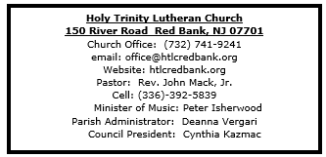

March 29, 2026
Sunday of the Passion/Palm Sunday

Introduction
Today, we encounter the paradox that defines our faith: Jesus Christ is glorified king and humiliated servant. We too are full of paradox: like Peter, we fervently desire to follow Christ, but find ourselves afraid, denying God. We wave palms in celebration today as Christ comes into our midst, and we follow with trepidation as his path leads to death on the cross. Amid it all we are invited into this paradoxical promise of life through Christ’s broken body and outpoured love in a meal of bread and wine. We begin this week that stands at the center of the church year, anticipating the completion of God’s astounding work.
Welcome & Announcements (Please silence your cell phone!)

Prelude (We prayerfully prepare our hearts and minds to worship!)

+ GATHERING +
(For those who are able, please join us on the front lawn!)

P: Blessed is the One who comes in the name of the Lord!
C: Hosanna in the highest!

Processional Gospel: Matthew 21:1-11

P: The Holy Gospel according to St. Matthew 21st chapter.
C: Glory to you, O Lord!
Jesus enters Jerusalem

¹ When they had come near Jerusalem and had reached Bethphage, at the Mount of Olives, Jesus sent two disciples, ² saying to them, “Go into the village ahead of you, and immediately you will find a donkey tied and a colt with her; untie them and bring them to me. ³ If anyone says anything to you, just say this, ‘The Lord needs them.’ And he will send them immediately.” ⁴ This took place to fulfill what had been spoken through the prophet:
⁵ “Tell the daughter of Zion,
Look, your king is coming to you,
humble and mounted on a donkey,
and on a colt, the foal of a donkey.”
⁶ The disciples went and did as Jesus had directed them; ⁷ they brought the donkey and the colt and put their cloaks on them, and he sat on them. ⁸ A very large crowd spread their cloaks on the road, and others cut branches from the trees and spread them on the road. ⁹ The crowds that went ahead of him and that followed were shouting,
“Hosanna to the Son of David!
Blessed is the one who comes in the name of the Lord!
Hosanna in the highest heaven!”
¹⁰ When he entered Jerusalem, the whole city was in turmoil, asking, “Who is this?” ¹¹ The crowds were saying, “This is the prophet Jesus from Nazareth in Galilee.”
P: The Gospel of the Lord.
C: Praise to you, O Christ!

The Blessing of the Palms (the congregation raise their palm branches)
P: The Lord be with you!
C: And also with you!
P: Let us pray. We praise you, O God, for redeeming the world through our Savior Jesus Christ. Today he entered the holy city in triumph and was proclaimed messiah and king by those who spread garments and branches his way. Bless these branches and those who carry them. Grant us grace to follow our Lord in the way of the cross, so that, joined to his death and resurrection, we enter into life with you; through the same Jesus Christ, who lives and reigns with you and the Holy Sprit, one God, now and forever.
C: Amen.
P: Let us go forth in peace,
C: In the name Christ. Amen!

*Gathering Hymn ELW 344 All Glory, Laud and Honor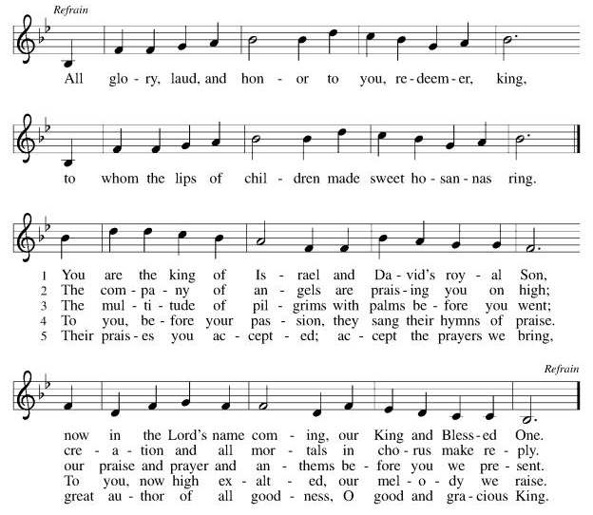

*Pastoral Greeting

P: The Grace and Peace of our Lord Jesus Christ, the love of God, and the communion of the Holy Spirit be with you all! C: And also with you!

*Kyrie: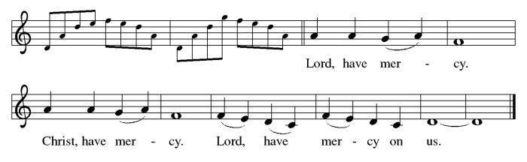

*Prayer of the Day
P: Everlasting God, in your endless love for the human race you sent our Lord Jesus Christ to take on our nature and to suffer death on the cross. In your mercy enable us to share in his obedience to your will and in the glorious victory of his resurrection, who lives and reigns with you and the Holy Spirit, one God, now and forever.
C: Amen!
Children’s message
+WORD+

First Reading: First Reading: Isaiah 50:4-9a
The image of the servant of God is one of the notable motifs in the book of Isaiah. Today’s reading describes the mission of the servant, whom early Christians associated with Jesus. Like Jesus, the servant does not strike back at his detractors but trusts in God’s steadfast love.

⁴The Lord God has given me
the tongue of a teacher,
that I may know how to sustain
the weary with a word.
Morning by morning he wakens—
wakens my ear
to listen as those who are taught.
⁵The Lord God has opened my ear,
and I was not rebellious,
I did not turn backward.
⁶I gave my back to those who struck me,
and my cheeks to those who pulled out the beard;
I did not hide my face
from insult and spitting.
⁷The Lord God helps me;
therefore I have not been disgraced;
therefore I have set my face like flint,
and I know that I shall not be put to shame;
⁸he who vindicates me is near.
Who will contend with me?
Let us stand up together.
Who are my adversaries?
Let them confront me.
^{9a}It is the Lord God who helps me;
who will declare me guilty?

Psalm: Psalm 31:9-16
Into your hands, O Lord, I commend my spirit. (Ps. 31:5)

⁹Have mercy on me, O Lord, for I | am in trouble;
my eye is consumed with sorrow, and also my throat | and my belly.
¹⁰For my life is wasted with grief, and my | years with sighing; my strength fails me because of affliction, and my bones | are consumed.
¹¹I am the scorn of all my enemies, a disgrace to my neighbors, a dismay to | my acquaintances;
when they see me in the street | they avoid me.
¹²Like the dead I am forgotten, | out of mind;
I am as useless as a | broken pot.
¹³For I have heard the whispering of the crowd; fear is | all around;
they put their heads together against me; they plot to | take my life.
¹⁴But as for me, I have trusted in | you, O Lord.
I have said, “You | are my God.
¹⁵My times are | in your hand; rescue me from the hand of my enemies, and from those who | persecute me.
¹⁶Let your face shine up- | on your servant;
save me in your | steadfast love.”

Second Reading: Philippians 2:5-11
Paul quotes from an early Christian hymn that describes Jesus’ humble obedience in his incarnation as a human being, even to death, and his exaltation and glory as Lord of all.

⁵Let the same mind be in you that was in Christ Jesus,
⁶who, though he was in the form of God,
did not regard equality with God
as something to be exploited,
⁷but emptied himself,
taking the form of a slave,
being born in human likeness.
And being found in human form,
⁸he humbled himself
and became obedient to the point of death—
even death on a cross.
⁹Therefore God also highly exalted him
and gave him the name
that is above every name,
¹⁰so that at the name of Jesus
every knee should bend,
in heaven and on earth and under the earth,
¹¹and every tongue should confess
that Jesus Christ is Lord,
to the glory of God the Father.

*Gospel Acclamation
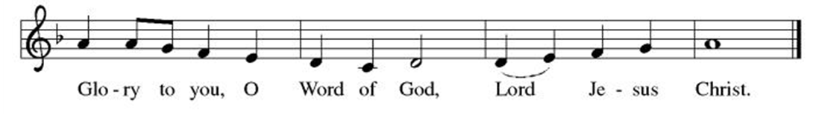

Gospel: Matthew 26:14—27:66

P. The Passion of our Lord Jesus Christ according to St. Matthew
C. Glory to You, O Lord!

Please use the Gospel inserts found in pews. (Please leave the inserts in pews after service.)
Narrator: Cynthia Kazmac
Jesus: Juslaine Costanza
Judas: Molly Foard
Peter: Casey Hochheiser
Witness: Jill Socha
High Priest: Jeff Ridberg
Servant: Debbie Yetka
Pialte: Adam Cheek

P: The Gospel of the Lord
C. Praise to you, O Christ!
*Hymn of the Day ELW 345 Jesus, I Will Ponder Now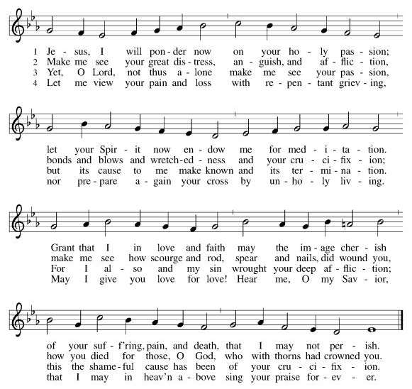

Nicene Creed
We believe in one God,
the Father, the Almighty,
maker of heaven and earth,
of all that is, seen and unseen.
We believe in one Lord, Jesus Christ,
the only Son of God,
eternally begotten of the Father,
God from God, Light from Light,
true God from true God,
begotten, not made,
of one Being with the Father;
through him all things were made.
For us and for our salvation
he came down from heaven,
was incarnate of the Holy Spirit and the Virgin Mary
and became truly human.
For our sake he was crucified under Pontius Pilate;
he suffered death and was buried.
On the third day he rose again
in accordance with the Scriptures;
he ascended into heaven
and is seated at the right hand of the Father.
He will come again in glory to judge the living and the dead,
and his kingdom will have no end.
We believe in the Holy Spirit, the Lord, the giver of life,
who proceeds from the Father and the Son,
who with the Father and the Son is worshiped and glorified,
who has spoken through the prophets.
We believe in one holy catholic and apostolic church.
We acknowledge one baptism for the forgiveness of sins.
We look for the resurrection of the dead,
and the life of the world to come. Amen.

*Prayers of Intercession
Reconciled by God’s mercy and sustained by God’s presence, let us pray for the world and its needs.
A brief silence.
O God, you announce words of grace and truth. Give wisdom to all preachers in your church both globally and locally (here local bishops, pastors, deacons, and lay preachers may be named). Open our hearts to encounter the infinite life you offer in Jesus. Hear us, O God.
C:Your mercy is great.
You hold the whole universe. Gather sun and moon, clouds and stars, land and sea, and plants and animals around the cross, so that all creation bears witness to your saving love. Hear us, O God.
C:Your mercy is great.
Your power is sure. Destroy inequity and division in every place, and build your beloved community among all people. Guide judges, attorneys, and juries so that they act with justice and fairness. Hear us, O God.
C:Your mercy is great.
Your heart breaks open at our pain. Send healing and vindication to all who, like Jesus, know the sting of betrayal, denial, abuse, or false accusations. Be with those experiencing pain or loss this day (especially). Hear us, O God.
C:Your mercy is great.
Your ways show compassion. Let this same mind be in us as we enter Holy Week. Bless those here who will lead worship and tell the story of Jesus’ death and resurrection. Hear us, O God.
C:Your mercy is great.
Here other intercessions may be offered.
O God, your embrace is eternal. Praise and thanks to you for (Hans Nielsen Hauge and) all the faithful departed who rest in your mercy. Deliver us all from death’s power and raise us to life in you. Hear us, O God.
C:Your mercy is great.
Receive our prayers, O God, through Jesus Christ, our strength and salvation.
C:Amen

Greeting of Peace
P: The peace of Christ be with you and those you love!
C: And also with you! (The peace is shared with all!)

Offering (Thank you for your support for our ministry!)

*Doxology ELW 186 (Please stand and join in singing as we share our gifts!)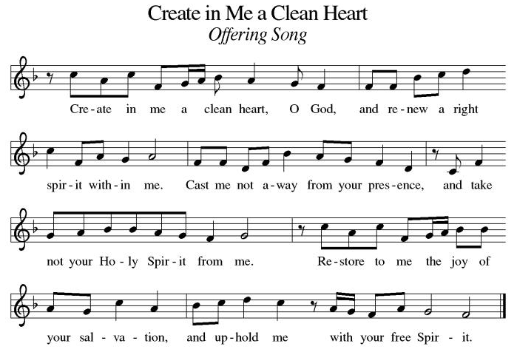

*Offering Prayer
A: O God, maker of heaven and earth,
C: your steadfast love embraces all creation.
You send rain and sunshine to nourish the earth
and bring forth its bounty.
Through these gifts of bread and wine,
draw us into the death and life of your Son,
who calls us to bear witness to his saving work.
We ask this in Jesus’ name.
Amen.

+MEAL+
(All are welcome at the table of our Lord!)
*Great Thanksgiving
P: The Lord be with you.
C: And also with you.

P: Lift up your hearts.
C: We lift them to the Lord.

P: Let us give thanks to the Lord our God.
C: It is right to give our thanks and praise.

P: It is indeed right, our duty and our joy,
that we should at all times and in all places
give thanks and praise to you, almighty and merciful God,
through our Savior Jesus Christ,
whose suffering and death gave salvation to all.
You gather your people around the tree of the cross,
transforming death into life.
And so, with all the choirs of angels,
with the church on earth and the hosts of heaven,
we praise your name and join their unending hymn:

*Sanctus
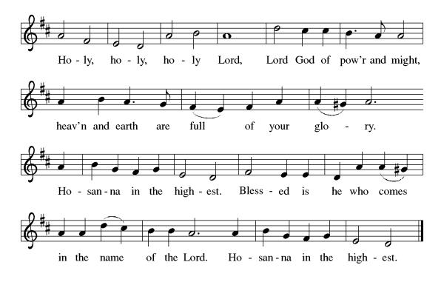
*Eucharistic Prayer
P: Holy, mighty, and merciful Lord,
heaven and earth are full of your glory.

In great love you sent to us Jesus, your Son,
who reached out to heal the sick and suffering,
who preached good news to the poor,
and who, on the cross, opened his arms to all.

In the night in which he was betrayed,
our Lord Jesus took bread, and gave thanks;
broke it, and gave it to his disciples, saying:
Take and eat; this is my body, given for you.
Do this for the remembrance of me.

Again, after supper, he took the cup, gave thanks,
and gave it for all to drink, saying:
This cup is the new covenant in my blood,
shed for you and for all people for the forgiveness of sin.
Do this for the remembrance of me.

Remembering, therefore, his death, resurrection, and ascension,
we await his coming in glory.

Pour out upon us the Spirit of your love, O Lord,
and unite the wills of all who share this heavenly food,
the body and blood of Jesus Christ, our Lord;
to whom, with you and the Holy Spirit,
be all honor and glory, now and forever.

C: Amen!

*THE LORD’S PRAYER
Our Father, who art in heaven,
hallowed be thy name,
thy kingdom come,
thy will be done,
on earth as it is in heaven.
Give us this day our daily bread;
and forgive us our trespasses,
as we forgive those
who trespass against us;
and lead us not into temptation,
but deliver us from evil.
For thine is the kingdom,
and the power, and the glory,
forever and ever. Amen.
*Lamb of God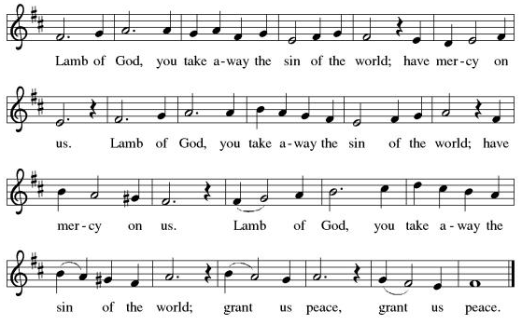

Spiritual Communion Prayer
P: Let us pray for the communion of all present here, those viewing our service virtually, those in our hearts and in our world.
C: Lord Jesus, I believe you are truly present in the Sacrament of Holy Communion. When I cannot receive Communion, I pray that you come into my heart. I know that nothing in Heaven or on earth can separate me from your love. Amen.

Invitation to Communion
P: Come to the table.
Feast on God’s goodness and mercy.

C: Thanks be to God.

(All are invited to the communion rail following the guidance of the ushers. Communion will be shared through the host and individual cups. If you would like communion but are unable to join us at the rail, please alert the usher!)

Communion Hymns (Please join in singing!)
ELW 351 O Sacred Head, Now Wounded
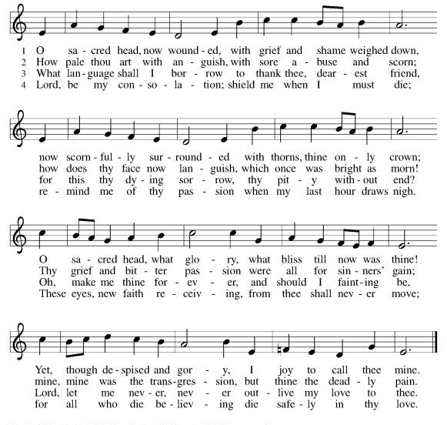
ELW 353 Were You There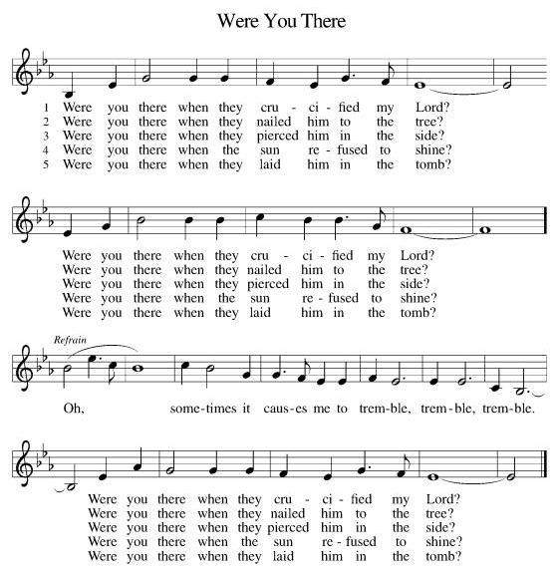

P: The body and blood of our Lord Jesus Christ strengthen you and keep you in his grace. C: Amen!

*Prayer after Communion
A: God of our salvation,
we give you thanks for this meal that restores our souls,
reconciles us to you, and strengthens us for the journey.
Through the body and blood of your Son,
may we become Christ’s body in the world,
bearing witness to your love for all creation,
through Jesus Christ, our Savior and Lord.
C: Amen!
+Sending+

*Blessing
P: Receive the blessing of the holy Trinity:
God, who calls all things into existence,
Jesus Christ, who redeems us,
and the Holy Spirit, whose breath sustains creation,
☩ bless you now and always.
C: Amen!

*Sending Hymn ELW 359 Where Charity and Love Prevail
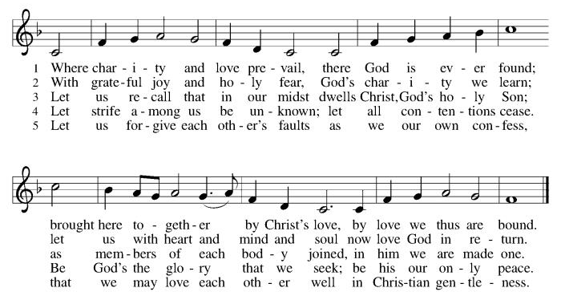

*Dismissal
A: Go in peace. Believe the good news.
C: Thanks be to God!
Postlude

Copyright © 2020 Augsburg Fortress. All rights reserved. Reprinted by permission under Augsburg Fortress Liturgies Annual License #SB106907. New Revised Standard Version Bible, Copyright © 1989, Division of Christian Education of the National Council of the Churches of Christ in the United States of America. Used by permission. All rights reserved. Revised Common Lectionary, Copyright © 1992 Consultation on Common Texts, admin Augsburg Fortress. Used by permission.

Treasurer’s Report

February giving totaled $53,512, putting us ahead of pace toward our 2026 Challenge goal of $244,000, with 29% raised in just 17% of the year. Continued participation through regular or additional Challenge gifts will help ensure we fully fund HTLC’s ministry and mission in the months ahead.

Worship Volunteer Schedule
Date | Asst. Min | Usher | Sacristan | Lector | Counter
April 5 | Easter
April 12 | Keith Bennett | The Gripps | Sherry Lee | Jeff Ridberg
April 19 | Chris Foard | Keith Bennett | Pat Pienkos | Emily Kaster
April 26 | Charlie Rugg | Jill Socha | Sherry Lee | Rosemary Lane
May 3 | Linda Coleman | Kathy Caputo | Joanne Giordano | Bill Spreen

Coffee Hour- Linda Coleman

ANNOUNCEMENTS Thank you! To all who consistently support our church and ministries through your time, talent, and treasure. Please help us grow by inviting your friends and family to worship and events. You are what makes Holy Trinity a wonderful church family!

Dorcas Circle- Will meet April 9th at noon due to Holy Week.

Stay in touch! Please visit our church website, www.htlcredbank.org for updates and information. You can also find us on Facebook and view services online. The office is open from 9am to 2pm, Monday to Thursday.

100 Anniversary Committee- If you are interested in being a part of the committee to help plan the 100th anniversary celebration of HTLC in 2028, please sign up in the red book. All are welcome! Also, the committee will be looking for photos and documents of HTLC throughout the years. If you have anything to share, please bring them to the church and marked envelopes or email electronic copies to the church office.

Name Tag Sundays: On the first Sunday of each month, names tags and markers will be at each entrance of the sanctuary. Please fill out a tag and wear one for worship and for coffee hour to welcome visitors and help newcomers put names to faces.

WELCA UPDATE -
Several WELCA members got together on 3/15 to discuss upcoming donations and events. Trivia Night brought in $709.75 and a donation will be made to Doctors Without Borders. We also discussed the need to continue to pay the $140.00 semi-annual dues to the NJ Chapter of WELCA. The Cross Roads Tee sign (a donation of $300) will be made along with social ministry and evangelism.

The Women of WELCA will be hosting coffee hour on April 12th. Please let Debbie Yetka know if you are able to bring something in and what it is.

Easter Dinner Donations:
Thank you for all the donations toward the collection for the Easter dinner bags. We were able to collect enough food for 28 bags. We were also able to donate some extra food items on the list and a gift card. Beth Gebhart, from Lutheran Social Ministries, picked up the food on March 23rd.

Sunday School in the New Year, we will continue to study stories and lessons from the Old Testament beginning with Jacob. Kids will love the crafts, songs and games that accompany each lesson.
The following dates there will be Sunday School:
Jan- 11 and 25, Feb- 8 and 22, March- 1, 15 and 29*Easter Egg Hunt!
April- 12 and 26, May- 3, 17 and 31, June- 7 and 14
As was done in the fall, there will be opportunities to volunteer as SS lead teacher. A signup will be emailed out shortly and will also be posted in the red binder. Consider signing up! All lesson materials will be supplied and laid out and a leader guide will be emailed to volunteers approximately 1 week in advance. Blessings for a wonderful 2026!~Lauren

Choir The Holy Trinity Choir welcomes our singers back for a preparation rehearsal on Sunday, September 7th at 9am in the church hall. All are welcome to join us in song as often as you are able. Choir meets each Sunday at 9am to practice and prepare our music. Join us and help us grow by spreading the word about the HTLC Choir!

Quilting- The Quilters need gently used any bed sheets of any size! Please leave any donations in the quilters closet in Fellowship Hall. Thank you!

Quilters Need Help
If anyone is traveling through Mechanicsville, PA, and can add a few extra minutes to your trip, the warehouse for shipping quilts, school kits, etc is located directly off one of the exits.
We accumulate many quilts throughout the year and we would appreciate sending some quilts with you to deliver. Any questions, please call Sherry Lee or Elaine Theophall.

Weekly Quilting on Wednesdays at 9:30. Bring your lunch and enjoy some fellowship at noon. All are welcome.

Social Ministry
*Year-round collections will continue for food items for Lunch Break. There is a sign-up sheet in the red book for those who can help drop these items to Lunch Break.
*We will also collect adult men's socks to periodically drop at the Red Bank Warminq Center.
*For those interested in the Heartwarminq Center — the new women's shelter is adjacent to the First Baptist Church of Red Bank at 90 Maple Ave. You can follow up on this mission through their website - https://www.thefeastnj.org- On this site, they also include wish list items that can be purchased through amazon. We will be exploring purchasing some of these through a Thrivent card. If you want to purchase on your own, you can leave items at church, and the Social Ministry will deliver them.

Pastoral Care and Prayer... We are here to care for and pray! Please contact the office to add or adjust prayer requests. If you or someone you know needs pastoral care, please contact the office and Pastor Mack!

THANK YOU for supporting and sustaining our church and ministries! All are welcome here! Please invite your family and friends to worship with us! Find us online at www.htlcredbank.org

Easter Flowers
Linda and Mark Csernica | In celebration of our grandchildren. Summer, Callum, Avery and Conor
Molly and Chris Foard | In gratitude to God for family and friends
The Grillon Family | In celebration of our grandchildren
Bruce and Rosemary Lane | In memory of our parents
Patricia and Jeff Pienkos | Flowers given in memory of Bobby Kronberger
Nancy and Bob Poole | The blessings of our family
Carol Rosen | Glory to God
Beth and Ron Ruberg | In memory of loved ones
Sue and David Steiger | Memory of our parents, Dorothy and Emil, Monica and John
Pete and Elaine Theophall | In memory of family and friends
Debbie Yetka | In memory of George Yetka

