Parkside Lutheran Church
Rediscovering the Radical Love of Jesus
Gathering All
Serving All
Caring For All

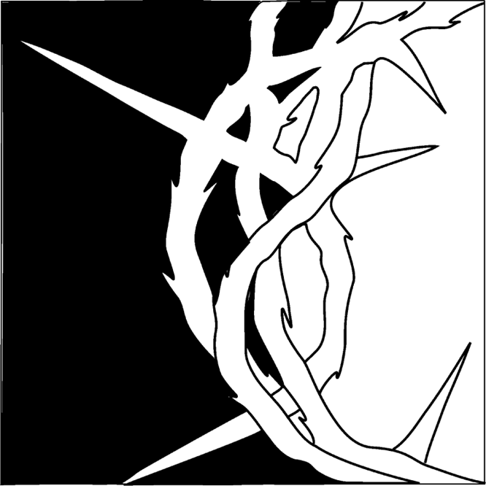

GOOD FRIDAY TENEBRAE SERVICE
April 3rd, 2026
Rev. Jeremiah Smith

TENEBRAE
Tenebrae is the Latin word for “darkness.” The Officium Tenebrae, the Service of Darkness, is a devotional and meditative service held on Good Friday to commemorate the crucifixion and death of Jesus. The Service of Darkness is not a funeral service for Jesus but a time for adoration (deep love and respect) of the Lamb of God in which we celebrate his sacrifice on the cross of Calvary. The darkness in the church symbolizes the miraculous Tenebrae, the darkness which surrounded the cross and darkened the earth from noon until three o’clock on the day Jesus died.

EIGHT CANDLES
There are eight candles in the front of the church. Throughout the service the candles are extinguished and the lights are dimmed representing the extinguishing of the life of Jesus. The eighth candle is not extinguished but it is removed from the chancel. Just as Christ’s body was hidden in the grave until the third day so also is the eighth candle removed from sight for a short time. It is returned to its place at the end of the service foreshadowing Christ’s return from death to life.

SILENCE
In keeping with the solemnity of the day, there is no pre-service or post-service music. The service begins in silence and ends in silence. Worshipers are invited to remain after the service for as long as they wish for prayer and meditation. All are asked to leave the sanctuary in silence. The stillness and darkness of tonight are intended to contrast with the bright and glorious celebration of Easter morning.


Welcome Visitors!
Please use QR code to let us know you were here today and/or to sign up for our weekly enewsletter. Find us on Facebook & Instagram
WIFI: Balcony password: FreeGrace

For your safety in the event of an emergency: In addition to the three exits in the back of the sanctuary, there are exits on either side of the altar (on left side: floor level near piano and up steps past altar. On right side: up steps to the altar, past band area)

Contact us: (716) 836-1361
2 Wallace Ave Buffalo, NY 14214 parksidelutheran@gmail.com
Visit our website at parksidelutheran.org for news and events

+Silent Processional
Call to Worship
L: We follow Jesus, C: who tells us to take up our cross.
L: We follow Jesus, C: who calls us to give up our lives.
L: We follow Jesus, C: who brings us into new life.
L: Come, let us worship Christ, who died so that we might live.

Procession of the Cross (ELW p. 264)
A cross is carried in procession through the church and is placed before the assembly. The assembly stands and faces the cross as it is brought forward. The following dialogue is spoken as the procession begins, the assembly echoing the leader.
L: Behold the life-giving cross on which was hung the Savior of the whole world.
C: Oh, come, let us worship him.
The dialogue is spoken a second time at the midpoint of the procession.
L: Behold the life-giving cross on which was hung the Savior of the whole world.
C: Oh, come, let us worship him.
The dialogue is spoken a third time at the end of the procession.
L: Behold the life-giving cross on which was hung the Savior of the whole world.
C: Oh, come, let us worship him.

Welcome and Invitation to Offer Prayers
This evening, we gather at the foot of the cross. You are invited to come forward, light a candle, offer your own prayers as we give thanks that Christ’s death offers life to all. We gather in solemn devotion, but always with the promise that the tree around which we assemble is indeed a tree of life. You are invited to proceed down the center aisle placing a lit candle in the sand at the base of the cross. Pastor and Worship Assistants will be nearby to help those who need assistance in placing their candle.

Solo

Prayer of the Day
L: We pray together…
C: broken and bleeding God,
do not let us turn away.
do not let us fall asleep.
do not let us fail to witness
the road you walk for us
the pain you bear for us
the love you pour out for us. Amen. –Prayer written by Slats Toole.
Meditation The Rev. Jeremiah P. Smith
(Congregation is seated for the remainder of the Service.)

Luke 23:32-38 “Father, forgive them, for they know not what they do.”
³²Two others also, who were criminals, were led away to be put to death with him. ³³When they came to the place that is called The Skull, they crucified Jesus there with the criminals, one on his right and one on his left. [[ ³⁴Then Jesus said, "Father, forgive them; for they do not know what they are doing."]] And they cast lots to divide his clothing. ³⁵And the people stood by, watching; but the leaders scoffed at him, saying, "He saved others; let him save himself if he is the Messiah of God, his chosen one!" ³⁶The soldiers also mocked him, coming up and offering him sour wine, ³⁷and saying, "If you are the King of the Jews, save yourself!" ³⁸There was also an inscription over him, "This is the King of the Jews."

HYMN “Ah, Holy Jesus” ELW #349
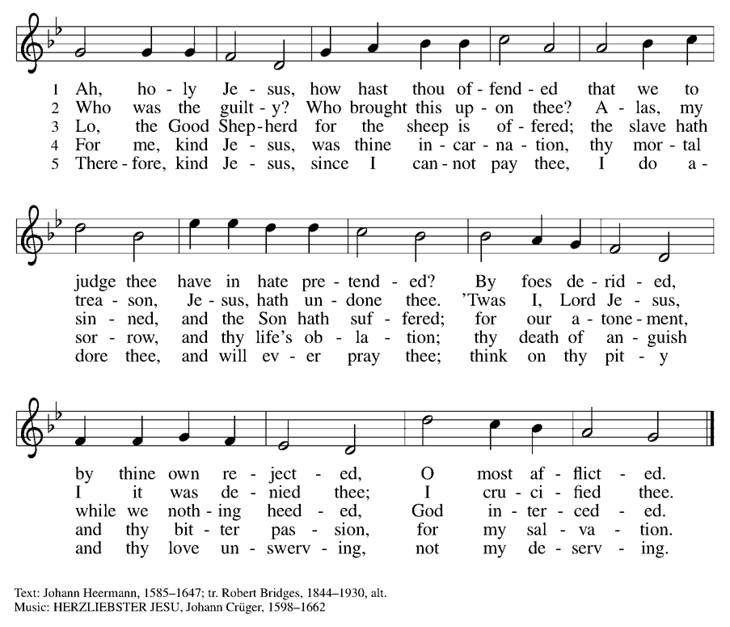
Luke 23:39-43 “Today you shall be with me in Paradise.”
³⁹One of the criminals who were hanged there kept deriding him and saying, "Are you not the Messiah? Save yourself and us!" ⁴⁰But the other rebuked him, saying, "Do you not fear God, since you are under the same sentence of condemnation? ⁴¹And we indeed have been condemned justly, for we are getting what we deserve for our deeds, but this man has done nothing wrong." ⁴²Then he said, "Jesus, remember me when you come into your kingdom." ⁴³He replied, "Truly I tell you, today you will be with me in Paradise."

HYMN “When I Survey the Wondrous Cross” ELW 803
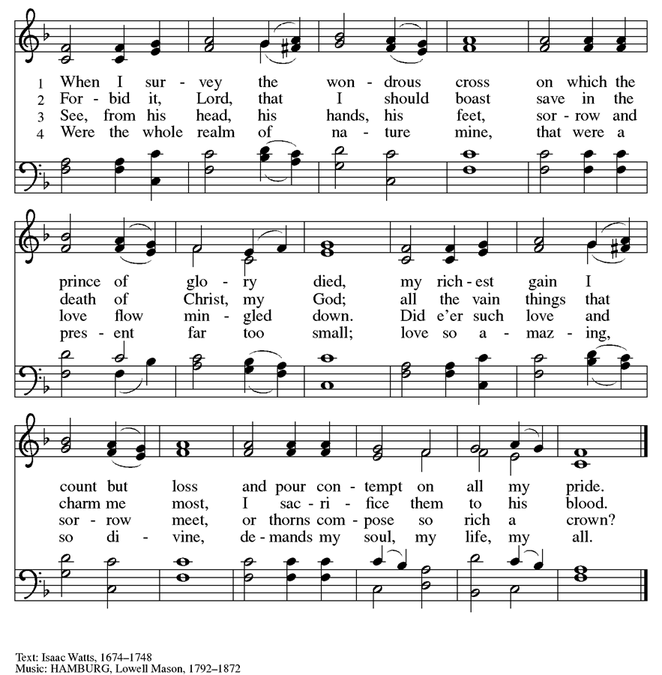

John 19:23-27 “Woman, behold you son. Behold your mother.”
²³When the soldiers had crucified Jesus, they took his clothes and divided them into four parts, one for each soldier. They also took his tunic; now the tunic was seamless, woven in one piece from the top. ²⁴So they said to one another, "Let us not tear it, but cast lots for it to see who will get it." This was to fulfill what the scripture says, "They divided my clothes among themselves, and for my clothing they cast lots." ²⁵And that is what the soldiers did. Meanwhile, standing near the cross of Jesus were his mother, and his mother's sister, Mary the wife of Clopas, and Mary Magdalene. ²⁶When Jesus saw his mother and the disciple whom he loved standing beside her, he said to his mother, "Woman, here is your son." ²⁷Then he said to the disciple, "Here is your mother." And from that hour the disciple took her into his own home.

Hymn I Want Jesus to Walk with Me ELW #325
(printed next page)
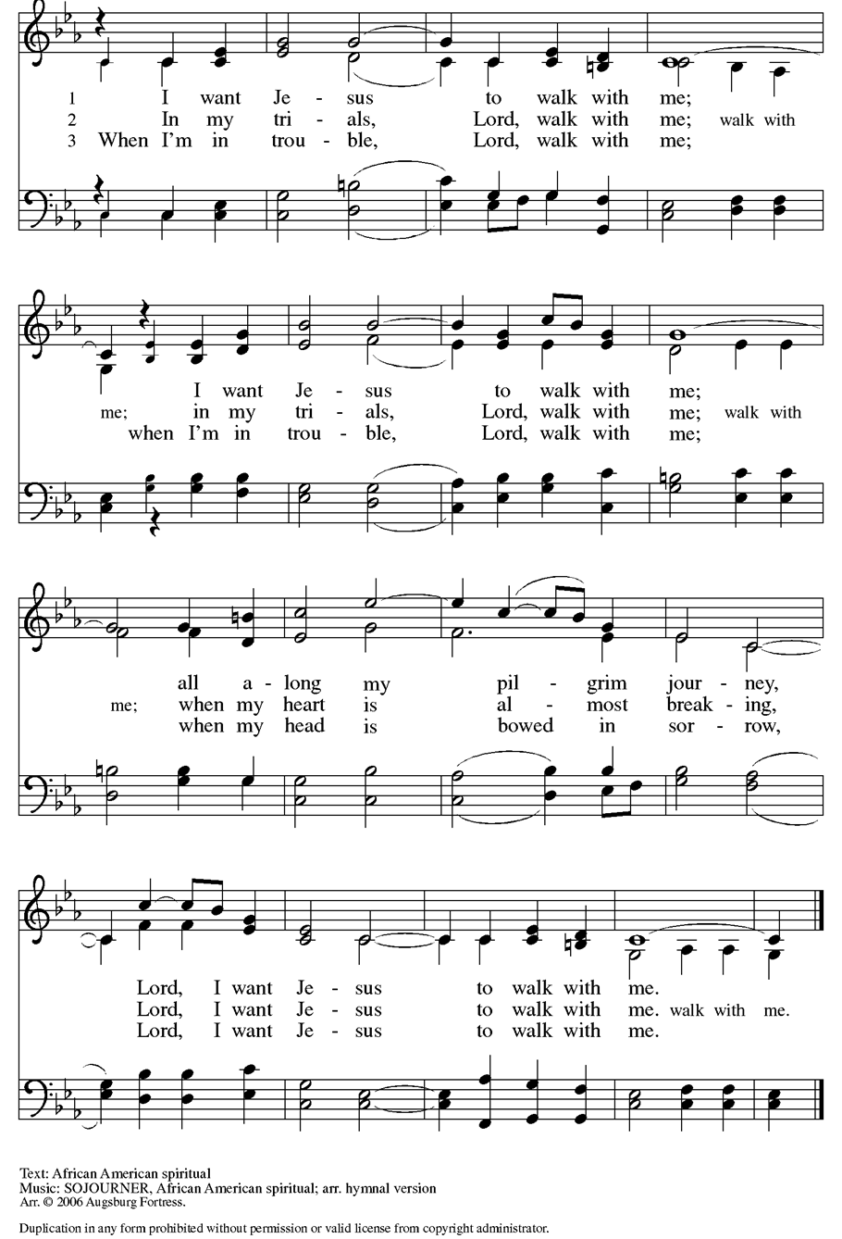
Matthew 27: 45-49
“My God, my God, why have you forsaken me?”
⁴⁵From noon on, darkness came over the whole land until three in the afternoon. ⁴⁶And about three o'clock Jesus cried with a loud voice, "Eli, Eli, lema sabachthani?" that is, "My God, my God, why have you forsaken me?" ⁴⁷When some of the bystanders heard it, they said, "This man is calling for Elijah." ⁴⁸At once one of them ran and got a sponge, filled it with sour wine, put it on a stick, and gave it to him to drink. ⁴⁹But the others said, "Wait, let us see whether Elijah will come to save him."

Hymn O Sacred Head, Now Wounded ELW #351

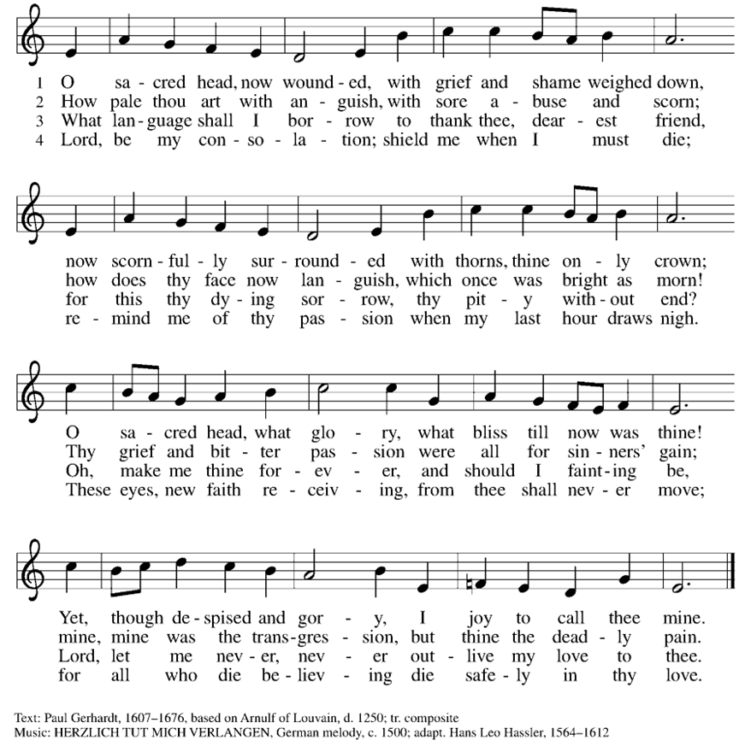
John 19:28-29 “I thirst”
²⁸After this, when Jesus knew that all was now finished, he said (in order to fulfill the scripture), "I am thirsty." ²⁹A jar full of sour wine was standing there. So they put a sponge full of the wine on a branch of hyssop and held it to his mouth.
Solemn Reproach

O my people, O my church, what have I done to you?
How have I offended you?
Answer me.
I led you out of slavery into freedom,
and delivered you through the waters of rebirth,
but you have prepared a cross for your Savior.
C: Holy God, holy and mighty, holy and immortal, have mercy on us.

O my people, O my church, what more could I have done for you?
Answer me.
Forty years I led you through the desert,
feeding you with manna on the way;
I saved you from the time of trial and gave you my body, the bread of heaven,
but you have prepared a cross for your Savior.
C: Holy God, holy and mighty, holy and immortal, have mercy on us.

O my people, O my church, what more could I have done for you?
Answer me.
I led you on your way in a pillar of cloud and fire,
but you led me to the judgment hall of Pilate;
I guided you by the light of the Holy Spirit,
but you have prepared a cross for your Savior.
C: Holy God, holy and mighty, holy and immortal, have mercy on us.

O my people, O my church, what more could I have done for you?
Answer me.
I planted you as my fairest vineyard, but you brought forth bitter fruit;
I made you branches of the vine and never left your side,
but you have prepared a cross for your Savior.
C: Holy God, holy and mighty, holy and immortal, have mercy on us.

O my people, O my church, what more could I have done for you?
Answer me.
I poured out saving water from the rock,
but you gave me vinegar to drink;
I poured out my life and gave you the new covenant in my blood,
but you have prepared a cross for your Savior.
C: Holy God, holy and mighty, holy and immortal, have mercy on us.

Gospel Acclamation ELW #262

John 19: 30-37 “It is finished.”
³⁰When Jesus had received the wine, he said, "It is finished." Then he bowed his head and gave up his spirit. ³¹Since it was the day of Preparation, the Jews did not want the bodies left on the cross during the sabbath, especially because that sabbath was a day of great solemnity. So they asked Pilate to have the legs of the crucified men broken and the bodies removed. ³²Then the soldiers came and broke the legs of the first and of the other who had been crucified with him. ³³But when they came to Jesus and saw that he was already dead, they did not break his legs. ³⁴Instead, one of the soldiers pierced his side with a spear, and at once blood and water came out. ³⁵(He who saw this has testified so that you also may believe. His testimony is true, and he knows that he tells the truth.) ³⁶These things occurred so that the scripture might be fulfilled, "None of his bones shall be broken." ³⁷And again another passage of scripture says, "They will look on the one whom they have pierced."

Solemn Reproach
O my people, O my church, what more could I have done for you? Answer me.
I have you a royal scepter, but you gave me a crown of thorns;
I gave you the kingdom and crowned you with eternal life,
but you have prepared a cross for your Savior.
C: Holy God, holy and mighty, holy and immortal, have mercy on us.

O my people, O my church, what more could I have done for you?
Answer me.
I struck down your enemies, but you struck my head with a reed;
I gave you my peace, but you draw the sword in my name,
and you have prepared a cross for your Savior.
C: Holy God, holy and mighty, holy and immortal, have mercy on us.

O my people, O my church, what more could I have done for you?
Answer me.
I opened the waters to lead you to the promised land,
but you opened my side with a spear;
I washed your feet as a sign of my love,
but you have prepared a cross for your Savior.
C: Holy God, holy and mighty, holy and immortal, have mercy on us.

O my people, O my church, what more could I have done for you?
Answer me.
I lifted you up to the heights,
but you lifted me high on a cross;
I raised you from death and prepared for you the tree of life,
but you have prepared a cross for your Savior.
C: Holy God, holy and mighty, holy and immortal, have mercy on us.
O my people, O my church, what more could I have done for you?
Answer me.
I grafted you into my people Israel,
but you made them scapegoats for your own guilt,
and you have prepared a cross for your Savior.
C: Holy God, holy and mighty, holy and immortal, have mercy on us.

O my people, O my church, what more could I have done for you?
Answer me.
I came to you in the least of your brothers and sisters,
but I was hungry and you gave me no food,
thirsty and you gave me no drink,
a stranger and you did not welcome me,
naked and you did not clothe me,
sick and in prison and you did not visit me,
and you have prepared a cross for your Savior.
C: Holy God, holy and mighty, holy and immortal, have mercy on us.

The Lord’s Prayer
L: Lord, remember us in your kingdom and teach us to pray….
C: Our Father, who art in heaven, hallowed be thy name, thy kingdom come, thy will be done, on earth as it is in heaven.
Give us this day our daily bread; and forgive us our trespasses, as we forgive those who trespass against us; and lead us not into temptation, but deliver us from evil.
For thine is the kingdom, and the power, and the glory, forever and ever. Amen.

Luke 23:44-49 “Father into thy hands I commend my spirit.”
⁴⁴It was now about noon, and darkness came over the whole land until three in the afternoon, ⁴⁵while the sun's light failed; and the curtain of the temple was torn in two. ⁴⁶Then Jesus, crying with a loud voice, said, "Father, into your hands I commend my spirit." Having said this, he breathed his last. ⁴⁷When the centurion saw what had taken place, he praised God and said, "Certainly this man was innocent." ⁴⁸And when all the crowds who had gathered there for this spectacle saw what had taken place, they returned home, beating their breasts. ⁴⁹But all his acquaintances, including the women who had followed him from Galilee, stood at a distance, watching these things.

Together we sing… (ELW # 616)

Jesus, remember me when you come into your kingdom.
Jesus, remember me when you come into your kingdom.

Silence for Prayer and Meditation
(During the darkness the silence will be broken by a loud sound-the symbol of the door of Christ’s tomb being sealed; but even in the face of death, the light of Christ will return, and with it, the hope of the resurrection.)

Silent Recession
At the conclusion of the service,
the Christ candle remains lit.
It reminds us of the light that
lingered in the minds of Jesus' most faithful followers,
and it also reminds us of the far greater light
that will break forth on Easter morning.

Worshipers depart in silence.

ELW Music licensed from Sundays & Seasons, Augsburg Fortress
CCLI MUSIC License # 11440069 , CCLI Streaming License#21835523
Do not duplicate any music or Liturgy herein without license and permission

