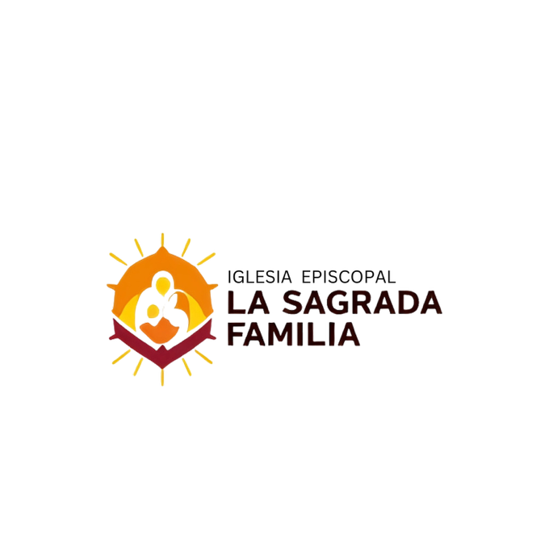

REQUIREMENTS FOR BAPTISM
Holy Baptism is the foundation of all Christian life, the gateway to life in the spirit and the door that opens access to the other sacraments. Through Baptism we are freed from sin and regenerated as children of God, we become members of Christ, and we are incorporated into the Church and made partakers of her mission:
"Baptism is the sacrament of the new birth by water and the word."

REQUIREMENTS
- The following requirements are for children under 7 years of age. For children over 7 years old, please contact the parish office.
- The parents of the child to be baptized must be registered parishioners of La Sagrada Familia parish or live in the area corresponding to the parish. If parents are parishioners of another parish or live outside the area, they must obtain a letter of authorization from their pastor.
- You must attach a copy of the child's birth certificate.
- Baptisms are celebrated. During Mass Every Sunday
- Sacraments, such as Baptism, are offered at no cost. However, the issuance of the certificate has a value of $5. In case it is requested after one year has elapsed since the celebration of the sacrament, the cost will be $100.
- Parents and godparents must attend two pre-baptismal preparation classes.
- All required documents must be submitted to the parish office at least 2 weeks prior to the pre-baptismal class date. Otherwise, the baptism will be postponed until all documents and requirements are submitted. The minor's parents or legal guardians will receive final written confirmation when all requirements have been completed.

___________________________
Signature of Father ___________________________
Date___________________________
Mother's signature

BAPTISM REGISTRATION FORM
CHILD INFORMATION
Every child to be baptized must be under 7 years of age.

CHILD'S NAME:
CITY OF BIRTH: | DATE OF BIRTH: | AGE:

PARENTS
FATHER'S NAME: |  |  | RELIGION:
MOTHER'S NAME, INCLUDING MAIDEN NAME: |  |  | RELIGION:
EMAIL: |  | TELEPHONE:
Address
ARE THEY MARRIED IN THE ROMAN CATHOLIC CHURCH? | ARE THE PARISHIONERS ACTIVE AT LA SAGRADA FAMILIA PARISH? |  | ENVELOPE OR REGISTRATION NUMBER:
GODPARENTS
- Godparents must be over 18 years of age and have received the Sacraments of Initiation: Baptism, First Communion and Confirmation. Copies of both godparents' certificates must be submitted.
- If the godparents are a couple, they must be married by the Roman Catholic Church.
- Godparents must be active and practicing Catholics (How then can they teach the child the Catholic faith?
GODFATHER'S FULL NAME | MARRIED □ SINGLE □ | CLASS DATE:
GODMOTHER'S FULL NAME | MARRIED □ SINGLE □ | CLASS DATE:

DATE OF CHRISTENING:

PERMIT [IF THEY LIVE OUTSIDE THE SAGRADA FAMILIA AREA]
If parents live outside the parish area, they must present a letter of authorization signed and stamped by the pastor of their parish.

FOR THE INTERVIEWER'S USE:
INTERVIEWER: |  | Telephone: |  | DATE OF THE BAPTISM:
Baptismal Classes Date: ___________  - Mother  Father  - Godmother  Godfather | Follow-up Needed:  Yes No  Yes, explain:
FOR OFFICE USE:
Donation  Amount: ______________________________  Date: ______________________________  Receipt #: _________________________ | - Copy of Birth Certificate (Attached)  - Copies of the Confirmation certificates of both godparents (Attached)  - *Letter of Authorization (Attached) | Confirmation sent on:  ______________________________  - Certificate Processed  - Sacramental Record

