City Road United Methodist Church
A Lighthouse Congregation

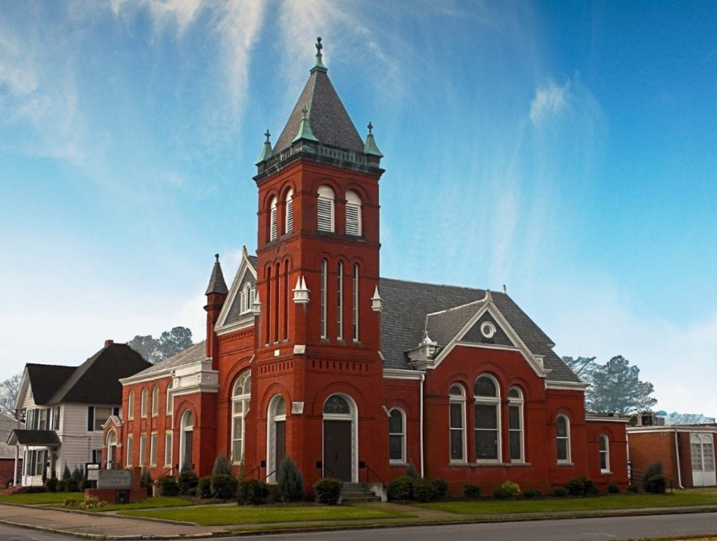
Rev. Josh Tester, Pastor

Office: (252) 335-2658
cityroadec.net crumcec@gmail.com

Facebook: https://www.facebook.com/CityRoadUMC

Sunday School: 10:00 a.m.
Sanctuary Worship: 11:00 a.m.

Tommy Venters- Organist/Choir Director
Dawn Baker- Secretary/Technology Specialist
JoAnn Herring- We Care

Service of Word
Palm Sunday: What r u up 2?

March 29th, 2026 11:00 a.m.
Gathering
Prelude
Introit “This is the Day that the Lord Hath Made” UMH 657
Words of Welcome Pastor Josh
*Call to Confession
*Prayer of Confession
Leader: Let us pray together:
All: Peace-loving God, our first instinct in fighting oppression is often to take up weapons, utter fighting words, and lash out with vitriol. But Jesus demonstrated humility and patience, even against his mortal enemies. In this moment of quiet, we lift up to you those things we’d like to give up for good… for the sake of The Good.

*Psalter of Assurance excerpts from Psalm 118
In the name of Christ, you are forgiven.
In the name of Christ, you are forgiven.
Glory to God, Amen!

*Sharing Peace
As a people forgiven and freed, we reach out to lift others up, offering the peace of Christ. Peace be with you!
And also with you!

You are invited to share the Peace with those around you [remembering to send your peace through the camera to those worshiping remotely*

Hymn of Praise “Rejoice, Ye Pure in Heart” UMH 160

Proclamation & Response

Children’s Time What’s Up? with Children

Call to the Offering
Offertory
Doxology
Prayer of Dedication

Hymn of Preparation “Tell me the Story of Jesus” UMH 277

Music for Soaring Chancel Choir

Gospel Lesson John 12: 12-16 The Word Uplifts
Sermon “Sit Up!” Pastor Josh

Pastoral Prayer
The Lord’s Prayer
Our Father who art in heaven, hallowed be thy name. Thy kingdom come; thy will be done on earth as it is in heaven. Give us this day our daily bread, and forgive us our trespasses, as we forgive those who trespass against us; and lead us not into temptation but deliver us from evil. For thine is the kingdom, and power, and glory forever. Amen

Sending Fourth

*Sending Hymn “Hosanna, Loud Hosanna” UMH 278
*Benediction
When someone asks you, “What are you up to?” you can respond,
“With God’s help, I’m up to something good!”
Let the people say, Amen!
Amen!

