PARISH HOUSE: Items for March
Items Needed: Canned Corn, Jelly (non-glass),
Cereal, Toothpaste, Deodorant

Upcoming Events:
TODAY – 4th Sunday Lunch
1:30pm Chosen
“The Wedding Gift”
March 25th – 6:00pm Choir Practice
April 1st – 7:00pm Leadership Team
April 2nd – Maundy Thursday
6:30pm Simple Meal
Tennerton UMC
April 3rd – 6:30pm Good Friday Service
West Buckhannon UMC

Living Cross – Fresh Flowers Easter morning

MARCH BIRTHDAYS
Shahna West – 6th, Shelia Hodges– 7th, Shane West – 20th,
Ina Jean Cutright – 25th, Lynn Frum – 29th

MARCH ANNIVERSARIES
Benny & Betty Smith – 2nd

Tithes and Offerings: Give your gifts,
tithes, and offerings through PayPal. It is
quick, easy, and safe! Just use the
camera on your phone to scan the QR
Code. All donations will be placed into
our General Account unless otherwise
stated.

TENNERTON
United Methodist Church
March 22, 2026
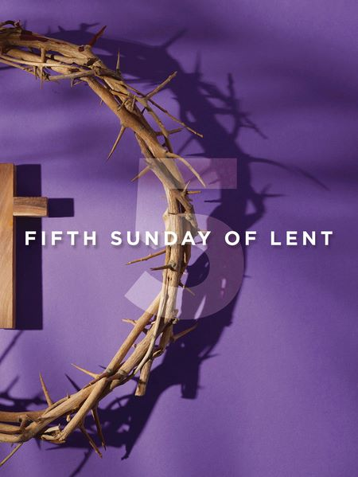
Pastor Jim Minutelli
304-629-9398

Office: 126 Tallmansville Rd.
Buckhannon, WV 26201
Office Phone: 304-472-1064
Sermon by Phone: 304-460-0029
Website: https://tennertonumc.org
Email: umc.tennerton@gmail.com
Facebook: https://www.facebook.com/thetennertonumc
Prayer Concerns: Call Candy George @ 304-613-6424

JOYS & CONCERNS
WELCOME/OPENING PRAYER Pastor
*OPENING HYMN: “Freely, Freely”
13/24 UMH 389

CALL TO WORSHIP: Fifth Sunday in Lent
Based on John 11: 1-45

Leader: When grief surrounds us and
hope feels buried.
People: Jesus stands with us and calls us
by name.
Leader: At the tomb of Lazarus, Christ wept.
People: Our Savior knows our sorrow.
Leader: “I am the resurrection and the life,”
says the Lord.
People: We believe, even in the face of death.
Leader: Roll away the stone.
People: Unbind us, O God, and let us go free.
Leader: Come, worship the One who brings
life out of death.
All: We gather in hope, trusting the power
of Christ. Amen.

*OFFERING/DOXOLOGY/PRAYER UMH 95
CHOIR: “Nothing but the Blood” 12/18 UMH 362
CHILDREN MESSAGE Vickie Snyder
ANNOUNCEMENTS (ON BACK PAGE)
READING: Romans 8: 6 – 11

*HYMN: “When We All Get to Heaven”
24/1 UMH 701
SCRIPTURE READING:

SERMON:

*CLOSING HYMN: “Have Thine Own Way, Lord”
13/18 UMH 382

*BENEDICTION

*Please stand if you are able. Don’t Forget to Feed the Pig

GREETERS & WORSHIP LEADERS
If you would like to be a greeter or lead worship service,
print your name on the clip board on the front pew.

This Week
GREETER(S): Rick Black
WORSHIP LEADER: Lynn Frum

Next Week
GREETER(S): Shahna West
WORSHIP LEADER: Vickie Snyder

