Welcome To
St. Benedict’s Anglican Church

For Generations Our Little Red Door Has Welcomed All To Meaning, Community And Hope

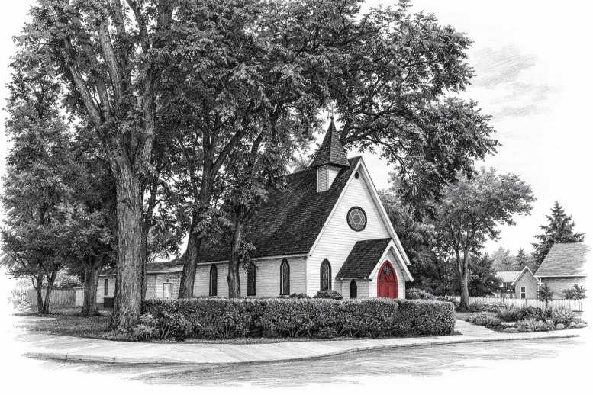

Since 1904, St. Benedict’s bell tower has been ringing in the heart of High River. Step inside to experience a place where hearts are lifted, friendships are formed, and faith comes alive. We invite you to discover a community ready to grow with you, we can’t wait to see you again!

Curious About St. Benedicts?
Flip the page to tell us a bit about yourself, we promise it’s quick! You’ll discover ways to join a small group, volunteer, or just connect with others.

Too Busy?
Get In Touch With Us Through Email Or Give Us A Call!

www.stbenshr.church.com
admin@stbenshr.church
priest@stbenshr.church
403-652-2271

We Would Love To Connect With You!

At St. Benedict’s, you are welcome, whether you’re a believer, an explorer, questioning or curious. This quick survey helps us get to know you, understand what you’re looking for in a church, and connect you with meaningful opportunities to worship, grow, and serve.

You can fill out this survey here or use the QR code to complete it online — whichever is easiest for you. Your responses help us make sure every visit is meaningful and that you feel at home in our community.

Tell Us About You!
Name: _______________________________________
Email: _______________________________________
Phone (Optional): (________)-__________-______________
What Service Did You Attend?
- Special Service (Christmas, Easter, Baptism, Etc.)
- Sunday Morning
- Other: ____________________________
Are you a:
- First time visitor
- Returning visitor
I consider myself
- Spiritually searching
- New to Christianity
- Returning to Faith
- Committed to the Christian Faith.
In What Ways Would You Like To Get Involved?
- Learning More About Jesus And Christianity
- Joining A Bible Study
- Being A Part Of St. Benedict’s Prayer Group
- Volunteering With Services Or Events
Have You Connected With Any Of Our Staff Or Leadership?
- Yes
- No
If No, Would You like Someone From Leadership To Message You?
- Yes, by Email
- Yes, by Phone No, Thank you.
Can We Include You Our Weekly Newsletter?
- Yes
- No
Please Note: Any Information Provided Will Not Be Shared Outside of St. Benedict’s Staff.

