TODAY’S WORSHIP TEAM MEMBERS
Pastor Andrew Burd-Harris
Deacon Megan Burd-Harris
Accompanist Andrew Martin
Audio Visual Team Justin Hahn, Steve Moyer, Mike Harris
Children’s Sermon Andrew Burd-Harris
Choir Director Sarah Snyder
Greeter ---
Head Usher Wendy Kauffman
Liturgist Megan Burd-Harris



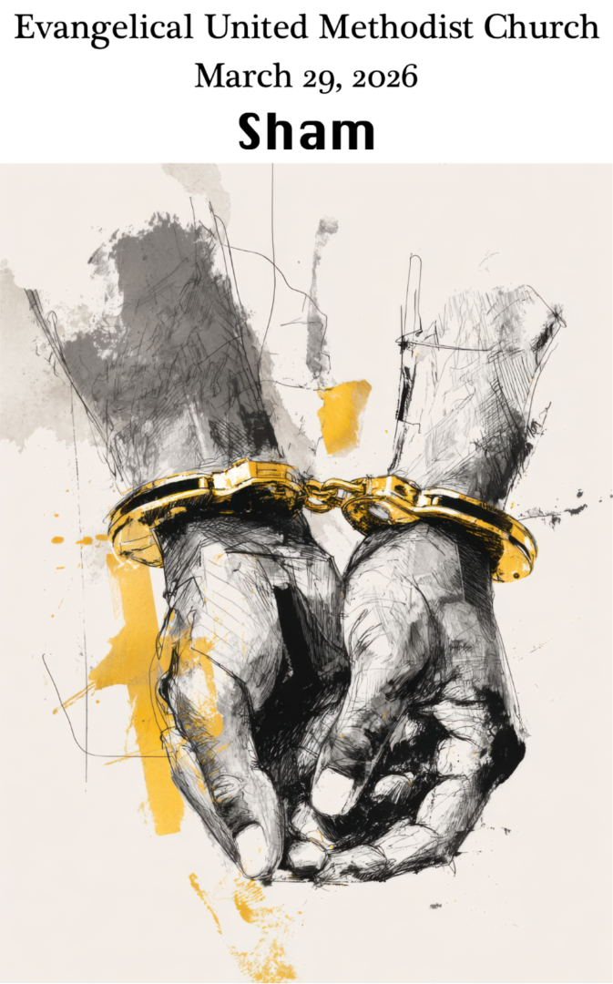

Evangelical United Methodist Church
157 East Water Street, Middletown, Pa. 17057
www.eumch.org; 717.944.6181; office@eumch.org
March 29, 2026
Palm/Passion Sunday
10:15 AM Service
Bold & Italicized print – All in unison l *Please stand if able.
UMH: United Methodist Hymnal l TFWS: The Faith We Sing l W&S: Worship & Song
~Start Live Stream~
Announcements
Worship video
*DIRECTING OUR ATTENTION TOWARD GOD:
“Tell Me Stories of Jesus” (verse 3) UMH 277

Proclamation of the entrance into Jerusalem Matthew 21: 1-11
Opening Prayer
Gracious God, Christ is the light of the World, and so we come to walk in his light. Christ is the resurrection and the life, and so we come to enter into his life. Christ raises us to new life, and so we come to surrender our lives to you, and be raised anew. Speak to us now, that we may hear the word of life. Amen.
(©2026 Steve Garnaas-Holmes. From Unfolding Light. Used by permission.)

*Hymn of Praise “All Glory, Laud, and Honor” UMH 280
JOYS AND CONCERNS:
We will pass around the microphone. Please remember we are livestreaming the service. Consider not using last names and please do not share concerns that a person would not want widely known. If you would like to add a joy or concern to our “Compassion for the Brethren” list please call our office at 717.944.6181, email the office at office@eumch.org, or fill out a prayer card and drop it in an offering plate.
Pastoral Prayer
Prayer Chorus “Kum By Ya” (Verse 2) UMH 494
Choir Anthem “Hosanna to the Son of David” Patty/Paris
ATTENDING TO GOD’S WORD:
Scripture Lessons John 50: 4-9a, John 18:28-19:18
This is God’s Word for everyone. Thanks be to God.
Children’s Sermon Andrew Burd-Harris
The Lord’s Prayer


Message: “Sham”

RESPONSES TO GOD’S WORD:
Sharing Our Gifts and Offering
Please put your offering in the offering plates located near the entrance(s) before the service starts. You can also give online using the link or QR code below. https://www.eumch.org/give

*Doxology “Praise God, from Whom All Blessings Flow” UMH 95
Affirmation of Faith “The Nicene Creed” UMH 880

GOING FORTH TO SHARE THE LIGHT OF CHRIST:
*Hymn “We Sang Our Glad Hosannas” TFWS 2011
(stanzas one through four)
Reaffirming God’s Presence
Choral Benediction “Jesus, Keep Me Near the Cross” UMH 301
(verse 3)
Postlude
~End Live Stream~

