EAST FAIRFIELD UNITED METHODIST CHURCH
Pastor: Rev. Lisa Courtwright
Organist: Ruth Rowley Ministers: The Congregation
Pianist: Nancy Setinsek Choir Director: Randy Hart

Sunday, March 22, 2026
Fifth Sunday in Lent

*Please stand in body or spirit as you are able

Welcome! You are invited to take this time to prepare for worship. In these moments, quiet your inner voice, become aware of being in community with others, and open your heart & mind to the leading of the Holy Spirit.

GATHERING God Is Our Refuge And Strength -Smith
Moment by Moment -Moody

CHRIST LIGHT ENTERS

MISSIONS AND MINISTRY UPDATEs Missy Roberts, Liturgist

PREPARING OUR HEARTS AND MINDS FOR WORSHIP

WORDS OF PREPARATION AND CENTERING

PRELUDE Morning Prayer -James

*CALL TO WORSHIP
Wilderness-wanderers, holiness-seekers, listen for God’s voice today—
A voice that says, “I see you. I know you. I love you.”
Even if, in your wandering, you have gotten lost—
God sees us. God knows us. God loves us.
In the power of being seen, known, and loved, a way becomes clear—
A new way, a different way, a way of freedom.
All: Let us travel the way together in the footsteps of Jesus, our waymaker.

*OPENING PRAYER
All-knowing One, sometimes we shrink from your gaze, ashamed of ourselves, our failures, our mistakes. You see it all, but you also see through it all—to the beloved child that you have created. Help us to rest in your sight, that being known, we might come to know ourselves. Free us from guilt and shame, so that we can stand up tall, do the work of repair and reconciliation, and step forward as the beloved children we are. In Jesus’ name we pray. Amen.

*OPENING HYMN “I Am Thine, O Lord” UMH #419

READING FROM THE PSALMS Psalm 15 (NIV) pg 436

*APOSTLES’ CREED see insert

*GLORIA PATRI UMH #70

CHILDREN’S MOMENT

CHOIR ANTHEM “What Have They Done?” -Althouse

OFFERING OURSELVES & OUR GIFTS
INVITATION
OFFERTORY A Shelter In The Time of Storm -Sankey
*DOXOLOGY UMH #95
*DEDICATION OF GIFTS

SEEKING GOD’S WORD

SHARING OF JOYS & CONCERNS
PASTORAL PRAYER
THE LORD’S PRAYER

*HYMN “He Touched Me” UMH #367

SERMON TEXT Luke 19:1-10 (NIV) pg 852
SERMON It’s Not Too Late to Live Differently Pastor Lisa

RESPONDING TO GOD’S WORD

*CLOSING HYMN “The Summons” TFWS #2130 see insert

SENDING FORTH WITH BLESSING
*BLESSING
LIGHT OF CHRIST GOES INTO THE WORLD

~ Go with joy to serve the Lord ~

As we conclude our service, please join us downstairs for a time to relax, continue conversations, and enjoy coffee and refreshments.

TODAY, MARCH 22
Livestream: Hannah Vollnogle Sound: Bill Rowley Computer: Vicki Freeman

Liturgist Next Sunday, March 29 – Jeannie Arnoto

Please keep in mind that the service is live-streamed and
recorded for public access. Please keep prayer requests
brief and do not use last names or identifying details.

PRAYER REQUESTS March 22, 2026
To submit a prayer request call Denise at 330-457-2465 or 330-727-9832

If you desire a home or hospital visit call Pastor Lisa (440-339-6463)

Prayer Blankets: call Joyce Ward (330-692-3346)

George Rockenberger (Jan’s brother-in-law) – Passed away March 18.
Pray for the family and his wife Janet.
Bruce (David Crook’s friend) – Marital problems.
Sue (David Crook’s friend) – Surgery March 30.
Dolly – Medicine not working. Trying another one.
Bob (Kathy’s husband) – Surgery for kidney stones.
Dale (Keith’s brother) – Heart bi-pass surgery March 30.
Bud & Phyllis – Health issues.
Sue (Kermit’s Wife) – At Briarfield in Boardman for rehab.
Georgia – Health issues.
Anita M. – Health issues.
Perry Bilsky (Denise & Anita’s nephew) – Fighting cancer.
Kristen (Anita Magill) – Hysterectomy in March due to cancer.
Rodney (Bud & Phyllis’ son) – At Parkside.

HOMEBOUND
Dolly K. Bill & Barb Anita M. Tom & Marie
Walt D. (Whispering Pines) Zelda C. (Whispering Pines)
Dorothy F. Esther C. Linda S.

IN MINISTRY
Lisa Courtwright Edie Boles Jeff Pellin

Ch Ph: 330-457-2465 Pastor: 440-339-6463
Email: revlisa18@gmail.com Ch Email:efumc@comcast.net Website: www.eastfairfieldumc.com CCLI # 1994841 CVLI #504 011 134


East Fairfield
United Methodist Church

Sunday, March 22, 2026
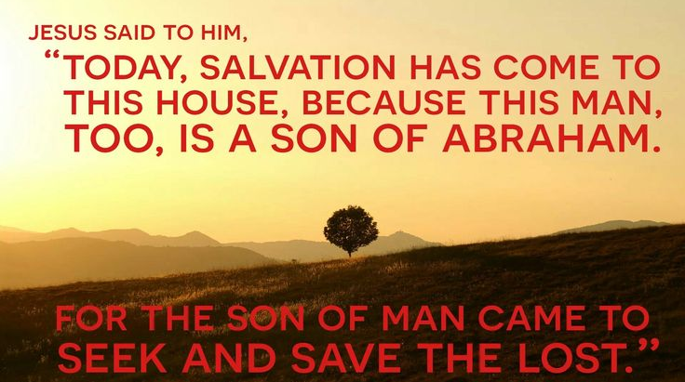
9:30 AM

Rev. Lisa Courtwright
440-339-6463
45675 State Route 558
New Waterford, OH 44445

“Working, playing, and praying together on our
faith journey, to share Jesus Christ with everyone.”

*APOSTLES’ CREED
I believe in God the Father Almighty,
maker of heaven and earth;
And in Jesus Christ his only Son our Lord:
who was conceived by the Holy Spirit,
born of the Virgin Mary,
suffered under Pontius Pilate,
was crucified, dead, and buried;
the third day he rose from the dead;
he ascended into heaven,
and sitteth at the right hand of God the Father Almighty;
from thence he shall come to judge the quick and the dead.
I believe in the Holy Spirit,
the holy catholic church,
the communion of saints,
the forgiveness of sins,
the resurrection of the body,
and the life everlasting. Amen.



Bake Sale
Sunday, April 26

The Joy Circle will have a Bake Sale on
Sunday, April 26 during coffee time immediately
following the church service (around 10:30 or so).

Be sure to stop by the Fellowship Hall and purchase
some tasty treats made by our Joy Circle members.

All money raised will be used for the benefit of organizations such as The Rescue Mission, Sophia House, and Flat Rock Homes
and also to continue our Prayer Blanket ministry.

We appreciate your support!

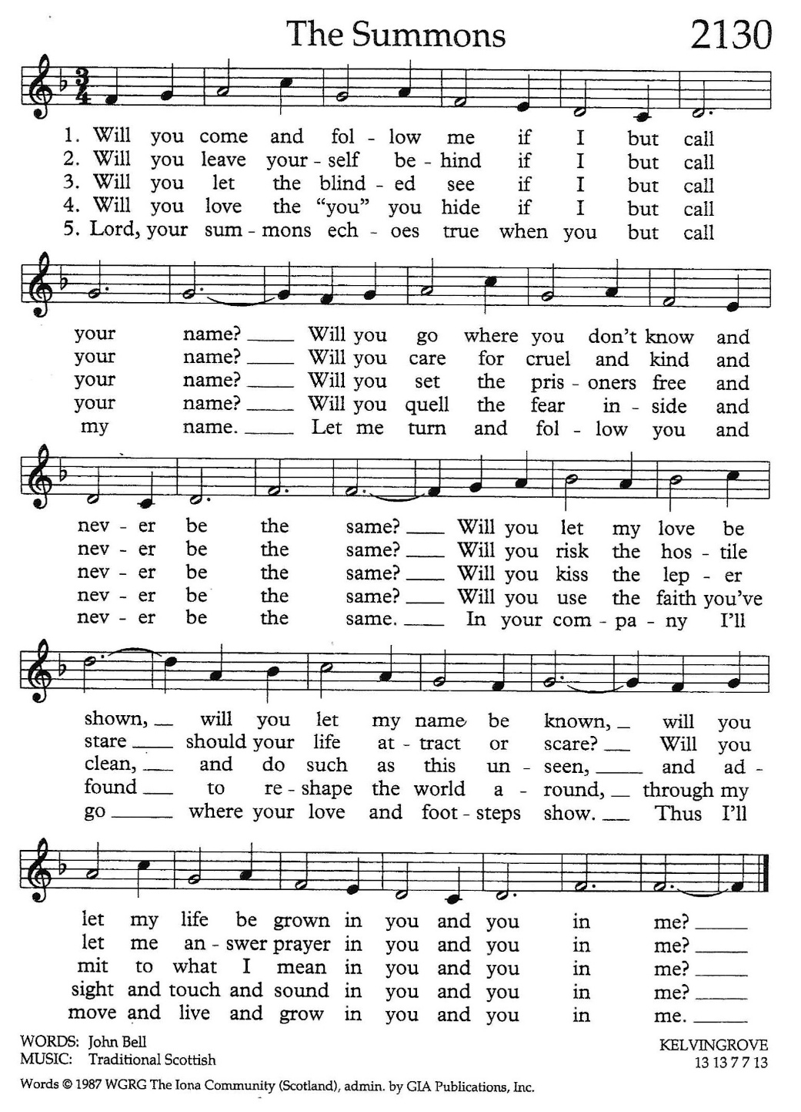

Sun | Mon | Tue | Wed | Thu | Fri | Sat
Mar 22  5th Sunday in Lent  9:30 Worship at EF  10:30 Coffee Time  10:45 Sunday School  5:00 Potluck  Fellowship at  Emmanuel UMC | Mar 23  1:00-4:00  Prayer  Blankets  6:00 Cub  Scouts | Mar 24  8:00 Men’s  Coffee at  East Fairfield  UMC  Newsletter  Deadline | Mar 25  6:00 Lenten  Study at  East Fairfield  7:00 Choir  Practice | Mar 26  9:00 Mailing  Com. at EF  7:00 Scripture  & Suds at  Sundog | Mar 27  Pastor’s  Day Off  Office Closed | Mar 28  8:30-10:00 AM  Caring for  God’s Lambs  Food Pantry  at Trinity UMC
Mar 29  Palm Sunday  9:30 Worship at EF  10:30 Coffee Time  10:45 Sunday School | Mar 30  12:00 Joy  Circle Lunch  at EF UMC  6:00 Cub  Scouts | Mar 31  8:00 Men’s  Coffee at  East Fairfield  UMC | Apr 1  7:00 Choir  Practice | Apr 2  Maudy Thursday  6:00 Dinner  7:00 Worship  w/ Communion | Apr 3  Office Closed  7:00 PM  Good  Friday  Service at  Centenary | Apr 4
Apr 5  Easter Sunday  9:30 Worship at EF  10:30 Coffee Time  10:45 Sunday School | Apr 6  Office  Closed  6:00 Cub  Scouts | Apr 7  8:00 Men’s  Coffee at  East Fairfield  UMC | Apr 8  7:00 Choir  Practice  7:00 Scripture  & Suds at  ‘ Brew Lounge | Apr 9 | Apr 10  Office Closed | Apr 11
Apr 12  9:30 Worship at EF  10:30 Coffee Time  10:45 Sunday School | Apr 13  6:00 Cub  Scouts | Apr 14  8:00 Men’s  Coffee at  East Fairfield  UMC  -Ladies’ Day | Apr 15  7:00 Choir  Practice | Apr 16  6:30 PM  County 4H  Goat Clinic  Meeting  Shannon  Fieldhouse | Apr 17  Office Closed | Apr 18
gf
Pastor’s Vacation
Pastor’s Vacation – April 7 thru April 13

LAST WEEK’S ATTENDANCE (March 15)

In-Person: 69
Online: 20

Update on Mission Giving for 2025
FUND | NAME OF FUND | NEED | RECEIVED | STILL NEED
2 | General Mission Fund | 5,099 | 1,610 | 3,489
33 | 4C’s | 125 | 100 | 25
32 | Cub Scouts | 150 | 375 | 0
37 | Way Station | 150 | 0 | 150
22 | Flat Rock | 175 | 160 | 15
64 | Farmer to Farmer - Liberia | 300 | 85 | 215
13 | UMCOR Sunday | Any  Donation
21 | UMCOR – U.S. Disasters | Any  Donation | 5
14 | Blanket Sunday | Any  Donation | 65
15 | Peace With Justice | Any  Donation
16 | World Communion | Any  Donation
17 | Student Day | Any  Donation
46 | Heroes & Halos | Any  Donation | 100
63 | InStep Program | Any  Donation
49 | Caring for God’s Lambs | Any  Donation
38 | Operation Christmas Child Boxes ($118)

Fund Balances as of end of February
Fund # 1 Ministry Operating -12,466
Fund # 2 Mission Fund 1,406
Fund # 3 Building Fund 60,320
Fund # 28 Elevator Fund 3,565

Mission of the Month for March
Farmer to Farmer – Fund #64

Our mission is to provide technical and
mechanized training in profitable and productive
farming to Liberian farmers. Our work in
Harrisburg, Liberia focuses on serving God,
serving community, farming, education, working
together, and building relationships.

4C’s Item – Cereal

