Palm Sunday:

March 29, 2026 10:30am

Pastor Tina Crog

*Prelude

*Welcome and Announcements worship assistant

* Prayer for the Palms Pastor Tina
Blessed be the holy Trinity, ☩ one God, who creates, redeems, and sustains us and all of creation. Amen.

The Holy Gospel according to Matthew, the 21st chapter. Glory to you, O Lord.

¹ When they had come near Jerusalem and had reached Bethphage, at the Mount of Olives, Jesus sent two disciples, ² saying to them, “Go into the village ahead of you, and immediately you will find a donkey tied and a colt with her; untie them and bring them to me. ³ If anyone says anything to you, just say this, ‘The Lord needs them.’ And he will send them immediately.” ⁴ This took place to fulfill what had been spoken through the prophet:
⁵ “Tell the daughter of Zion,
Look, your king is coming to you,
humble and mounted on a donkey,
and on a colt, the foal of a donkey.”
⁶ The disciples went and did as Jesus had directed them; ⁷ they brought the donkey and the colt and put their cloaks on them, and he sat on them. ⁸ A very large crowd spread their cloaks on the road, and others cut branches from the trees and spread them on the road. ⁹ The crowds that went ahead of him and that followed were shouting,
“Hosanna to the Son of David!
Blessed is the one who comes in the name of the Lord!
Hosanna in the highest heaven!”
¹⁰ When he entered Jerusalem, the whole city was in turmoil, asking, “Who is this?” ¹¹ The crowds were saying, “This is the prophet Jesus from Nazareth in Galilee.”
The Holy Gospel of the Lord. Praise to you, O Christ

* Prayer for the Palms pastor Tina
Blessed is he who comes in the name of the Lord! Hosanna in the highest!
The Lord be with you. And also with you.

We praise you, O God, for redeeming the world through our Savior Jesus Christ. Today he entered the holy city in triumph and was proclaimed messiah and king by those who spread garments and branches along his way. Bless these branches and those who carry them. Grant us grace to follow our Lord in the way of the cross, so that, joined to his death and resurrection, we enter into life with you; through the same Jesus Christ, who lives and reigns with you and the Holy Spirit, one God, now and forever. Amen.

* Processional Hymn All Glory, Laud, and Honor” ELW #344 vs. 1, 3, 5
Public Domain
Refrain
All glory, laud, and honor
to you, redeemer, king,
to whom the lips of children
made sweet hosannas ring.

1 You are the king of Israel
and David's royal Son,
now in the Lord's name coming,
our King and Blessed One. Refrain

3 The multitude of pilgrims
with palms before you went;
our praise and prayer and anthems
before you we present. Refrain

5 Their praises you accepted;
accept the prayers we bring,
great author of all goodness,
O good and gracious King. Refrain

* Prayer of Confession Pastor Tina
Let us confess our sin in the presence of God and of one another.

To you, O God, all hearts are open, to you all desires are known and no secrets are hid. We come to you, confessing our sins. Forgive us in your mercy, and remember us in your love. Show us your ways; teach us your paths; and lead us in justice and truth, for the sake of your goodness in Jesus Christ our Savior. Amen.

In the mercy of almighty God, Jesus Christ was given to die for us, and for his sake God forgives us all our sins. As a called and ordained minister of word and sacrament in the church of Christ, and by his authority, I therefore declare to you the entire forgiveness of all your sins, in the name of the Father, and of the ☩ Son, and of the Holy Spirit. Amen.

*Children’s Message Pastor Tina

*Passing of the Peace Worship Assistant
May the peace of christ be with you always. and also with you.

Please share the peace of Christ with one another with a wave. Then wave to those watching from their home.

*First Reading - Philippians 2:5-11 Reader
Paul uses an early Christian hymn to help us comprehend Jesus’ obedient selflessness on the cross and how God has made Christ lord over all reality. The perspective of the cross becomes the way we rightly understand God, Christ, our own lives, and fellowship within the community of Christ.

⁵ Let the same mind be in you that was in Christ Jesus,
⁶ who, though he existed in the form of God,
did not regard equality with God
as something to be grasped,
⁷ but emptied himself,
taking the form of a slave,
assuming human likeness.
And being found in appearance as a human,
⁸ he humbled himself
and became obedient to the point of death—
even death on a cross.
⁹ Therefore God exalted him even more highly
and gave him the name
that is above every other name,
¹⁰ so that at the name given to Jesus
every knee should bend,
in heaven and on earth and under the earth,
¹¹ and every tongue should confess
that Jesus Christ is Lord,
to the glory of God the Father.

* Gospel Acclamation Blessed is the One ACS 929
One License A-700000
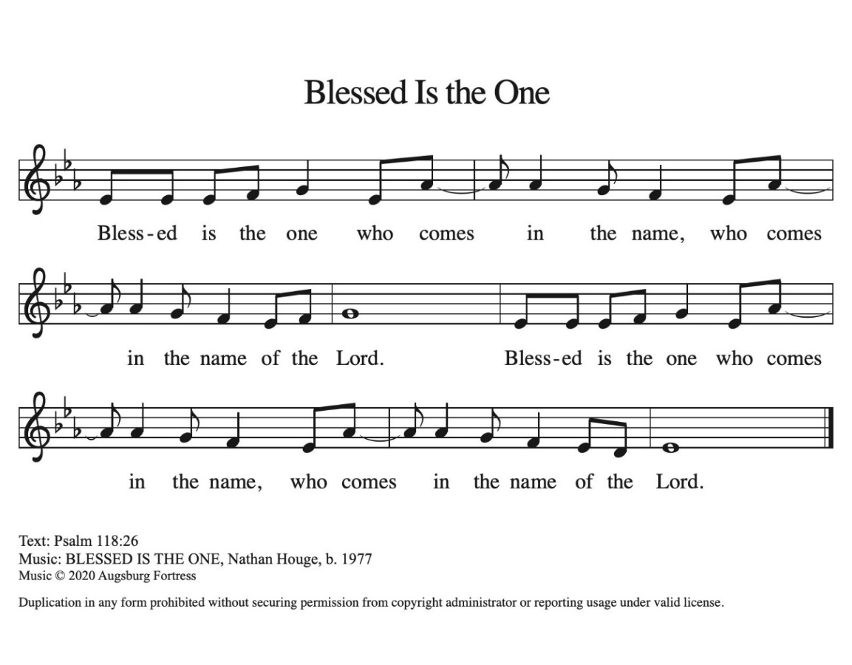

* Gospel – Matthew 21:12-17 Pastor Tina
The Holy Gospel according to Matthew, the 21st chapter. Glory to you, O Lord.

¹² Then Jesus entered the temple and drove out all who were selling and buying in the temple, and he overturned the tables of the money changers and the seats of those who sold doves. ¹³ He said to them, “It is written,
‘My house shall be called a house of prayer,’
but you are making it a den of robbers.”
¹⁴ The blind and the lame came to him in the temple, and he cured them. ¹⁵ But when the chief priests and the scribes saw the amazing things that he did and heard the children crying out in the temple and saying, “Hosanna to the Son of David,” they became angry ¹⁶ and said to him, “Do you hear what these are saying?” Jesus said to them, “Yes; have you never read,
‘Out of the mouths of infants and nursing babies
you have prepared praise for yourself’?”
¹⁷ He left them, went out of the city to Bethany, and spent the night there.
The Gospel of the Lord. Praise to you, O Christ.

*Hymn of the Day "Prepare the Royal Highway" ELW 264
One License A-700000
1.Prepare the royal highway; the King of kings is near! Let ev’ry hill
and valley a level road appear! Then greet the King of glory, foretold
in sacred story: Hosanna to the Lord, for he fulfills God’s word!

2.God’s people, see him coming: your own eternal king! Palm
branches strew before him! Spread garments! Shout and sing! God’s
promise will not fail you! No more shall doubt assail you! Hosanna to
The Lord, for he fulfills God’s word!

3.Then fling the gates wide open to greet your promised king! Your
king, yet ev’ry nation its tribute too may bring. All lands will bow
before him; their voices join your singing: Hosanna to the Lord, for
He fulfills God’s word!

4.His is no early kingdom; it comes from heav’n above. His rule is
peace and freedom and justice, truth, and love. So let your praise be
sounding for kindness so abounding. Hosanna to the Lord, for he
fulfills God’s word!

* Prayers of Intercession Pastor Tina

Be Seated

Any Prayer Requests or Joys to share
Led by the Spirit, let us turn to God in prayer for the church, the world, and all those in need. A brief silence.
Guide your church this Holy Week as we follow in the servant way of Jesus. Protect those who face hostility or oppression for their faith. Humble those who would use faith to dominate others and reinforce their own power. God, in your mercy, receive our prayer.

Make your creation a living witness to Christ’s passion and resurrection: in waving palms, shouting stones, fragrant vineyards, murmuring wheat, and revealing fire. Make us attentive to your holy presence in the world, that we may care for the earth you love. God, in your mercy, receive our prayer.

Let your face shine upon the leaders of nations and let the same mind be in them as was in Christ Jesus, so that those with the most power may humble themselves to serve the most vulnerable. God, in your mercy, receive our prayer.

Sustain the weary with a word. Help us remember that in his arrest, Jesus yoked himself with all who are in prisoned. Abide with all who are in jails, detention centers, or prisons. Console all who experience times of trial or suffering (especially). God, in your mercy, receive our prayer.

Give strength to those who will lead worship during Holy Week: pastors and deacons, altar guilds and sacristans, musicians and assisting ministers, ushers, and office staff. Instill in them awe and joy, that their service may reflect the love of Jesus. God, in your mercy, receive our prayer.

We give thanks to you for our beloved dead, trusting that as the cross of Jesus led to the empty tomb, so you welcome those who have died into the paradise of your presence. God, in your mercy, receive our prayer.
Receive the prayers of your people and draw all things together in your love, in the name of Jesus, who leads us from death to life. Amen.

*Offertory worship assistant

the monthly mission for March is for the Altar Guild Repairs.

Let us give to god what he has first given to us.

*Special Music by Jared

* Offertory Response “Come to the Table” ELW 481
CCLI 11222261
Come to the table of mercy, prepared with the wine and the bread.
All who are hungry and thirsty, come, and your souls will be fed.
Come at the Lord’s invitation; receive from his nail scarred hand.
Eat of the bread of salvation; drink of the blood of the Lamb.

* Offertory Prayer Worship Assistant and Congregation
Hosanna, Son of David, we thank you for showing us how to care for each other. May these gifts build shelters, and food for those who are hungry. Give us grateful hearts, O God, in the name of the one who came to draw all people to himself, Jesus Christ, our Savior. Amen.

* Liturgy of Holy Communion Pastor Tina ELW Setting 4

Dialogue ELW pg 147

In peace, let us pray to the lord. Lord have mercy.

for the peace from above, and for our salvation, let us pray

to the Lord. Lord, have mercy.

Holy, Holy, Holy ELW pg 153

Holy, holy, holy Lord. Lord God of pow’r and might: Heav’n and earth are full of your glory. Hosanna in the highest. Blessed is he who comes in the name of the Lord. Hosanna in the highest.

* Lord’s Prayer ELW pg 154
Our father, who art in heaven, hallowed be thy name, thy kingdom
come, thy will be done, on earth as it is in heaven. Give us this day
our daily bread; and forgive us our trespasses as we forgive
those who trespass against us; and lead us not into temptation,
but deliver us from evil. for thine is the kingdom, and the power,
and the glory, forever and ever. amen.
* Lamb of God ELW pg 154
Lamb of god, you take away the sin of the world: have mercy on
us. lamb of god, you take away the sin of the world: have mercy
on us. lamb of god, you take away the sin of the world: grant us
peace.

- Special Music by Jared

* Post Communion Blessing pastor tina

* Prayer After Communion Pastor Tina and congregation
Hosanna, Son of David. We thank you that in your passion you offer forgiveness and invite us to be with you where hunger is no more and death has no dominion; may the broken bread of life fracture our stony hearts for the sake of another world. We pray this for the sake of the One who comes in the name of the Lord. Amen.

* Sending Gospel: Matthew 26:1-16 Pastor Tina
After Jesus’s glorious entry into Jerusalem, he went to the temple to preach. He taught in the temple for several days. The following is the last of his lessons during his final week.
The Holy Gospel according to Matthew, the 26th chapter. Glory to you, O Lord.
¹ When Jesus had finished saying all these things, he said to his disciples, ² “You know that after two days the Passover is coming, and the Son of Man will be handed over to be crucified.”
³ Then the chief priests and the elders of the people gathered in the courtyard of the high priest, who was called Caiaphas, ⁴ and they conspired to arrest Jesus by stealth and kill him. ⁵ But they said, “Not during the festival, or there may be a riot among the people.”
⁶ Now while Jesus was at Bethany in the house of Simon the leper, ⁷ a woman came to him with an alabaster jar of very costly ointment, and she poured it on his head as he sat at the table. ⁸ But when the disciples saw it, they were angry and said, “Why this waste? ⁹ For this ointment could have been sold for a large sum and the money given to the poor.” ¹⁰ But Jesus, aware of this, said to them, “Why do you trouble the woman? She has performed a good service for me. ¹¹ For you always have the poor with you, but you will not always have me. ¹² By pouring this ointment on my body she has prepared me for burial. ¹³ Truly I tell you, wherever this good news is proclaimed in the whole world, what she has done will be told in remembrance of her.”
¹⁴ Then one of the twelve, who was called Judas Iscariot, went to the chief priests ¹⁵ and said, “What will you give me if I betray him to you?” They paid him thirty pieces of silver. ¹⁶ And from that moment he began to look for an opportunity to betray him.
The Gospel of the Lord. Praise to you, O Christ.

* Closing Hymn “Lamb of God” ELW #336
CCLI 11222261
1.Your only Son, no sin to hide, but you have sent him from your side
to walk upon this guilty sod and to become the Lamb of God. O
Lamb of God, sweet Lamb of God. I love the holy Lamb of God. Oh,
wash me in your precious blood, my Jesus Christ, the Lamb of God.

2.Your gift of love we crucified. We laughed and scorned him as he
died. The humble king we named a fraud and sacrificed the Lamb
of God. O Lamb of God, sweet Lamb of God, I love the holy Lamb of
God. 0h, wash me in your precious blood, my Jesus Christ, the
Lamb of God.

3. I was so lost, I should have died, but you have brought me to your
side to be led by your staff and rod and to be called a lamb of God.
O Lamb of God, sweet Lamb of God. I love the holy Lamb of God.
Oh, wash me in your precious blood, my, my Jesus Christ, the Lamb
of God.

* Dismissal
Go in peace. Jesus meets you on the way. Thanks be to God.

*Postlude

The Confession and Forgiveness and the Prayer of the Day is by Sarah Are Speed | A Sanctified Art LLC | sanctifiedart.org

