Holy Trinity Lutheran Church
150 River Road Red Bank, NJ 07701
Church Office: (732) 741-9241 Fax: (732) 741-9577
email: holytrinitychurch4@verizon.net
Website: htlcredbank.org
Pastor: Rev. John Mack, Jr.
Cell: (336)-392-5839
Minister of Music: Peter Isherwood
Parish Administrator: Deanna Vergari
Council President: Cynthia Kazmac

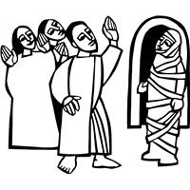

March 22, 2026

Fifth Sunday in Lent

Introduction
In today’s gospel Jesus reveals his power over death by raising Lazarus from the dead. The prophet Ezekiel prophesies God breathing new life into dry bones. To those in exile or living in the shadows of death, these stories proclaim God’s promise of resurrection. In baptism we die with Christ that we might also be raised with him to new life. At the Easter Vigil we will welcome the newly baptized as we remember God’s unfailing promise in our baptism.

Welcome & Announcements (Please remember to silence your cell phone!)

Prelude (We prayerfully prepare our hearts and minds to worship!)

+ GATHERING +

Confession and Forgiveness
All may make the sign of the cross, the sign that is marked at baptism, as the presiding minister begins.
P:Blessed be the holy Trinity, ☩ one God,
who forgives all our sin,
whose mercy endures forever.
C:Amen.
P:Let us confess our sin before God, who removes our guilt
and blots out all offenses.
Silence is kept for reflection.
Gracious God,
C:have mercy on us according to your steadfast love.
P:For seeking worldly delights that deceive us and dishonor you:
Gracious God,
have mercy on us according to your steadfast love.
For desiring self-reliance instead of hungering for your word:
Gracious God,
C:have mercy on us according to your steadfast love.
P:For failing to recognize your coming reign,
and for hindering the work of the Spirit: Gracious God,
C:have mercy on us according to your steadfast love.
P:For drawing from the well of self-serving ambition,
and for disdaining the living water Christ offers: Gracious God,
C:have mercy on us according to your steadfast love.
P:For disregarding voices from the margin,
and for distrusting signs of your healing and hope in the world:
Gracious God,
C:have mercy on us according to your steadfast love.
P:For dwelling in tombs of self-pity and discontent,
and for disregarding Christ’s call to come forth to life:
Gracious God,
C:have mercy on us according to your steadfast love.
P:God’s steadfast love, grace, and forgiveness abound.
Through faith, the free gift of God,
you have been clothed in the righteousness of Christ.
In the name of ☩ Jesus Christ, your sins are forgiven.
The Spirit of the One who raised Christ from the dead
dwells in you,
pours God’s love into your hearts,
and gives you life and peace.
C:Amen.

*Gathering Hymn ELW 667 Take Up Your Cross, the Savior Said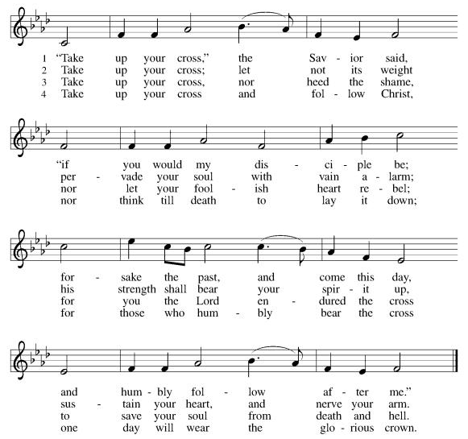

*Pastoral Greeting

P: The Grace of our Lord Jesus Christ, the love of God, and the communion of the Holy Spirit be with you all.

C: And also with you!

Kyrie: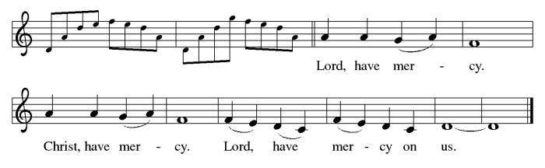

*Prayer of the Day
P: Almighty God, your Son came into the world to free us all from sin and death. Breathe upon us the power of your Spirit, that we may be raised to new life in Christ and serve you in righteousness all our days, through Jesus Christ, our Savior and Lord, who lives and reigns with you and the Holy Spirit, one God, now and forever.
C: Amen!

+WORD+

First Reading: Ezekiel 37:1-14
Ezekiel’s vision of the valley of dry bones is a promise that Israel as a nation, though dead in exile, will live again in their land through God’s life-giving spirit. Three times Israel is assured that through this vision they will know that “I am the Lord.”

¹ The hand of the Lord came upon me, and he brought me out by the spirit of the Lord and set me down in the middle of a valley; it was full of bones. ² He led me all around them; there were very many lying in the valley, and they were very dry. ³ He said to me, “Mortal, can these bones live?” I answered, “O Lord God, you know.” ⁴ Then he said to me, “Prophesy to these bones and say to them: O dry bones, hear the word of the Lord. ⁵ Thus says the Lord God to these bones: I will cause breath to enter you, and you shall live. ⁶ I will lay sinews on you and will cause flesh to come upon you and cover you with skin and put breath in you, and you shall live, and you shall know that I am the Lord.”
⁷ So I prophesied as I had been commanded, and as I prophesied, suddenly there was a noise, a rattling, and the bones came together, bone to its bone. ⁸ I looked, and there were sinews on them, and flesh had come upon them, and skin had covered them, but there was no breath in them. ⁹ Then he said to me, “Prophesy to the breath, prophesy, mortal, and say to the breath: Thus says the Lord God: Come from the four winds, O breath, and breathe upon these slain, that they may live.” ¹⁰ I prophesied as he commanded me, and the breath came into them, and they lived and stood on their feet, a vast multitude.
¹¹ Then he said to me, “Mortal, these bones are the whole house of Israel. They say, ‘Our bones are dried up, and our hope is lost; we are cut off completely.’ ¹² Therefore prophesy and say to them: Thus says the Lord God: I am going to open your graves and bring you up from your graves, O my people, and I will bring you back to the land of Israel. ¹³ And you shall know that I am the Lord when I open your graves and bring you up from your graves, O my people. ¹⁴ I will put my spirit within you, and you shall live, and I will place you on your own soil; then you shall know that I, the Lord, have spoken and will act, says the Lord.”

Psalm: Psalm 130
I wait for you, O Lord; in your word is my hope. (Ps. 130:5)

¹ Out | of the depths
I cry to | you, O Lord;
² O Lord, | hear my voice!
Let your ears be attentive to the voice of my | supplication.
³ If you were to keep watch | over sins,
O Lord, | who could stand?
⁴ Yet with you | is forgiveness,
in order that you | may be feared.
⁵ I wait for you, O Lord; | my soul waits;
in your word | is my hope.
⁶ My soul waits for the Lord more than those who keep watch | for the morning,
more than those who keep watch | for the morning.
⁷ O Israel, wait for the Lord, for with the Lord there is | steadfast love;
with the Lord there is plen- | teous redemption.
⁸ For the Lord shall | redeem Israel
from | all their sins.

Second Reading: Romans 8:6-11
For Paul, Christian spirituality entails living in the reality of the Holy Spirit. The driving force behind our actions and values is not our sinful desire for self-satisfaction but the very Spirit by which God raised Jesus from the dead and will also raise us from the dead.

⁶ To set the mind on the flesh is death, but to set the mind on the Spirit is life and peace. ⁷ For this reason the mind that is set on the flesh is hostile to God; it does not submit to God’s law—indeed, it cannot, ⁸ and those who are in the flesh cannot please God.
⁹ But you are not in the flesh; you are in the Spirit, since the Spirit of God dwells in you. Anyone who does not have the Spirit of Christ does not belong to him. ¹⁰ But if Christ is in you, then the body is dead because of sin, but the Spirit is life because of righteousness. ¹¹ If the Spirit of him who raised Jesus from the dead dwells in you, he who raised Christ Jesus from the dead will give life to your mortal bodies also through his Spirit that dwells in you.

Gospel Acclamation
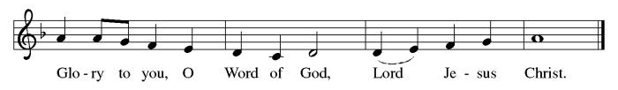

P: The Holy Gospel According to St. John 11th Chapter
C: Glory to You O Lord!

Gospel: John 11:1-45
Jesus is moved to sorrow when his friend Lazarus falls ill and dies. Then, in a dramatic scene, he calls his friend out of the tomb and restores him to life.

¹ Now a certain man was ill, Lazarus of Bethany, the village of Mary and her sister Martha. ² Mary was the one who anointed the Lord with perfume and wiped his feet with her hair; her brother Lazarus was ill. ³ So the sisters sent a message to Jesus, “Lord, he whom you love is ill.” ⁴ But when Jesus heard it, he said, “This illness does not lead to death; rather, it is for God’s glory, so that the Son of God may be glorified through it.” ⁵ Accordingly, though Jesus loved Martha and her sister and Lazarus, ⁶ after having heard that Lazarus was ill, he stayed two days longer in the place where he was.
⁷ Then after this he said to the disciples, “Let us go to Judea again.” ⁸ The disciples said to him, “Rabbi, the Jews were just now trying to stone you, and are you going there again?” ⁹ Jesus answered, “Are there not twelve hours of daylight? Those who walk during the day do not stumble because they see the light of this world. ¹⁰ But those who walk at night stumble because the light is not in them.” ¹¹ After saying this, he told them, “Our friend Lazarus has fallen asleep, but I am going there to awaken him.” ¹² The disciples said to him, “Lord, if he has fallen asleep, he will be all right.” ¹³ Jesus, however, had been speaking about his death, but they thought that he was referring merely to sleep. ¹⁴ Then Jesus told them plainly, “Lazarus is dead. ¹⁵ For your sake I am glad I was not there, so that you may believe. But let us go to him.” ¹⁶ Thomas, who was called the Twin, said to his fellow disciples, “Let us also go, that we may die with him.”
¹⁷ When Jesus arrived, he found that Lazarus had already been in the tomb four days. ¹⁸ Now Bethany was near Jerusalem, some two miles away, ¹⁹ and many of the Jews had come to Martha and Mary to console them about their brother. ²⁰ When Martha heard that Jesus was coming, she went and met him, while Mary stayed at home. ²¹ Martha said to Jesus, “Lord, if you had been here, my brother would not have died. ²² But even now I know that God will give you whatever you ask of him.” ²³ Jesus said to her, “Your brother will rise again.” ²⁴ Martha said to him, “I know that he will rise again in the resurrection on the last day.” ²⁵ Jesus said to her, “I am the resurrection and the life. Those who believe in me, even though they die, will live, ²⁶ and everyone who lives and believes in me will never die. Do you believe this?” ²⁷ She said to him, “Yes, Lord, I believe that you are the Messiah, the Son of God, the one coming into the world.”
²⁸ When she had said this, she went back and called her sister Mary and told her privately, “The Teacher is here and is calling for you.” ²⁹ And when she heard it, she got up quickly and went to him. ³⁰ Now Jesus had not yet come to the village but was still at the place where Martha had met him. ³¹ The Jews who were with her in the house consoling her saw Mary get up quickly and go out. They followed her because they thought that she was going to the tomb to weep there. ³² When Mary came where Jesus was and saw him, she knelt at his feet and said to him, “Lord, if you had been here, my brother would not have died.” ³³ When Jesus saw her weeping and the Jews who came with her also weeping, he was greatly disturbed in spirit and deeply moved. ³⁴ He said, “Where have you laid him?” They said to him, “Lord, come and see.” ³⁵ Jesus began to weep. ³⁶ So the Jews said, “See how he loved him!” ³⁷ But some of them said, “Could not he who opened the eyes of the blind man have kept this man from dying?”
³⁸ Then Jesus, again greatly disturbed, came to the tomb. It was a cave, and a stone was lying against it. ³⁹ Jesus said, “Take away the stone.” Martha, the sister of the dead man, said to him, “Lord, already there is a stench because he has been dead four days.” ⁴⁰ Jesus said to her, “Did I not tell you that if you believed you would see the glory of God?” ⁴¹ So they took away the stone. And Jesus looked upward and said, “Father, I thank you for having heard me. ⁴² I knew that you always hear me, but I have said this for the sake of the crowd standing here, so that they may believe that you sent me.” ⁴³ When he had said this, he cried with a loud voice, “Lazarus, come out!” ⁴⁴ The dead man came out, his hands and feet bound with strips of cloth and his face wrapped in a cloth. Jesus said to them, “Unbind him, and let him go.”
⁴⁵ Many of the Jews, therefore, who had come with Mary and had seen what Jesus did believed in him.

P: The Gospel of the Lord
C: Praise to you, O Christ!
Sermon
*Hymn of the Day TFF 97 I Heard an Old, Old Story
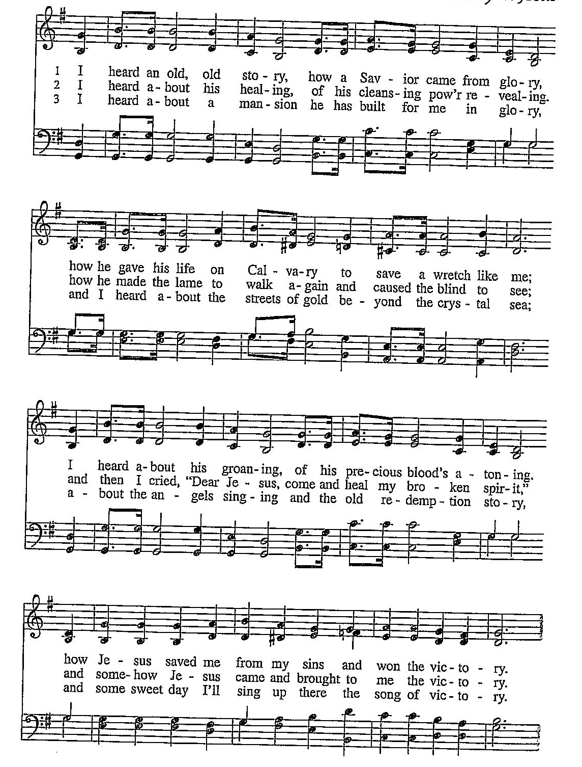
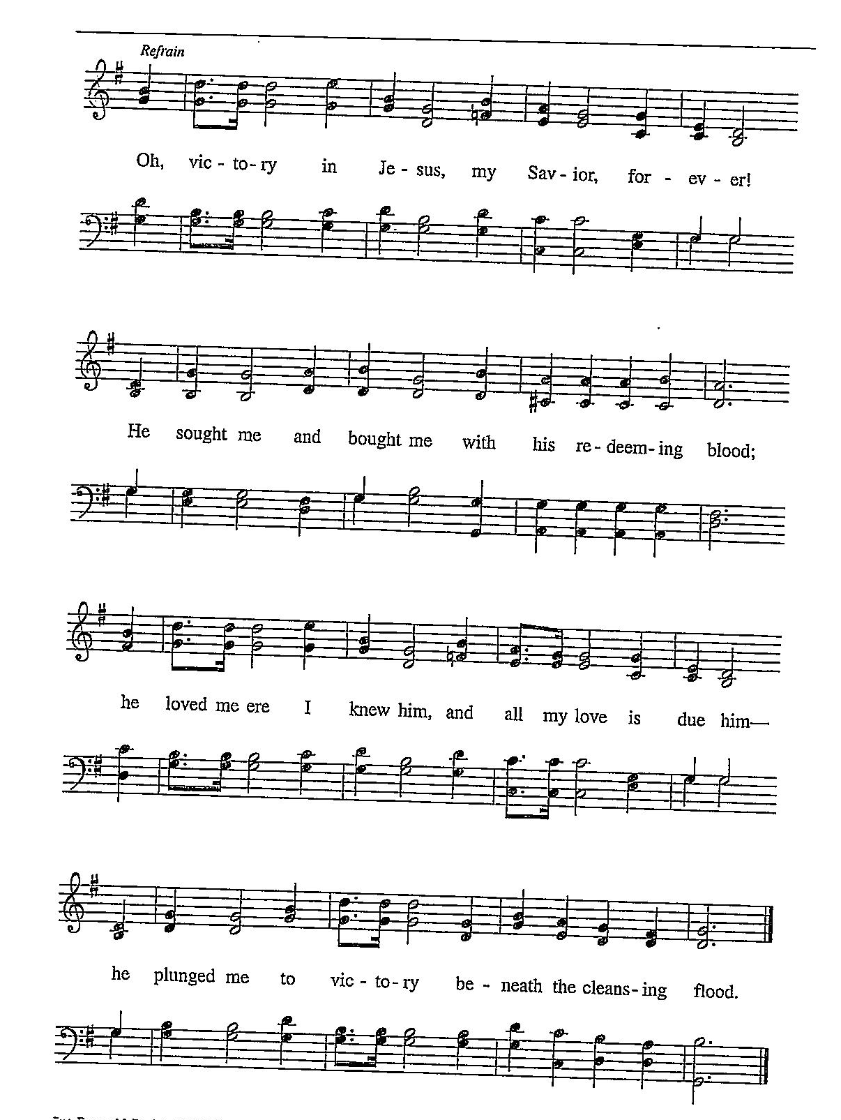

Nicene Creed
We believe in one God,
the Father, the Almighty,
maker of heaven and earth,
of all that is, seen and unseen.
We believe in one Lord, Jesus Christ,
the only Son of God,
eternally begotten of the Father,
God from God, Light from Light,
true God from true God,
begotten, not made,
of one Being with the Father;
through him all things were made.
For us and for our salvation
he came down from heaven,
was incarnate of the Holy Spirit and the Virgin Mary
and became truly human.
For our sake he was crucified under Pontius Pilate;
he suffered death and was buried.
On the third day he rose again
in accordance with the Scriptures;
he ascended into heaven
and is seated at the right hand of the Father.
He will come again in glory to judge the living and the dead,
and his kingdom will have no end.
We believe in the Holy Spirit, the Lord, the giver of life,
who proceeds from the Father and the Son,
who with the Father and the Son is worshiped and glorified,
who has spoken through the prophets.
We believe in one holy catholic and apostolic church.
We acknowledge one baptism for the forgiveness of sins.
We look for the resurrection of the dead,
and the life of the world to come. Amen.

*Prayers of Intercession
Reconciled by God’s mercy and sustained by God’s presence, let us pray for the world and its needs.
A brief silence.
We pray for the church. Grant life and peace to all who gather in your name. Breathe into us so that we may share your message of forgiveness, hope, and love. Hear us, O God.
C:Your mercy is great.
We pray for creation. Renew landscapes that have dried up, prosper the work of those who restore homes and habitats after natural disasters, and sustain places where biodiversity thrives (local places in nature may be named). Hear us, O God.
C:Your mercy is great.
We pray for the nations. Unbind leaders trapped by fear to act boldly for justice, free all who live in places of war and violence, and guide refugees and asylum seekers to safety. Hear us, O God.
C:Your mercy is great.
We pray for all people in need. Take away the stone of poverty that weighs down so many. Console any who weep and heal all who are sick (especially). Hear us, O God.
C:Your mercy is great.
We pray for this assembly. Ready the hearts and spirits of all preparing to be baptized (especially). Deepen our wonder at the mystery of your resurrection and life. Hear us, O God.
C:Your mercy is great.
Here other intercessions may be offered.
We offer our thanksgiving for (Jonathan Edwards and ) all people who have died in faith. Give us faith to trust in your power to redeem and save, and bring us up from our graves to life in you. Hear us, O God.
C:Your mercy is great.
Receive our prayers, O God, through Jesus Christ, our strength and salvation.
C: Amen.

Greeting of Peace
P: The peace of Christ be with you always!
C: And also with you!

Offering (Thank you for your support for our ministry!)

*Doxology ELW 186 Create in Me a Clean Heart
(Please stand and join in singing as we share our gifts!)
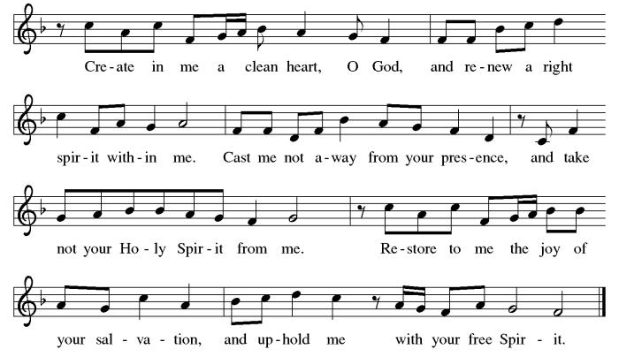

*Offering Prayer
A: O God, maker of heaven and earth,
C: your steadfast love embraces all creation.
You send rain and sunshine to nourish the earth
and bring forth its bounty.
Through these gifts of bread and wine,
draw us into the death and life of your Son,
who calls us to bear witness to his saving work.
We ask this in Jesus’ name.
Amen!

+MEAL+
*Great Thanksgiving
P: The Lord be with you.
C: And also with you.

P: Lift up your hearts.
C: We lift them to the Lord.

P: Let us give thanks to the Lord our God.
C: It is right to give our thanks and praise.

P: It is indeed right, our duty and our joy,
that we should at all times and in all places
give thanks and praise to you, almighty and merciful God,
through our Savior Jesus Christ.
You call your people to cleanse their hearts
and prepare with joy for the paschal feast,
that, renewed in the gift of baptism,
we may come to the fullness of your grace.
And so, with all the choirs of angels,
with the church on earth and the hosts of heaven,
we praise your name and join their unending hymn:

*Sanctus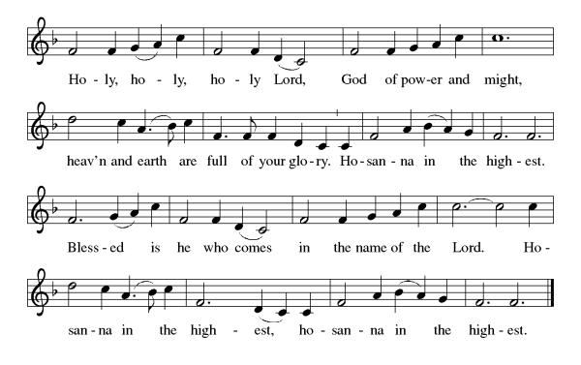
*Eucharistic Prayer
P: Holy, mighty, and merciful Lord,
heaven and earth are full of your glory.

In great love you sent to us Jesus, your Son,
who reached out to heal the sick and suffering,
who preached good news to the poor,
and who, on the cross, opened his arms to all.

In the night in which he was betrayed,
our Lord Jesus took bread, and gave thanks;
broke it, and gave it to his disciples, saying:
Take and eat; this is my body, given for you.
Do this for the remembrance of me.

Again, after supper, he took the cup, gave thanks,
and gave it for all to drink, saying:
This cup is the new covenant in my blood,
shed for you and for all people for the forgiveness of sin.
Do this for the remembrance of me.

Remembering, therefore, his death, resurrection, and ascension,
we await his coming in glory.

Pour out upon us the Spirit of your love, O Lord,
and unite the wills of all who share this heavenly food,
the body and blood of Jesus Christ, our Lord;
to whom, with you and the Holy Spirit,
be all honor and glory, now and forever.

C: Amen!

*THE LORD’S PRAYER
Our Father, who art in heaven,
hallowed be thy name,
thy kingdom come,
thy will be done,
on earth as it is in heaven.
Give us this day our daily bread;
and forgive us our trespasses,
as we forgive those
who trespass against us;
and lead us not into temptation,
but deliver us from evil.
For thine is the kingdom,
and the power, and the glory,
forever and ever. Amen.
*Lamb of God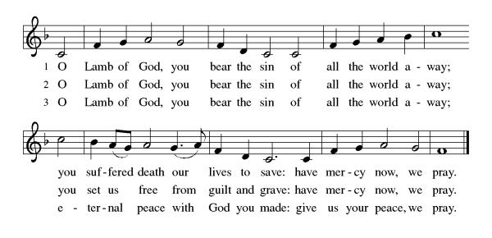
Spiritual Communion Prayer
P: Let us pray for the communion of all present here, those viewing our service virtually, those in our hearts and in our world.
C: Lord Jesus, I believe you are truly present in the Sacrament of Holy Communion. When I cannot receive Communion, I pray that you come into my heart. I know that nothing in Heaven or on earth can separate me from your love. Amen.

Invitation to Communion
P: Come to the table.
Feast on God’s goodness and mercy.

C: Thanks be to God!

(All are invited to the communion rail following the guidance of the ushers. Communion will be shared through the host and individual cups. If you would like communion but are unable to join us at the rail, please alert the usher!)

Communion Hymns (Please join in singing!)
ELW 592 Just As I Am, without One Plea
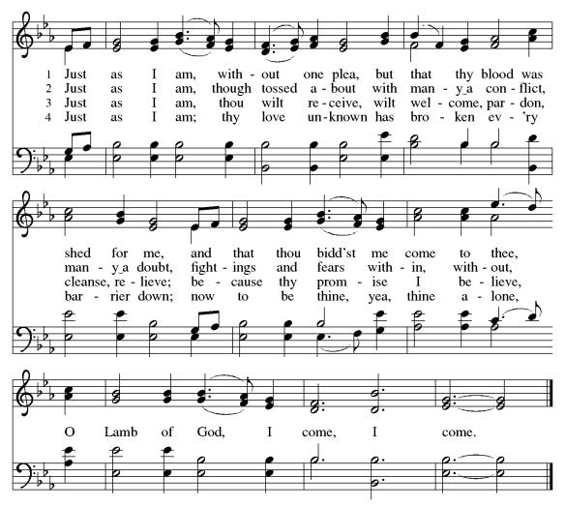

ELW 685 Take My Life, That I May Be
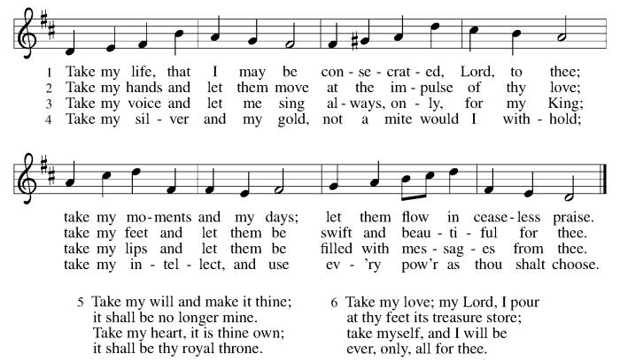

P: The body and blood of our Lord Jesus Christ strengthen you and keep you in his grace. C: Amen!

*Prayer after Communion
A: God of our salvation,
we give you thanks for this meal that restores our souls,
reconciles us to you, and strengthens us for the journey.
Through the body and blood of your Son,
may we become Christ’s body in the world,
bearing witness to your love for all creation,
through Jesus Christ, our Savior and Lord.
C: Amen.
+Sending+

*Blessing
P: Receive the blessing of the holy Trinity:
God, who calls all things into existence,
Jesus Christ, who redeems us,
and the Holy Spirit, whose breath sustains creation,
☩ bless you now and always. C: Amen!

*Sending Hymn ELW 767 Lord, Take My Hand and Lead Me
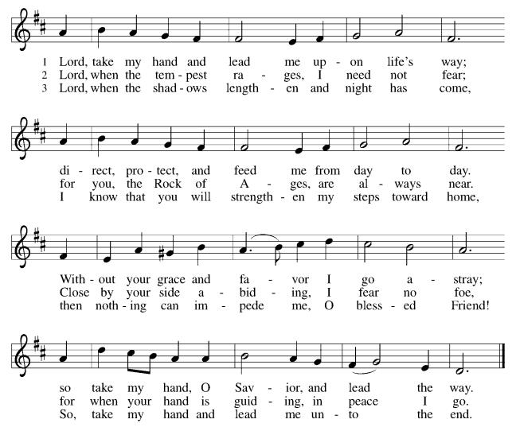

*Dismissal
A: Go in peace. Believe the good news.
C: Thanks be to God!

Postlude

Copyright © 2020 Augsburg Fortress. All rights reserved. Reprinted by permission under Augsburg Fortress Liturgies Annual License #SB106907. New Revised Standard Version Bible, Copyright © 1989, Division of Christian Education of the National Council of the Churches of Christ in the United States of America. Used by permission. All rights reserved. Revised Common Lectionary, Copyright © 1992 Consultation on Common Texts, admin Augsburg Fortress. Used by permission.

Treasurer’s Report

February giving totaled $53,512, putting us ahead of pace toward our 2026 Challenge goal of $244,000, with 29% raised in just 17% of the year. Continued participation through regular or additional Challenge gifts will help ensure we fully fund HTLC’s ministry and mission in the months ahead.
Worship Volunteer Schedule
Date | Asst. Min | Usher | Sacristan | Lector | Counter
March 1 | Charlie Rugg | Gary Joblon | Pat Pienkos | Cynthia Kazmac | Bohner/Volk
March 8 | Linda Coleman | Keith Bennett | Joanne Giordano | Emily Kaster | Carleo/Csernica
March 15 | Keith Bennett | Jill Socha | Carol Rosen | Jeff Ridberg | Bradford/Foard
March 22 | Chris Foard | Kathy Caputo | Joanne Giordano | Bill Spreen | McKenna/Kazmac
March 29 | Charlie Rugg | Jill Socha | Helga Britton | Molly Foard | Coleman/Giordano

Coffee Hour- Linda Coleman

ANNOUNCEMENTS Thank you! To all who consistently support our church and ministries through your time, talent, and treasure. Please help us grow by inviting your friends and family to worship and events. You are what makes Holy Trinity a wonderful church family!

Dorcas Circle- Will meet April 9th at noon due to Holy Week.

Stay in touch! Please visit our church website, www.htlcredbank.org for updates and information. You can also find us on Facebook and view services online. The office is open from 9am to 2pm, Monday to Thursday.

100 Anniversary Committee- If you are interested in being a part of the committee to help plan the 100th anniversary celebration of HTLC in 2028, please sign up in the red book. All are welcome! Also, the committee will be looking for photos and documents of HTLC throughout the years. If you have anything to share, please bring them to the church and marked envelopes or email electronic copies to the church office.

Name Tag Sundays: On the first Sunday of each month, names tags and markers will be at each entrance of the sanctuary. Please fill out a tag and wear one for worship and for coffee hour to welcome visitors and help newcomers put names to faces.

Sunday School in the New Year, we will continue to study stories and lessons from the Old Testament beginning with Jacob. Kids will love the crafts, songs and games that accompany each lesson.
The following dates there will be Sunday School:
Jan- 11 and 25, Feb- 8 and 22, March- 1, 15 and 29*Easter Egg Hunt!
April- 12 and 26, May- 3, 17 and 31, June- 7 and 14
As was done in the fall, there will be opportunities to volunteer as SS lead teacher. A signup will be emailed out shortly and will also be posted in the red binder. Consider signing up! All lesson materials will be supplied and laid out and a leader guide will be emailed to volunteers approximately 1 week in advance. Blessings for a wonderful 2026!~Lauren

Choir The Holy Trinity Choir welcomes our singers back for a preparation rehearsal on Sunday, September 7th at 9am in the church hall. All are welcome to join us in song as often as you are able. Choir meets each Sunday at 9am to practice and prepare our music. Join us and help us grow by spreading the word about the HTLC Choir!

Quilting- The Quilters need gently used any bed sheets of any size! Please leave any donations in the quilters closet in Fellowship Hall. Thank you!

Quilters Need Help
If anyone is traveling through Mechanicsville, PA, and can add a few extra minutes to your trip, the warehouse for shipping quilts, school kits, etc is located directly off one of the exits.
We accumulate many quilts throughout the year and we would appreciate sending some quilts with you to deliver. Any questions, please call Sherry Lee or Elaine Theophall.

Weekly Quilting on Wednesdays at 9:30. Bring your lunch and enjoy some fellowship at noon. All are welcome.

Social Ministry
*Year-round collections will continue for food items for Lunch Break. There is a sign-up sheet in the red book for those who can help drop these items to Lunch Break.
*We will also collect adult men's socks to periodically drop at the Red Bank Warminq Center.
*For those interested in the Heartwarminq Center — the new women's shelter is adjacent to the First Baptist Church of Red Bank at 90 Maple Ave. You can follow up on this mission through their website - https://www.thefeastnj.org- On this site, they also include wish list items that can be purchased through amazon. We will be exploring purchasing some of these through a Thrivent card. If you want to purchase on your own, you can leave items at church, and the Social Ministry will deliver them.

Pastoral Care and Prayer... We are here to care for and pray! Please contact the office to add or adjust prayer requests. If you or someone you know needs pastoral care, please contact the office and Pastor Mack!

THANK YOU for supporting and sustaining our church and ministries! All are welcome here! Please invite your family and friends to worship with us! Find us online at www.htlcredbank.org

