St. Paul
UNITED CHURCH OF CHRIST

March 1, 2025 10:30am
Welcome! Whether you are a guest, friend or member, we are delighted that you are here. Large print bulletins are available at either door. Ask a greeter for any directions you may need.

“Please note that this service will be live-streamed on Facebook. If you do not wish to be visible on camera, please let an usher know so we can take appropriate measures to ensure
your privacy."

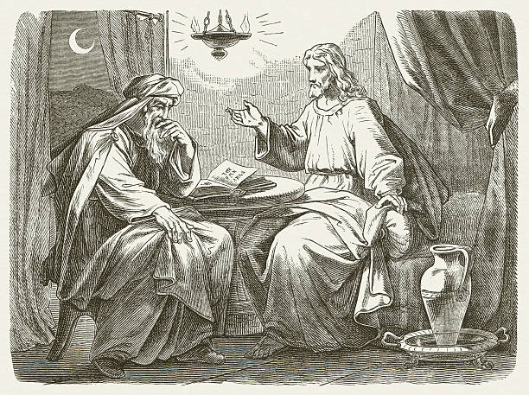

Rev. Jim Oleson, Pastor
Christopher Dickmeyer, Musician
Second Sunday in Lent
*Please rise in body or spirit
Ringing of the Bell
Welcome & Announcements
In the last days, says God, I will pour out my Spirit upon all people. Your sons and daughters shall prophesy. Your young people shall see visions, and your old people shall dream dreams. People of God, we have been baptized into one Spirit and one body through Jesus Christ. Let us worship today.
Prelude and Lighting of the Candles
*Call to Worship
One: We are met in the presence of God
Many: And we do not meet alone.
One: With the angels in the highest heaven
Many: We gather to worship the Lord.
One: With Abraham and Sarah
Many: We gather to worship the Lord.
One: With the saints of every age
Many: We gather to worship the Lord.
One: We embark on our own journey of faith
Many: God’s Holy name be praised.
One: God makes of us a great people
Many: God’s Holy name be praised.
One: In the desert and in the den, in barrio and basilica
Many: God’s Holy name be praised.
One: We journey in the presence of God.
All: And we do not journey alone.
*Invocation
Creator God, maker of the heavens and earth, lead us to the still waters when the storms are raging. Lead us through the mountains and valleys; may we know You are guiding us always on this journey of faith. Sometimes we find You are leading the way; sometimes You are the one who pushes and prods us from behind, making sure we are not lost or lagging. Most of all, may we feel Your presence beside us and within us. Lead us into the way of life. In the name of Christ, our companion on this journey of faith, we pray. Amen.
*Hymn of Praise #427 New Century God Made From One Blood
*Prayer for Transformation and New Life
Holy God, You are the Judge we answer to, but too often we have judged our neighbors and condemned them, before we know them, before we have even heard them speak. We have abused others by calling ourselves saved and others condemned; we have hurt others by trying to save them. We have forgotten, O God, that You have called us to judge ourselves, to seek forgiveness, to remove the log from our own eye. May we seek forgiveness where we have harmed others and may we deepen our trust in You. In the name of Jesus, who calls us to be born in a new way, we pray. Amen.
<pause for silent reflection >
Words of Grace
One: God leads us into life.
Many: God is with us, in the beginning and the end, watching out for us and leading us on.
One: God renews us, restores us, and sets our feet on right paths.
Many: God is our help and strength and comfort.
One: Seek God, trust in God, and know that you are forgiven and loved.
Many: Amen.
*Response of Praise
Glory be to the Father, and to the Son, and to the Holy Ghost; As it was in the beginning, is now, and ever shall be, World without end. Amen. Amen.
Mission Moment
Written Word Genesis 12:1-4a
Romans 4:1-5, 13-17
John 3:1-17
Hymn #455 New Century I Am Yours, O Lord
Message A Journey of Faith Rev. Jim Oleson
Genesis 12:1-4a
Church in Prayer
Pastoral Prayer
Lord’s Prayer (Debts, Debtors)
Offertory
Invitation to Generosity
*Doxology (Tune: Old Hundredth)
Praise God, from Whom all blessings flow; Praise Him, all creatures here below;
Praise Him above, ye heavenly host; Praise Father, Son, and Holy Ghost. Amen.
*Prayer of Dedication
God, you are mercifully steadfast in your love for us, calling us to you, and raising us up. We give you our thanks with these gifts and the way we intend to live our lives. Amen.
*Closing Hymn #25 New Century O God, Our Help in Ages Past
*Commission and Benediction
*Christ’s Light Leads Us into the World
*Congregational Response #207 New Century Just As I Am
(Verse 1)
*Ringing of the Bell and Postlude

903 Meier Road, Old Monroe, Missouri 63369
stpauluccom@gmail.com
Website: stpauluccom.com
636-665-5329

OFFICE HOURS
Wednesday: 9:00am – 3:00pm
Friday: 9:00am - Noon

March Stewardship

Oasis Resource Center

In March, the Stewardship offering will benefit the Oasis Resource Center in Troy. Oasis provides help and hope during and after pregnancy for moms and dads, specializing in pregnancy, infant, toddler and family related resources.

From free pregnancy testing, ultrasound screening and counseling on options once a pregnancy is confirmed, Oasis provides a wide range of services. Nurses are available to answer questions pertaining to pregnancy as well as infant and toddler care. Counselors are available to provide guidance and support in a variety of areas including family relationships, parenting education resources and connecting clients with other services such as job and housing placement.

Oasis not only provides self-improvement and parenting education resource services for women but also for men. Fathers can take advantage of these services even if their partner is not a client of Oasis. One option for dads is a 14-week evening class offering guidance and providing additional tools to help them be a better parent and create a healthier family environment.

Oasis Baby Boutique, which offers new and gently used baby items, is also a part of their services. Credits earned from participating in self-improvement or parenting classes gives parents the opportunity to earn credits and use those credits toward the purchase of new baby items at a reduced cost.

Please consider contributing to Oasis. Help in their effort to create stronger, healthier families for little ones who are dependent on others for their most basic needs. Help give these parents an opportunity to create a stronger family foundation for their children and the possibility to thrive, not just survive

It Happens
Here St. Paul UCC
Weekly Calendar
March 1st - March 8th

March 1st Second Sunday in Lent
9:15am Bible/Book Study
10:30am Worship
11:30am Fellowship Hour

March 8th Third Sunday in Lent
9:15am Bible/Book Study
10:30am Worship
11:30am Fellowship Hour

Looking Ahead

March 16th
5:30pm Council Meeting

March 22nd
10:30am Pastor Jim’s Installation

________________________________________________________________________________________
OUR GIVING IN 2026
Needed weekly to meet our commitments $2190.29 $ 2190.29
General Fund Offering February 22nd $ 855.00 February Average $ 1226.25 Stewardship Offering February 22nd $ 5.00 January Average $ 1478.33
______ __________________________________________________ __ ____________________ ________

HAPPENING IN OUR COMMUNITY`
Sunday, March 8: Sausage Dinner at Femme Osage UCC in Augusta. Dine in or carry out. Serving 11:30am to 6:00pm.

Carolyn is currently in rehab at The Villages of St. Peters. She would greatly appreciated visits, cards or phone calls. She has her cell phone with her.
Carolyn Meier
The Villages of St. Peters
5400 Executive Centre Pkwy
St. Peters, MO 63376

Pastor Jim’s installation will take place during the regular Sunday Service on March 22nd. More information coming.

Thank you to all our volunteers!

Greeters/Ushers
Bob Bothe & Joyce Noble

Acolyte
Joyce Noble

Liturgist

Fellowship Hour
Messenger


In our prayers …

This week we added Kristie N. to our prayers.

We continue to keep in our prayers Lauretta, Lynn and Ron D., Ernie M., Eileen T., Chuck and Marlene, Lyle R., Jamie, Nor, Rick C., Bob R., Sandy R., Carolyn M., the family and friends of Marsha, Roy, and Donnie, and the family of Mike S.

We lift up in our prayers those who need prayers for their long-term circumstances: Carol Jean P.

REMINDER…Please DO NOT adjust the programmable thermostat in the Sanctuary.

The Worship Committee is looking for a volunteer to be the Communion Stewart. This is a person who prepares Communion on the first Sunday of the month and for special services. Also requires cleaning up and putting away the Communion ware. If there are any questions, please see a Worship Committee member.

