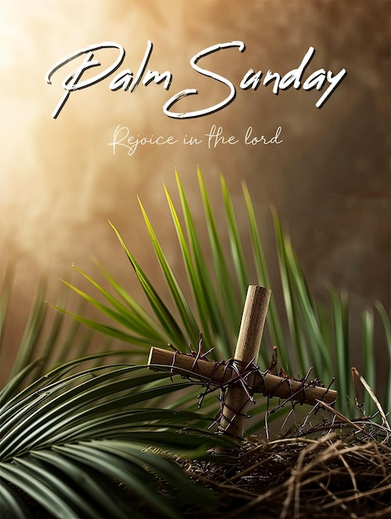
✨ Come and pray with us as we celebrate the light of Christ revealed to the world✨

🕊️ Sunday Services
- 8:00 a.m. and 10 a.m. – Holy Communion 📍 St. George’s
- 9:00 a.m. – Holy Communion 📍 St. Mary’s
- 9:00 a.m. –Morning Prayer 📍 St Andrews
- 11:00 a.m.- Holy Communion 📍St James
- 5:00 p.m. – Evening Prayer 📍 St. George’s
✝️🌿 Weekday Worship 🌿
Daily Morning Prayer
🕣 8:30 a.m. 📍 Chapel of St. George’s

✝️ Thursday Service
- 10:00 a.m. – The Holy Eucharist 📍 St. George’s Chapel

🤍 Additional Services
- First & Third Tuesday of each month
🕙 10:00 a.m. – The Holy Eucharist 📍 People’s Park Tower / Camden Terrace Chapel
- Second Tuesday of each month
🕚 11:00 a.m. – The Holy Eucharist 📍 Kenneth Spencer Memorial Home
Bible Study
- 10:30 a.m. Bible Study 📍 St. George’s
- 1:00 p.m. Bible Study 📍 St. James

Sunday, March 29

