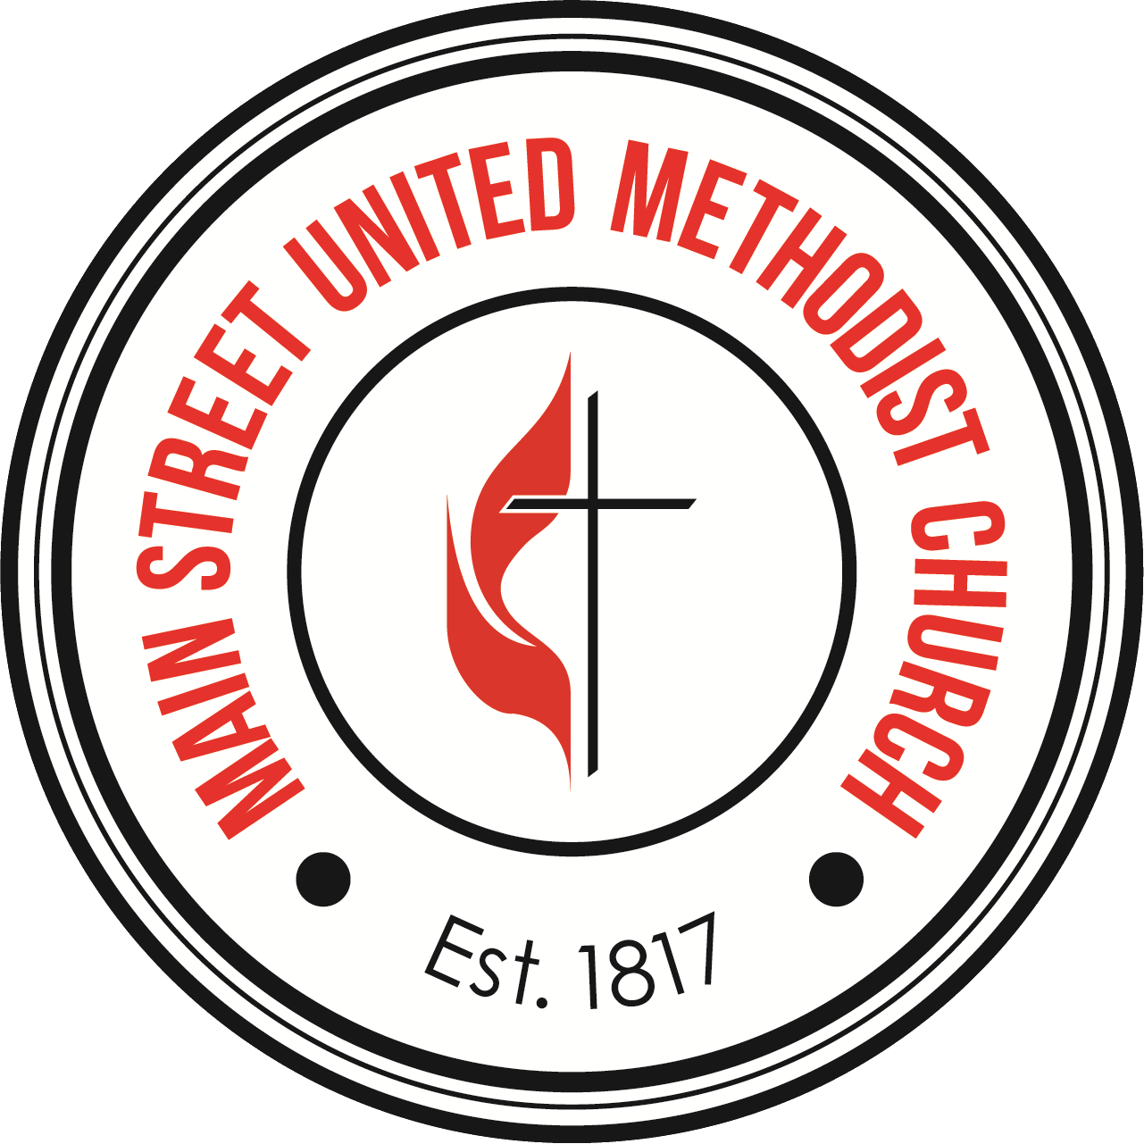

Dorothy Canon Scholarship Fund
The Dorothy Canon Scholarship Fund has been established to provide scholarships for campers who would miss the camping experience due to their family’s financial circumstances. Dorothy Canon was a member of Main Street United Methodist Church (MSUMC), who as a child was unable to attend church youth camp because of the very same reason. Her generous donation to MSUMC has made camping and other Illinois Great Rivers Conference (IGRC) children/youth sponsored events possible.
In order to qualify for the scholarship, the camper must be one of the following:
- A member of MSUMC
- A child of a member of MSUMC
- A child whose parent/guardian(s) are not members of a United Methodist Church but are active in church activities
- The camper must be active in one of MSUMC’s sponsored children/youth programs
- One parent/guardian of a child camper attending Family Camp at Little Grassy UMC Camp. Note: this is a specific and limited one-time only exception for adults.
Financial Support:
- Campers can obtain funding for up to 75% of the cost of camp but shall not exceed. $500.00.
- In some circumstances, some families may need more than the 75% grant. If this is the circumstance, please contact the youth leader or Directing Pastor and additional fund will be considered on a case-by-case basis.
- Every applicant family will be asked to contribute at least $25 as they are financially able to do so.
- One (1) scholarship per camper per year.
- Scholarship funds are limited and intended to support the maximum number of campers. No financial information will be asked of any family. Since we are managing the program on the honor system, we ask all applicant families to abide by the intent of Dorothy Canon’s wishes to assist those families that are truly in need.
Instruction for Applicants
- Fill out the Application in full, including the Pastor’s signature at the bottom
- There are lines to add additional need request. Examples include tent, sleeping bag, toiletry items, Bible, etc.
- Mail or return application to MSUMC, 1400 Main St. Alton, IL 62002 attn: Camp Scholarships.
Dorothy Canon Scholarship Fund
Applicant Information:

Name:_________________________________________ DOB:_____/_______/_________

Address: _____________________________________________ Apt/Unit#__________________

Phone: (______) ________- _____________ Email:_______________________________________

Parent/Guardian:________________________________________________

Event/Camp Planning to attend and date: _____________________________________

Cost of Event/Camp to attend: ___________________________________

Event/Camping Needs:________________________________________________________

___________________________________________________________

Parent/Guardian Signature:___________________________________________________

Parent/Guardian Printed Name:______________________________________________

Pastor Signature: ____________________________________________________________

