

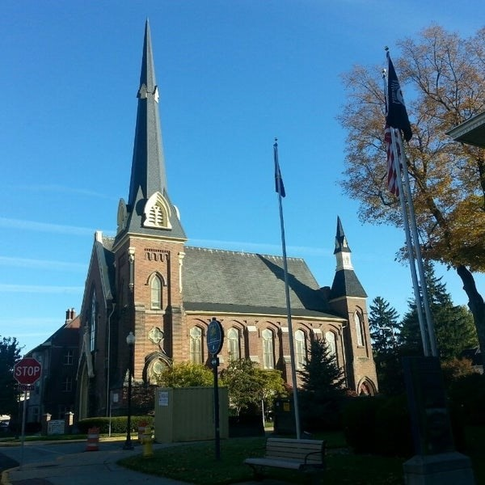
March 11, 2026

A Global Methodist Church
214 S. 5th Street
Goshen, IN 46528
Phone: 574-533-9518
Web Site: goshenfirstgmc.org

Office Hours: Monday-Friday,
8:00 a.m.-12:00 noon
Worship: 9:00 a.m.
Sunday School: 10:30 a.m.
Pastor Jeff & Lisa
Associate Pastor Rich Hull
OUR VISION: “Growing in Faith, Gathering in Community, and Giving in Love”.

LENTEN BREAKFASTS

The schedule for the 2026 Lenten Breakfasts is finalized. Plan on an 8:30 a.m. start time, and everything will run the same as years past. All are welcome!
March 14 – Goshen First Church (in the Garden Room)
March 21 - Dunlap United Methodist Church
March 28 - Jamestown United Methodist Church


On Thursday, March 19, the Primetimers will meet at the Goshen Family Restaurant in Waterford at 11:00 a.m. for lunch. After lunch, at 1:00 p.m. they will visit Ryan’s Place.
Ryan’s Place is a grief center for children, teens, and their families. They offer peer support groups staffed by trained facilitators as well as outreach grief services. They offer grief support services for local schools and businesses. Ryan’s Place also offers individual therapy on a limited basis. All services are provided free of charge. Please bring $5 as a donation to Ryan’s Place.


On Saturday, March 21, from 5:00-8:00 p.m., there will be an Empty Bowl Fundraiser here in the gym for the First Light Mission. For a charge of $20, you can choose from 8 different soups, with bread and a brownie, and you receive your own soup bowl. There are gluten-free options also. Everyone is welcome!! No reservations are needed.

We will have an Easter Cantata here at the church on Sunday, March 22, with
our choir and orchestra, at 9:00 a.m. All are welcome!

There will be a Missions meeting on Monday, March 23, at 5:30 p.m. here at
the church. Everyone is welcome!

HOLY WEEK SCHEDULE
Monday, March 30: 6:30 p.m. – “The Passion of the Christ” movie.
Wednesday, April 1: 5:30 p.m. – Meal, adult and children’s classes afterward.
Maundy Thursday, April 2: 7:00 p.m. – A Tennebrae service at the church.
Good Friday, April 3: 9:00 a.m.-3:30 p.m. – Carry the Cross on streets of Goshen.
Easter Sunrise Service, April 5: 7:00 a.m. – At Fidler Pond.
Easter Breakfast: 8:00 a.m. – At the church – All are welcome.
Easter Service, April 5: 9:00 a.m. – All are welcome. There will be no Sunday
School classes, but there will be Coffee Hour after the service.

VOLUNTEERS – Thank you for your service! Sunday morning, March 15
Greeters: Janet Taylor VIP: Patty Krebs
Elevator Hosts: Max Leatherman & Betty Jo Morris
Ushers: Randy Cripe, Pam Lichty, Dan Seltenright,Mateo Tenorio, Williston Tenorio
Scripture Reader: Larry Solyom
Elementary Junior Church: Rachel Parsons Tenorio, Marcia Parsons
Junior High Church: Loraine Troyer
Coffee Hour: Dan & Kathy Seltenright
Bus Driver: Randy Cripe

HOLY WEEK SCHEDULE



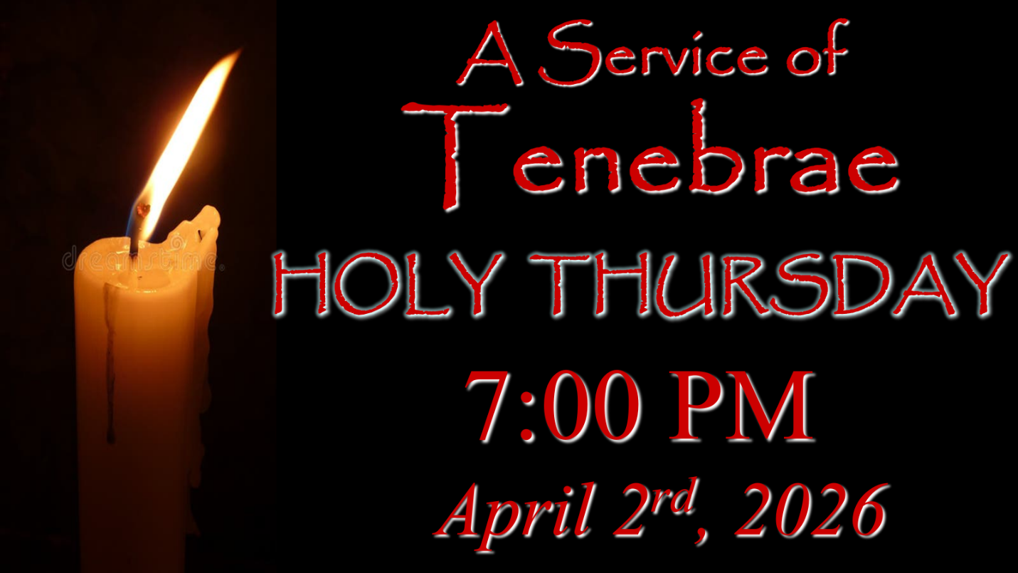

HOLY WEEK SCHEDULE

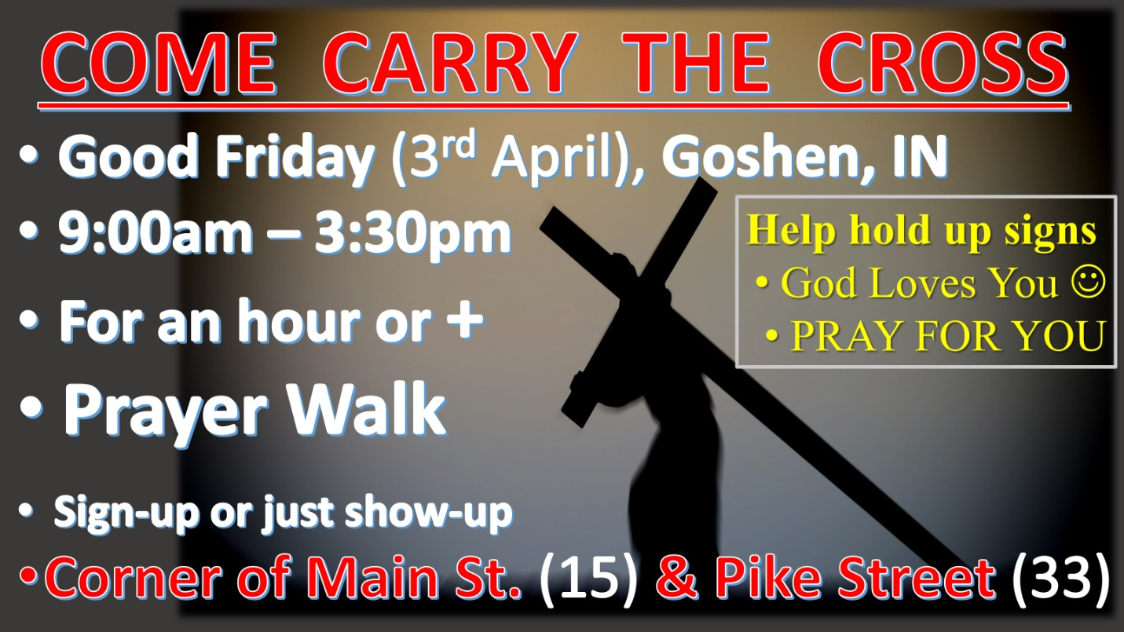



HOLY WEEK SCHEDULE

