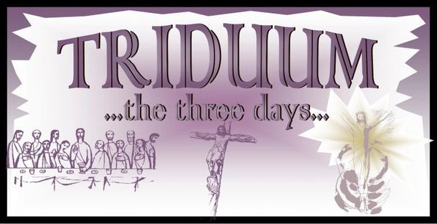

The Great Triduum
The Holy Three Days of Easter are traditionally celebrated as a single extended service of worship. Beginning with the institution of the Lord’s Supper on Maundy Thursday there is no dismissal until Easter Sunday, for the Church keeps constant vigil until the Lord rises from the dead. So, although we will gather at different times and places it is understood that these events form a single act of worship over the three most holy days in the Christian Year.
Blessed is He who comes in the Name of the LORD!
Maundy Thursday
April 3, 2026
St. James’ Port Daniel Maundy Thursday 7:00 PM

Good Friday
April 4, 2026
April 7 St. Andrew’s New Carlisle Stations of the Cross 10:00 AM

St. James’ Hopetown Good Friday 3:00 PM

Holy Saturday
April 4, 2026
April 8 St. Andrew’s New Carlisle Easter Vigil/Baptism 7:00 PM

Easter Sunday
April 5, 2026
April 9 Easter Sunday
St. Andrew’s in the Chapel Sunrise 6:00 AM
St. Andrew’s New Carlisle Holy Eucharist 9:00 AM
St. Paul’s Shigawake Holy Eucharist 11:00 AM

