Holy Trinity Lutheran Church
150 River Road Red Bank, NJ 07701
Church Office: (732) 741-9241 Fax: (732) 741-9577
email: holytrinitychurch4@verizon.net
Website: htlcredbank.org
Pastor: Rev. John Mack, Jr.
Cell: (336)-392-5839
Minister of Music: Peter Isherwood
Parish Administrator: Deanna Vergari
Council President: Cynthia Kazmac



March 08, 2026

Third Sunday in Lent

Introduction
In today’s gospel the Samaritan woman asks Jesus for water, an image of our thirst for God. Jesus offers living water, a sign of God’s grace flowing from the waters of baptism. The early church used this gospel and those of the next two Sundays to deepen baptismal reflection during the final days of preparation before baptism at Easter. As we journey to the resurrection feast, Christ comes among us in word, bath, and meal—offering us the life-giving water of God’s mercy and forgiveness.

Welcome & Announcements (Please remember to silence your cell phone!)

Prelude (We prayerfully prepare our hearts and minds to worship!)

+ GATHERING +

Confession and Forgiveness
All may make the sign of the cross, the sign that is marked at baptism, as the presiding minister begins.
P:Blessed be the holy Trinity, ☩ one God,
who forgives all our sin,
whose mercy endures forever.
C:Amen.
P:Let us confess our sin before God, who removes our guilt
and blots out all offenses.
Silence is kept for reflection.
Gracious God,
C:have mercy on us according to your steadfast love.
P:For seeking worldly delights that deceive us and dishonor you:
Gracious God,
have mercy on us according to your steadfast love.
For desiring self-reliance instead of hungering for your word:
Gracious God,
C:have mercy on us according to your steadfast love.
P:For failing to recognize your coming reign,
and for hindering the work of the Spirit: Gracious God,
C:have mercy on us according to your steadfast love.
P:For drawing from the well of self-serving ambition,
and for disdaining the living water Christ offers: Gracious God,
C:have mercy on us according to your steadfast love.
P:For disregarding voices from the margin,
and for distrusting signs of your healing and hope in the world:
Gracious God,
C:have mercy on us according to your steadfast love.
P:For dwelling in tombs of self-pity and discontent,
and for disregarding Christ’s call to come forth to life:
Gracious God,
C:have mercy on us according to your steadfast love.
P:God’s steadfast love, grace, and forgiveness abound.
Through faith, the free gift of God,
you have been clothed in the righteousness of Christ.
In the name of ☩ Jesus Christ, your sins are forgiven.
The Spirit of the One who raised Christ from the dead
dwells in you,
pours God’s love into your hearts,
and gives you life and peace.
C:Amen.

*Gathering Hymn ELW 320 The Glory of These Forty Days (v.1&2)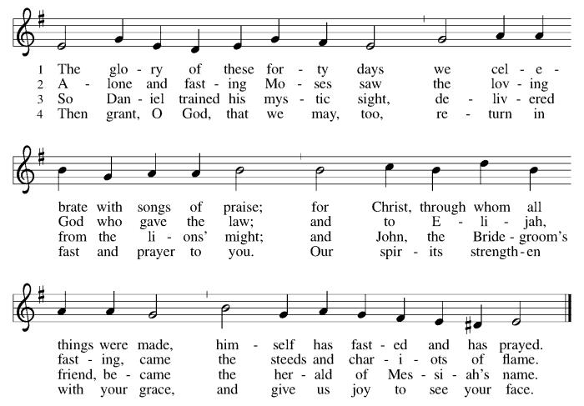

*Pastoral Greeting

P: The Grace of our Lord Jesus Christ, the love of God, and the communion of the Holy Spirit be with you all.

C: And also with you!

Kyrie:

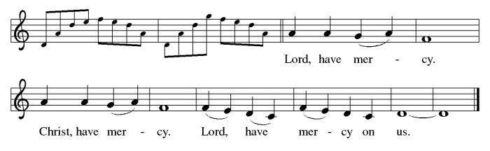

*Prayer of the Day
P: Merciful God, the fountain of living water, you quench our thirst and wash away our sin. Give us this water always. Bring us to drink from the well that flows with the beauty of your truth through Jesus Christ, our Savior and Lord, who lives and reigns with you and the Holy Spirit, one God, now and forever.
C: Amen!

+WORD+

First Reading: Exodus 17:1-7
Because the thirsty Israelites quarreled with Moses and put God to the test, Moses cried out in desperation to God. God commanded Moses to strike the rock to provide water for the people. The doubt-filled question—“Is the Lord among us or not?”—received a very positive answer.

¹ From the wilderness of Sin the whole congregation of the Israelites journeyed by stages, as the Lord commanded. They camped at Rephidim, but there was no water for the people to drink. ² The people quarreled with Moses and said, “Give us water to drink.” Moses said to them, “Why do you quarrel with me? Why do you test the Lord?” ³ But the people thirsted there for water, and the people complained against Moses and said, “Why did you bring us out of Egypt, to kill us and our children and livestock with thirst?” ⁴ So Moses cried out to the Lord, “What shall I do for this people? They are almost ready to stone me.” ⁵ The Lord said to Moses, “Go on ahead of the people and take some of the elders of Israel with you; take in your hand the staff with which you struck the Nile and go. ⁶ I will be standing there in front of you on the rock at Horeb. Strike the rock, and water will come out of it, so that the people may drink.” Moses did so, in the sight of the elders of Israel. ⁷ He called the place Massah and Meribah, because the Israelites quarreled and tested the Lord, saying, “Is the Lord among us or not?”

Psalm: Psalm 95
Let us shout for joy to the rock of our salvation. (Ps. 95:1)

¹ Come, let us sing | to the Lord;
let us shout for joy to the rock of | our salvation.
² Let us come before God’s presence | with thanksgiving
and raise a loud shout to the | Lord with psalms.
³ For you, Lord, | are a great God,
and a great ruler a- | bove all gods.
⁴ In your hand are the caverns | of the earth;
the heights of the hills are | also yours.
⁵ The sea is yours, | for you made it,
and your hands have molded | the dry land.
⁶ Come, let us worship | and bow down,
let us kneel before the | Lord our maker.
⁷ For the Lord is our God, and we are the people of God’s pasture and the sheep | of God’s hand.
Oh, that today you would | hear God’s voice!
⁸ “Harden | not your hearts,
as at Meribah, as on that day at Massah | in the desert.
⁹ There your ancestors | tested me,
they put me to the test, though they had | seen my works.
¹⁰ Forty years I loathed that gener- | ation, saying,
‘The heart of this people goes astray; they do not | know my ways.’
¹¹ Indeed I swore | in my anger,
‘They shall never come | to my rest.’ ”

Second Reading: Romans 5:1-11
Though we often hear that God helps those who help themselves, here Paul tells us that through Jesus’ death God helps utterly helpless sinners. Since we who had been enemies are reconciled to God in the cross, we now live in hope for our final salvation.

¹ Since we are justified by faith, we have peace with God through our Lord Jesus Christ, ² through whom we have obtained access to this grace in which we stand, and we boast in our hope of sharing the glory of God. ³ And not only that, but we also boast in our afflictions, knowing that affliction produces endurance, ⁴ and endurance produces character, and character produces hope, ⁵ and hope does not put us to shame, because God’s love has been poured into our hearts through the Holy Spirit that has been given to us.
⁶ For while we were still weak, at the right time Christ died for the ungodly. ⁷ Indeed, rarely will anyone die for a righteous person—though perhaps for a good person someone might actually dare to die. ⁸ But God proves his love for us in that while we still were sinners Christ died for us. ⁹ Much more surely, therefore, since we have now been justified by his blood, will we be saved through him from the wrath of God. ¹⁰ For if while we were enemies we were reconciled to God through the death of his Son, much more surely, having been reconciled, will we be saved by his life. ¹¹ But more than that, we even boast in God through our Lord Jesus Christ, through whom we have now received reconciliation.

Gospel Acclamation
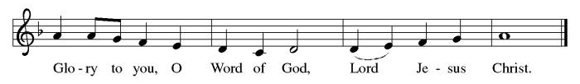

P: The Holy Gospel According to St. John 4th Chapter
C: Glory to You O Lord!

Gospel: John 4:5-42
Jesus defies convention to engage a Samaritan woman in conversation. Her testimony, in turn, leads many others to faith.

⁵ [Jesus] came to a Samaritan city called Sychar, near the plot of ground that Jacob had given to his son Joseph.⁶ Jacob’s well was there, and Jesus, tired out by his journey, was sitting by the well. It was about noon.
⁷ A Samaritan woman came to draw water, and Jesus said to her, “Give me a drink.” ⁸ (His disciples had gone to the city to buy food.) ⁹ The Samaritan woman said to him, “How is it that you, a Jew, ask a drink of me, a woman of Samaria?” (Jews do not share things in common with Samaritans.) ¹⁰ Jesus answered her, “If you knew the gift of God and who it is that is saying to you, ‘Give me a drink,’ you would have asked him, and he would have given you living water.” ¹¹ The woman said to him, “Sir, you have no bucket, and the well is deep. Where do you get that living water? ¹² Are you greater than our ancestor Jacob, who gave us the well and with his sons and his flocks drank from it?” ¹³ Jesus said to her, “Everyone who drinks of this water will be thirsty again, ¹⁴ but those who drink of the water that I will give them will never be thirsty. The water that I will give will become in them a spring of water gushing up to eternal life.” ¹⁵ The woman said to him, “Sir, give me this water, so that I may never be thirsty or have to keep coming here to draw water.”
¹⁶ Jesus said to her, “Go, call your husband, and come back.” ¹⁷ The woman answered him, “I have no husband.” Jesus said to her, “You are right in saying, ‘I have no husband,’ ¹⁸ for you have had five husbands, and the one you have now is not your husband. What you have said is true!” ¹⁹ The woman said to him, “Sir, I see that you are a prophet. ²⁰ Our ancestors worshiped on this mountain, but you say that the place where people must worship is in Jerusalem.” ²¹ Jesus said to her, “Woman, believe me, the hour is coming when you will worship the Father neither on this mountain nor in Jerusalem. ²² You worship what you do not know; we worship what we know, for salvation is from the Jews. ²³ But the hour is coming and is now here when the true worshipers will worship the Father in spirit and truth, for the Father seeks such as these to worship him. ²⁴ God is spirit, and those who worship him must worship in spirit and truth.” ²⁵ The woman said to him, “I know that Messiah is coming” (who is called Christ). “When he comes, he will proclaim all things to us.” ²⁶ Jesus said to her, “I am he, the one who is speaking to you.”
²⁷ Just then his disciples came. They were astonished that he was speaking with a woman, but no one said, “What do you want?” or, “Why are you speaking with her?” ²⁸ Then the woman left her water jar and went back to the city. She said to the people, ²⁹ “Come and see a man who told me everything I have ever done! He cannot be the Messiah, can he?” ³⁰ They left the city and were on their way to him.
³¹ Meanwhile the disciples were urging him, “Rabbi, eat something.” ³² But he said to them, “I have food to eat that you do not know about.” ³³ So the disciples said to one another, “Surely no one has brought him something to eat?” ³⁴ Jesus said to them, “My food is to do the will of him who sent me and to complete his work. ³⁵ Do you not say, ‘Four months more, then comes the harvest’? But I tell you, look around you, and see how the fields are ripe for harvesting. ³⁶ The reaper is already receiving wages and is gathering fruit for eternal life, so that sower and reaper may rejoice together. ³⁷ For here the saying holds true, ‘One sows and another reaps.’ ³⁸ I sent you to reap that for which you did not labor. Others have labored, and you have entered into their labor.”
³⁹ Many Samaritans from that city believed in him because of the woman’s testimony, “He told me everything I have ever done.” ⁴⁰ So when the Samaritans came to him, they asked him to stay with them, and he stayed there two days. ⁴¹ And many more believed because of his word. ⁴² They said to the woman, “It is no longer because of what you said that we believe, for we have heard for ourselves, and we know that this is truly the Savior of the world.”

P: The Gospel of the Lord
C: Praise to you, O Christ!

Sermon

*Hymn of the Day ELW 623 Rock of Ages, Cleft for Me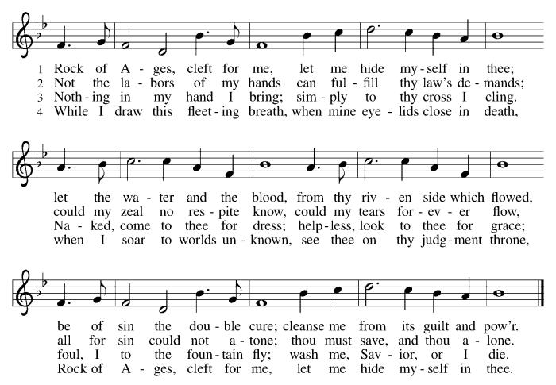

Nicene Creed
We believe in one God,
the Father, the Almighty,
maker of heaven and earth,
of all that is, seen and unseen.
We believe in one Lord, Jesus Christ,
the only Son of God,
eternally begotten of the Father,
God from God, Light from Light,
true God from true God,
begotten, not made,
of one Being with the Father;
through him all things were made.
For us and for our salvation
he came down from heaven,
was incarnate of the Holy Spirit and the virgin Mary
and became truly human.
For our sake he was crucified under Pontius Pilate;
he suffered death and was buried.
On the third day he rose again
in accordance with the scriptures;
he ascended into heaven
and is seated at the right hand of the Father.
He will come again in glory to judge the living and the dead,
and his kingdom will have no end.
We believe in the Holy Spirit, the Lord, the giver of life,
who proceeds from the Father and the Son,*
who with the Father and the Son is worshiped and glorified,
who has spoken through the prophets.
We believe in one holy catholic and apostolic church.
We acknowledge one baptism for the forgiveness of sins.
We look for the resurrection of the dead,
and the life of the world to come. Amen.

*Prayers of Intercession
Reconciled by God’s mercy and sustained by God’s presence, let us pray for the world and its needs.
A brief silence.
O God, when suffering arises, preserve your church. Give to pastors, deacons, bishops, and all servants of your gospel the endurance that produces character and the hope that will never disappoint. Hear us, O God.
C:Your mercy is great.
When the waters run dry, sustain this earth. Send water to places languishing with drought (especially), and bring relief to places damaged by floods (especially). Hear us, O God.
C:Your mercy is great.
When quarrels ensue, soften our hearts. Quell hostilities between nations and peoples, and reconcile all humans across the lines of race, class, nationality, moral conviction, religion, and all else that divides or oppresses. Hear us, O God.
C:Your mercy is great.
When your people thirst, satisfy their needs. Send water and food to all who need nourishment. Grant welcome to all who are excluded. Show your mercy to any in need (especially). Hear us, O God.
C:Your mercy is great.
When we gather to worship, send us your Spirit. Renew our hearts through the joyful noise we make and bless the work of our church musicians and musical ensembles (especially). Hear us, O God.
C:Your mercy is great.
Here other intercessions may be offered.
O God, when death draws near, we rejoice in the promise of life with you. We remember all who have entered eternal rest, and we pray that you bring us the hope of sharing in your glory. Hear us, O God.
C:Your mercy is great.
Receive our prayers, O God, through Jesus Christ, our strength and salvation.
C: Amen.

Greeting of Peace
P: The peace of Christ be with you always!
C: And also with you!

Offering (Thank you for your support for our ministry!)

*Doxology ELW 186 Create in Me a Clean Heart
(Please stand and join in singing as we share our gifts!)
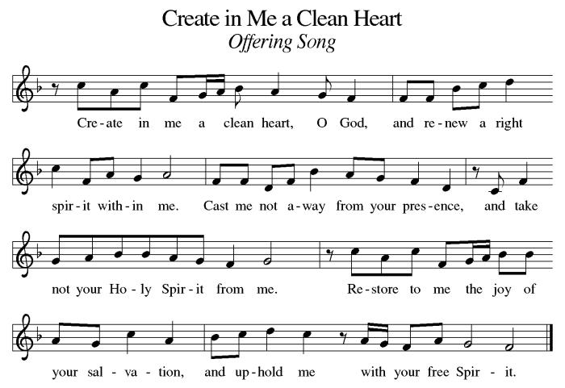

*Offering Prayer
A: O God, maker of heaven and earth,
C: your steadfast love embraces all creation.
You send rain and sunshine to nourish the earth
and bring forth its bounty.
Through these gifts of bread and wine,
draw us into the death and life of your Son,
who calls us to bear witness to his saving work.
We ask this in Jesus’ name.
Amen!

+MEAL+
*Great Thanksgiving
P: The Lord be with you.
C: And also with you.

P: Lift up your hearts.
C: We lift them to the Lord.

P: Let us give thanks to the Lord our God.
C: It is right to give our thanks and praise.

P: It is indeed right, our duty and our joy,
that we should at all times and in all places
give thanks and praise to you, almighty and merciful God,
through our Savior Jesus Christ.
You call your people to cleanse their hearts
and prepare with joy for the paschal feast,
that, renewed in the gift of baptism,
we may come to the fullness of your grace.
And so, with all the choirs of angels,
with the church on earth and the hosts of heaven,
we praise your name and join their unending hymn:

*Sanctus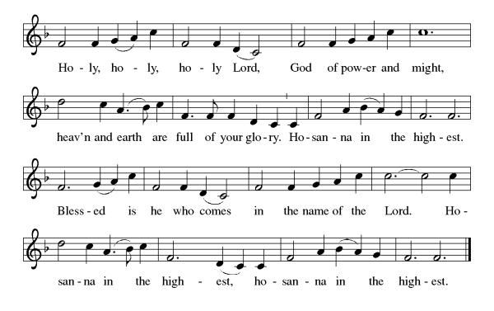
*Eucharistic Prayer
P: Holy, mighty, and merciful Lord,
heaven and earth are full of your glory.

In great love you sent to us Jesus, your Son,
who reached out to heal the sick and suffering,
who preached good news to the poor,
and who, on the cross, opened his arms to all.

In the night in which he was betrayed,
our Lord Jesus took bread, and gave thanks;
broke it, and gave it to his disciples, saying:
Take and eat; this is my body, given for you.
Do this for the remembrance of me.

Again, after supper, he took the cup, gave thanks,
and gave it for all to drink, saying:
This cup is the new covenant in my blood,
shed for you and for all people for the forgiveness of sin.
Do this for the remembrance of me.

Remembering, therefore, his death, resurrection, and ascension,
we await his coming in glory.

Pour out upon us the Spirit of your love, O Lord,
and unite the wills of all who share this heavenly food,
the body and blood of Jesus Christ, our Lord;
to whom, with you and the Holy Spirit,
be all honor and glory, now and forever.

C: Amen!

*THE LORD’S PRAYER
Our Father, who art in heaven,
hallowed be thy name,
thy kingdom come,
thy will be done,
on earth as it is in heaven.
Give us this day our daily bread;
and forgive us our trespasses,
as we forgive those
who trespass against us;
and lead us not into temptation,
but deliver us from evil.
For thine is the kingdom,
and the power, and the glory,
forever and ever. Amen.
*Lamb of God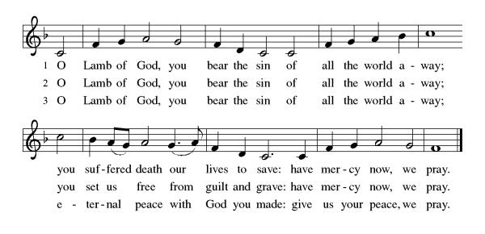

Spiritual Communion Prayer
P: Let us pray for the communion of all present here, those viewing our service virtually, those in our hearts and in our world.
C: Lord Jesus, I believe you are truly present in the Sacrament of Holy Communion. When I cannot receive Communion, I pray that you come into my heart. I know that nothing in Heaven or on earth can separate me from your love. Amen.

Invitation to Communion
P: Come to the table.
Feast on God’s goodness and mercy.
C: Thanks be to God!

(All are invited to the communion rail following the guidance of the ushers. Communion will be shared through the host and individual cups. If you would like communion but are unable to join us at the rail, please alert the usher!)

Communion Hymns (Please join in singing!)
ELW 658 O Jesus, Joy of Loving Hearts
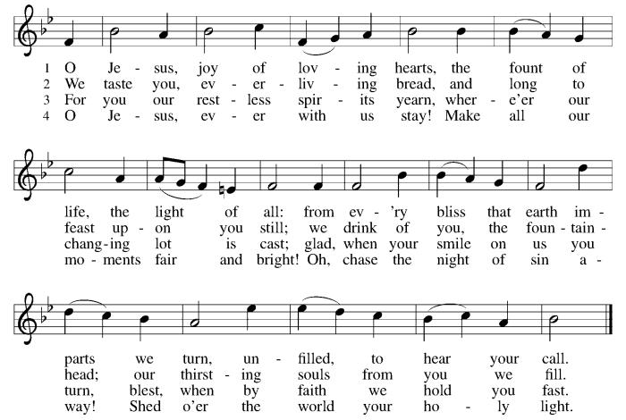

ELW 331 As the Deer Runs to the River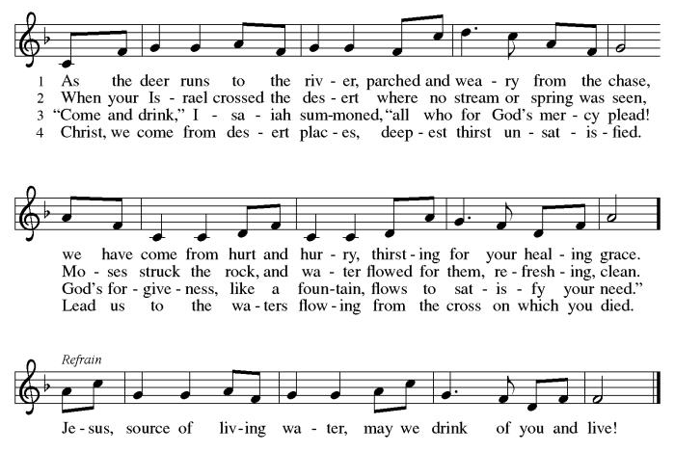

*Prayer after Communion
A: God of our salvation,
we give you thanks for this meal that restores our souls,
reconciles us to you, and strengthens us for the journey.
Through the body and blood of your Son,
may we become Christ’s body in the world,
bearing witness to your love for all creation,
through Jesus Christ, our Savior and Lord.
C: Amen.
+Sending+

*Blessing
P: Receive the blessing of the holy Trinity:
God, who calls all things into existence,
Jesus Christ, who redeems us,
and the Holy Spirit, whose breath sustains creation,
☩ bless you now and always. C: Amen!

*Sending Hymn ELW 624 Jesus, Still Lead On
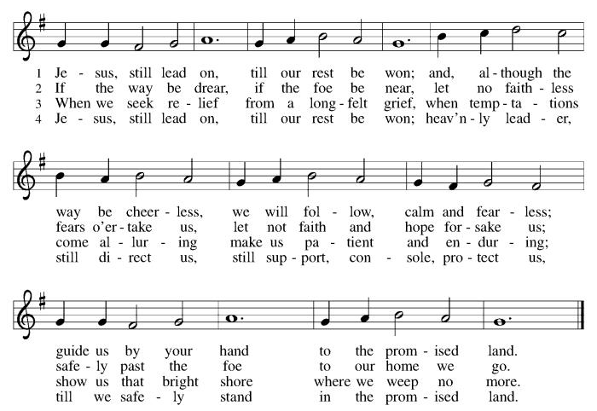

*Dismissal
A: Go in peace. Believe the good news.
C: Thanks be to God!

Postlude

Copyright © 2020 Augsburg Fortress. All rights reserved. Reprinted by permission under Augsburg Fortress Liturgies Annual License #SB106907. New Revised Standard Version Bible, Copyright © 1989, Division of Christian Education of the National Council of the Churches of Christ in the United States of America. Used by permission. All rights reserved. Revised Common Lectionary, Copyright © 1992 Consultation on Common Texts, admin Augsburg Fortress. Used by permission.

Treasurer’s Report

Monthly Financial Snapshot
Category | Actual | Budget | +/- vs Budget | Status
January Results
January Income | $18,830 | $19,167 | -$337 ▼ | Attention
January Expenses | $22,199 | $22,626 | -$427 ▲ | On Track
January Net Surplus/Deficit | -$3,369 | -$3,460 | $90 ▲ | On Track
Year-To-Date Results
YTD Income | $18,830 | $19,167 | -$337 ▼ | Attention
YTD Expenses | $22,199 | $22,626 | -$427 ▲ | On Track
YTD Net Surplus/Deficit | -$3,369 | -$3,460 | $90 ▲ | On Track
2026 Challenge Results
Timeframe | Actual | Goal | +/- vs Goal | % of Goal
January Income | $18,830 | $20,367 | -$1,537 ▼ | 92%
YTD Income | $18,830 | $20,367 | -$1,537 ▼ | 92%
HTLC’s 2026 finances are off to a steady start, with expenses running under budget and

January giving reaching 92% of our Challenge goal. As we work to increase giving by $28,000 over 2025, please prayerfully consider increasing your pledge or using recurring e-giving to help us meet the Challenge and strengthen our ministry for the year ahead. The QR Code can be used to access the Church's e-giving portal.

Worship Volunteer Schedule
Date | Asst. Min | Usher | Sacristan | Lector | Counter
February 22 | Elaine Bradford | The Gripps | Nancy Poole | Bill Spreen | Socha/Giordano
March 1 | Charlie Rugg | Gary Joblon | Pat Pienkos | Cynthia Kazmac | Bohner/Volk
March 8 | Linda Coleman | Keith Bennett | Joanne Giordano | Emily Kaster | Carleo/Csernica
March 15 | Keith Bennett | Jill Socha | Carol Rosen | Jeff Ridberg | Bradford/Foard
March 22 | Chris Foard | Kathy Caputo | Joanne Giordano | Bill Spreen | McKenna/Kazmac
March 29 | Charlie Rugg | Jill Socha | Helga Britton | Molly Foard | Coleman/Giordano

Coffee Hour-

ANNOUNCEMENTS Thank you! To all who consistently support our church and ministries through your time, talent, and treasure. Please help us grow by inviting your friends and family to worship and events. You are what makes Holy Trinity a wonderful church family!

Stay in touch! Please visit our church website, www.htlcredbank.org for updates and information. You can also find us on Facebook and view services online. The office is open from 9am to 2pm, Monday to Thursday.

100 Anniversary Committee- If you are interested in being a part of the committee to help plan the 100th anniversary celebration of HTLC in 2028, please sign up in the red book. All are welcome! Also, the committee will be looking for photos and documents of HTLC throughout the years. If you have anything to share, please bring them to the church and marked envelopes or email electronic copies to the church office.

Name Tag Sundays: On the first Sunday of each month, names tags and markers will be at each entrance of the sanctuary. Please fill out a tag and wear one for worship and for coffee hour to welcome visitors and help newcomers put names to faces.

Sunday School in the New Year, we will continue to study stories and lessons from the Old Testament beginning with Jacob. Kids will love the crafts, songs and games that accompany each lesson.
The following dates there will be Sunday School:
Jan- 11 and 25, Feb- 8 and 22, March- 1, 15 and 29*Easter Egg Hunt!
April- 12 and 26, May- 3, 17 and 31, June- 7 and 14
As was done in the fall, there will be opportunities to volunteer as SS lead teacher. A signup will be emailed out shortly and will also be posted in the red binder. Consider signing up! All lesson materials will be supplied and laid out and a leader guide will be emailed to volunteers approximately 1 week in advance. Blessings for a wonderful 2026!~Lauren

The Finance Committee invites you to meet in the sanctuary after the service on March 15th for a discussion of Legacy Gifts and Planned Giving. We will form a small working group to become a resource for members interested in charitable bequests and the means by which lifetime donations can generate income for the donor. Topics will include some straight forward information about the estate planning process and some tax-advantaged concepts that magnify our ability to support the church and other charities we care about. If you have an interest in this work but cannot attend, please contact Roger Foss (Cell 732.693.3574 and Office 732.741.2525)

WELCA- we would like to schedule a quick meeting after church in March 15th. As a group we can share the success of Trivia Night, the agency to collect from the event, and future donations like a Cross Roads tee sign. Any questions, please contact Jill Socha

Easter Breakfast
Our Easter Food Drive is Coming!
Again this year, WELCA is collecting requested foods for Lutheran Social Ministries of NJ to distribute in April. Food will be collected during February and March, and we hope to fill at least 35 grocery bags!. Watch for the labeled bins at the side door to the church and thanks for your help. We need the following food items:
  - Boxed potatoes- Rice - Pasta - Mac & Cheese
  - Canned Vegetables and Beans canned fruit or Pineapple or Apple Sauce
  - Small Olive or Canola Oil
  - Corn Bread/Muffin Mix - Carnation Milk Can
  - Cake Mix and Frosting or Brown Sugar

Choir The Holy Trinity Choir welcomes our singers back for a preparation rehearsal on Sunday, September 7th at 9am in the church hall. All are welcome to join us in song as often as you are able. Choir meets each Sunday at 9am to practice and prepare our music. Join us and help us grow by spreading the word about the HTLC Choir!

Quilting- The Quilters need gently used any bed sheets of any size! Please leave any donations in the quilters closet in Fellowship Hall. Thank you!

Quilters Need Help
If anyone is traveling through Mechanicsville, PA, and can add a few extra minutes to your trip, the warehouse for shipping quilts, school kits, etc is located directly off one of the exits.
We accumulate many quilts throughout the year and we would appreciate sending some quilts with you to deliver. Any questions, please call Sherry Lee or Elaine Theophall.

Weekly Quilting on Wednesdays at 9:30. Bring your lunch and enjoy some fellowship at noon. All are welcome.

Evening Quilting Evening Quilting –
Please share this information . This is an important ministry that helps so many. It’s very easy and you don’t need to know how to sew. We have a great time socializing too! We will meet: Jan. 21, Feb. 18, March 18 at 6:00 PM. Note: If we have to cancel I will send an email. Please let me know only if you can come. Contacts: Pat Pienkos 732-513-9615 Debbie Yetka 908-461-4084 Looking forward to seeing you all!

The Souper Bowl of Caring fundraising project, held on Sunday 2/8, raised $129.82. The church Social Outreach Ministry will be sending Lunch Break a check with a donation of $129.82.

Social Ministry
*Year-round collections will continue for food items for Lunch Break. There is a sign-up sheet in the red book for those who can help drop these items to Lunch Break.
*We will also collect adult men's socks to periodically drop at the Red Bank Warminq Center.
*For those interested in the Heartwarminq Center — the new women's shelter is adjacent to the First Baptist Church of Red Bank at 90 Maple Ave. You can follow up on this mission through their website - https://www.thefeastnj.org- On this site, they also include wish list items that can be purchased through amazon. We will be exploring purchasing some of these through a Thrivent card. If you want to purchase on your own, you can leave items at church, and the Social Ministry will deliver them.

Pastoral Care and Prayer... We are here to care for and pray! Please contact the office to add or adjust prayer requests. If you or someone you know needs pastoral care, please contact the office and Pastor Mack!

THANK YOU for supporting and sustaining our church and ministries! All are welcome here! Please invite your family and friends to worship with us! Find us online at www.htlcredbank.org


