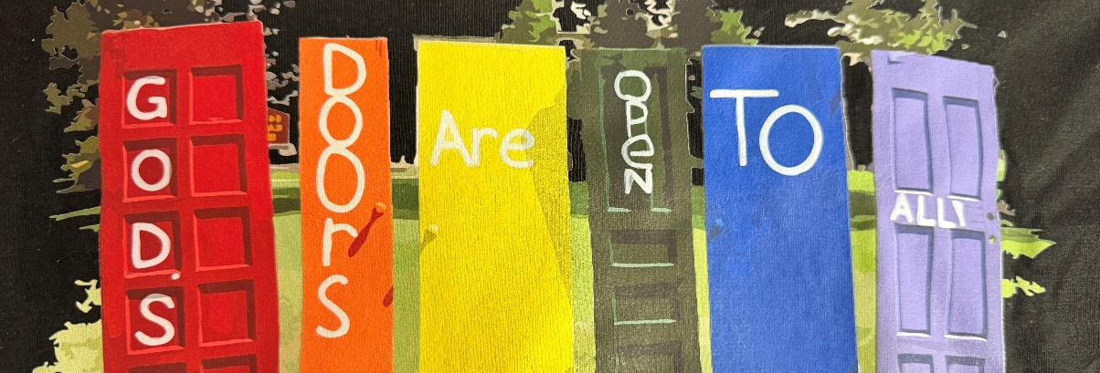
Parkside Lutheran Apparel Sale
Proclaim GOD'S DOORS ARE OPEN TO ALL with a Parkside Lutheran t-shirt and/or hoodie!

Perfect to wear at the Pride Parade, Burrito Project, God's Work-Our Hands, or any other time you wish to share the radical love of Jesus.

All options will come in black fabric and feature a full color image of our rainbow doors on the front and our values on the back. (Proclaiming Grace, Practicing Hospitality, Loving Boldly, Cultivating Community)

$20 - Youth T-Shirts
$25 - Adult T-Shirts, Premium Fabric - Unisex or Ladies Cut
$40 - Hoodie - available in Youth and Adult sizes


Scan code to complete the order form
(https://forms.gle/ziXpgbuDNqocYhAR8)

Please submit orders and payment
by Sunday, May 10, 2026

