Holy Trinity Lutheran Church
150 River Road Red Bank, NJ 07701
Church Office: (732) 741-9241 Fax: (732) 741-9577
email: holytrinitychurch4@verizon.net
Website: htlcredbank.org
Pastor: Rev. John Mack, Jr.
Cell: (336)-392-5839
Minister of Music: Peter Isherwood
Parish Administrator: Deanna Vergari
Council President: Cynthia Kazmac

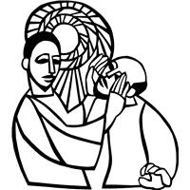

March 15, 2026

Fourth Sunday in Lent

Introduction
Baptism is sometimes called enlightenment. The gospel for this Sunday is the story of the man born blind healed by Christ. “I was blind, now I see,” declares the man. In baptism God opens our eyes to see the truth of who we are: God’s beloved children. As David was anointed king of Israel, in baptism God anoints our head with oil, and calls us to bear witness to the light of Christ in our daily lives.

Welcome & Announcements (Please remember to silence your cell phone!)

Prelude (We prayerfully prepare our hearts and minds to worship!)

+ GATHERING +

Confession and Forgiveness
All may make the sign of the cross, the sign that is marked at baptism, as the presiding minister begins.
P:Blessed be the holy Trinity, ☩ one God,
who forgives all our sin,
whose mercy endures forever.
C:Amen.
P:Let us confess our sin before God, who removes our guilt
and blots out all offenses.
Silence is kept for reflection.
Gracious God,
C:have mercy on us according to your steadfast love.
P:For seeking worldly delights that deceive us and dishonor you:
Gracious God,
have mercy on us according to your steadfast love.
For desiring self-reliance instead of hungering for your word:
Gracious God,
C:have mercy on us according to your steadfast love.
P:For failing to recognize your coming reign,
and for hindering the work of the Spirit: Gracious God,
C:have mercy on us according to your steadfast love.
P:For drawing from the well of self-serving ambition,
and for disdaining the living water Christ offers: Gracious God,
C:have mercy on us according to your steadfast love.
P:For disregarding voices from the margin,
and for distrusting signs of your healing and hope in the world:
Gracious God,
C:have mercy on us according to your steadfast love.
P:For dwelling in tombs of self-pity and discontent,
and for disregarding Christ’s call to come forth to life:
Gracious God,
C:have mercy on us according to your steadfast love.
P:God’s steadfast love, grace, and forgiveness abound.
Through faith, the free gift of God,
you have been clothed in the righteousness of Christ.
In the name of ☩ Jesus Christ, your sins are forgiven.
The Spirit of the One who raised Christ from the dead
dwells in you,
pours God’s love into your hearts,
and gives you life and peace.
C:Amen.

*Gathering Hymn ELW 320 The Glory of These Forty Days (v.3&4)
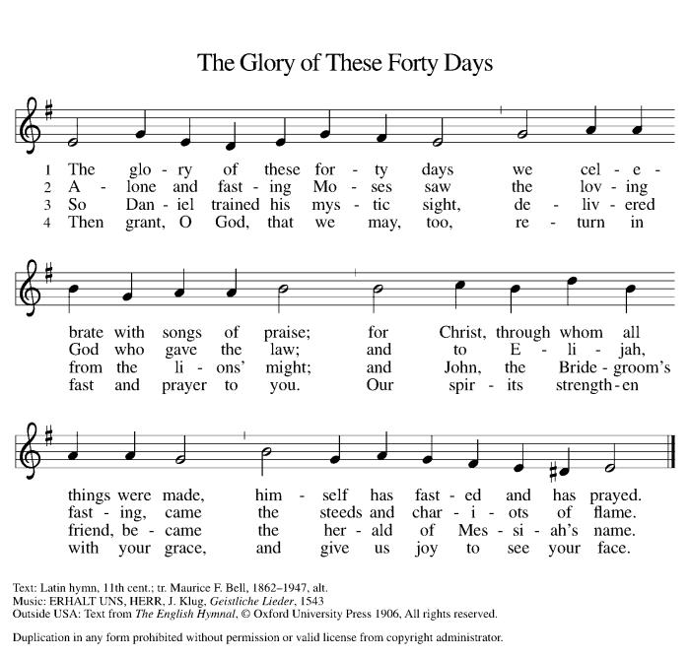

*Pastoral Greeting

P: The Grace of our Lord Jesus Christ, the love of God, and the communion of the Holy Spirit be with you all.

C: And also with you!

Kyrie: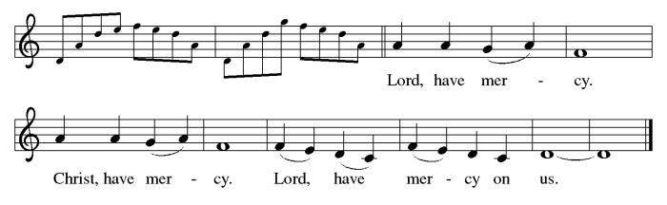

*Prayer of the Day
P: Bend your ear to our prayers, Lord Christ, and come among us. By your gracious life and death for us, bring light into the darkness of our hearts, and anoint us with your Spirit, for you live and reign with the Father and the Holy Spirit, one God, now and forever.
C: Amen!

Children’s Message

+WORD+

First Reading: 1 Samuel 16:1-13
Samuel anointed David even though he was the eighth-oldest son of Jesse and did not match his brothers in height or other physical characteristics. With the anointing came endowment with the Spirit of the Lord, designating David as the Lord’s chosen successor to Saul.

¹ The Lord said to Samuel, “How long will you grieve over Saul? I have rejected him from being king over Israel. Fill your horn with oil and set out; I will send you to Jesse the Bethlehemite, for I have provided for myself a king among his sons.” ² Samuel said, “How can I go? If Saul hears of it, he will kill me.” And the Lord said, “Take a heifer with you and say, ‘I have come to sacrifice to the Lord.’ ³ Invite Jesse to the sacrifice, and I will show you what you shall do, and you shall anoint for me the one whom I name to you.” ⁴ Samuel did what the Lord commanded and came to Bethlehem. The elders of the city came to meet him trembling and said, “Do you come peaceably?” ⁵ He said, “Peaceably. I have come to sacrifice to the Lord; sanctify yourselves and come with me to the sacrifice.” And he sanctified Jesse and his sons and invited them to the sacrifice.
⁶ When they came, he looked on Eliab and thought, “Surely his anointed is now before the Lord.” ⁷ But the Lord said to Samuel, “Do not look on his appearance or on the height of his stature, because I have rejected him, for the Lord does not see as mortals see; they look on the outward appearance, but the Lord looks on the heart.” ⁸ Then Jesse called Abinadab and made him pass before Samuel. He said, “Neither has the Lord chosen this one.” ⁹ Then Jesse made Shammah pass by. And he said, “Neither has the Lord chosen this one.” ¹⁰ Jesse made seven of his sons pass before Samuel, and Samuel said to Jesse, “The Lord has not chosen any of these.” ¹¹ Samuel said to Jesse, “Are all your sons here?” And he said, “There remains yet the youngest, but he is keeping the sheep.” And Samuel said to Jesse, “Send and bring him, for we will not sit down until he comes here.” ¹² He sent and brought him in. Now he was ruddy and had beautiful eyes and was handsome. The Lord said, “Rise and anoint him, for this is the one.” ¹³ Then Samuel took the horn of oil and anointed him in the presence of his brothers, and the spirit of the Lord came mightily upon David from that day forward. Samuel then set out and went to Ramah.

Psalm: Psalm 23
You anoint my head with oil. (Ps. 23:5)

¹ The Lord | is my shepherd;
I shall not | be in want.
² The Lord makes me lie down | in green pastures
and leads me be- | side still waters.
³ You restore my | soul, O Lord,
and guide me along right pathways | for your name’s sake.
⁴ Though I walk through the valley of the shadow of death, I shall | fear no evil;
for you are with me; your rod and your staff, they | comfort me.
⁵ You prepare a table before me in the presence | of my enemies;
you anoint my head with oil, and my cup is | running over.
⁶ Surely goodness and mercy shall follow me all the days | of my life,
and I will dwell in the house of the | Lord forever.

Second Reading: Ephesians 5:8-14
Because we now live in the divine light which is Jesus Christ, we conduct our lives in ways that reflect the light of Christ, so that our activity is truly pleasing to God.

⁸ Once you were darkness, but now in the Lord you are light. Walk as children of light, ⁹ for the fruit of the light is found in all that is good and right and true. ¹⁰ Try to find out what is pleasing to the Lord. ¹¹ Take no part in the unfruitful works of darkness; rather, expose them. ¹² For it is shameful even to mention what such people do secretly, ¹³ but everything exposed by the light becomes visible, ¹⁴ for everything that becomes visible is light. Therefore it says,
“Sleeper, awake!
Rise from the dead,
and Christ will shine on you.”

Gospel Acclamation
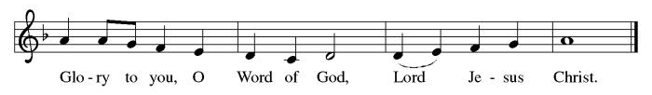

P: The Holy Gospel According to St. John 9th Chapter
C: Glory to You O Lord!

Gospel: John 9:1-41
Jesus heals a man born blind, provoking a hostile reaction that he regards as spiritual blindness to the things of God.

¹ As [Jesus] walked along, he saw a man blind from birth. ² His disciples asked him, “Rabbi, who sinned, this man or his parents, that he was born blind?” ³ Jesus answered, “Neither this man nor his parents sinned; he was born blind so that God’s works might be revealed in him. ⁴ We must work the works of him who sent me while it is day; night is coming, when no one can work. ⁵ As long as I am in the world, I am the light of the world.” ⁶ When he had said this, he spat on the ground and made mud with the saliva and spread the mud on the man’s eyes, ⁷ saying to him, “Go, wash in the pool of Siloam” (which means Sent). Then he went and washed and came back able to see. ⁸ The neighbors and those who had seen him before as a beggar began to ask, “Is this not the man who used to sit and beg?” ⁹ Some were saying, “It is he.” Others were saying, “No, but it is someone like him.” He kept saying, “I am he.” ¹⁰ But they kept asking him, “Then how were your eyes opened?” ¹¹ He answered, “The man called Jesus made mud, spread it on my eyes, and said to me, ‘Go to Siloam and wash.’ Then I went and washed and received my sight.” ¹² They said to him, “Where is he?” He said, “I do not know.”
¹³ They brought to the Pharisees the man who had formerly been blind. ¹⁴ Now it was a Sabbath day when Jesus made the mud and opened his eyes. ¹⁵ Then the Pharisees also began to ask him how he had received his sight. He said to them, “He put mud on my eyes. Then I washed, and now I see.” ¹⁶ Some of the Pharisees said, “This man is not from God, for he does not observe the Sabbath.” Others said, “How can a man who is a sinner perform such signs?” And they were divided. ¹⁷ So they said again to the blind man, “What do you say about him? It was your eyes he opened.” He said, “He is a prophet.”
¹⁸ The Jews did not believe that he had been blind and had received his sight until they called the parents of the man who had received his sight ¹⁹ and asked them, “Is this your son, who you say was born blind? How then does he now see?” ²⁰ His parents answered, “We know that this is our son and that he was born blind, ²¹ but we do not know how it is that now he sees, nor do we know who opened his eyes. Ask him; he is of age. He will speak for himself.” ²² His parents said this because they were afraid of the Jews, for the Jews had already agreed that anyone who confessed Jesus to be the Messiah would be put out of the synagogue. ²³ Therefore his parents said, “He is of age; ask him.”
²⁴ So for the second time they called the man who had been blind, and they said to him, “Give glory to God! We know that this man is a sinner.” ²⁵ He answered, “I do not know whether he is a sinner. One thing I do know, that though I was blind, now I see.” ²⁶ They said to him, “What did he do to you? How did he open your eyes?” ²⁷ He answered them, “I have told you already, and you would not listen. Why do you want to hear it again? Do you also want to become his disciples?” ²⁸ Then they reviled him, saying, “You are his disciple, but we are disciples of Moses. ²⁹ We know that God has spoken to Moses, but as for this man, we do not know where he comes from.” ³⁰ The man answered, “Here is an astonishing thing! You do not know where he comes from, yet he opened my eyes. ³¹ We know that God does not listen to sinners, but he does listen to one who worships him and obeys his will. ³² Never since the world began has it been heard that anyone opened the eyes of a person born blind. ³³ If this man were not from God, he could do nothing.” ³⁴ They answered him, “You were born entirely in sins, and are you trying to teach us?” And they drove him out.
³⁵ Jesus heard that they had driven him out, and when he found him he said, “Do you believe in the Son of Man?” ³⁶ He answered, “And who is he, sir? Tell me, so that I may believe in him.” ³⁷ Jesus said to him, “You have seen him, and the one speaking with you is he.” ³⁸ He said, “Lord, I believe.” And he worshiped him. ³⁹ Jesus said, “I came into this world for judgment, so that those who do not see may see and those who do see may become blind.” ⁴⁰ Some of the Pharisees who were with him heard this and said to him, “Surely we are not blind, are we?” ⁴¹ Jesus said to them, “If you were blind, you would not have sin. But now that you say, ‘We see,’ your sin remains.”

P: The Gospel of the Lord
C: Praise to you, O Christ!

Sermon

*Hymn of the Day ELW 606 Our Father, We Have Wandered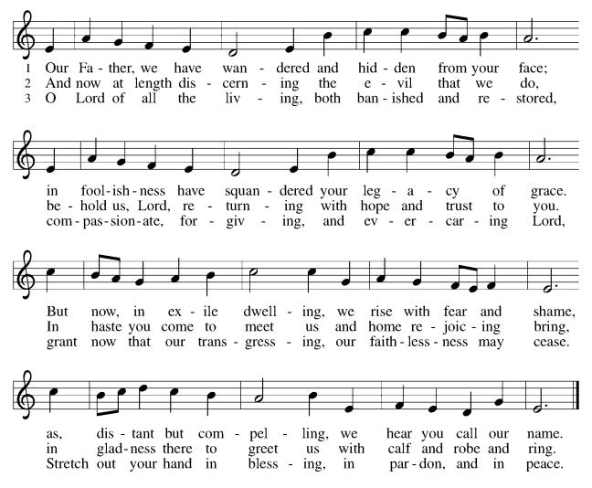

Nicene Creed
We believe in one God,
the Father, the Almighty,
maker of heaven and earth,
of all that is, seen and unseen.
We believe in one Lord, Jesus Christ,
the only Son of God,
eternally begotten of the Father,
God from God, Light from Light,
true God from true God,
begotten, not made,
of one Being with the Father;
through him all things were made.
For us and for our salvation
he came down from heaven,
was incarnate of the Holy Spirit and the virgin Mary
and became truly human.
For our sake he was crucified under Pontius Pilate;
he suffered death and was buried.
On the third day he rose again
in accordance with the scriptures;
he ascended into heaven
and is seated at the right hand of the Father.
He will come again in glory to judge the living and the dead,
and his kingdom will have no end.
We believe in the Holy Spirit, the Lord, the giver of life,
who proceeds from the Father and the Son,*
who with the Father and the Son is worshiped and glorified,
who has spoken through the prophets.
We believe in one holy catholic and apostolic church.
We acknowledge one baptism for the forgiveness of sins.
We look for the resurrection of the dead,
and the life of the world to come. Amen.

*Prayers of Intercession
Reconciled by God’s mercy and sustained by God’s presence, let us pray for the world and its needs.
A brief silence.
God, our shepherd, we pray that you guide the church. Lead Christians in our community (here local congregations may be named) and across the globe (here international companion churches and synods may be named) in right paths for your name’s sake. Hear us, O God.
C:Your mercy is great.
God our provider, we cry out for this planet and the life it holds. Rescue endangered animals and plants, preserve threatened ecosystems, and save creatures from natural disasters. Hear us, O God.
C:Your mercy is great.
God our sovereign, we plead for your peace on earth. Bring an end to war and violence, and raise up leaders in governments, courts, businesses, schools, and community organizations who seek goodness and mercy. Hear us, O God.
C:Your mercy is great.
God our healer, we call to you in our need. Uplift all who are made to feel unimportant, and transform the hearts of all infected by bigotry and prejudice. Care for all in special need this day (especially). Hear us, O God.
C:Your mercy is great.
God our friend, we praise you for the diversity of people among us. Awaken us to share and receive the gifts we each possess, and stir up a spirit of understanding, celebration, and welcome for all. Hear us, O God.
C:Your mercy is great.
Here other intercessions may be offered.
God our home, we thank you for all who have died and completed their baptismal journeys. Grant us faith to live until we too dwell in your house forever. Hear us, O God.
C:Your mercy is great.
Receive our prayers, O God, through Jesus Christ, our strength and salvation.
C: Amen.

Greeting of Peace
P: The peace of Christ be with you always!
C: And also with you!

Offering (Thank you for your support for our ministry!)

*Doxology ELW 186 Create in Me a Clean Heart
(Please stand and join in singing as we share our gifts!)
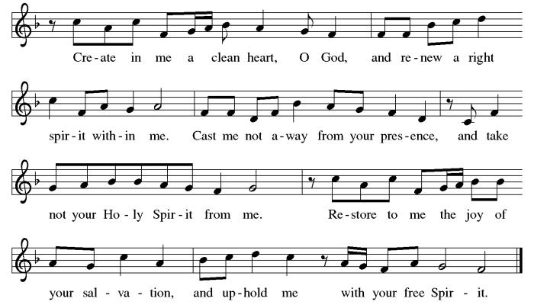

*Offering Prayer
A: O God, maker of heaven and earth,
C: your steadfast love embraces all creation.
You send rain and sunshine to nourish the earth
and bring forth its bounty.
Through these gifts of bread and wine,
draw us into the death and life of your Son,
who calls us to bear witness to his saving work.
We ask this in Jesus’ name.
Amen!

+MEAL+
*Great Thanksgiving
P: The Lord be with you.
C: And also with you.

P: Lift up your hearts.
C: We lift them to the Lord.

P: Let us give thanks to the Lord our God.
C: It is right to give our thanks and praise.

P: It is indeed right, our duty and our joy,
that we should at all times and in all places
give thanks and praise to you, almighty and merciful God,
through our Savior Jesus Christ.
You call your people to cleanse their hearts
and prepare with joy for the paschal feast,
that, renewed in the gift of baptism,
we may come to the fullness of your grace.
And so, with all the choirs of angels,
with the church on earth and the hosts of heaven,
we praise your name and join their unending hymn:

*Sanctus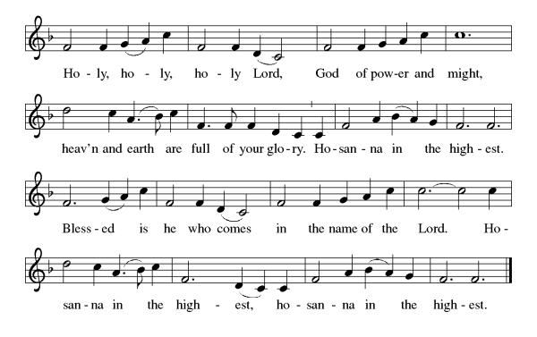
*Eucharistic Prayer
P: Holy, mighty, and merciful Lord,
heaven and earth are full of your glory.

In great love you sent to us Jesus, your Son,
who reached out to heal the sick and suffering,
who preached good news to the poor,
and who, on the cross, opened his arms to all.

In the night in which he was betrayed,
our Lord Jesus took bread, and gave thanks;
broke it, and gave it to his disciples, saying:
Take and eat; this is my body, given for you.
Do this for the remembrance of me.

Again, after supper, he took the cup, gave thanks,
and gave it for all to drink, saying:
This cup is the new covenant in my blood,
shed for you and for all people for the forgiveness of sin.
Do this for the remembrance of me.

Remembering, therefore, his death, resurrection, and ascension,
we await his coming in glory.

Pour out upon us the Spirit of your love, O Lord,
and unite the wills of all who share this heavenly food,
the body and blood of Jesus Christ, our Lord;
to whom, with you and the Holy Spirit,
be all honor and glory, now and forever.

C: Amen!

*THE LORD’S PRAYER
Our Father, who art in heaven,
hallowed be thy name,
thy kingdom come,
thy will be done,
on earth as it is in heaven.
Give us this day our daily bread;
and forgive us our trespasses,
as we forgive those
who trespass against us;
and lead us not into temptation,
but deliver us from evil.
For thine is the kingdom,
and the power, and the glory,
forever and ever. Amen.
*Lamb of God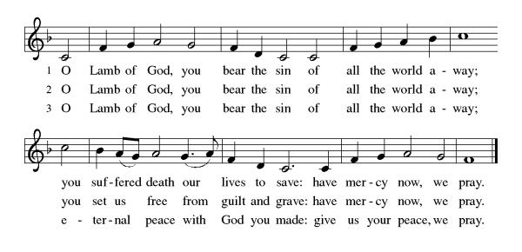

Spiritual Communion Prayer
P: Let us pray for the communion of all present here, those viewing our service virtually, those in our hearts and in our world.
C: Lord Jesus, I believe you are truly present in the Sacrament of Holy Communion. When I cannot receive Communion, I pray that you come into my heart. I know that nothing in Heaven or on earth can separate me from your love. Amen.

Invitation to Communion
P: Come to the table.
Feast on God’s goodness and mercy.
C: Thanks be to God!

(All are invited to the communion rail following the guidance of the ushers. Communion will be shared through the host and individual cups. If you would like communion but are unable to join us at the rail, please alert the usher!)

Communion Hymns (Please join in singing!)
ELW 608 Softly and Tenderly Jesus is Calling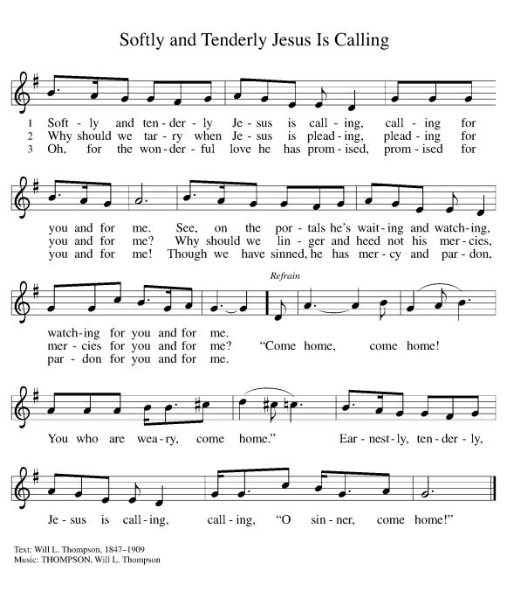

ELW 763 My Life Flows On in Endless Song
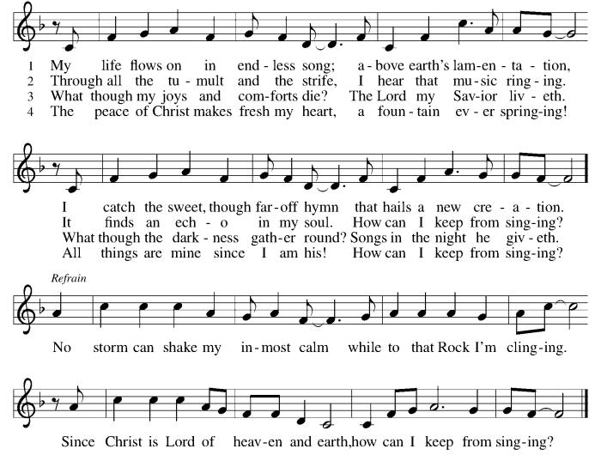

*Prayer after Communion
A: God of our salvation,
we give you thanks for this meal that restores our souls,
reconciles us to you, and strengthens us for the journey.
Through the body and blood of your Son,
may we become Christ’s body in the world,
bearing witness to your love for all creation,
through Jesus Christ, our Savior and Lord.
C: Amen.
+Sending+

*Blessing
P: Receive the blessing of the holy Trinity:
God, who calls all things into existence,
Jesus Christ, who redeems us,
and the Holy Spirit, whose breath sustains creation,
☩ bless you now and always. C: Amen!

*Sending Hymn ELW 328 Restore in Us, O God
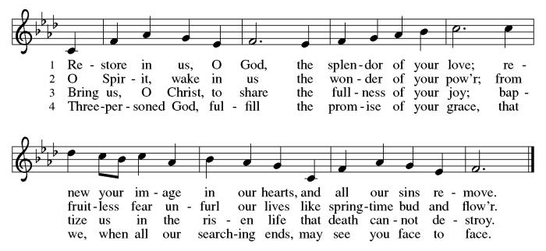

*Dismissal
A: Go in peace. Believe the good news.
C: Thanks be to God!

Postlude

Copyright © 2020 Augsburg Fortress. All rights reserved. Reprinted by permission under Augsburg Fortress Liturgies Annual License #SB106907. New Revised Standard Version Bible, Copyright © 1989, Division of Christian Education of the National Council of the Churches of Christ in the United States of America. Used by permission. All rights reserved. Revised Common Lectionary, Copyright © 1992 Consultation on Common Texts, admin Augsburg Fortress. Used by permission.

Treasurer’s Report

Monthly Financial Snapshot
Category | Actual | Budget | +/- vs Budget | Status
January Results
January Income | $18,830 | $19,167 | -$337 ▼ | Attention
January Expenses | $22,199 | $22,626 | -$427 ▲ | On Track
January Net Surplus/Deficit | -$3,369 | -$3,460 | $90 ▲ | On Track
Year-To-Date Results
YTD Income | $18,830 | $19,167 | -$337 ▼ | Attention
YTD Expenses | $22,199 | $22,626 | -$427 ▲ | On Track
YTD Net Surplus/Deficit | -$3,369 | -$3,460 | $90 ▲ | On Track
2026 Challenge Results
Timeframe | Actual | Goal | +/- vs Goal | % of Goal
January Income | $18,830 | $20,367 | -$1,537 ▼ | 92%
YTD Income | $18,830 | $20,367 | -$1,537 ▼ | 92%
HTLC’s 2026 finances are off to a steady start, with expenses running under budget and

January giving reaching 92% of our Challenge goal. As we work to increase giving by $28,000 over 2025, please prayerfully consider increasing your pledge or using recurring e-giving to help us meet the Challenge and strengthen our ministry for the year ahead. The QR Code can be used to access the Church's e-giving portal.

Worship Volunteer Schedule
Date | Asst. Min | Usher | Sacristan | Lector | Counter
March 1 | Charlie Rugg | Gary Joblon | Pat Pienkos | Cynthia Kazmac | Bohner/Volk
March 8 | Linda Coleman | Keith Bennett | Joanne Giordano | Emily Kaster | Carleo/Csernica
March 15 | Keith Bennett | Jill Socha | Carol Rosen | Jeff Ridberg | Bradford/Foard
March 22 | Chris Foard | Kathy Caputo | Joanne Giordano | Bill Spreen | McKenna/Kazmac
March 29 | Charlie Rugg | Jill Socha | Helga Britton | Molly Foard | Coleman/Giordano

Coffee Hour-

ANNOUNCEMENTS Thank you! To all who consistently support our church and ministries through your time, talent, and treasure. Please help us grow by inviting your friends and family to worship and events. You are what makes Holy Trinity a wonderful church family!

Stay in touch! Please visit our church website, www.htlcredbank.org for updates and information. You can also find us on Facebook and view services online. The office is open from 9am to 2pm, Monday to Thursday.

100 Anniversary Committee- If you are interested in being a part of the committee to help plan the 100th anniversary celebration of HTLC in 2028, please sign up in the red book. All are welcome! Also, the committee will be looking for photos and documents of HTLC throughout the years. If you have anything to share, please bring them to the church and marked envelopes or email electronic copies to the church office.

Name Tag Sundays: On the first Sunday of each month, names tags and markers will be at each entrance of the sanctuary. Please fill out a tag and wear one for worship and for coffee hour to welcome visitors and help newcomers put names to faces.

Sunday School in the New Year, we will continue to study stories and lessons from the Old Testament beginning with Jacob. Kids will love the crafts, songs and games that accompany each lesson.
The following dates there will be Sunday School:
Jan- 11 and 25, Feb- 8 and 22, March- 1, 15 and 29*Easter Egg Hunt!
April- 12 and 26, May- 3, 17 and 31, June- 7 and 14
As was done in the fall, there will be opportunities to volunteer as SS lead teacher. A signup will be emailed out shortly and will also be posted in the red binder. Consider signing up! All lesson materials will be supplied and laid out and a leader guide will be emailed to volunteers approximately 1 week in advance. Blessings for a wonderful 2026!~Lauren

The Finance Committee invites you to meet in the sanctuary after the service on March 15th for a discussion of Legacy Gifts and Planned Giving. We will form a small working group to become a resource for members interested in charitable bequests and the means by which lifetime donations can generate income for the donor. Topics will include some straight forward information about the estate planning process and some tax-advantaged concepts that magnify our ability to support the church and other charities we care about. If you have an interest in this work but cannot attend, please contact Roger Foss (Cell 732.693.3574 and Office 732.741.2525)

WELCA- we would like to schedule a quick meeting after church in March 15th. As a group we can share the success of Trivia Night, the agency to collect from the event, and future donations like a Cross Roads tee sign. Any questions, please contact Jill Socha

Our Easter Food Drive is Coming! COLLECTION IS COMPLETE ON 3/22/2026
Again this year, WELCA is collecting requested foods for Lutheran Social Ministries of NJ to distribute in April. Food will be collected during February and March, and we hope to fill at least 35 grocery bags!. Watch for the labeled bins at the side door to the church and thanks for your help. We need the following food items:
  - Boxed potatoes- Rice - Pasta - Mac & Cheese
  - Canned Vegetables and Beans canned fruit or Pineapple or Apple Sauce
  - Small Olive or Canola Oil
  - Corn Bread/Muffin Mix - Carnation Milk Can
  - Cake Mix and Frosting or Brown Sugar

Choir The Holy Trinity Choir welcomes our singers back for a preparation rehearsal on Sunday, September 7th at 9am in the church hall. All are welcome to join us in song as often as you are able. Choir meets each Sunday at 9am to practice and prepare our music. Join us and help us grow by spreading the word about the HTLC Choir!

Quilting- The Quilters need gently used any bed sheets of any size! Please leave any donations in the quilters closet in Fellowship Hall. Thank you!

Quilters Need Help
If anyone is traveling through Mechanicsville, PA, and can add a few extra minutes to your trip, the warehouse for shipping quilts, school kits, etc is located directly off one of the exits.
We accumulate many quilts throughout the year and we would appreciate sending some quilts with you to deliver. Any questions, please call Sherry Lee or Elaine Theophall.

Weekly Quilting on Wednesdays at 9:30. Bring your lunch and enjoy some fellowship at noon. All are welcome.

Evening Quilting Evening Quilting –
Please share this information . This is an important ministry that helps so many. It’s very easy and you don’t need to know how to sew. We have a great time socializing too! We will meet: Jan. 21, Feb. 18, March 18 at 6:00 PM. Note: If we have to cancel I will send an email. Please let me know only if you can come. Contacts: Pat Pienkos 732-513-9615 Debbie Yetka 908-461-4084 Looking forward to seeing you all!

Social Ministry
*Year-round collections will continue for food items for Lunch Break. There is a sign-up sheet in the red book for those who can help drop these items to Lunch Break.
*We will also collect adult men's socks to periodically drop at the Red Bank Warminq Center.
*For those interested in the Heartwarminq Center — the new women's shelter is adjacent to the First Baptist Church of Red Bank at 90 Maple Ave. You can follow up on this mission through their website - https://www.thefeastnj.org- On this site, they also include wish list items that can be purchased through amazon. We will be exploring purchasing some of these through a Thrivent card. If you want to purchase on your own, you can leave items at church, and the Social Ministry will deliver them.

Pastoral Care and Prayer... We are here to care for and pray! Please contact the office to add or adjust prayer requests. If you or someone you know needs pastoral care, please contact the office and Pastor Mack!

THANK YOU for supporting and sustaining our church and ministries! All are welcome here! Please invite your family and friends to worship with us! Find us online at www.htlcredbank.org


