Holy Trinity Evangelical Lutheran Church

March 22, 2026, at 10:30 am

Fifth Sunday of Lent

Lay Speaker, Bill Pim

*Prelude

* welcome and Announcements Worship Assistant

*Opening Hymn “Beneath the Cross of Jesus” ELW 338
Public Domain
1.Beneath the cross of Jesus I long to take my stand;
the shadow of a mighty rock within a weary land.
a home within a wilderness, a rest upon the way,
from the burning of the noontide heat and burdens of the day.

2.Upon the cross of Jesus, my eye at times can see
the very dying form of one who suffered there for me.
And from my contrite heart, with tears, two wonders I confess;
the wonder of his glorious love and my unworthiness.

3.I take, O cross, your shadow for my abiding place;
I ask no other sunshine than the sunshine of his face;
content to let the world go by, to know no gain nor loss,
my sinful self my only shame, my glory all, the cross.

* Confession and Forgiveness Bill Pim
Blessed be the holy Trinity, ☩ one God, who forgives all our sin, whose mercy endures forever. Amen.

Let us confess our sin before God, who removes our guilt and blots out all offenses.

Generous God, you provide enough for all and call us to trust in your care. Yet we confess that we grasp and hoard. We take what is not ours, cling to what we fear losing, and measure our worth by what we possess. We hunger for security instead of righteousness. Forgive us our sin. Teach us to desire what truly gives life. In the name of Christ, we pray. Amen.

Hear the good news: God does not give up on what God has made. As a called and ordained minister of the church of Christ, and by his authority, I therefore declare to you the entire forgiveness of all your sins. In the name of the Father, and the Son, ✚ and the Holy Spirit. Amen.

* Canticle of Praise “Hear Our Prayer” ELW 178
One License A-700000
Hear our prayer, hear our prayer, Lord, make us whole:
Peace to all people, hope for each soul.
God of grace, in this place, hear now our prayer.

*Greeting Bill Pim
The Grace of our Lord, Jesus Christ, the Love of God and the communion of the Holy Spirit be with you all. And Also with you.

*Prayer of the Day Worship Assistant
Generous God, you provide all that we need and call us to trust in your care. Free us from fear and grasping for peace in sources other than you. Turn our hearts toward righteousness, and strengthen us to seek your justice, even when it comes at a cost; through Jesus Christ, our Savior and Lord. Amen.

* Passing of the Peace Worship Assistant
may the peace of christ be with you always. and also with you.

please share the peace of christ with one another with a wave, then wave to those watching from their home.

Children’s Moment – Pulpit Prequel Bill Pim

*First Lesson: Deuteronomy 22: 1-4 Reader
¹ “You shall not watch your neighbor’s ox or sheep straying away and ignore them; you shall take them back to their owner. ² If the owner does not reside near you or you do not know who the owner is, you shall bring it to your own house, and it shall remain with you until the owner claims it; then you shall return it. ³ You shall do the same with a neighbor’s donkey; you shall do the same with a neighbor’s garment; and you shall do the same with anything else that your neighbor loses and you find. You may not withhold your help.
⁴ “You shall not see your neighbor’s donkey or ox fallen on the road and ignore it; you shall help to lift it up.
The Word of the Lord. Thanks be to God.

*Second Lesson: Leviticus 6:1-7 Reader
¹ The Lord spoke to Moses, saying, ² “When any of you sin and commit a trespass against the Lord by deceiving a neighbor in a matter of a deposit or a pledge or by robbery or if you have defrauded a neighbor ³ or have found something lost and lied about it—if you swear falsely regarding any of the various things that one may do and sin ⁴ when you have sinned and recognize your guilt and would restore what you took by robbery or by fraud or the deposit that was committed to you or the lost thing that you found ⁵ or anything else about which you have sworn falsely, you shall repay the principal amount and add one-fifth to it. You shall pay it to its owner when you recognize your guilt. ⁶ And you shall bring to the priest, as your guilt offering to the Lord, a ram without blemish from the flock, or its equivalent, for a guilt offering. ⁷ The priest shall make atonement on your behalf before the Lord, and you shall be forgiven for any of the things that one may do and incur guilt thereby.”
The Word of the Lord. Thanks be to God.

* Acclamation “Remember That You are Dust” ACS 919
One License A-700000
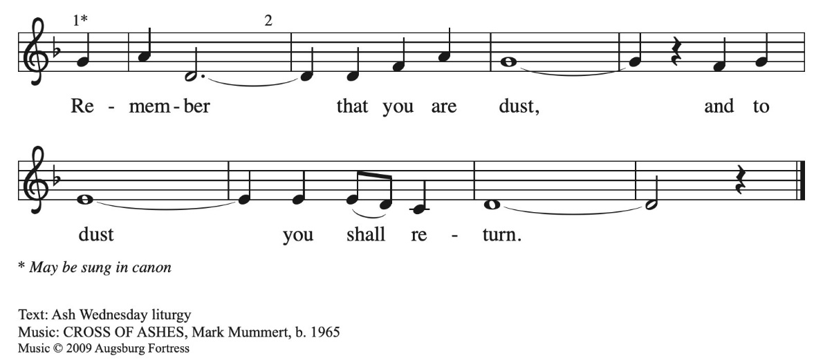

* Gospel: Matthew 6:24-34 Bill Pim
The Holy Gospel according to Matthew, the 6th chapter. Glory to you, O Lord.
[Jesus said] ²⁴ “No one can serve two masters, for a slave will either hate the one and love the other or be devoted to the one and despise the other. You cannot serve God and wealth.
²⁵ “Therefore I tell you, do not worry about your life, what you will eat or what you will drink, or about your body, what you will wear. Is not life more than food and the body more than clothing? ²⁶ Look at the birds of the air: they neither sow nor reap nor gather into barns, and yet your heavenly Father feeds them. Are you not of more value than they? ²⁷ And which of you by worrying can add a single hour to your span of life? ²⁸ And why do you worry about clothing? Consider the lilies of the field, how they grow; they neither toil nor spin, ²⁹ yet I tell you, even Solomon in all his glory was not clothed like one of these. ³⁰ But if God so clothes the grass of the field, which is alive today and tomorrow is thrown into the oven, will he not much more clothe you—you of little faith? ³¹ Therefore do not worry, saying, ‘What will we eat?’ or ‘What will we drink?’ or ‘What will we wear?’ ³² For it is the gentiles who seek all these things, and indeed your heavenly Father knows that you need all these things. ³³ But seek first the kingdom of God and his righteousness, and all these things will be given to you as well.
³⁴ “So do not worry about tomorrow, for tomorrow will bring worries of its own. Today’s trouble is enough for today.
The Gospel of the Lord. Praise to you, O Christ.

*Sermon “Finders Weepers, Losers Keepers” Bill Pim
* Hymn of the Day “Let Us Ever Walk with Jesus” ELW 802 VS 1,4
One License A-700000
1.LET US EVER WALK WITH JESUS, FOLLOW HIS EXAMPLE
PURE, THROUGH A WORLD THAT WOULD DECEIVE US AND
TO SIN OUR SPIRITS LURE. ONWARD IN HIS FOOTSTEPS
TREADING, TRAV’LERS HERE, OUR HOME ABOVE, FULL OF
FAITH AND HOPE AND LOVE, LET US DO OUR SAVIOR’S
BIDDING. FAITHFUL LORD, WITH ME ABIDE; I SHALL FOLLOW
WHERE YOU GUIDE.

4.LET US ALSO LIVE WITH JESUS. HE HAS RISEN FROM THE
DEAD THAT TO LIFE WE MAY AWAKEN. JESUS, YOU ARE
NOW OUR HEAD, WE ARE YOUR OWN LIVING MEMBERS,
WHERE YOU LIVE, THERE WE SHALL BE IN YOUR PRESENCE
CONSTANTLY, LIVING THERE WITH YOU FOREVER. JESUS,
LET ME FAITHFUL BE; LIFE ETERNAL GRANT TO ME.

* Apostle’s Creed Worship Assistant
Let us proclaim our faith in the words of the apostle’s creed

I believe in God, the Father almighty,
creator of heaven and earth.
I believe in Jesus Christ, God's only Son, our Lord,
who was conceived by the power of the Holy Spirit,
born of the Virgin Mary,
suffered under Pontius Pilate,
was crucified, died, and was buried;
he descended to the dead.
On the third day he rose again;
he ascended into heaven,
he is seated at the right hand of the Father,
and he will come to judge the living and the dead.
I believe in the Holy Spirit,
the holy catholic Church,
the communion of saints,
the forgiveness of sins,
the resurrection of the body,
and the life everlasting. Amen.

* Prayers of Intercession Bill Pim
Be Seated
Any Prayer requests or joys to share
Reconciled by God’s mercy and sustained by God’s presence, let us pray for the world and its needs.

We pray for the church. Grant life and peace to all who gather in your name. Breathe into us so that we may share your message of forgiveness, hope, and love. Hear us, O God. Your mercy is great.

We pray for creation. Renew landscapes that have dried up, prosper the work of those who restore homes and habitats after natural disasters, and sustain places where biodiversity thrives (local places in nature may be named). Hear us, O God. Your mercy is great.

We pray for the nations. Unbind leaders trapped by fear to act boldly for justice, free all who live in places of war and violence, and guide refugees and asylum seekers to safety. Hear us, O God. Your mercy is great.

We pray for all people in need. Take away the stone of poverty that weighs down so many. Console any who weep and heal all who are sick (especially). Hear us, O God. Your mercy is great.

We pray for this assembly. Ready the hearts and spirits of all preparing to be baptized (especially). Deepen our wonder at the mystery of your resurrection and life. Hear us, O God. Your mercy is great.

We offer our thanksgiving for all people who have died in faith. Give us faith to trust in your power to redeem and save, and bring us up from our graves to life in you. Hear us, O God. Your mercy is great.

Receive our prayers, O God, through Jesus Christ, our strength and salvation.
Amen.

*Offering worship assistant
The monthly mission the month of march is “altar Guild Repairs.”
let us give to god what he has first given us.
*Offering music by Jared

* Offering Hymn “Create in Me a Clean Heart” ELW #188
Public Domain
Create in me a clean heart, O God, and renew a right spirit within
Me. Cast me not away from your presence, and take not your Holy Spirit from me. Restore unto me the joy of your salvation,
and uphold me with your free Spirit.

* Offering Prayer Worship Assistant and congregation
Faithful God, you have given us all that we are and all that we have. Receive these gifts as signs of our trust and use them for your work in the world. Form our lives in humility, mercy, and love, that we may bear witness to your kingdom; through Jesus Christ, our Savior and Lord. Amen.

* Lord’s Prayer Bill Pim ELW pg.145
Gathered into one by the holy spirit, let us pray as Jesus taught us to pray.
Our Father, who art in heaven, hallowed be thy name, thy kingdom come, thy will be done, on earth as it is in heaven. Give us this day our daily bread; and forgive us our trespasses, as
we forgive those who trespass against us; and lead us not into temptation, but deliver us from evil. for thine is the kingdom,
and the power and the glory, forever and ever. amen.

* Blessing Bill Pim
Receive the blessing of the holy Trinity:
God, who calls all things into existence,
Jesus Christ, who redeems us,
and the Holy Spirit, whose breath sustains creation,
☩ bless you now and always.
Amen.

*Hymnology story Bill Pim

* Closing Hymn “Oh, for a Thousand Tongues to Sing” ELW 886
Public Domain vs. 1, 2, 3, & 6
1.Oh, for a thousand tongues to sing my great Redeemer’s
praise, the glories of my God and king, the triumphs of his
grace!

2.My gracious Master and my God, assist me to proclaim,
to spread through all the earth abroad the honors of your
name.

3.The name of Jesus charms our fears and bids our sorrows
cease, sings music in the sinner’s ears, brings life and
health and peace.

6.To God all glory, praise, and love be now and ever giv’n by
saints below and saints above, the church in earth and
heav’n.
* Dismissal worship assistant
Go in peace. Go in peace. Believe the good news.
Thanks be to God!

*Postlude

