PARISH HOUSE: Items for March
Items Needed:
Canned Corn, Jelly (non-glass), Cereal,
Toothpaste, Deodorant

Upcoming Events:
TODAY – 1:30pm Chosen
“The Rock On Which It Is Built”

March 18th – 6:00pm Choir Practice

March 22nd – 4th Sunday Lunch

MARCH BIRTHDAYS
Shahna West – 6th, Shelia Hodges– 7th, Shane West – 20th,
Ina Jean Cutright – 25th, Lynn Frum – 29th

MARCH ANNIVERSARIES
Benny & Betty Smith – 2nd


Tithes and Offerings: Give your gifts,
tithes, and offerings through PayPal. It is
quick, easy, and safe! Just use the
camera on your phone to scan the QR
Code. All donations will be placed into
our General Account unless otherwise
stated.

TENNERTON
United Methodist Church
March 15, 2026
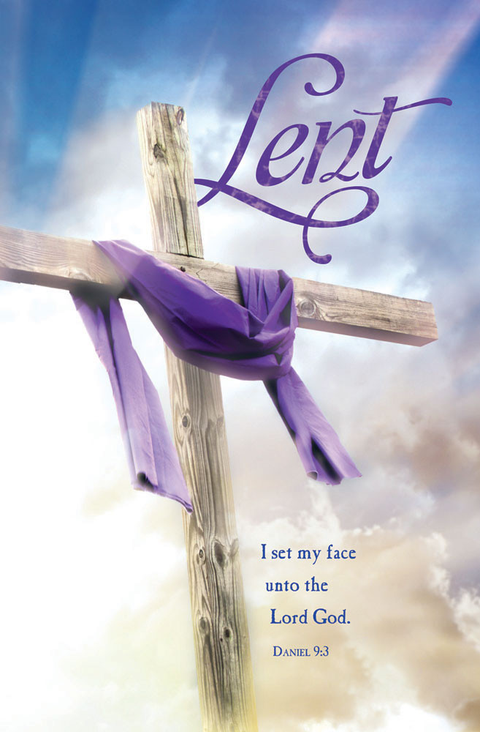
Pastor Jim Minutelli
304-629-9398

Office: 126 Tallmansville Rd.
Buckhannon, WV 26201
Office Phone: 304-472-1064
Sermon by Phone: 304-460-0029
Website: https://tennertonumc.org
Email: umc.tennerton@gmail.com
Facebook: https://www.facebook.com/thetennertonumc
Prayer Concerns: Call Candy George @ 304-613-6424

JOYS & CONCERNS
WELCOME/OPENING PRAYER Pastor
*OPENING HYMN: “Turn Your Eyes Upon Jesus”
12/4 UMH 349

CALL TO WORSHIP: Fourth Sunday in Lent
Based on Ephesians 5: 8-14

Leader: Once we were darkness, but now
we are light in the Lord.
People: We come to walk as children
of light.
Leader: In a world shadowed by fear and
division,
People: Christ shines upon us.
Leader: Awake, O sleeper, and rise from
the dead!
People: Christ will shine on us.
Leader: Let us live as people of goodness,
righteousness, and truth.
All: We worship the One who brings us
from darkness into light. Amen.

*OFFERING/DOXOLOGY/PRAYER UMH 95
CHOIR: “Leave It There” 18/7 UMH 522
CHILDREN MESSAGE Vickie Snyder
ANNOUNCEMENTS (ON BACK PAGE)
READING: Ephesians 5: 8 – 14

*HYMN: “Are Ye Able” 18/15 UMH 530
SCRIPTURE READING:

SERMON:

*CLOSING HYMN: “Nearer, My God to Thee”
18/13 UMH 528

*BENEDICTION

*Please stand if you are able. Don’t Forget to Feed the Pig

GREETERS & WORSHIP LEADERS
If you would like to be a greeter or lead worship service,
print your name on the clip board on the front pew.

This Week
GREETER(S): Billi & Shane West
WORSHIP LEADER: Kathy Black

Next Week
GREETER(S): Rick Black
WORSHIP LEADER: Lynn Frum

