Saturday, March 14 & Sunday, March 15, 2026 – Lent 4
Prayer of the Day
Let us pray. Bend your ear to our prayers, Lord Christ, and come among us. By your gracious life and death for us, bring light into the darkness of our hearts, and anoint us with your Spirit, for you live and reign with the Father and the Holy Spirit, one God, now and forever. Amen.
First Reading: 1 Samuel 16:1-13
The Lord said to Samuel, “How long will you grieve over Saul? I have rejected him from being king over Israel. Fill your horn with oil and set out; I will send you to Jesse the Bethlehemite, for I have provided for myself a king among his sons.” Samuel said, “How can I go? If Saul hears of it, he will kill me.” And the Lord said, “Take a heifer with you and say, ‘I have come to sacrifice to the Lord.’ Invite Jesse to the sacrifice, and I will show you what you shall do, and you shall anoint for me the one whom I name to you.” Samuel did what the Lord commanded and came to Bethlehem. The elders of the city came to meet him trembling and said, “Do you come peaceably?” He said, “Peaceably. I have come to sacrifice to the Lord; sanctify yourselves and come with me to the sacrifice.” And he sanctified Jesse and his sons and invited them to the sacrifice. When they came, he looked on Eliab and thought, “Surely his anointed is now before the Lord.” But the Lord said to Samuel, “Do not look on his appearance or on the height of his stature, because I have rejected him, for the Lord does not see as mortals see; they look on the outward appearance, but the Lord looks on the heart.” Then Jesse called Abinadab and made him pass before Samuel. He said, “Neither has the Lord chosen this one.” Then Jesse made Shammah pass by. And he said, “Neither has the Lord chosen this one.” Jesse made seven of his sons pass before Samuel, and Samuel said to Jesse, “The Lord has not chosen any of these.” Samuel said to Jesse, “Are all your sons here?” And he said, “There remains yet the youngest, but he is keeping the sheep.” And Samuel said to Jesse, “Send and bring him, for we will not sit down until he comes here.” He sent and brought him in. Now he was ruddy and had beautiful eyes and was handsome. The Lord said, “Rise and anoint him, for this is the one.” Then Samuel took the horn of oil and anointed him in the presence of his brothers, and the spirit of the Lord came mightily upon David from that day forward. Samuel then set out and went to Ramah.
Word of God, word of life.
Thanks be to God.

Psalm 23 (read responsively)
¹The Lord is my shepherd; I shall not be in want.
²The Lord makes me lie down in green pastures and leads me beside still waters.
³You restore my soul, O Lord, and guide me along right pathways for your name’s sake.
⁴Though I walk through the valley of the shadow of death, I shall fear no evil; for you are with me; your rod and your staff, they comfort me.
⁵You prepare a table before me in the presence of my enemies; you anoint my head with oil, and my cup is running over.
⁶Surely goodness and mercy shall follow me all the days of my life, and I will dwell in the house of the Lord forever.
Second Reading: Ephesians 5:8-14
for once you were darkness, but now in the Lord you are light. Walk as children of light, for the fruit of the light is found in all that is good and right and true. Try to find out what is pleasing to the Lord. Take no part in the unfruitful works of darkness; rather, expose them. For it is shameful even to mention what such people do secretly, but everything exposed by the light becomes visible, for everything that becomes visible is light. Therefore it says, “Sleeper, awake! Rise from the dead, and Christ will shine on you.”
Word of God, word of life.
Thanks be to God.
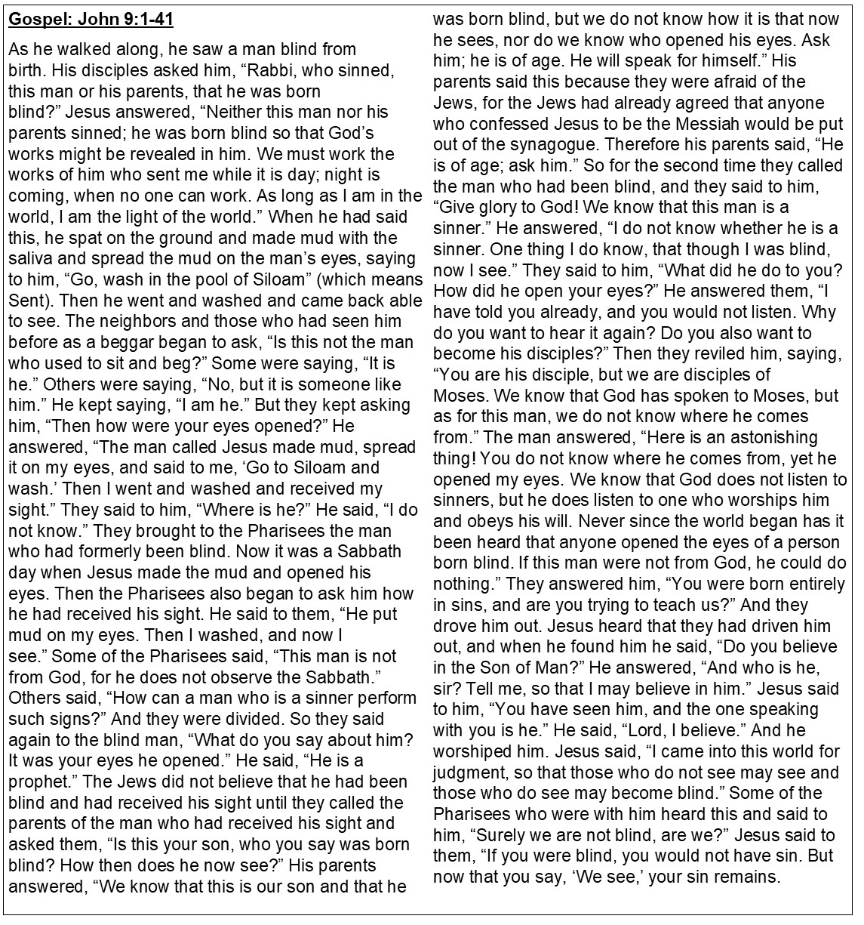
Prayers of Intercession – March 14 & 15, 2026
Reconciled by God’s mercy and sustained by God’s presence, let us pray for the world and its needs.
A brief silence.
God, our shepherd, we pray that you guide the church. Lead Christians in our community (here local congregations may be named) and across the globe (here international companion churches and synods may be named) in right paths for your name’s sake. Receive our prayers, O God.
Your mercy is great.
God our provider, we cry out for this planet and the life it holds. Rescue endangered animals and plants, preserve threatened ecosystems, and save creatures from natural disasters. Receive our prayers, O God.
Your mercy is great.
God our sovereign, we plead for your peace on earth. Bring an end to war and violence, and raise up leaders in governments, courts, businesses, schools, and community organizations who seek goodness and mercy.
Receive our prayers, O God.
Your mercy is great.
God our healer, we call to you in our need. Uplift all who are made to feel unimportant, and transform the hearts of all infected by bigotry and prejudice. Care for all in special need this day ( especially [names].…and all other people or concerns we now name aloud on our lips or in the silence of our hearts.) Receive our prayers, O God.
Your mercy is great.
God our friend, we praise you for the diversity of people among us. Awaken us to share and receive the gifts we each possess, and stir up a spirit of understanding, celebration, and welcome for all. Receive our prayers, O God.
Your mercy is great.
God our home, we thank you for all who have died and completed their baptismal journeys. Grant us faith to live until we too dwell in your house forever. Receive our prayers, O God.
Your mercy is great.
Receive our prayers, O God, through Jesus Christ, our strength and salvation.
Amen.

