Parkside Lutheran Church
Rediscovering the Radical Love of Jesus
Gathering All
Serving All
Caring For All



The Good News is
Rooted in Justice, Mercy, and Faithfulness

March 22nd, 2026
Fifth Sunday in Lent
Holy Communion 10:00am
Rev. Jeremiah Smith
Parkside Lutheran Values

Proclaiming Grace - Jesus shared and lived out a message of grace, love, and new life. We believe these promises come from God freely, as a gift for all. We are loved and the Spirit inspires us to share this good news in accessible, relevant, and new ways. Luke 4:17-19, John 1:16-17, John 3:16-17, Ephesians 2:8-9

Practicing Hospitality – Jesus welcomed the little children, broke bread with outcasts, and proclaimed the Good News to all. Whether you are strong in faith, wrestling with doubt, or somewhere in between, we affirm that you are welcome here. Jesus is for everyone. Leviticus 19:34, Matthew 9:10, Matthew 19:14, Hebrews 13:2

Loving Boldly - Jesus challenged traditions to demonstrate God’s justice and love of neighbor. His compassionate and sacrificial love inspires us to take risks. Striving to follow his command to love neighbor, our ministries serve, transform, and advocate for folks near and far. Micah 6:8, Mark 11:15-17, Luke 10:25-28, John 15:12-13

Cultivating Community - Jesus built communities that transformed lives. We are the body of Christ and we are called to continue this ministry of transformation. Guided by the Holy Spirit, we build connections within and outside of these walls, and with all of God’s creation. Ecclesiastes 4:9-12, Matthew 28:16-20, 1 Corinthians 12:12-14, Galatians 3:26-29

Welcome Visitors!
Please use QR code
to let us know you were here today or to sign up for our weekly enewsletter
or, sign up for weekly enewsletter via website parksidelutheran.org.
Find us on Facebook & Instagram WIFI: Balcony password: FreeGrace

For your safety in the event of an emergency: In addition to the three exits in the back of the sanctuary, there are exits on either side of the altar (on left side: floor level near piano and up steps past altar. On right side: up steps to the altar, past band area)

Contact us: (716) 836-1361
2 Wallace Ave. Buffalo, NY 14214
parksidelutheran.org | parksidelutheran@gmail.com
GATHER
The Holy Spirit calls us together as the people of God.

Prelude Michael Hooker, Music Director

Call to Worship
WA: Welcome to the weary and the worn.
C: Welcome to the wiggly and the eager.
WA: Welcome to the skeptical and the seeking.
C: Welcome to the early risers and those still trying to wake up.
WA: Welcome to the rule followers and the rule breakers.
C: Welcome to those hungry for justice and those desperate for mercy.
WA: Welcome to the sinners and the saints.
C: This is God’s house.
WA: You can make yourself at home here.
C: Let us worship our just, merciful, and faithful God!

+Gathering Hymn: Tree of Life and Awesome Mystery ELW #334
v. 1-3 and Lent 5

Lent 5: God of all our fear and sorrow,
God who lives beyond our death,
hold us close through each tomorrow,
love as near as ev’ry breath,
love as near as ev’ry breath.

Welcome and Announcements

Holy Baptism: Caleb Michael Gonzalez ELW p. 227

P: God, who is rich in mercy and love, gives us a new birth into a living hope through the sacrament of baptism. By water and the Word God delivers us from sin and death and raises us to new life in Jesus Christ. We are united with all the baptized in the one body of Christ, anointed with the gift of the Holy Spirit, and joined in God's mission for the life of the world.
P: Who do you present to be baptized? Sponsors: We present Caleb for baptism.

P: Called by the Holy Spirit, trusting in the grace and love of God, as his parents, do you desire to have Caleb baptized into Christ? Parents: We do.

P: As you bring him to receive the gift of baptism, you are entrusted with responsibilities: to live with him among God's faithful people, bring him to the word of God and the holy supper, teach him the Lord's Prayer, the Creed, and the Ten Commandments, place in his hands the holy scriptures, and nurture him in faith and prayer, so that he may learn to trust God, proclaim Christ through word and deed, care for others and the world God made, and work for justice and peace.

P: Do you promise to help Caleb grow in the Christian faith and life?
Parents: We do.

P: Sponsors, do you promise to nurture Caleb in the Christian faith as you are empowered by God's Spirit, and to help him live in the covenant of baptism and in communion with the church? Sponsors: We do.

P: People of God, do you promise to support Caleb and pray for him in his new life in Christ? C: We do.

+ Profession of Faith
P: All together as the people of God, I ask you to profess your faith in Christ Jesus, reject sin, and confess the faith of the church.

P: Do you renounce the devil and all the forces that defy God?
C: We renounce them.

P: Do you renounce the powers of this world that rebel against God?
C: We renounce them.

P: Do you renounce the ways of sin that draw you from God?
C: We renounce them.

P: Do you believe in God the Father?
C: I believe in God, the Father almighty, creator of heaven and earth.
P: Do you believe in Jesus Christ, the Son of God?
C: I believe in Jesus Christ, God's only Son, our Lord, who was conceived by the Holy Spirit, born of the virgin Mary, suffered under Pontius Pilate, was crucified, died, and was buried; he descended to the dead.* On the third day he rose again; he ascended into heaven, he is seated at the right hand of the Father, and he will come to judge the living and the dead.

P: Do you believe in God the Holy Spirit?
C: I believe in the Holy Spirit, the holy catholic church, the communion of saints, the forgiveness of sins, the resurrection of the body, and the life everlasting.

Thanksgiving at the Font
P: The Lord be with you. C: And also with you.
P: Let us give thanks to the Lord our God.
C: It is right to give our thanks and praise.

P: We give you thanks, O God, for in the beginning your Spirit moved over the waters and by your Word you created the world, calling forth life in which you took delight. Through the waters of the flood you delivered Noah and his family, and through the sea you led your people Israel from slavery into freedom.
At the river your Son was baptized by John and anointed with the Holy Spirit. By the baptism of Jesus' death and resurrection you set us free from the power of sin and death and raise us up to live in you.
Pour out your Holy Spirit, the power of your living Word, that those who are washed in the waters of baptism may be given new life. To you be given honor and praise through Jesus Christ our Lord, in the unity of the Holy Spirit, now and forever. C: Amen.

Baptism
P: Caleb Michael, I baptize you in the name of the Father, and of the Son, and of the Holy Spirit. Amen.

Let us pray. We give you thanks, O God, that through water and the Holy Spirit you give your daughters and sons new birth, cleanse them from sin, and raise them to eternal life.
Laying both hands on the head of Caleb the minister prays.

P: Sustain Caleb with the gift of your Holy Spirit: the spirit of wisdom and understanding, the spirit of counsel and might, the spirit of knowledge and the fear of the Lord, the spirit of joy in your presence, both now and forever. Amen.

P: Caleb, child of God, you have been sealed by the Holy Spirit and marked with the cross of Christ forever. Amen.

Welcome
WA: Jesus said, I am the light of the world.
Whoever follows me will have the light of life.

P: Let us welcome Caleb.
C: We welcome you into the body of Christ and into the mission we share: join us in giving thanks and praise to God and bearing God's creative and redeeming word to all the world.

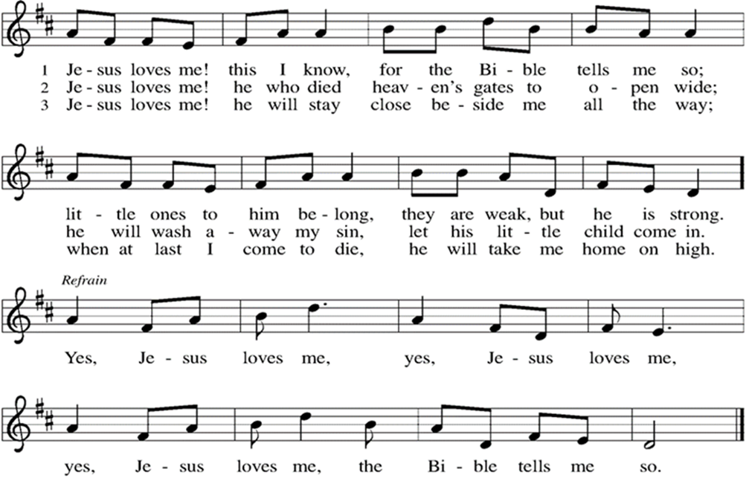

Greeting

WA: The grace of our Lord, Jesus Christ, the love of God, and the communion of the Holy Spirit be with you all. C: And also with you.

Prayer of the Day

WA: Let us pray together.
C: Holy One, when you speak, we don’t want to miss it. When you bend down and write in the dirt, when you move through the trees, when you wake with the dawn, when you tug on our hearts, or whisper into our dreams, we don’t want to miss it. So today we pray, clear out the cobwebs in our ears. Quiet the steady stream of thoughts marching through our minds. Open up space in our hearts so that we can receive your word for us today. With hope we pray. Amen.

WORD
God speaks to us in scripture readings, preaching and song.

“The Things that Matter Most” L: I wrecked the family car, an old gold minivan
that had traveled every inch of I-95. It had worn cushions
and an old school map in the glove box.
It held a folder full of mix CDs under the passenger seat
and every memory of every family trip,
and I wrecked it.
I called the tow truck while the engine
hissed and smoked. I called my dad,
my own apologies tripping over themselves
to get to the front of the line.
I expected to be grounded.
I expected a “How could you?”
But when I got home that night,
my dad held me close and said,
“A car is just a car, but you are my child.
The only thing that matters is that you are okay.”
And I knew it for what it was.
It was mercy. It was love.
It was the thing that mattered most.
Poem by Rev. Sarah A. Speed

Reading: Matthew 23:1-12; 23-24

L: ¹ Then Jesus said to the crowds and to his disciples, ² “The scribes and the Pharisees sit on Moses’s seat; ³ therefore, do whatever they teach you and follow it, but do not do as they do, for they do not practice what they teach. ⁴ They tie up heavy burdens, hard to bear, and lay them on the shoulders of others, but they themselves are unwilling to lift a finger to move them. ⁵ They do all their deeds to be seen by others, for they make their phylacteries broad and their fringes long. ⁶ They love to have the place of honor at banquets and the best seats in the synagogues ⁷ and to be greeted with respect in the marketplaces and to have people call them rabbi. ⁸ But you are not to be called rabbi, for you have one teacher, and you are all brothers and sisters. ⁹ And call no one your father on earth, for you have one Father, the one in heaven. ¹⁰ Nor are you to be called instructors, for you have one instructor, the Messiah. ¹¹ The greatest among you will be your servant. ¹² All who exalt themselves will be humbled, and all who humble themselves will be exalted. ²³ “Woe to you, scribes and Pharisees, hypocrites! For you tithe mint, dill, and cumin and have neglected the weightier matters of the law: justice and mercy and faith. It is these you ought to have practiced without neglecting the others. ²⁴ You blind guides! You strain out a gnat but swallow a camel!

L: Word of God, word of life. C: Thanks be to God

Please stand as you are able

Gospel Acclamation ELW #262

Gospel Reading: John 8:2-11
P: The Holy Gospel according to John. C: Glory to you, O Lord.
P: ² Early in the morning he came again to the temple. All the people came to him, and he sat down and began to teach them. ³ The scribes and the Pharisees brought a woman who had been caught in adultery, and, making her stand before all of them, ⁴ they said to him, “Teacher, this woman was caught in the very act of committing adultery. ⁵ Now in the law Moses commanded us to stone such women. Now what do you say?” ⁶ They said this to test him, so that they might have some charge to bring against him. Jesus bent down and wrote with his finger on the ground. ⁷ When they kept on questioning him, he straightened up and said to them, “Let anyone among you who is without sin be the first to throw a stone at her.” ⁸ And once again he bent down and wrote on the ground. ⁹ When they heard it, they went away, one by one, beginning with the elders, and Jesus was left alone with the woman standing before him. ¹⁰ Jesus straightened up and said to her, “Woman, where are they? Has no one condemned you?” ¹¹ She said, “No one, sir.” And Jesus said, “Neither do I condemn you. Go your way, and from now on do not sin again.”

P: The Gospel of the Lord. C: Praise to you, O Christ.

Sermon Rev. Jeremiah Smith

Please stand as you are able

+Hymn of the Day: What Wondrous Love is This? ELW #666
(printed next page)

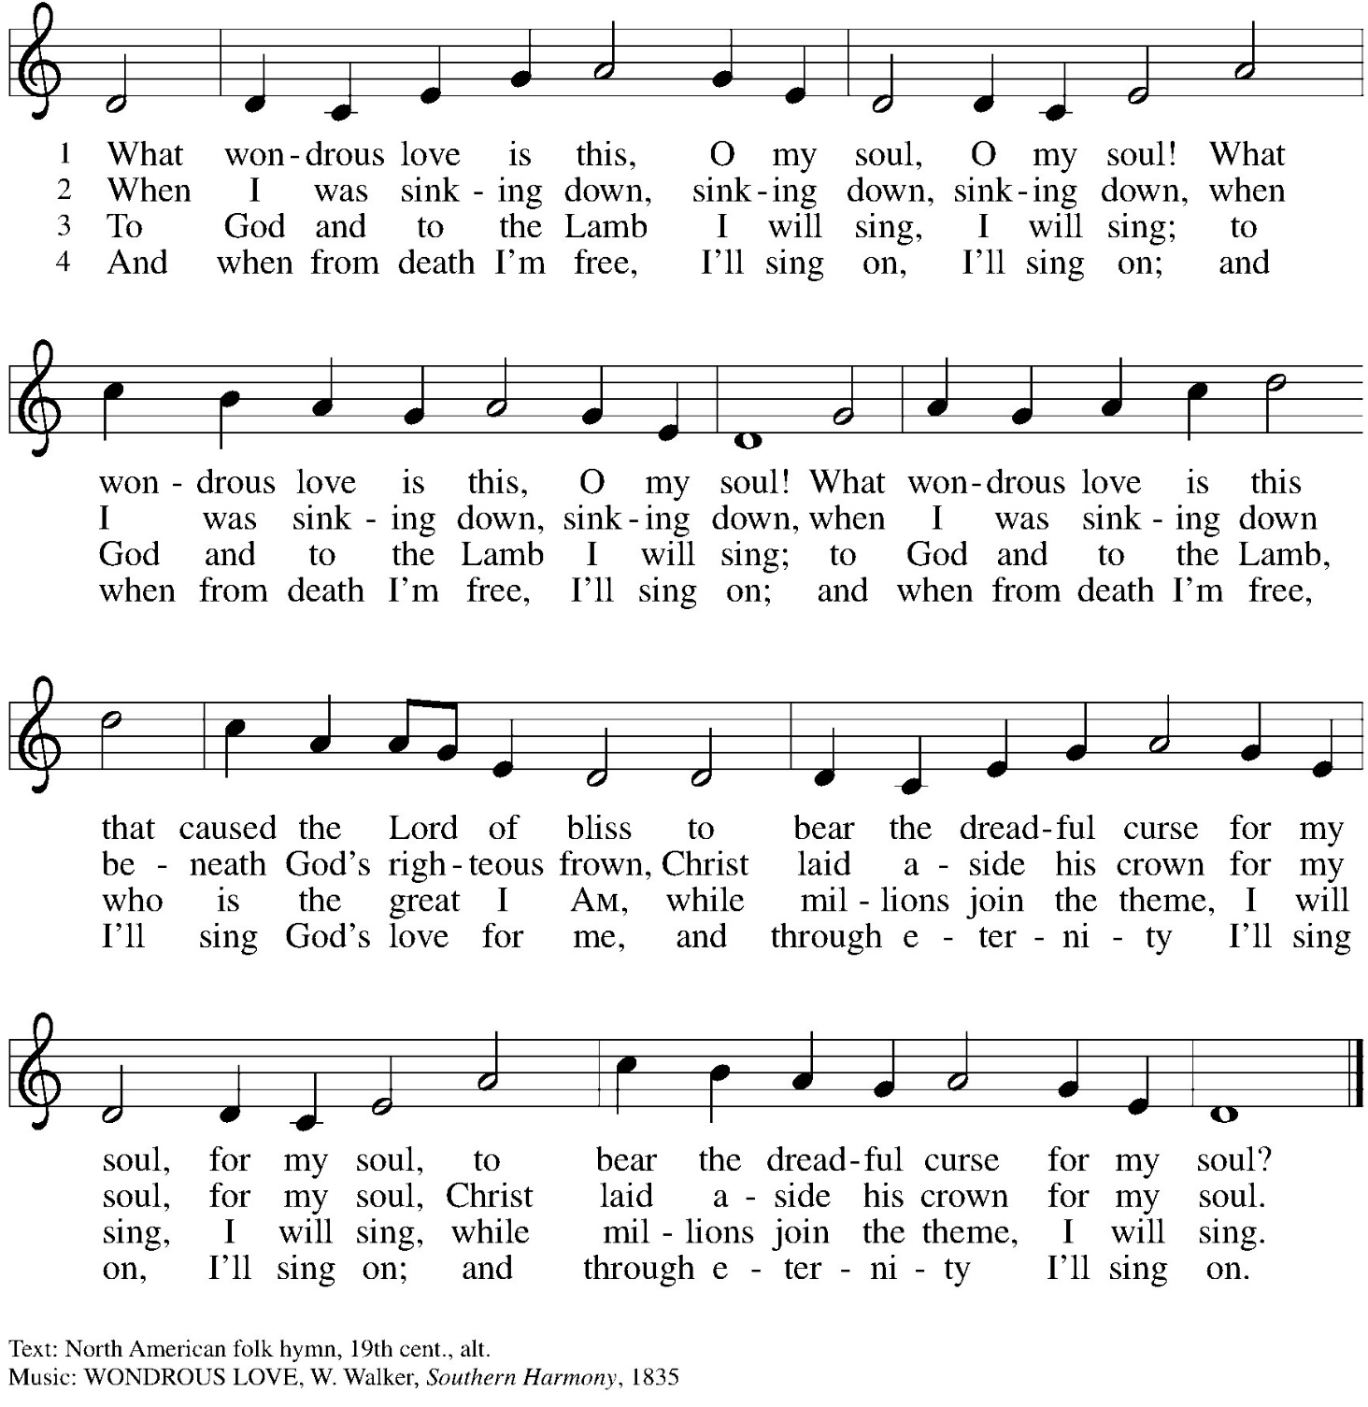

Prayers of the People WA: Reconciled by God’s mercy and sustained by God’s presence, let us pray for the world and its needs. (a brief silence)
WA: Renewing God, in a world obsessed with consumption, fossil fuels, and maximizing profits, help us to care for creation. Inspire us to make sustainable life-giving choices remembering that everything from the sun, the rain, and the apple seed is a gift from you. Lord, in your mercy, C: receive our prayer.
WA: Forgiving God, we are quick to judge. We make assumptions. We assign blame and utilize shame. Help us to put down our stones. Increase our curiosity and open our hearts to grace filled possibilities. Lord, in your mercy, C: receive our prayer.
WA: With us God, In the next few weeks we hope to fill our food pantry with loaves and fishes, serve the community a Spaghetti dinner, and build a community garden. But if we are honest; we worry it isn’t enough, we doubt what is possible. Take our offerings, take our gifts, and help us to serve our neighbors, mind, bodies, and spirits with your love. Lord, in your mercy, C: receive our prayer.
WA: Freeing God, our hearts are filled with worry. Scared for Migrants, for those in the path of war, for loved ones with failing health, for the bills that continue to pile up. We pray especially for those worries and for those people we say aloud or in the silence of our hearts… Help us to let go of worry, confident that Easter is coming. Lord, in your mercy, C: receive our prayer.

WA: Welcoming God, we give thanks for Caleb, all the newly Baptized, and all the Saints who have gone before us. We give thanks for families of all shapes, sizes, and origins. We give thanks that love is not limited by DNA. Inspire this church family to embody the welcome you have given to us all in the waters of Baptism. Lord, in your mercy, C: receive our prayer.

We offer these prayers, O God, through Jesus Christ, our strength and salvation. C: Amen.

Peace
P: The peace of Christ be with you always. C: And also with you.

Meal - God feeds us with the presence of Jesus Christ

Offering
We are grateful to those who help sustain our mission. To donate online, please use QR code:


Please stand as you are able

Offering Music: “Above All” by Lenny LaBlanc & Paul Baloche
Faith Journey

Offering Prayer
WA: Let us pray together:
C: O God, maker of heaven and earth, your steadfast love embraces all creation. You send rain and sunshine to nourish the earth and bring forth its bounty. Through these gifts of bread and wine, draw us into the death and life of your Son, who calls us to bear witness to his saving work. We ask this in Jesus’ name. Amen.

+ Offertory Song Create in Me ELW 186
(printed next page)
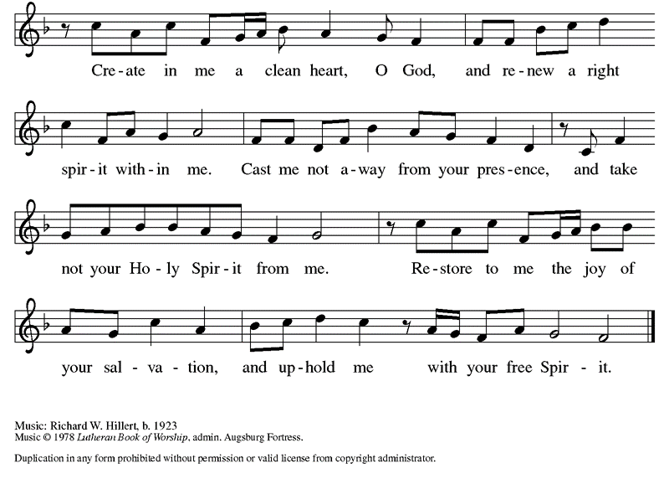

Great Thanksgiving
P: The Lord be with you. C: And also with you.
P: Lift up your hearts. C: We lift them to the Lord.
P: Let us give thanks to the Lord our God.
C: It is right to give our thanks and praise.

Preface
P: It is indeed right, our duty and our joy, that we should at all times and in all places give thanks and praise to you, almighty and merciful God, through our Savior Jesus Christ. You call your people to cleanse their hearts and prepare with joy for the paschal feast, that renewed in the gift of baptism, we may come to the fullness of your grace. And so, with all the choirs of angels, with the church on earth and the hosts of heaven, we praise your name and join their unending hymn:

Holy Holy Holy (spoken)
Holy, holy, holy Lord, God of power and might,
Heaven and earth are full of your glory. Hosanna in the highest.
Blessed is he who comes in the name of the Lord.
Hosanna in the highest, hosanna in the highest.
Thanksgiving at the Table

P: God meets us in the night—
C: before the sun rises, before the wound heals, before there are answers, before there is closure.
P: God meets us in the light—
C: where joy is effervescent, where laughter is contagious, where flowers bloom from cracks in the sidewalk, where people gather around tables.
P: God meets us in between—
C: at the edge of the water, at the beginning of the wilderness, at the start of something new, on the edge of faith.
P: And if God meets us in all those places,
C: then surely God meets us everywhere—at the water’s edge, at the start of something new, after baptism, and before the call.
P: We are not alone. God is all around.
C: Let us meet God in bread and wine.
P: In the night in which he was betrayed, our Lord Jesus took bread, and gave thanks; broke it, and gave it to his disciples, saying: Take and eat; this is my body, given for you. Do this for the remembrance of me. Again, after supper, he took the cup, gave thanks, and gave it for all to drink, saying: This cup is the new covenant in my blood, shed for you and for all people for the forgiveness of sin. Do this for the remembrance of me. C: Amen

Lord’s Prayer
P: Lord, remember us in your kingdom and teach us to pray.
C: Our Father, who art in heaven, hallowed be thy name, thy kingdom come, thy will be done, on earth as it is in heaven. Give us this day our daily bread; and forgive us our trespasses, as we forgive those who trespass against us; and lead us not into temptation, but deliver us from evil. For thine is the kingdom, and the power, and the glory, forever and ever. Amen.

Invitation to the Table
At Parkside Lutheran Church we have an open table. We believe the invitation to receive comes from Jesus himself and all are welcome at Christ’s table. More than just Bread and Wine these are tangible signs of God’s love for you! If you do not wish to receive communion but would like a blessing, come forward and cross your arms over your chest. The Pastor will give you a blessing before you return to your seat via the side aisle. You’ll receive a communion wafer* in your hands. You may dip it in the cup of wine or juice. When giving the bread and cup, the communion ministers say: “The body of Christ, given for you. The blood of Christ, shed for you.”
and each person may respond: Amen
*Please let Pastor know if you need a gluten-free wafer
P: Come to the table. Feast on God’s goodness and mercy.

The Communion Distribution

Communion Song ELW setting 10 (p. 208)
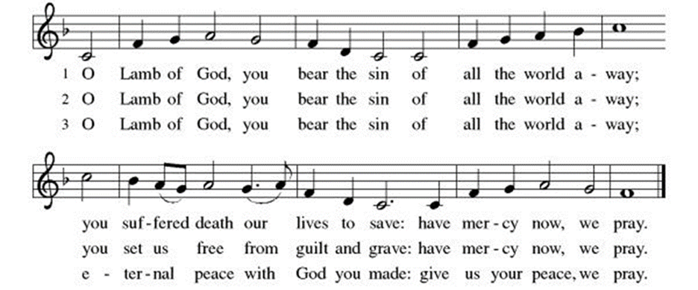

Communion Song: “Think About His Love” by Walt Harrah

Communion Song: Eat This Bread, Drink This Cup ELW #492
(printed next page)

Post Communion Blessing
P: The Body and Blood of our Lord and Savior, Jesus Christ, strengthen you and keep you in God's grace. C: Amen.

Prayer After Communion
WA: Let us pray together.
C: God of our salvation, we give you thanks for this meal that restores our souls, reconciles us to you, and strengthens us for the journey. Through the body and blood of your Son, may we become Christ’s body in the world, bearing witness to your love for all creation, through Jesus Christ, our Savior and Lord. Amen.

Sending - God blesses us and sends us in mission to the world.

Blessing
P: As you leave this place, when you meet anger, speak with love. When you meet fear, speak with hope. When you meet pain, speak with gentleness. But no matter what, speak the good news. For the good news of the gospel is love and justice for all. It is joy that surprises, and nonviolence that transforms.
The good news of the gospel is alive in the world, so go forth speaking. For if you won’t, then who will? Thanks be to God for this good, good news. May you be blessed in the name of The Creator, Redeemer + and Sustainer. C: Amen

Sending Hymn: There’s a Wideness in God’s Mercy ELW #588
Dismissal
P: Parkside Lutheran Church is rediscovering the radical love of Jesus.
C: Gathering All, Serving All, Caring For All
P: Go in peace. Believe the good news. C: Thanks be to God.

Postlude: “Send Us Out” by Larry Olson

ELW Music licensed from Sundays & Seasons, Augsburg Fortress CCLI MUSIC License # 11440069 , CCLI Streaming License#21835523 Do not duplicate any music or Liturgy herein without license and permission
scripture readings adapted and written by susan lukey

- Sponsor Easter Lilies or a Soloist in honor of a loved one
or to mark a special occasion. Contact the office for more info.
PARKSIDE STAFF:
• The Rev. Jeremiah Smith: prjeremiahpsmith@gmail.com
• Kris Pope & Suzanne Gracie, Admin. Assistants (Church Office): parksidelutheran@gmail.com
• Mike Hooker, Music Director: mrhooker@me.com

CHURCH OFFICE HOURS: M/T/R 10:00am-3:00pm (716)836-1361
SCHEDULES and Events:
Acolytes: |  |  | Worship Assistants
3/22 – Annalie & Lorenzo |  |  | 3/22 - John
3/29 – Emmet & Genevieve |  |  | 3/29 – Vince
Readers: |  |  | Ushers:
3/22 – Sarah |  |  | 3/22 - Tom S, Joanne N, Charlie R
3/29 – Josiah |  |  | 3/29 - Kathy S, Gary S, Charlie R
Coming up:
- TODAY! Easter Lily Orders are DUE!
- March 25th - 5:30pm Lenten Dinner & Worship
- March 29th – Palm Sunday Worship at 10am
- April 2nd – Maundy Thursday Spaghetti Dinner – 5:30 – 7pm
- April 3rd – Good Friday Tenebrae Candlelight Service – 7pm
- April 5th – Easter Sunday Worship at 10am, followed by an Easter Egg Hunt – Contact the Office, or Visit the Events Section of the website to SIGN UP to DONATE or VOLUNTEER!

Visit our website for more information about these and other Events at Parkside – www.parksidelutheran.org/events
Volunteers needed: Want to help with worship but don’t want to stand up front? We are seeking folks to help run the Power Point and/or the live stream during worship. You arrive ten minutes before worship and either click the slides through or click the buttons to change camera angles. Speak to Pastor Jeremiah or Kristen Lenz if you would like to learn more. kristenlenz@gmail.com
Powerpoint Slides Background Image Credit:
| A Sanctified Art LLC | sanctifiedart.org

