THE PARABLES OF LENT
Receive Forgiveness
The Parable of The Prodigal Son
March 25th, 2026

Opening Hymn #802: Let Us Ever Walk With Jesus
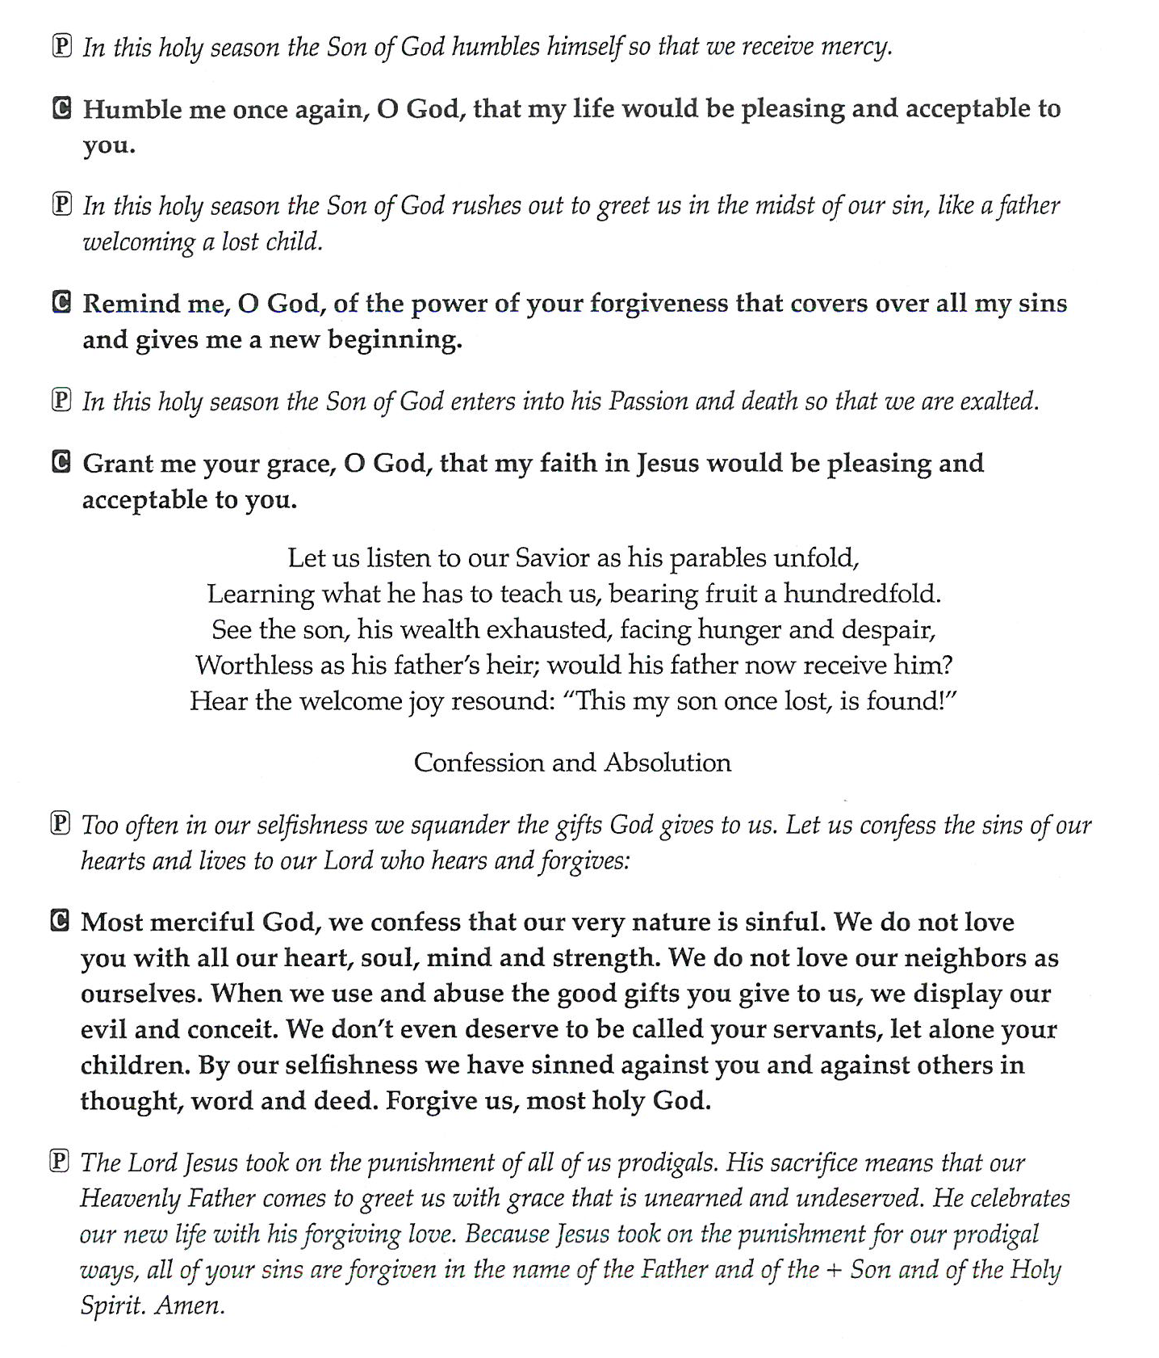

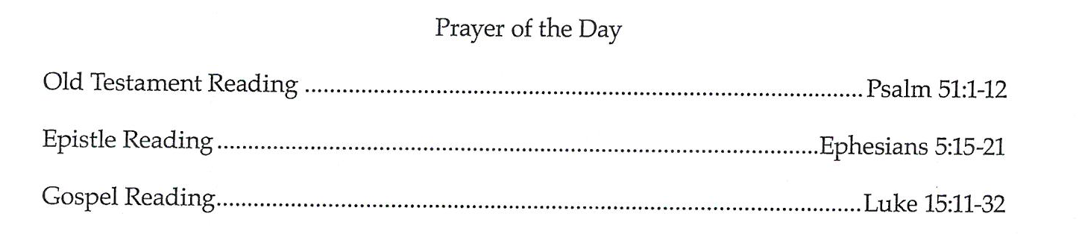
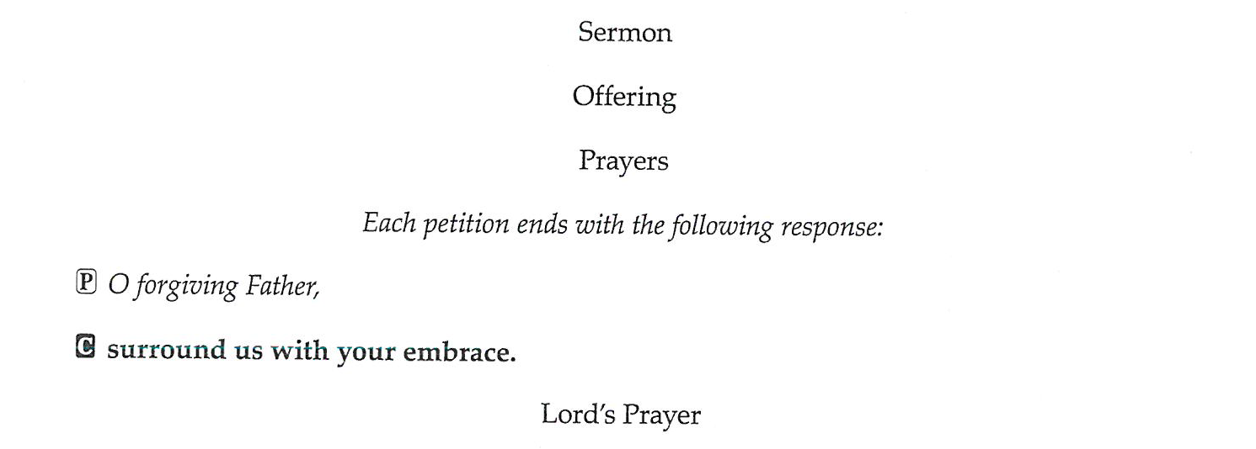

Closing Hymn #608: Softly and Tenderly Jesus is Calling

