THE PARABLES OF LENT
Receive Grace
The Parable of The Workers In The Vineyard
March 18th, 2026

Opening Hymn #802: Let Us Ever Walk With Jesus
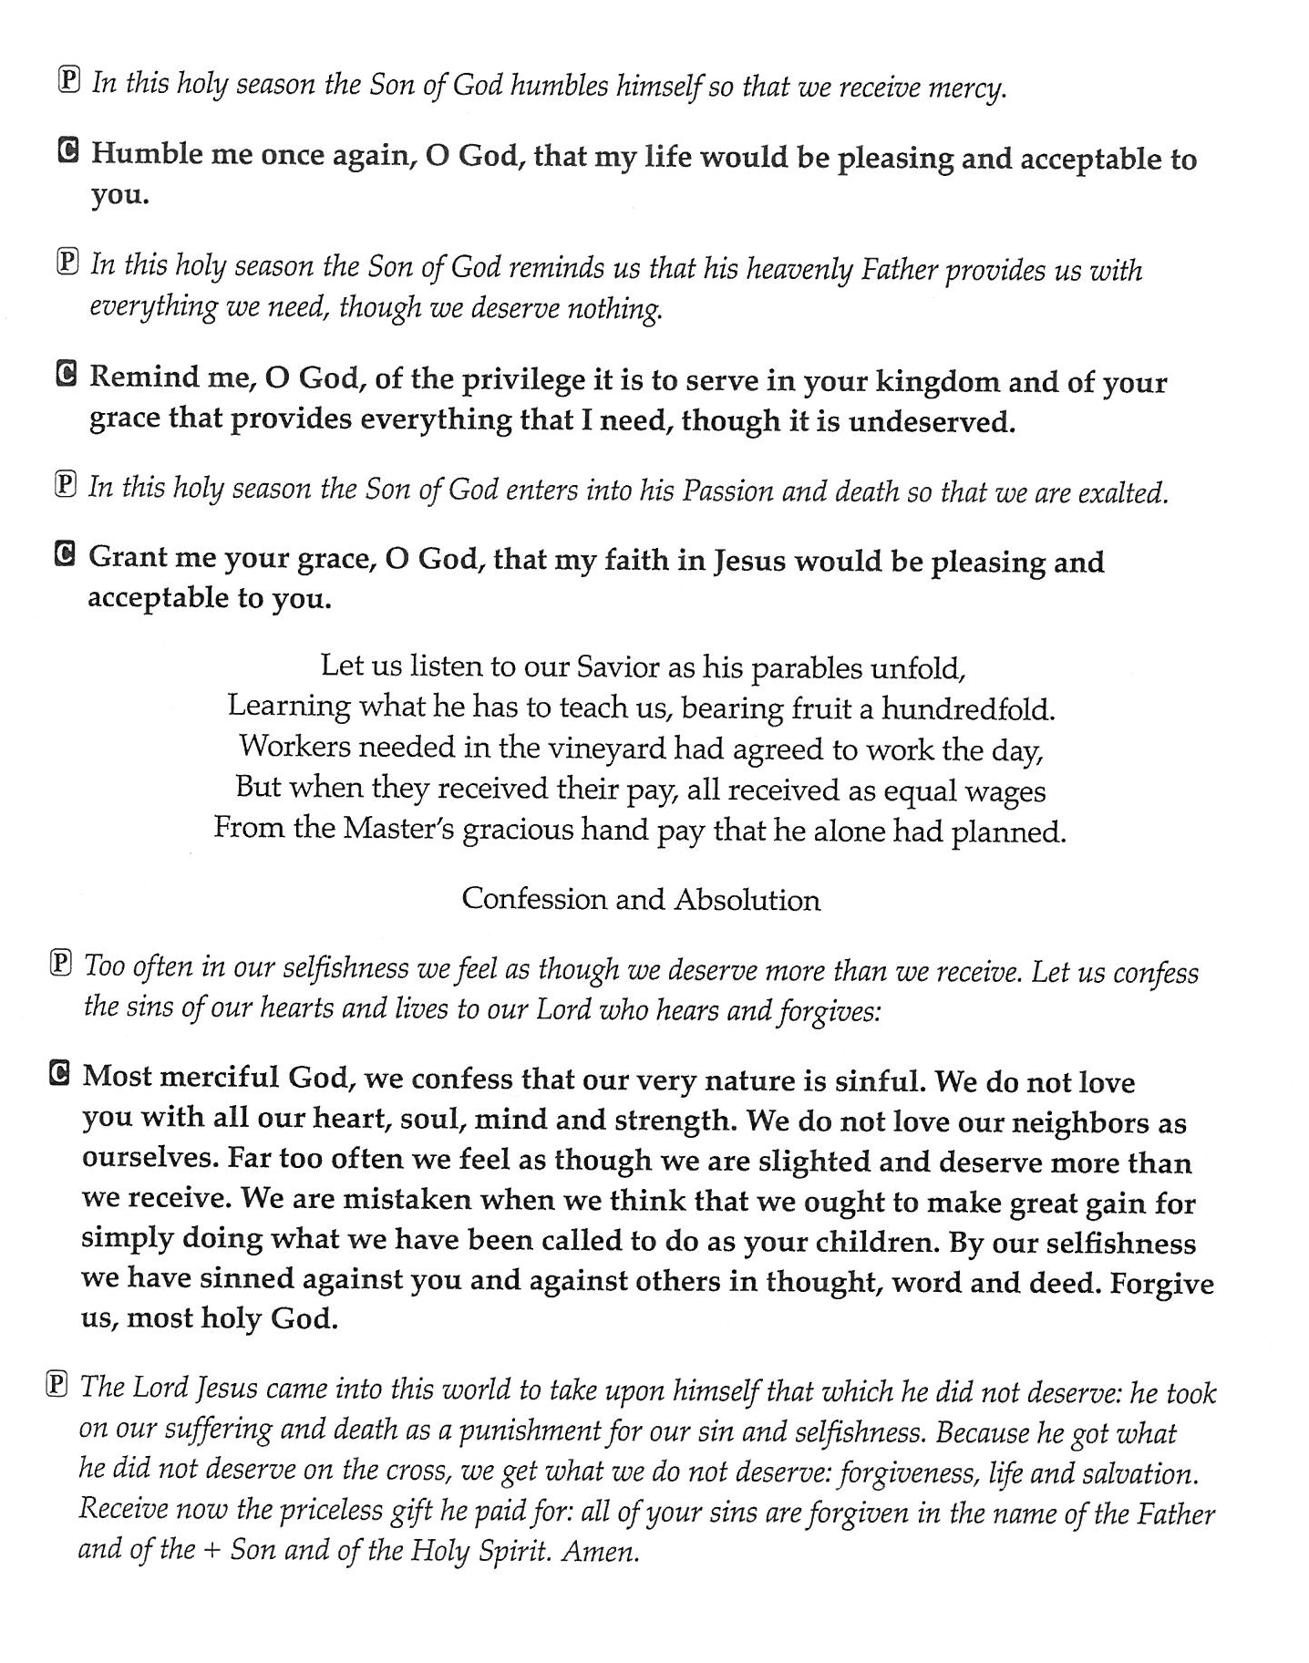
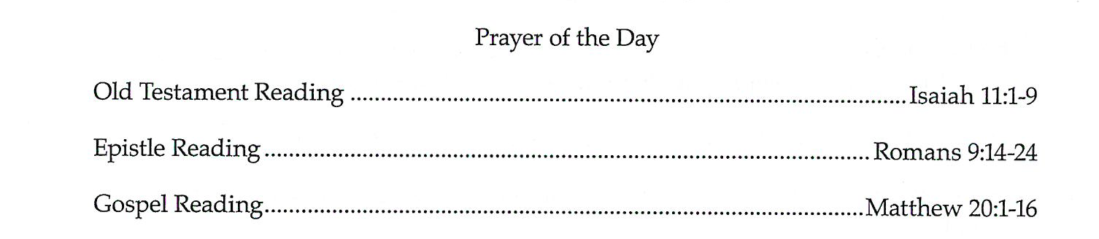

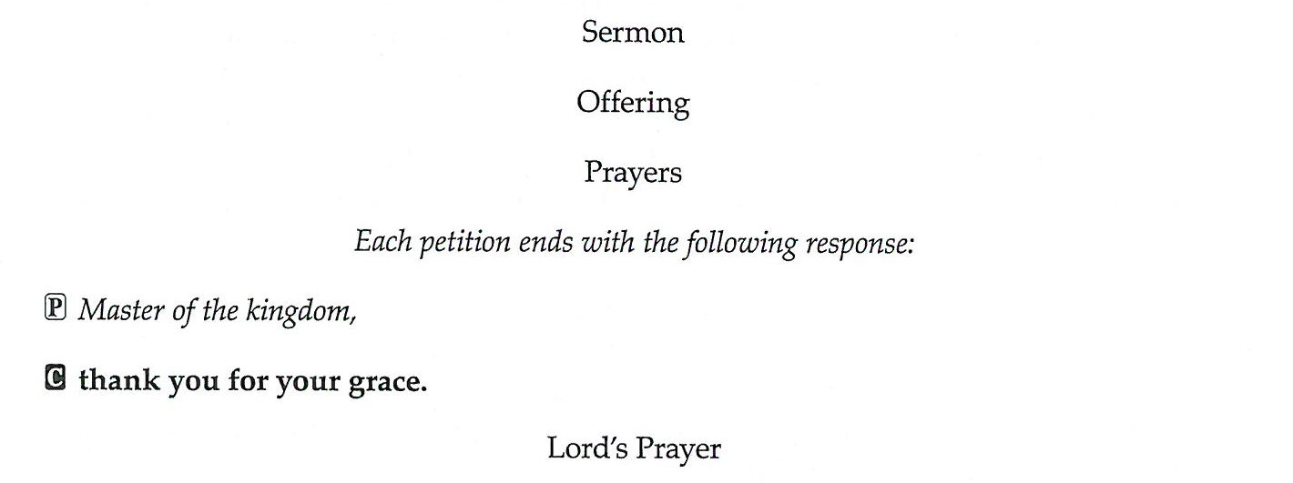

Closing Hymn #712: Lord, Whose Love in Humble Service

