LIVING LIKE CHRIST ~ A Journey Through Ephesians
Armor of God
March 15, 2026

Ephesians 6:10-20 Finally, be strong in the Lord and in his mighty power. ¹¹ Put on the full armor of God, so that you can take your stand against the devil’s schemes. ¹² For our struggle is not against flesh and blood, but against the rulers, against the authorities, against the powers of this dark world and against the spiritual forces of evil in the heavenly realms. ¹³ Therefore put on the full armor of God, so that when the day of evil comes, you may be able to stand your ground, and after you have done everything, to stand. ¹⁴ Stand firm then, with the belt of truth buckled around your waist, with the breastplate of righteousness in place, ¹⁵ and with your feet fitted with the readiness that comes from the gospel of peace. ¹⁶ In addition to all this, take up the shield of faith, with which you can extinguish all the flaming arrows of the evil one. ¹⁷ Take the helmet of salvation and the sword of the Spirit, which is the word of God.
₁₈ And pray in the Spirit on all occasions with all kinds of prayers and requests. With this in mind, be alert and always keep on praying for all the Lord’s people. ¹⁹ Pray also for me, that whenever I speak, words may be given me so that I will fearlessly make known the mystery of the gospel, 20 for which I am an ambassador in chains. Pray that I may declare it fearlessly, as I should.

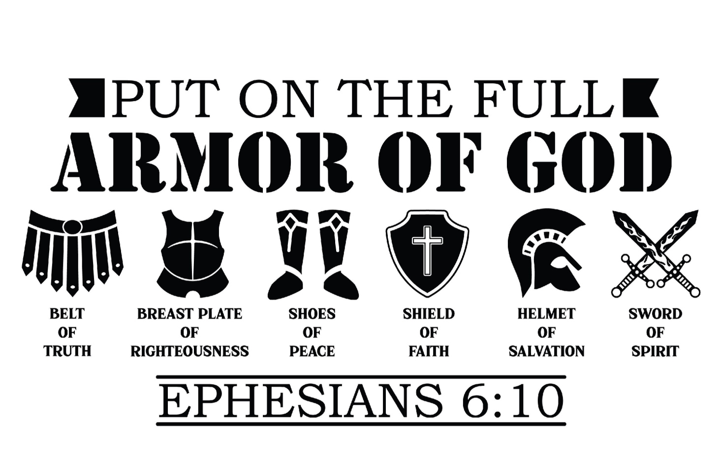

Sermon Discussion Guide
LIVING LIKE CHRIST ~ A Journey Through Ephesians
Armor of God
March 15, 2026

Read Ephesians 6:10-20

- Understanding the Text

- What does the concept of "putting on the whole armor of God" mean in your life?

- How can you personally apply each piece of armor mentioned (belt of truth, breastplate of righteousness, etc.)?

- What does Paul mean by "our struggle is not against flesh and blood"?

- How does this perspective change your understanding of conflict and challenges in your life?

- Reflection

- Reflect on a time when you felt you were engaged in spiritual warfare.

- How did the truths in this passage help you during that situation?

- What are some daily practices that can help you remain spiritually vigilant as suggested in these verses?

- How can consistency in these practices impact your spiritual growth?

- Other Impacts

- What is the significance of prayer in relation to the armor of God?

- How can prayer be woven into daily life alongside the other aspects of spiritual armor?

- Personal Application

- Which piece of the armor of God do you find most challenging to implement?

- What specific barriers do you face in using that armor effectively?

