THE ANGLICAN PARISH OF ST. MARK
“Drawing People to the Light”
Part of the Diocese of British Columbia
www.stmarkqualicum.ca https://bc.anglican.ca
The Fourth Sunday of Lent
March 15, 2026

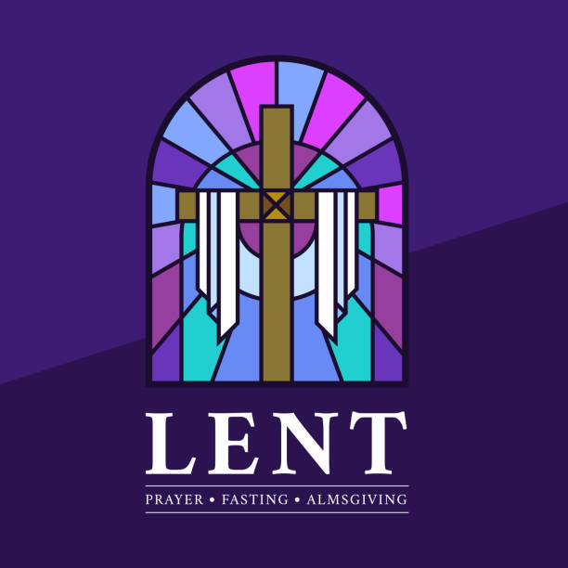

In a state of openness, and with a desire to learn the truth of our shared history, we acknowledge that we worship on the unceded territory of the Qualicum First Nation. We give thanks for their careful stewardship of the forests, rivers, oceans, lands and air, so that we might walk with them and celebrate the gift of the Creator. We commit to a lifelong journey of respectful understanding.

Celebrant: The Reverend Deborah Rivet

Before the service, please observe silence so that we can be in quiet prayer.

Celebrant: The Reverend Deborah Rivet
Before the service, please observe silence so that we can be in quiet prayer.

Opening Sentence: I am the Light of the World, says the Lord; those who follow me will have the light of life. John 8: 12

Processional Hymn: The King of Love My Shepherd Is CP 520

The Gathering of the Community

Celebrant: The grace of our Lord Jesus Christ, and the love of God, and the fellowship of the Holy Spirit, be with you all.
People and also with you.

Celebrant Almighty God,
People to you all hearts are open, all desires known, and from you no secrets are hidden. Cleanse the thoughts of our hearts by the inspiration of your Holy Spirit, that we may perfectly love you, and worthily magnify your holy name; through Christ our Lord. Amen.

Trisagion: Holy God,
(said 3 X) Holy and mighty,
Holy immortal one,
Have mercy upon us.

The Collect of the Day:
Almighty God,
Whose Son was revealed in majesty
Before he suffered death upon the cross,
Give us faith to perceive his glory,
That being strengthened by his grace,
We may be changed into his likeness, from glory to glory; who lives and reigns with you and the Holy Spirit,
One God, now and for ever.

The Proclamation of the Word

First Reading: 1st Samuel 16: 1-13
Reader’s Introduction of the Reading: In this passage from First Samuel, we hear how God sends the prophet Samuel to Bethlehem to anoint a new king. While Samuel looks at outward appearance, God reveals a deeper truth: the Lord chooses by seeing the heart. Here we witness the surprising call of David, the youngest son of Jesse, and the beginning of his Spirit‑filled vocation.
A READING FROM THE FIRST BOOK OF SAMUEL
The Lord said to Samuel, "How long will you grieve over Saul? I have rejected him from being king over Israel. Fill your horn with oil and set out; I will send you to Jesse the Bethlehemite, for I have provided for myself a king among his sons." Samuel said, "How can I go? If Saul hears of it, he will kill me." And the Lord said, "Take a heifer with you, and say, 'I have come to sacrifice to the Lord.' Invite Jesse to the sacrifice, and I will show you what you shall do; and you shall anoint for me the one whom I name to you." Samuel did what the Lord commanded, and came to Bethlehem. The elders of the city came to meet him trembling, and said, "Do you come peaceably?" He said, "Peaceably; I have come to sacrifice to the Lord; sanctify yourselves and come with me to the sacrifice." And he sanctified Jesse and his sons and invited them to the sacrifice. When they came, he looked on Eliab and thought, "Surely the Lord's anointed is now before the Lord." But the Lord said to Samuel, "Do not look on his appearance or on the height of his stature, because I have rejected him; for the Lord does not see as mortals see; they look on the outward appearance, but the Lord looks on the heart." Then Jesse called Abinadab, and made him pass before Samuel. He said, "Neither has the Lord chosen this one." Then Jesse made Shammah pass by. And he said, "Neither has the Lord chosen this one." Jesse made seven of his sons pass before Samuel, and Samuel said to Jesse, "The Lord has not chosen any of these." Samuel said to Jesse, "Are all your sons here?" And he said, "There remains yet the youngest, but he is keeping the sheep." And Samuel said to Jesse, "Send and bring him; for we will not sit down until he comes here." He sent and brought him in. Now he was ruddy, and had beautiful eyes, and was handsome. The Lord said, "Rise and anoint him; for this is the one." Then Samuel took the horn of oil, and anointed him in the presence of his brothers; and the spirit of the Lord came mightily upon David from that day forward. Samuel then set out and went to Ramah.
Please see the response on the next page.
The Word of the Lord
Thanks be to God

Psalm 23 (said together by congregation, sung refrain (CP519) by cantor, John Smith)
The Lord is my shepherd, I shall not be in want.
The Lord is my shepherd; I shall not be in want.
He makes me lie down in green pastures and leads me beside still waters.
The Lord is my shepherd, I shall not be in want.
He revives my soul and guides me along right pathways for his name's sake.
Though I walk through the valley of the shadow of death, I shall fear no evil; for you are with me; your rod and your staff, they comfort me.
The Lord is my shepherd, I shall not be in want.
You spread a table before me in the presence of those who trouble me; you have anointed my head with oil, and my cup is running over.
Surely your goodness and mercy shall follow me all the days of my life, and I will dwell in the house of the Lord for ever.
The Lord is my shepherd, I shall not be in want.

Second Reading: EPHESIANS 5:8-14

A READING FROM THE LETTER OF PAUL TO THE EPHESIANS
For once you were darkness, but now in the Lord you are light. Live as children of light - for the fruit of the light is found in all that is good and right and true. Try to find out what is pleasing to the Lord. Take no part in the unfruitful works of darkness, but instead expose them. For it is shameful even to mention what such people do secretly; but everything exposed by the light becomes visible, for everything that becomes visible is light. Therefore, it says, "Sleeper, awake! Rise from the dead, and Christ will shine on you.
The Word of the Lord
Thanks be to God
Gospel Procession: My Song is Love Unknown verses 1,2,3 CP 184
Reader: The Lord be with you
People: And also with you.
Reader: The Holy Gospel of our Lord Jesus Christ according to John.
People: Glory to you, Lord Jesus Christ.
The Gospel: John 9: 1-41 (Please stand as you are able)
Reader’s Introduction: In today’s Gospel, Jesus encounters a man blind from birth and reveals that God’s grace is not bound by human assumptions. Through this healing, we see Christ as the Light of the World—opening eyes, restoring lives, and challenging all who believe they already see.
THE HOLY GOSPEL OF OUR LORD JESUS CHRIST ACCORDING TO JOHN: As Jesus walked along, he saw a man blind from birth. His disciples asked him, "Rabbi, who sinned, this man or his parents, that he was born blind?" Jesus answered, "Neither this man nor his parents sinned; he was born blind so that God's works might be revealed in him. We must work the works of him who sent me while it is day; night is coming when no one can work. As long as I am in the world, I am the light of the world." When he had said this, he spat on the ground and made mud with the saliva and spread the mud on the man's eyes, saying to him, "Go, wash in the pool of Siloam" (which means Sent). Then he went and washed and came back able to see. The neighbours and those who had seen him before as a beggar began to ask, "Is this not the man who used to sit and beg?" Some were saying, "It is he." Others were saying, "No, but it is someone like him." He kept saying, "I am the man." But they kept asking him, "Then how were your eyes opened?" He answered, "The man called Jesus made mud, spread it on my eyes, and said to me, 'Go to Siloam and wash.' Then I went and washed and received my sight." They said to him, "Where is he?" He said, "I do not know." They brought to the Pharisees the man who had formerly been blind. Now it was a sabbath day when Jesus made the mud and opened his eyes. Then the Pharisees also began to ask him how he had received his sight. He said to them, "He put mud on my eyes. Then I washed, and now I see." Some of the Pharisees said, "This man is not from God, for he does not observe the sabbath." But others said, "How can a man who is a sinner perform such signs?" And they were divided. So they said again to the blind man, "What do you say about him? It was your eyes he opened." He said, "He is a prophet." The Jews did not believe that he had been blind and had received his sight until they called the parents of the man who had received his sight and asked them, "Is this your son, who you say was born blind? How then does he now see?" His parents answered, "We know that this is our son, and that he was born blind; but we do not know how it is that now he sees, nor do we know who opened his eyes. Ask him; he is of age. He will speak for himself." His parents said this because they were afraid of the Jews; for the Jews had already agreed that anyone who confessed Jesus to be the Messiah would be put out of the synagogue. Therefore, his parents said, "He is of age; ask him." So, for the second time they called the man who had been blind, and they said to him, "Give glory to God! We know that this man is a sinner." He answered, "I do not know whether he is a sinner. One thing I do know, that though I was blind, now I see." They said to him, "What did he do to you? How did he open your eyes?" He answered them, "I have told you already, and you would not listen. Why do you want to hear it again? Do you also want to be-come his disciples?" Then they reviled him, saying, "You are his disciple, but we are disciples of Moses. We know that God has spoken to Moses, but as for this man, we do not know where he comes from." The man answered, "Here is an astonishing thing! You do not know where he comes from, and yet he opened my eyes. We know that God does not listen to sinners, but he does listen to one who worships him and obeys his will. Never since the world began has it been heard that anyone opened the eyes of a person born blind. If this man were not from God, he could do nothing." They answered him, "You were born entirely in sins, and are you trying to teach us?" And they drove him out. Jesus heard that they had driven him out, and when he found him, he said, "Do you believe in the Son of Man?" He answered, "And who is he, sir? Tell me, so that I may believe in him." Jesus said to him, "You have seen him, and the one speaking with you is he." He said, "Lord, I believe." And he worshipped him. Jesus said, "I came into this world for judgement so that those who do not see may see, and those who do see may become blind." Some of the Pharisees near him heard this and said to him, "Surely we are not blind, are we?" Jesus said to them, "If you were blind, you would not have sin. But now that you say, 'We see,' your sin remains."
Reader: The Gospel of Christ
People: Praise to you, Lord Jesus Christ.
Gospel Procession: My Song is Love Unknown verses 4, 5, 6 CP 184
Sermon: Rev Deborah

Choir Anthem: Make Me a Channel of Your Peace Sebastian Temple
Affirming our Christian Narrative
Presider: Let us affirm our faith in Jesus Christ the Son of God.
People: Though he was divine
he did not cling to equality with God,
but made himself nothing.
Taking the form of a slave,
He was born in human likeness.
He humbled himself
And was obedient to death,
Even death on the cross.
Therefore, God has raised him on high,
And given him the name above every name:
That at the name of Jesus,
Every knee should bow,
And every voice proclaim that Jesus Christ is Lord,
To the glory of God the Father. Amen
(cf Philippians 2. 6-11 from Creating Uncommon Worship by Richard Giles)

Prayers of the People (Intercessor)
Intercessor: Lord, in your mercy…
Response: Hear our prayer.
Confession
Celebrant Dear friends in Christ, God is steadfast in love and infinite in mercy; God welcomes sinners and invites us to this table. Let us confess our sins, confident in God’s forgiveness.
Silence is kept

Celebrant: Most merciful God,
We confess that we have sinned against you in thought, word, and deed, by what we have done, and by what we have left undone. We have not loved you with our whole heart; we have not loved our neighbours as ourselves. We are truly sorry and we humbly repent. For the sake of your Son Jesus Christ, have mercy on us and forgive us, that we may delight in your will, and walk in your ways, to the glory of your name. Amen.

Almighty God have mercy upon you, pardon and deliver you from all your sins, confirm and strengthen you in all goodness, and keep you in eternal life; through Jesus Christ our Lord. Amen.

Celebrant: The peace of the Lord be always with you.
People: And also with you.

Offertory Hymn: I am the Light of the World SGP 24

You people come and follow me.
If you follow and love, You'll learn the mystery
Of what you were meant to do and be.
1. When the song of the angels is stilled.
When the star in the sky is gone.
When the kings and the shepherds have found their way home.
The work of Christmas is begun!
2. To find the lost and lonely one,
To heal that broken soul with love,
To feed the hungry children with warmth and good food,
To feel the earth below the sky above!
3. To free the prisoner from his chains,
To make the powerful care,
To rebuild the nations with strength and goodwill,
To call a man your brother everywhere.
4. To bring hope to every task you do,
To dance at a baby's new birth,
To make music in an old man's heart,
And sing to the colours of the earth!
The Holy Eucharist
Prayer over the Gifts
God of Light, your Word brings to us a new vision of your glory. Accept our offering of praise and thanksgiving, through Jesus Christ our Lord. Amen

Celebrant God is here.
All: The Spirit is with us.

Celebrant Lift up your hearts and minds.
All: We lift them up to God.

Celebrant Let us give thanks to God the Creator.
All: It is right to give our thanks and praise

Celebrant: It is indeed right that we should praise you,
God of love, our source and our fulfillment,
for you create all things and in you we live and move and have our being.
Your wonder is manifest in land and sea and sky.
You made us in your image.
And even though we turn from you,
again and again, you call us to yourself,
and in every age, promise liberation.
As a mother gathers her children,
you embraced a people as your own,
to nurture them in the way of compassionate love.
You sent Jesus among us,
incarnate of the Holy Spirit and born of Mary.
Jesus revealed your love for all Creation,
and showed us the way of reconciliation.
Having lived among us - Jesus suffered the cross,
Died,
And in rising again became the firstborn of the renewed family.
And so, as we gather around your table,
With saints of every age and your beloved creation we raise our voices and sing:

All: Holy, holy, holy Lord, God of power and might,
heaven and earth are full, of your glory.
Hosanna in the highest. Hosanna in the highest.
Blessed is he who comes in the name of the Lord.
Hosanna in the highest. Hosanna in the highest.

Celebrant: To you be glory, almighty God,
because on the night before he died,
Jesus took bread,
when he had given thanks,
he broke it, gave it to his disciples, and said:
Take, eat, this is my body
which is given for you; do this to remember me.
After supper he took the cup;
when he had given thanks,
he gave it to them and said:
Drink this all of you.
This is my blood of the new covenant,
Poured out for you and for many;
do this to remember me.
Great is the mystery of faith.

All: Christ has died, Christ is risen, Christ will come again.

Celebrant: Recalling Christ’s death and resurrection, we ask you to accept this, our sacrifice of praise.
Pour out your Holy Spirit on us gathered here, and on these gifts of bread and wine that we may be fed with the body and blood of your Son.
When all of creation groans, unite us in Christ and give us your hope that we might be strengthened to do your work, as your body in the world. Through Christ our Redeemer, in the power of the Spirit, all praise and glory be yours, Almighty God, now and forever. Amen

The Lord’s Prayer – (sung) David Haas

The Breaking of the Bread
We break this bread,
Communion in Christ’s body once broken.

Let the Church be the wheat which bears its fruit in dying.
If we have died with him,
We shall live with him,
We shall live with him;
If we hold firm, we shall reign with him. Amen

Invitation to The Communion Table
Come to this table,
you who have much faith and you who would like to have more;
you who have been to this sacrament often
and you who have not been for a long time;
you who have tried to follow Jesus and you who have failed.
Come, it is Christ who invites us to meet him here.

The Gifts of God for the People of God
Thanks be to God.

The Healing Ministry Prayer Team and Eucharistic Team
will proceed to the Altar first for Communion.
If you would prefer Holy Communion brought to you in the pew, please stand and the Eucharistic Ministers will come to you.

Communion at the Altar Rail commences
with the Choir Members followed by the Congregation
Prayer Ministry
Our healing prayer team invites you to join them to pray or give thanks to God in the narthex (entrance) during or after communion, or in the alcove under the Exit sign after the service. Confidentiality is assured.

Post Communion Hymn: Nothing Can Trouble CP 568
Creator of heaven and earth,
We thank you for these holy mysteries,
Which bring us now a share in the life to come,
Through Jesus Christ our Lord.

Celebrant: Glory to God,
All: whose power, working in us, can do infinitely more than we can ask or imagine. Glory to God from generation to generation, in the Church and in Christ Jesus, for ever and ever. Amen.

Recessional Hymn: Make A Joyful Noise CP 500
Refrain:
Spirit, open my heart
to the joy and pain of living.
As you love may I love,
in receiving and in giving.
Spirit, open my heart.
1 God, replace my stony heart
with a heart that's kind and tender.
All my coldness and fear
2 Write your love upon my heart
as my law, my goal, my story.
In each thought, word, and deed,
may my living bring you glory. (Refrain)
3 May I weep with those who weep;
share the joy of sister, brother.
In the welcome of Christ,
may we welcome one another. (Refrain)
to your grace I now surrender. (Refrain)

Dismissal

Liturgical: Go from this place with the cross on your hearts.
Assistant
People: We will empty ourselves with Christ for the life of the world.

For Emergency Pastoral Care please contact:
Morag Atherstone at 250-248-6353 or Cynthia Preyser at 250-954-9122

Thank you to those who assisted in the service today.
Celebrant: | Rev Deborah | Greeters: | Maggie & Neil
Liturgical Assistant: | Wendy | Reader: | Morag
Chalice: | Wendy & Cynthia | Musical Director: Guitarist: | Pippa  Richard
Intercessor: | Michael | Altar Guild: | Nancy

SPECIAL EVENT AT ST MARY’S NANOOSE BAY
The Rev Kirsten Evenden is inviting St Mark’s parishioners to join St Mary’s for a day of sharing reflection and creativity as we move through the Last Seven Words of Jesus together. Coffee and tea will be available but please bring a bag lunch. If you are planning to attend. Please let Rev Kirsten know so she can plan accordingly!
Rev Kirsten Evenden: kevenden@bc.anglican.ca
+1-250-468-5684

ANNOUNCEMENTS
- A warm welcome to all of you who are worshipping with us today. Please join us in the hall following the service for coffee and conversation in the parish hall.
- St. Mark's will hold a Plant and Bake Sale on Saturday, May 2nd Richard is asking for cuttings from flowering bushes, perennials and seedlings. Please speak to him for further details. Sandy Morter will organize this Sale. You'll be glad to know the Pie Ladies will be back with their Holy Roller Pies!
- Manna Ministries is not accepting any clothing at the moment. They are accepting sleeping bags, tarps and tents.
- If you haven’t had your photo taken yet for our Parish Family Photo Board in the library/lounge, please do so at coffee time. At the same time, please consider giving your approval to have your telephone contact shared with others in the parish.
- As we are in the process of reorganizing the mailbox cubbyholes in the church hall, we would greatly appreciate you clearing any accumulated mail in your slot. We will soon assign mail slots to our new parishioners.
- The Lenten study session based on “The Chosen” video continues each Wednesday with a soup-and-bun lunch following the 11:30 service. Contact Michael King at errege@icloud.com for more information.
- Bell practice for the Beaux and Belles handbell choir now takes place 4:00 pm-5:00 pm on Tuesdays.
- Please wear your name tag and help others recall your name. If you are new, or have misplaced your name tag, please request one by signing up on the clipboard on the narthex cabinet. When done, new tags will be placed in your mail slot.

ST MARK’S CALENDAR
March 16th to March 22nd
Monday March 16
9:00 MIFAC
7:00 – 9:00 St Andrews Historical Society

Tuesday March 17
9:00 –3:00 Seaside Quilters
4:00- 5:00 – Handbells

Wednesday March 18
10:00- Sermon Circle
11:30- Holy Communion
12:30 – 3:00 Lenten Study
5:30 NAC

Thursday March 19
9:00 overnight “sew days” Quilters
11:15- Choir
3:30- 52 Ways

Friday March 20
9:00 – 3:00 PQHQG “Sew days” Quilters
1:30 – 3:00 Outreach Ministry (Library)

Saturday March 21

Sunday Mar 22
Palm Sunday
8:30 – Contemplative Matins – BCP
10:00 – Morning Prayer – BAS


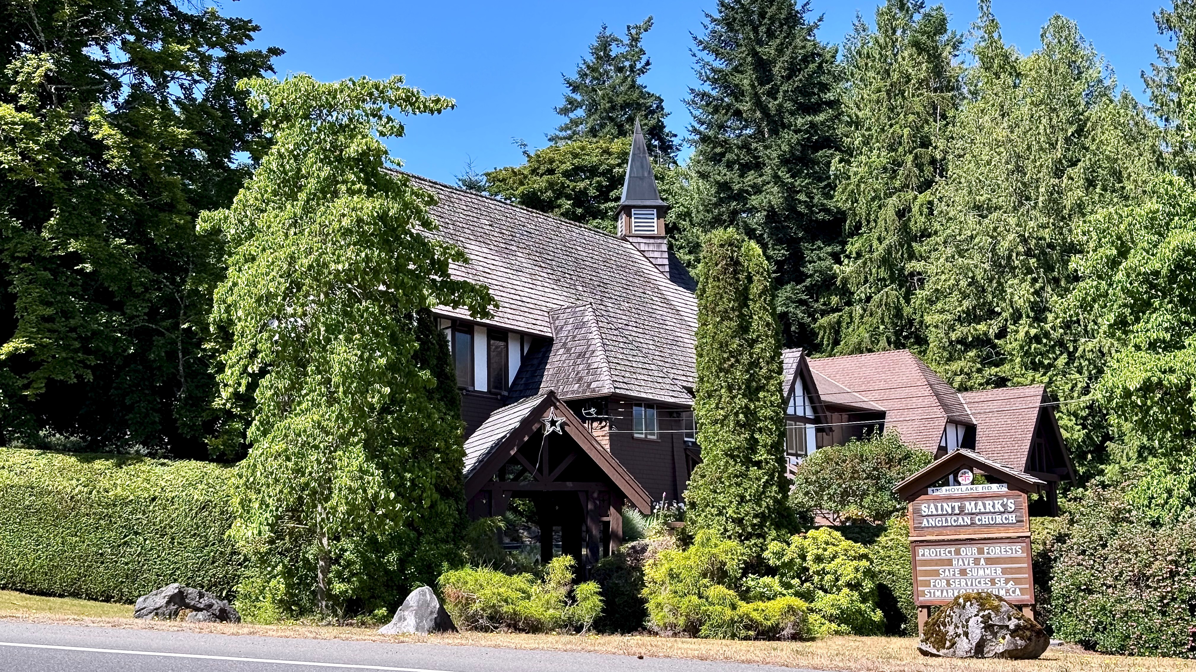

138 Hoylake Rd W
Qualicum Beach, BC V9K 1K3
PARISH OFFICE
+1-250-752-5414
admin@stmarkqualicum.ca
wardens@stmarkqualicum.ca
INTERIM PRIEST
Rev Deborah Rivet
+1-250-709-4017
revdeb@shaw.ca
WEB
https://www.stmarkqualicum.ca
EMERGENCY CONTACTS FOR PASTORAL CARE
Morag Atherstone +1-250-248-6353
Cynthia Preyser +1-250-954-9122

We draw the circle wide so all will find a home in the House of God
…and a place at the table of the Lord

