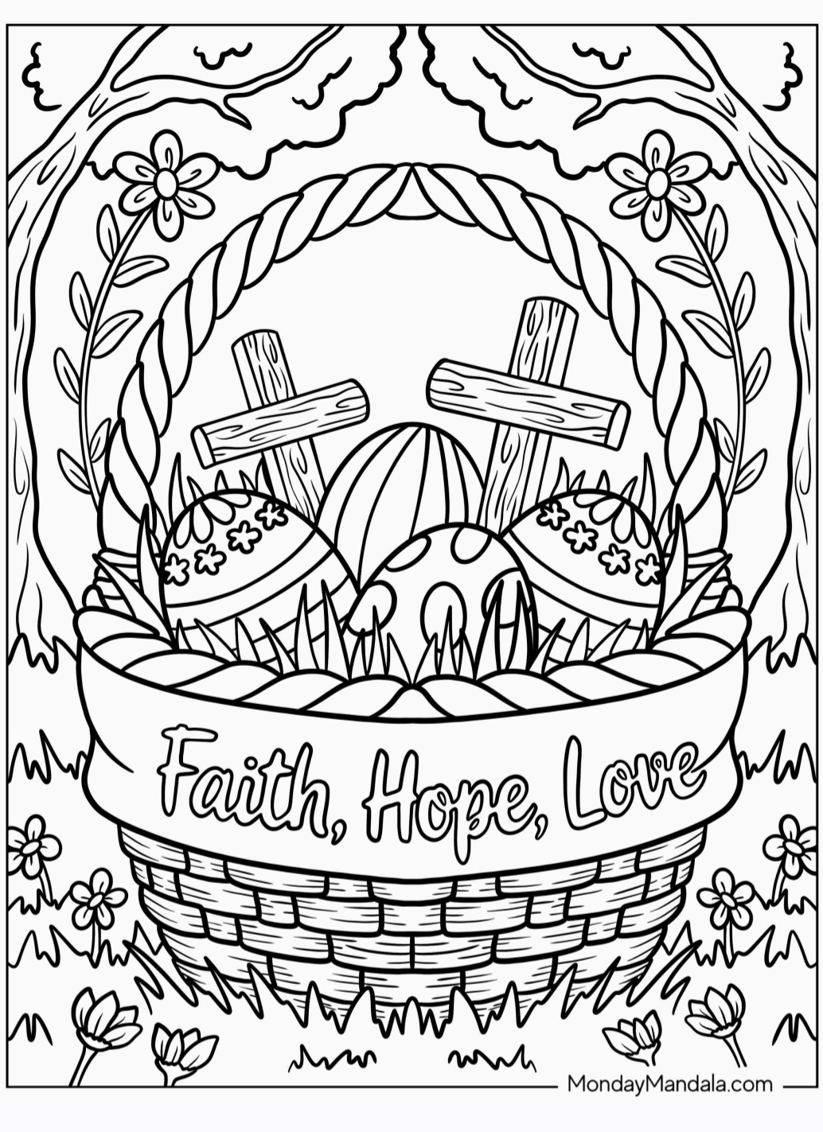

----------------------------------------------------------------------------------------------------------------------------------------------------------------
Name: _______________________________________________________
Age: ____________________
Phone Number: _________________________________________________________

