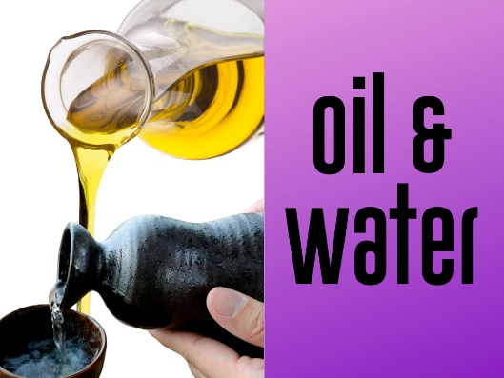


Each week of Lent we will focus on some object that is found in our daily lives and look at how it can remind us of Jesus and his love for us, his desires for us. These sheets are to help you carry the theme throughout your week, so don’t feel you have to do everything one day! This week is all about oil and water!

To Know:
In Biblical times and still today, oil and water are both used to anoint people who are set apart for something special. Oil is used in anointing kings/queens, rulers, priests, pastors, etc. And it is often used in baptisms to mark the sign of the cross on someone’s forehead. Water is used by Christians all over the world to set us apart for life with and claimed by Jesus.

Something to do:
- Water

  - Have some fun with water this week. Maybe have a water fight in the bathroom or outside if it’s warm enough. It can even be a little water splashing in the tub – just have some fun!
- Remember your baptism
  - During bath time or right before/after, talk about your child(ren) about their baptisms. What was the day like, who was there, how did you feel? Talk about why they were baptized/set apart for God.
  - During bath time you can make a ritual out of pouring water or dabbing water on your child’s head saying something like, “remember you were baptized in the name of God the Creator, Jesus the Savior and the Holy Spirit -three in one.” OR “Remember your baptism, beloved child of God”.

- Oil
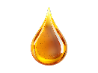
  - Once everyone has gotten something, have each person share what they brought and why it’s so special to them.
  - Bring out a small bowl of cooking/essential oil. Let your child(ren) touch it, rub it into their skin. Talk about how some oils in Jesus’ day were kept for special occasions – like when someone became a priest/pastor or when a king started to reign. Then people would pour oil over the person’s head to show they were special and set apart.
  - Tell your child(ren) today we don’t usually pour the oil over someone’s head, but we do put it on people’s foreheads in the sign of the cross to set them apart for something special – serving and living for God.
  - Tell your family tonight you are going to anoint each other with oil by making the sign of the cross on each other’s foreheads and saying something like – Remember child of God – you are loved and set apart for Jesus.

