THE ANGLICAN PARISH OF ST. MARK
“Drawing People to the Light”
Part of the Diocese of British Columbia
www.stmarkqualicum.ca https://bc.anglican.ca
The Third Sunday of Lent
March 8, 2026
Service of the Word ( BAS)

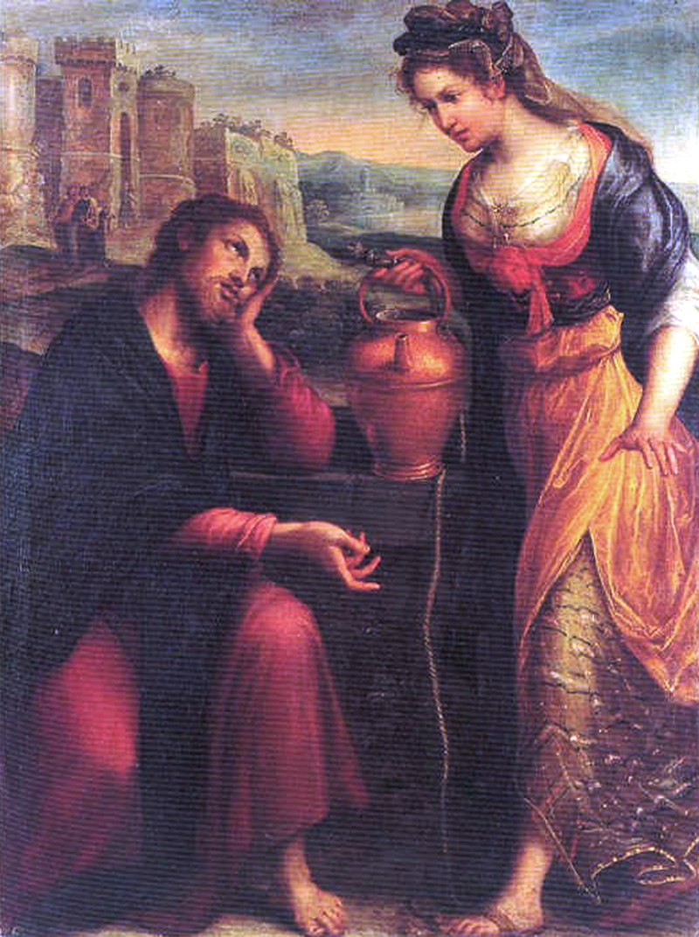

In a state of openness, and with a desire to learn the truth of our shared history, we acknowledge that we worship on the unceded territory of the Qualicum First Nation. We give thanks for their careful stewardship of the forests, rivers, oceans, lands and air, so that we might walk with them and celebrate the gift of the Creator. We commit to a lifelong journey of respectful understanding.

Celebrant: The Reverend Deborah Rivet

Before the service, please observe silence so that we can be in quiet prayer.

Lay Worship Leader Cynthia Preyser

Opening Sentence: Lord, you are indeed the Saviour of the world. Give us living water, that we may not thirst.

Processional Hymn: Guide me, O thou great Jehovah (Common Praise 565)

The Gathering of the Community

Lay Worship Leader: The grace of our Lord Jesus Christ, and the love of God, and the fellowship of the Holy Spirit, be with you all.
People and also with you.

Lay Worship Leader Almighty God,
People to you all hearts are open, all desires known, and from you no secrets are hidden. Cleanse the thoughts of our hearts by the inspiration of your Holy Spirit, that we may perfectly love you, and worthily magnify your holy name, through Christ our Lord. Amen.

Trisagion: Holy God,
(said 3 X) Holy and mighty,
Holy immortal one,
Have mercy upon us.

The Collect of the Day:
Almighty God,
Whose Son Jesus gives the water of eternal life, may we always thirst for you, the spring of life and source of goodness; through him who lives and reigns with you and the Holy Spirit, one God, now and forever. Amen

The Proclamation of the Word

First Reading: Exodus 17:1-7
From the wilderness of Sin, the whole congregation of the Israelites journeyed by stages, as the LORD commanded. They camped at Rephidim, but there was no water for the people to drink.

The people quarreled with Moses and said, "Give us water to drink." Moses said to them, "Why do you quarrel with me? Why do you test the LORD?"
But the people thirsted there for water, and the people complained against Moses and said, "Why did you bring us out of Egypt, to kill us and our children and livestock with thirst?"

So Moses cried out to the LORD, "What shall I do for this people? They are almost ready to stone me."

The LORD said to Moses, "Go on ahead of the people and take some of the elders of Israel with you; take in your hand the staff with which you struck the Nile and go.
I will be standing there in front of you on the rock at Horeb. Strike the rock, and water will come out of it, so that the people may drink." Moses did so, in the sight of the elders of Israel.

He called the place Massah and Meribah, because the Israelites quarreled and tested the LORD, saying, "Is the LORD among us or not?"

Hear what the spirit is saying to the People
Thanks be to God

Psalm 95 (said by half verse)
Come, let us sing to the Lord;
let us shout for joy to the rock of our salvation.
Let us come before his presence with thanksgiving
and raise a loud shout to him with psalms.
For the Lord is a great God,
and a great king above all gods.
In his hand are the caverns of the earth,
and the heights of the hills are his also.
The sea is his, for he made it,
and his hands have molded the dry land.
Come, let us bow down, and bend the knee,
and kneel before the Lord our Maker.
For he is our God, and we are the people of his pasture and the sheep of his hand.
Oh, that today you would hearken to his voice!
Harden not your hearts, as your forebears did in the wilderness
at Meribah, and on that day at Massah, when they tempted me.
They put me to the test,
though they had seen my works.
Forty years long I detested that generation and said,
“This people are wayward in their hearts; they do not know my ways.”
So I swore in my wrath,
“They shall not enter into my rest.
Glory to the Father and to the Son, and to the Holy Spirit
as it was in the beginning, is now and will be forever
Amen

Second Reading: Roman 5: 1-11

Therefore, since we are justified by faith, we have peace with God through our Lord Jesus Christ, through whom we have obtained access to this grace in which we stand, and we boast in our hope of sharing the glory of God and not only that, but we also boast in our afflictions, knowing that affliction produces endurance, and endurance produces character, and character produces hope, and hope does not put us to shame, because God's love has been poured into our hearts through the Holy Spirit that has been given to us. For while we were still weak, at the right time Christ died for the ungodly. Indeed, rarely will anyone die for a righteous person--though perhaps for a good person someone might actually dare to die. But God proves his love for us in that while we still were sinners Christ died for us.

Much more surely, therefore, since we have now been justified by his blood, will we be saved through him from the wrath of God.

For if while we were enemies we were reconciled to God through the death of his Son, much more surely, having been reconciled, will we be saved by his life.

But more than that, we even boast in God through our Lord Jesus Christ, through whom we have now received reconciliation.
Hear what the spirit is saying to the people
Thanks be to God

Gospel Procession: Hymn: God whose almighty Word (Common Praise 560) Verses 1 and 2

Reader The Lord be with you
People And also with you.

Reader The Holy Gospel of our Lord Jesus Christ according to John.
People Glory to you, Lord Jesus Christ.

The Gospel: John 4: 5-42
So he came to a Samaritan city called Sychar, near the plot of ground that Jacob had given to his son Joseph. Jacob's well was there, and Jesus, tired out by his journey, was sitting by the well. It was about noon. A Samaritan woman came to draw water, and Jesus said to her, "Give me a drink. (His disciples had gone to the city to buy food.) The Samaritan woman said to him, "How is it that you, a Jew, ask a drink of me, a woman of Samaria?" (Jews do not share things in common with Samaritans.) Jesus answered her, "If you knew the gift of God and who it is that is saying to you, 'Give me a drink,' you would have asked him, and he would have given you living water." The woman said to him, "Sir, you have no bucket, and the well is deep. Where do you get that living water?
Are you greater than our ancestor Jacob, who gave us the well, and with his sons and his flocks drank from it?" Jesus said to her, "Everyone who drinks of this water will be thirsty again, but those who drink of the water that I will give them will never be thirsty. The water that I will give will become in them a spring of water gushing up to eternal life."
The woman said to him, "Sir, give me this water, so that I may never be thirsty or have to keep coming here to draw water." Jesus said to her, "Go, call your husband, and come back." The woman answered him, "I have no husband." Jesus said to her, "You are right in saying, 'I have no husband,' for you have had five husbands, and the one you have now is not your husband. What you have said is true!" The woman said to him, "Sir, I see that you are a prophet.
Our ancestors worshiped on this mountain, but you say that the place where people must worship is in Jerusalem." Jesus said to her, "Woman, believe me, the hour is coming when you will worship the Father neither on this mountain nor in Jerusalem. You worship what you do not know; we worship what we know, for salvation is from the Jews. But the hour is coming and is now here when the true worshipers will worship the Father in spirit and truth, for the Father seeks such as these to worship him. God is spirit, and those who worship him must worship in spirit and truth."
The woman said to him, "I know that Messiah is coming" (who is called Christ). "When he comes, he will proclaim all things to us." Jesus said to her, "I am he, the one who is speaking to you." Just then his disciples came. They were astonished that he was speaking with a woman, but no one said, "What do you want?" or, "Why are you speaking with her?" Then the woman left her water jar and went back to the city. She said to the people, "Come and see a man who told me everything I have ever done! He cannot be the Messiah, can he?" They left the city and were on their way to him.
Meanwhile the disciples were urging him, "Rabbi, eat something." But he said to them, "I have food to eat that you do not know about." So the disciples said to one another, "Surely no one has brought him something to eat?" Jesus said to them, "My food is to do the will of him who sent me and to complete his work. Do you not say, 'Four months more, then comes the harvest'? But I tell you, look around you, and see how the fields are ripe for harvesting. The reaper is already receiving wages and is gathering fruit for eternal life, so that sower and reaper may rejoice together.
For here the saying holds true, 'One sows and another reaps.' I sent you to reap that for which you did not labor. Others have labored, and you have entered into their labor." Many Samaritans from that city believed in him because of the woman's testimony, "He told me everything I have ever done."
So when the Samaritans came to him, they asked him to stay with them, and he stayed there two days. And many more believed because of his word. They said to the woman, "It is no longer because of what you said that we believe, for we have heard for ourselves, and we know that this is truly the Savior of the world."
Lay Worship Leader: The Gospel of Christ
People Praise to you, Lord Jesus Christ.

Lay Worship Leader: Gospel Procession: God whose almighty Word (Common Praise 560) Verses 3 and 4

Sermon: Rev Deborah’s Sermon for today Delivered by Cynthia

Sermon Prayer: Lay Worship Leader: Let us pray together:
Gracious and ever-present God,
you meet us in our thirst, in our longing, and in our need.
As you brought water from the rock for your people,
and living water to the woman at the well,
pour your grace upon us this day.
Where our hearts are anxious, bring peace.
Where our memories deceive us, bring clarity.
Where our spirits are weary, bring refreshment.
Lead us from the deserts of fear
into the wide places of trust and hope.
Strengthen us for the journey ahead,
and remind us always that you walk beside us,
now and forever.
Amen.

Lord, in your mercy,
quench our thirst with your grace.
Open our hearts to trust you,
and lead us into the life you promise.
Amen.

Affirming our Christian Narrative

Lay Worship Leader: Let us affirm our faith in Jesus Christ the Son of God.
People: Though he was divine
he did not cling to equality with God,
but made himself nothing.
Taking the form of a slave,
He was born in human likeness.
He humbled himself
And was obedient to death,
Even death on the cross.
Therefore, God has raised him on high,
And given him the name above every name:
That at the name of Jesus,
Every knee should bow,
And every voice proclaim that Jesus Christ is Lord,
To the glory of God, the Father. Amen

Prayers of the People
Prayer Leader: Lord in your Mercy
People: Hear our Prayer

Lay Worship Leader The peace of the Lord be always with US.
People Thanks be to God

Offertory Hymn: For the Healing of the Nations (Page 576 in Common Praise)

Prayer over the Gifts (For the Offering) We say together

Spring of Life and Source of all goodness,
Receive all we offer you this day,
And bring us to the living water,
Jesus Christ, your Son our Lord. Amen

The Lord’s Prayer – (sung) David Haas

Prayer Ministry
Our healing prayer team invites you to join them to pray or give thanks to God in the narthex (entrance) or in the alcove under the Exit sign after the service. Confidentiality is assured.

God of our pilgrimage, we have found the living water.
Refresh and sustain us as we go forth in our journey,
the name of Jesus Christ, the Lord. Amen

Prayer Reflection Time: No Communion
Hymn The Tree of Life CP 179 VS 1,2,3/ 6D
Lay Worship Leader Glory to God,
All whose power, working in us, can do infinitely more than we can ask or imagine. Glory to God from generation to generation, in the Church and in Christ Jesus, for ever and ever. Amen.

Recessional Hymn: Your hand O God, Has Guided (Common Praise 444)

Dismissal

Liturgical Assistant: Go from this place with the cross on your hearts.

People: We will empty ourselves with Christ for the life of the world.

For Emergency Pastoral Care please contact:
Morag Atherstone @ 250-248-6353 or Cynthia Preyser @ 250-954-9122
Thank you to those who assisted in the service today.
Lay Worship Leader: | Cynthia Preyser | Greeters: | Lilian Jon/Liz
Liturgical Assistant: | Anne | Reader: | Wendy de Candole
Chalice: | Not this service | Musical Director: Guitarist: | Pippa  Richard
Intercessor: | Paul Gillan | Altar Guild: | Nancy

ST. MARKS ANNOUNCEMENTS
- A warm welcome to all of you who are worshipping with us today at this service of Morning Prayer led by Cynthia Preyser. Rev Deborah is away. Please join us in the hall following the service for coffee and conversation in the parish hall.

- St. Mark’s stood up for people who are unhoused and unsheltered in Oceanside by raising a spectacular $12,930 for the Coldest Night of the Year
(CNOY) campaign this February. Our church surpassed last year’s fundraising by an unprecedented $5000. Way to go, St. Mark’s!

- NEW photos of everyone in our parish family are being taken during coffee time to help us update our Parish Family Photo Board in the library/lounge. At the same time, we will be asking you if you wish to have your telephone contact shared with others in the parish.

- Our Parish Administrator, Marianne, will be on vacation this week (March 10 - 12), but there will still be someone in the office Tuesday - Thursday of the week to assist parishioners and renters.

- Bell practice for the Beaux and Belles handbell choir takes place 4:00 - 5:00pm on Tuesdays until June 16.

- Please wear your name tag to help us learn others’ names. If you are new, or have misplaced your name tag, please request one by signing up on the clipboard on the narthex cabinet. When done, new tags will be placed in your mail slot.

- We are in the process of re-organizing the mailbox cubbyholes in the church hall. Please take time to clear your box of accumulated mail. New mail slots will soon be assigned to our new parishioners.

- A 6-week Lenten study session based on “The Chosen” video continues each Wednesday with a soup-and-bun lunch following the 11:30 service. Contact Michael King at errege@icloud.com for more information.

- We respectfully request that everyone makes an effort to maintain a “Scent-Free” environment at St. Mark’s. Many of our church family have sensitivities to perfume, aftershave and scented hand creams. Your help in keeping our space “neutral” will be greatly appreciated.

St Marks Calendar

March 9th to March 15th

Monday March 9

Tuesday March 10
9:00 –3:00 O.K. Quilters
4:00- 5:00 – Handbells

Wednesday March 11
10:00- Sermon Circle
11:30- Holy Communion
12:30 – 3:00 Lenten Study
5:30 NAC

Thursday March 12
12:30 – 4:00 MIFAC
11:15- Choir
3:30- 52 Ways

Friday March 13
9:00 – 3:00 Comfort Quilters

Saturday March 14
9:00 -4:00 PKS Quilt Workshop
9:30 Discernment Committee (downstairs)

Sunday Mar 15

8:30 – Holy Communion – BCP
10:00 – Holy Communion – BAS

