

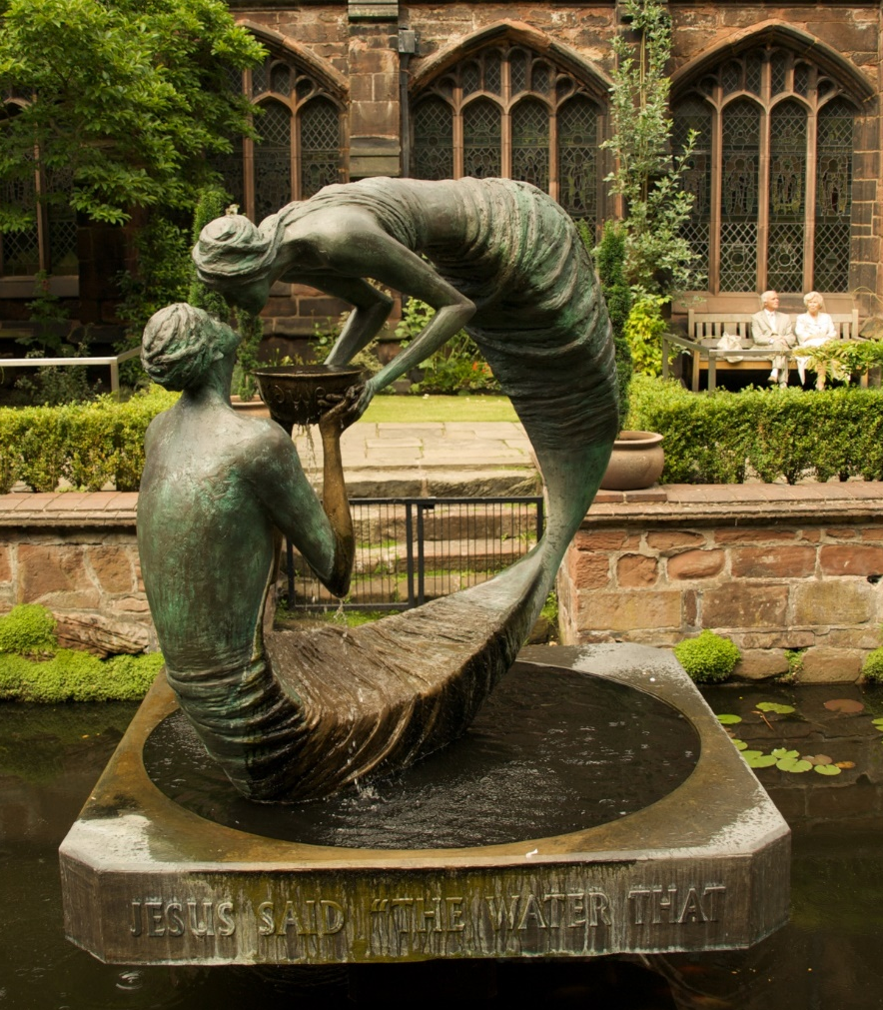

Sunday 8 March 2026, Lent 3
Family Eucharist
Service outline, Parish News & Events
8.00 am HOLY EUCHARIST _____________________
Celebrant and preacher: Fr. Allen Doerksen

9.30 am FAMILY EUCHARIST ___________________
Celebrant and preacher: Fr. Allen Doerksen
The Gathering of the Community
Worship Songs
Welcome
Territorial Acknowledgement
Greeting
Collect for Purity
Kyrie eleison (Lord have mercy, Christ have mercy)
The Story of Faith is Proclaimed
Children’s Time – Tenebrae candles
Stay With Me
First Reading: Exodus 17:1-7
Gradual Hymn
Gospel Acclamation: Your Word
Gospel: John 4:5-42
Gospel Acclamation: Your Word
Sermon
A short period of silent reflection follows,
signalled by the sound of a bell
Collect
Prayers of the People
Confession and Absolution
The Peace BAS 192
Offertory Hymn
Prayer over the Gifts BAS 290

The Celebration of the Eucharist
Eucharistic Prayer BAS 198 3
Sanctus: Holy, holy, holy Lord
The Lord’s Prayer (sung) BAS 211
Breaking of the Bread BAS 213 #7
The Communion
Music during Communion
Prayer after Communion BAS 290
Doxology (Glory to God) BAS 214
Announcements and Birthday Box
Blessing
Closing Song
Dismissal

Welcome to St Philip!
Please join us for coffee and fellowship after the service.
The abbreviation BAS in the service order refers to page numbers in the Book of Alternative Services, the green volume in the pews. CP is Common Praise, the blue hymn book.
Welcome to Communion

We want you to feel welcome at St. Philip. All are encouraged to come forward to receive the bread (communion wafer) and wine. If you prefer to receive a blessing, please keep your head and hands down. If you are more comfortable not drinking from the cup, you may keep your head down and let it pass, or return to your pew after receiving the bread. Please tell the person distributing the bread if you require a gluten-free wafer. Prayer Ministers are available during Communion at the 9:30 am service, at the side of the altar.

Offering
It is Anglican custom to receive a financial offering in our worship, as an expression of gratitude to God. Please do not feel compelled to participate in this offering. Your presence is gift enough.
Services this week
8 March 2026 – 3rd Sunday in Lent
8am Holy Communion - Celebrant & preacher: Fr. Allen Doerksen
9am Community Prayers downstairs in the youth room
9.30am Holy Eucharist, in-person & streamed via Facebook Live
- Celebrant and preacher: Fr. Allen Doerksen
- Altar Guild: Felicity, Beth
- Usher: Susan Smith
- Musicians: Chris and Alix Harvey, Ceal and Ged McLean
- Children's ministry: Melinda Weicker
- Tenebrae candles: Tarnowsky family - Lucy and Rosie
- Readers: Bruce and Kathy Fyfe
- Prayers of the People: Chris Harvey
- Chalice bearer: Lillian Konkin
- Powerpoint slides: Clayton Savage, Neil Ryan
- Facebook Live: Karishma Iyer
- Coffee: Barb Britton
- Offerings Counters: Sharon and Leslee
10 March Tuesday 10:30 am Contemplative Prayer
12 March Thursday 10.00 am Holy Eucharist followed by coffee and discussion.
Vestry update - new Parish Council
Full minutes of Vestry will be appearing shortly; in the meantime, here is the list of our 2026 Parish Council as confirmed at the Vestry Meeting on 24 February:
Chair: Allen Doerksen, rector
People's Warden: Judith Armstrong
Rector's Warden: Mike Pipes
Deputy Warden: Larry Anthony
Treasurer: Mark Laidlaw
Synod delegates: Dave Conway, Bruce Richmond
Alternate delegate: John Laidlaw
Members-at-Large: Gerianne Knowles-Robson, Evelyn Savage, Paul Scambler, Adam Tarnowsky.
Welcome to new members, and thank-you to Jackie Prowse and Marcus Schlag for their service to our community over the past years on Parish Council. PC was strengthened by their suggestions and service; their advocacy for areas that they are passionate about enriched our common life.
- Allen, Judith, Larry, and Mike
Maundy Thursday Agape Meal & Stripping of the Altar
Save the date for our annual Agape Meal on Thursday of Holy Week: April 2 at 5:30 pm in St. Philip’s lower hall.
The Agape Meal is a simple meal of soup, bread and wine to celebrate God’s love and the love within our community. Along with the meal, we include readings, reflections and a communion service. It is suitable for all ages and children are warmly invited.
This year we are simplifying the event and doing only one sitting instead of two, so we can all partake of this stage of Holy Week together. We’ll try to fit everyone in. One sitting will demand less work from our volunteers, and everyone will have the chance to attend the Stripping of the Altar service which will be held in the sanctuary at 7 pm.
Sign up sheets will be in the narthex beginning this week. PLEASE SIGN UP EARLY to help organizers plan food quantities and seating arrangements. Since there is only one sitting, places may be limited. Sign up sheets will also be out for soup makers, set up crew, food preparers, dish washers and cleanup crews.
If you can’t sign up in person or have questions, contact Ceal McLean celiamclean@gmail.com or Karen van Rheenen pkvanrhe@gmail.com.
Contemplative Prayer
Please join us on Tuesday mornings, 10:30 - 11:30, meeting in the choir area of the nave (at the front of the church), for a 20 minute contemplative sit with a time of prayer following.

Faith Tides & Anglican Journal
March edition now available from faithtides.ca and anglicanjournal.com, and in print on the office door or on request from Anna, admin@stphilipvictoria.ca
Community Karaoke Night: Friday, March 13, 2026, 6.30-9.30pm
All age karaoke event! Just bring yourself - friends, families, snacks and (non-alcoholic) drinks are welcome too.
Dates: 6.30-9.30 on 2nd Fridays - 13 March, 10 April
Location: downstairs hall at St Philip’s - step-free ramp entrance from the parking lot. Follow the sign! Drop in or leave at any time.
Questions? contact Anderson at bvsdawnofnewyear@gmail.com!
Street Hope Easter socks drive
We are once again preparing chocolate stuffed socks for our sisters and brothers on Pandora Street to celebrate Easter. We are hoping to prepare 100 pairs of socks which the children and youth will fill and decorate March 29. We would really appreciate donations of socks and /or chocolates to help with this Mission's project.
Items needed:
1) colourful socks - 100 pairs
2) chocolates - soft or suckable candy (many people have bad teeth and cannot chew)
Please bring to church by March 23 and leave in the designated box in the narthex - thank you
FYI St Philip is getting a reputation as the "chocolate sock church!" Those who received the socks in the past have been very grateful at being remembered, and touched by the cards the children write for them.
Thank you everyone for your support.
Jackie on behalf of the Missions Committee, and Rob, Jenni and Melinda
Victoria Sketch Club spring show 17-22 March
The VICTORIA SKETCH CLUB is holding its 117th Annual ART SHOW & SALE at Glenlyon Norfolk Junior School, 1701 Beach Drive during the March school break. Artists include GILLIAN RHODES, VICTOR LOTTO & MIKE PIPES
Opening Tues Mar 17 4pm- 7pm; then Wed – Sat Mar 18-21 10am – 6pm; and Sun Mar 22 10am-3pm
VSC Show bookmarks are available in the narthex, while supplies last
Living Plastic Free - update
Good news: since my talk about Living Plastic Free last fall, I have learned that Canadian company Good Juju now makes laundry strips that are free from formaldehyde, 1,4-Dioxane, SLS and phthalates! Their ordering system offers flexible scheduling of repeat orders as well.
- Merle Campbell
Oak Bay United: The Village Workshop Series. Building Bridges Through Understanding the Village - Saturday, March 14, 2026, 9 am-4 pm
On Saturday, March 14 9am-4pm, Oak Bay United Church and St Mary's Anglican Church will host Kathi Camilleri’s “Building Bridges Through Understanding the Village,” an experiential workshop that helps us explore our own, personal role in supporting the revival of the values that worked so beautifully in indigenous villages for thousands of years. As a group, we also explore in‐depth the effects of Residential Schools and Canada’s Policy of Assimilation on Indigenous communities.
Venue: OBUC downstairs Community Hall from - access via Granite St. entrance to the left/east of the main entrance ramp.
Cost: $30 incl lunch & refreshments by Songhees Catering.
To register/e-transfer instructions: admin@oakbayunitedchurch.ca | 250-598-5021x1.
Payment: cash or cheque to the OBUC office during regular office hours or by e-transfer.
more about Kathi's work: https://villageworkshopseries.com/
Cover image: Broadbent, Stephen, 1961-. Christ and the Samaritan Woman, 1994. Chester Cathedral, England. Image from Art in the Christian Tradition, a project of the Vanderbilt Divinity Library, Nashville, TN. https://diglib.library.vanderbilt.edu/act-imagelink.pl?RC=54775 [retrieved March 5, 2026]. Original source: http://www.flickr.com/photos/mtgf/4934508926/.
“The water feature depicts the encounter between Jesus and the Woman of Samaria, showing their shared bowl overflowing with water….My intentions with the piece were to show an intensity of relationship, in such, at that very moment, there was no one else existing in the world. In its sculptural form, I felt Christ needed to be set below this remarkable woman, while at the same time revealing how her life was springing out from his. I also wanted to show some ambiguity as to who was giving the water, and importantly for the water to be overflowing. It was the tenderness of Christ that touched me personally, her shame was to be taken away and not paraded across her community, with whom she became wonderfully reconciled.”
https://broadbent.studio/water-of-life-casestudy

Rector: Rev. Allen Doerksen (incumbent@stphilipvictoria.ca,
work cell 236-508-2928; day off: Friday)
Warden: Judith Armstrong (jarmstrong@stphilipvictoria.ca)
Warden: Mike Pipes (mpipes@stphilipvictoria.ca)
Parish Office Hours: Mon 1-4.30, Wed & Thurs 9-4.30
250-592-6823 | admin@stphilipvictoria.ca
Facebook including live streams: https://www.facebook.com/stphilipoakbay
Instagram: https://www.instagram.com/stphilipoakbay/

Thank you for avoiding scented products at church.

