Holy Trinity Lutheran Church
150 River Road Red Bank, NJ 07701
Church Office: (732) 741-9241 Fax: (732) 741-9577
email: holytrinitychurch4@verizon.net
Website: htlcredbank.org
Pastor: Rev. John Mack, Jr.
Cell: (336)-392-5839
Minister of Music: Peter Isherwood
Parish Administrator: Deanna Vergari
Council President: Cynthia Kazmac



March 01, 2026

Second Sunday in Lent

Introduction

During Lent we journey with all those around the world who will be baptized at the Easter Vigil. In today’s gospel Jesus tells Nicodemus that he must be born of water and Spirit. At the font we are a given a new birth as children of God. As God made a covenant with Abraham, in baptism God promises to raise us up with Christ to new life. From worship we are sent forth to proclaim God’s love for all the world.

Welcome & Announcements (Please remember to silence your cell phone!)

Prelude (We prayerfully prepare our hearts and minds to worship!)

+ GATHERING +

Confession and Forgiveness
All may make the sign of the cross, the sign that is marked at baptism, as the presiding minister begins.
P:Blessed be the holy Trinity, ☩ one God,
who forgives all our sin,
whose mercy endures forever.
C:Amen.
P:Let us confess our sin before God, who removes our guilt
and blots out all offenses.
Silence is kept for reflection.
Gracious God,
C:have mercy on us according to your steadfast love.
P:For seeking worldly delights that deceive us and dishonor you:
Gracious God,
have mercy on us according to your steadfast love.
For desiring self-reliance instead of hungering for your word:
Gracious God,
C:have mercy on us according to your steadfast love.
P:For failing to recognize your coming reign,
and for hindering the work of the Spirit: Gracious God,
C:have mercy on us according to your steadfast love.
P:For drawing from the well of self-serving ambition,
and for disdaining the living water Christ offers: Gracious God,
C:have mercy on us according to your steadfast love.
P:For disregarding voices from the margin,
and for distrusting signs of your healing and hope in the world:
Gracious God,
C:have mercy on us according to your steadfast love.
P:For dwelling in tombs of self-pity and discontent,
and for disregarding Christ’s call to come forth to life:
Gracious God,
C:have mercy on us according to your steadfast love.
P:God’s steadfast love, grace, and forgiveness abound.
Through faith, the free gift of God,
you have been clothed in the righteousness of Christ.
In the name of ☩ Jesus Christ, your sins are forgiven.
The Spirit of the One who raised Christ from the dead
dwells in you,
pours God’s love into your hearts,
and gives you life and peace.
C:Amen.

*Gathering Hymn ELW 319 O Lord, Throughout These Forty Days (v. 3&4)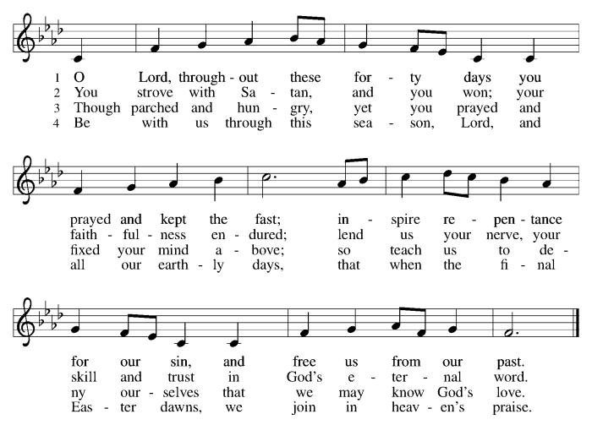

*Pastoral Greeting

P: The Grace of our Lord Jesus Christ, the love of God, and the communion of the Holy Spirit be with you all.

C: And also with you!

Kyrie:

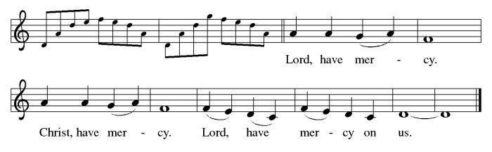

*Prayer of the Day
P: O God, our leader and guide, in the waters of baptism you bring us to new birth to live as your children. Strengthen our faith in your promises, that by your Spirit we may lift up your life to all the world through your Son, Jesus Christ, our Savior and Lord, who lives and reigns with you and the Holy Spirit, one God, now and forever.
C: Amen!

Children’s Message

+WORD+

First Reading: Genesis 12:1-4a
God’s call of Abram and Sarai has a clear purpose—that through them all the families of the earth would gain a blessing. As they set out on their journey, they are accompanied by promises of land, nation, and a great reputation.
¹ The Lord said to Abram, “Go from your country and your kindred and your father’s house to the land that I will show you. ² I will make of you a great nation, and I will bless you and make your name great, so that you will be a blessing. ³ I will bless those who bless you, and the one who curses you I will curse, and in you all the families of the earth shall be blessed.”
^{4a} So Abram went, as the Lord had told him, and Lot went with him.

Psalm: Psalm 121
I lift up my eyes to the hills; my help comes from the Lord. (Ps. 121:1, 2)

¹ I lift up my eyes | to the hills;
from where is my | help to come?
² My help comes | from the Lord,
the maker of heav- | en and earth.
³ The Lord will not let your | foot be moved
nor will the one who watches over you | fall asleep.
⁴ Behold, the keep- | er of Israel
will neither slum- | ber nor sleep;
⁵ the Lord watches | over you;
the Lord is your shade at | your right hand;
⁶ the sun will not strike | you by day,
nor the | moon by night.
⁷ The Lord will preserve you | from all evil
and will | keep your life.
⁸ The Lord will watch over your going out and your | coming in,
from this time forth for- | evermore.

Second Reading: Romans 4:1-5, 13-17
In the person and example of Abraham we discover that a right relationship with God does not involve earning a reward from God but entails trusting God’s promises. Abraham is the forebear and model for both Jews and Gentiles, because we too trust that ours is a God who gives life to the dead.
¹ What then are we to say was gained by Abraham, our ancestor according to the flesh? ² For if Abraham was justified by works, he has something to boast about, but not before God. ³ For what does the scripture say? “Abraham believed God, and it was reckoned to him as righteousness.” ⁴ Now to one who works, wages are not reckoned as a gift but as something due. ⁵ But to one who does not work but trusts him who justifies the ungodly, such faith is reckoned as righteousness.
¹³ For the promise that he would inherit the world did not come to Abraham or to his descendants through the law but through the righteousness of faith. ¹⁴ For if it is the adherents of the law who are to be the heirs, faith is null and the promise is void. ¹⁵ For the law brings wrath, but where there is no law, neither is there transgression.
¹⁶ For this reason the promise depends on faith, in order that it may rest on grace, so that it may be guaranteed to all his descendants, not only to the adherents of the law but also to those who share the faith of Abraham (who is the father of all of us, ¹⁷ as it is written, “I have made you the father of many nations”), in the presence of the God in whom he believed, who gives life to the dead and calls into existence the things that do not exist.

Gospel Acclamation
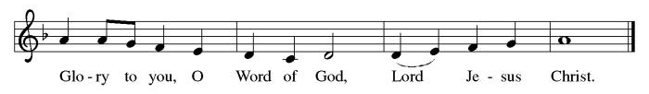

P: The Holy Gospel According to St. John 3rd Chapter
C: Glory to You O Lord!

Gospel: John 3:1-17
A curious Pharisee visits Jesus by night to learn from the teacher his friends reject. Jesus speaks to him about life in the Spirit and the kingdom of God.

¹ Now there was a Pharisee named Nicodemus, a leader of the Jews. ² He came to Jesus by night and said to him, “Rabbi, we know that you are a teacher who has come from God, for no one can do these signs that you do unless God is with that person.” ³ Jesus answered him, “Very truly, I tell you, no one can see the kingdom of God without being born from above.” ⁴ Nicodemus said to him, “How can anyone be born after having grown old? Can one enter a second time into the mother’s womb and be born?” ⁵ Jesus answered, “Very truly, I tell you, no one can enter the kingdom of God without being born of water and Spirit. ⁶ What is born of the flesh is flesh, and what is born of the Spirit is spirit. ⁷ Do not be astonished that I said to you, ‘You must be born from above.’ ⁸ The wind blows where it chooses, and you hear the sound of it, but you do not know where it comes from or where it goes. So it is with everyone who is born of the Spirit.” ⁹ Nicodemus said to him, “How can these things be?” ¹⁰ Jesus answered him, “Are you the teacher of Israel, and yet you do not understand these things?
¹¹ “Very truly, I tell you, we speak of what we know and testify to what we have seen, yet you do not receive our testimony. ¹² If I have told you about earthly things and you do not believe, how can you believe if I tell you about heavenly things? ¹³ No one has ascended into heaven except the one who descended from heaven, the Son of Man. ¹⁴ And just as Moses lifted up the serpent in the wilderness, so must the Son of Man be lifted up, ¹⁵ that whoever believes in him may have eternal life.
¹⁶ “For God so loved the world that he gave his only Son, so that everyone who believes in him may not perish but may have eternal life.
¹⁷ “Indeed, God did not send the Son into the world to condemn the world but in order that the world might be saved through him.”

P: The Gospel of the Lord
C: Praise to you, O Christ!

Sermon

*Hymn of the Day ELW 324 In the Cross of Christ I Glory
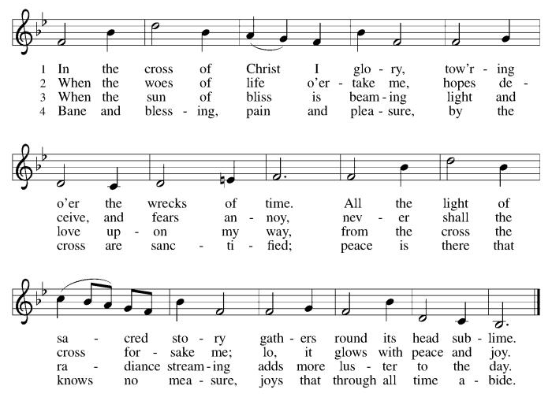
Nicene Creed
We believe in one God,
the Father, the Almighty,
maker of heaven and earth,
of all that is, seen and unseen.
We believe in one Lord, Jesus Christ,
the only Son of God,
eternally begotten of the Father,
God from God, Light from Light,
true God from true God,
begotten, not made,
of one Being with the Father;
through him all things were made.
For us and for our salvation
he came down from heaven,
was incarnate of the Holy Spirit and the Virgin Mary
and became truly human.
For our sake he was crucified under Pontius Pilate;
he suffered death and was buried.
On the third day he rose again
in accordance with the Scriptures;
he ascended into heaven
and is seated at the right hand of the Father.
He will come again in glory to judge the living and the dead,
and his kingdom will have no end.
We believe in the Holy Spirit, the Lord, the giver of life,
who proceeds from the Father and the Son,
who with the Father and the Son is worshiped and glorified,
who has spoken through the prophets.
We believe in one holy catholic and apostolic church.
We acknowledge one baptism for the forgiveness of sins.
We look for the resurrection of the dead,
and the life of the world to come. Amen.

*Prayers of Intercession
Reconciled by God’s mercy and sustained by God’s presence, let us pray for the world and its needs.
A brief silence.
Faithful One, you renew us by grace. As you have inspired faith through the work of church artists and hymnwriters throughout the ages (like George Herbert whom the church remembers today), give your church the means to praise your beauty today. Hear us, O God.
C:Your mercy is great.
Living One, you delight in this world. The sun and moon, the wind and the water declare your goodness. Preserve this earth, and protect conservationists, scientists, and all who labor in service to creation. Hear us, O God.
C:Your mercy is great.
Ruling One, you bless us to be a blessing. Open the hearts of all leaders to seek the flourishing of every person and lend your help to all who wait for justice, deliverance, and peace. Hear us, O God.
C:Your mercy is great.
Compassionate One, you send your Son to save. Declare your word of acceptance to any who feel condemned and lift up any brought low by hatred and exclusion. Tend to all who are struggling with illness or loss (especially). Hear us, O God.
C:Your mercy is great.
Guiding One, you watch over our going out and coming in. Bless newcomers and new members in this assembly (especially) and accompany those who have recently left this community to journey elsewhere (especially). Hear us, O God.
C:Your mercy is great.
Here other intercessions may be offered.
Eternal One, you neither slumber nor sleep. Be our keeper in life and in death. Thank you for our beloved who have died, and for your promise which saves this whole world by your love. Hear us, O God.
C:Your mercy is great.
Receive our prayers, O God, through Jesus Christ, our strength and salvation.
C: Amen.

Greeting of Peace
P: The peace of Christ be with you always!
C: And also with you!

Offering (Thank you for your support for our ministry!)

*Doxology ELW 186 Create in Me a Clean Heart
(Please stand and join in singing as we share our gifts!)
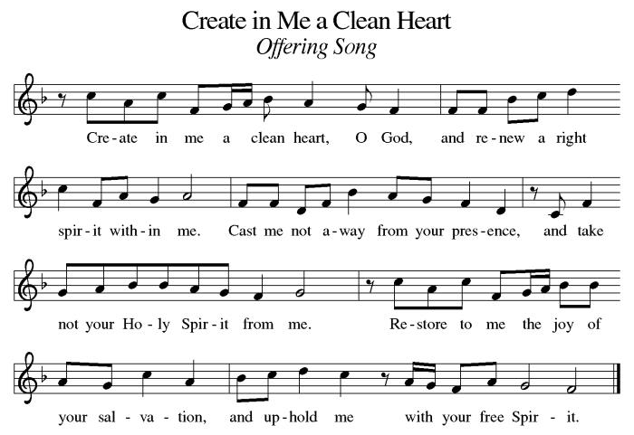

*Offering Prayer
A: O God, maker of heaven and earth,
C: your steadfast love embraces all creation.
You send rain and sunshine to nourish the earth
and bring forth its bounty.
Through these gifts of bread and wine,
draw us into the death and life of your Son,
who calls us to bear witness to his saving work.
We ask this in Jesus’ name.
Amen!

+MEAL+
*Great Thanksgiving
P: The Lord be with you.
C: And also with you.

P: Lift up your hearts.
C: We lift them to the Lord.

P: Let us give thanks to the Lord our God.
C: It is right to give our thanks and praise.

P: It is indeed right, our duty and our joy,
that we should at all times and in all places
give thanks and praise to you, almighty and merciful God,
through our Savior Jesus Christ.
You call your people to cleanse their hearts
and prepare with joy for the paschal feast,
that, renewed in the gift of baptism,
we may come to the fullness of your grace.
And so, with all the choirs of angels,
with the church on earth and the hosts of heaven,
we praise your name and join their unending hymn:
*Sanctus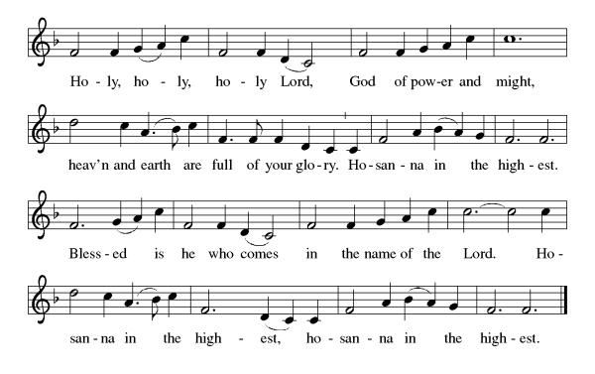
*Eucharistic Prayer
P: Holy, mighty, and merciful Lord,
heaven and earth are full of your glory.

In great love you sent to us Jesus, your Son,
who reached out to heal the sick and suffering,
who preached good news to the poor,
and who, on the cross, opened his arms to all.

In the night in which he was betrayed,
our Lord Jesus took bread, and gave thanks;
broke it, and gave it to his disciples, saying:
Take and eat; this is my body, given for you.
Do this for the remembrance of me.

Again, after supper, he took the cup, gave thanks,
and gave it for all to drink, saying:
This cup is the new covenant in my blood,
shed for you and for all people for the forgiveness of sin.
Do this for the remembrance of me.

Remembering, therefore, his death, resurrection, and ascension,
we await his coming in glory.

Pour out upon us the Spirit of your love, O Lord,
and unite the wills of all who share this heavenly food,
the body and blood of Jesus Christ, our Lord;
to whom, with you and the Holy Spirit,
be all honor and glory, now and forever.

C: Amen!

*THE LORD’S PRAYER
Our Father, who art in heaven,
hallowed be thy name,
thy kingdom come,
thy will be done,
on earth as it is in heaven.
Give us this day our daily bread;
and forgive us our trespasses,
as we forgive those
who trespass against us;
and lead us not into temptation,
but deliver us from evil.
For thine is the kingdom,
and the power, and the glory,
forever and ever. Amen.
*Lamb of God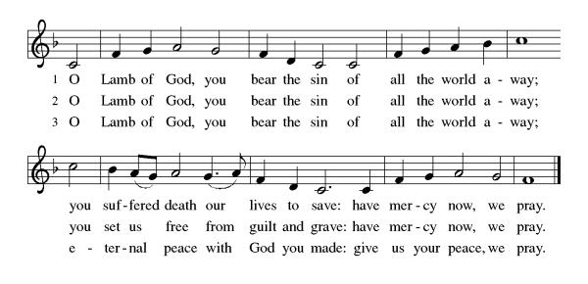

Spiritual Communion Prayer
P: Let us pray for the communion of all present here, those viewing our service virtually, those in our hearts and in our world.
C: Lord Jesus, I believe you are truly present in the Sacrament of Holy Communion. When I cannot receive Communion, I pray that you come into my heart. I know that nothing in Heaven or on earth can separate me from your love. Amen.

Invitation to Communion
P: Come to the table.
Feast on God’s goodness and mercy.
C: Thanks be to God!

(All are invited to the communion rail following the guidance of the ushers. Communion will be shared through the host and individual cups. If you would like communion but are unable to join us at the rail, please alert the usher!)

Communion Hymns (Please join in singing!)
ELW 338 Beneath the Cross of Jesus
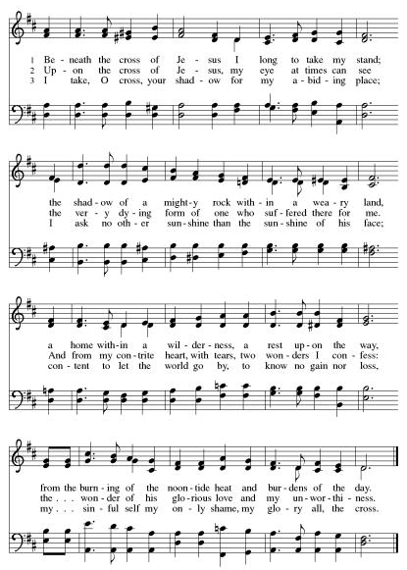

ELW 596 My Hope Is Built on Nothing Less
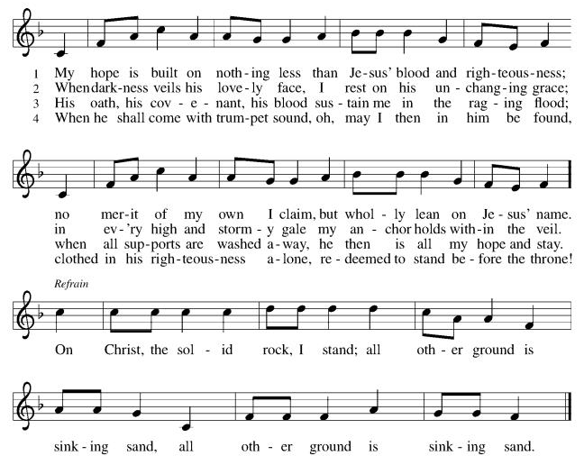

*Prayer after Communion
A: God of our salvation,
we give you thanks for this meal that restores our souls,
reconciles us to you, and strengthens us for the journey.
Through the body and blood of your Son,
may we become Christ’s body in the world,
bearing witness to your love for all creation,
through Jesus Christ, our Savior and Lord.
C: Amen.
+Sending+

*Blessing
P: Receive the blessing of the holy Trinity:
God, who calls all things into existence,
Jesus Christ, who redeems us,
and the Holy Spirit, whose breath sustains creation,
☩ bless you now and always. C: Amen!
*Sending Hymn ELW 328 Retore in Us, O God
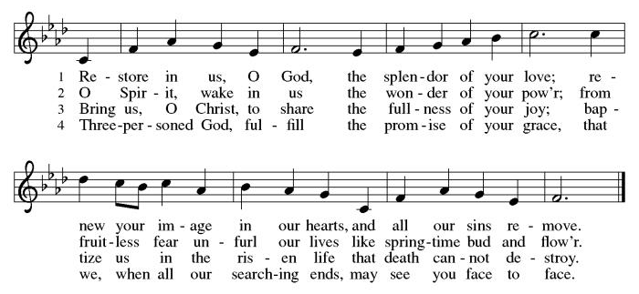

*Dismissal
A: Go in peace. Believe the good news.
C: Thanks be to God!

Postlude

Copyright © 2020 Augsburg Fortress. All rights reserved. Reprinted by permission under Augsburg Fortress Liturgies Annual License #SB106907. New Revised Standard Version Bible, Copyright © 1989, Division of Christian Education of the National Council of the Churches of Christ in the United States of America. Used by permission. All rights reserved. Revised Common Lectionary, Copyright © 1992 Consultation on Common Texts, admin Augsburg Fortress. Used by permission.

Treasurer’s Report

Monthly Financial Snapshot
Category | Actual | Budget | +/- vs Budget | Status
January Results
January Income | $18,830 | $19,167 | -$337 ▼ | Attention
January Expenses | $22,199 | $22,626 | -$427 ▲ | On Track
January Net Surplus/Deficit | -$3,369 | -$3,460 | $90 ▲ | On Track
Year-To-Date Results
YTD Income | $18,830 | $19,167 | -$337 ▼ | Attention
YTD Expenses | $22,199 | $22,626 | -$427 ▲ | On Track
YTD Net Surplus/Deficit | -$3,369 | -$3,460 | $90 ▲ | On Track
2026 Challenge Results
Timeframe | Actual | Goal | +/- vs Goal | % of Goal
January Income | $18,830 | $20,367 | -$1,537 ▼ | 92%
YTD Income | $18,830 | $20,367 | -$1,537 ▼ | 92%

HTLC’s 2026 finances are off to a steady start, with expenses running under budget and January giving reaching 92% of our Challenge goal. As we work to increase giving by $28,000 over 2025, please prayerfully consider increasing your pledge or using recurring e-giving to help us meet the Challenge and strengthen our ministry for the year ahead. The QR Code can be used to access the Church's e-giving portal.

Worship Volunteer Schedule
Date | Asst. Min | Usher | Sacristan | Lector | Counter
March 1 | Charlie Rugg | Gary Joblon | Pat Pienkos | Cynthia Kazmac | Bohner/Volk
March 8 | Linda Coleman | Keith Bennett | Joanne Giordano | Emily Kaster | Carleo/Csernica
March 15 | Keith Bennett | Jill Socha | Carol Rosen | Jeff Ridberg | Bradford/Foard
March 22 | Chris Foard | Kathy Caputo | Joanne Giordano | Bill Spreen | McKenna/Kazmac
March 29 | Charlie Rugg | Jill Socha | Helga Britton | Molly Foard | Coleman/Giordano

Coffee Hour-

ANNOUNCEMENTS Thank you! To all who consistently support our church and ministries through your time, talent, and treasure. Please help us grow by inviting your friends and family to worship and events. You are what makes Holy Trinity a wonderful church family!

Stay in touch! Please visit our church website, www.htlcredbank.org for updates and information. You can also find us on Facebook and view services online. The office is open from 9am to 2pm, Monday to Thursday.

100 Anniversary Committee- If you are interested in being a part of the committee to help plan the 100th anniversary celebration of HTLC in 2028, please sign up in the red book. All are welcome! Also, the committee will be looking for photos and documents of HTLC throughout the years. If you have anything to share, please bring them to the church and marked envelopes or email electronic copies to the church office.

Name Tag Sundays: On the first Sunday of each month, names tags and markers will be at each entrance of the sanctuary. Please fill out a tag and wear one for worship and for coffee hour to welcome visitors and help newcomers put names to faces.

Sunday School in the New Year, we will continue to study stories and lessons from the Old Testament beginning with Jacob. Kids will love the crafts, songs and games that accompany each lesson.
The following dates there will be Sunday School:
Jan- 11 and 25, Feb- 8 and 22, March- 1, 15 and 29*Easter Egg Hunt!
April- 12 and 26, May- 3, 17 and 31, June- 7 and 14
As was done in the fall, there will be opportunities to volunteer as SS lead teacher. A signup will be emailed out shortly and will also be posted in the red binder. Consider signing up! All lesson materials will be supplied and laid out and a leader guide will be emailed to volunteers approximately 1 week in advance. Blessings for a wonderful 2026!~Lauren

Trivia Night!! Mark your calendars! Plan for a fun night at Holy Trinity on Feb. 28 at 5pm for great food and trivia. We have an International theme, so we ask you to bring a pot luck dinner item showing your ethnic heritage. There is a sign up sheet for your convenience.
You don't have to be another Ken Jennings---this is just for fun. See you then!

Choir The Holy Trinity Choir welcomes our singers back for a preparation rehearsal on Sunday, September 7th at 9am in the church hall. All are welcome to join us in song as often as you are able. Choir meets each Sunday at 9am to practice and prepare our music. Join us and help us grow by spreading the word about the HTLC Choir!

Quilting- The Quilters need gently used any bed sheets of any size! Please leave any donations in the quilters closet in Fellowship Hall. Thank you!

Quilters Need Help
If anyone is traveling through Mechanicsville, PA, and can add a few extra minutes to your trip, the warehouse for shipping quilts, school kits, etc is located directly off one of the exits.
We accumulate many quilts throughout the year and we would appreciate sending some quilts with you to deliver. Any questions, please call Sherry Lee or Elaine Theophall.

Weekly Quilting on Wednesdays at 9:30. Bring your lunch and enjoy some fellowship at noon. All are welcome. There will be no quilting on Wednesday September 24 due to the garage sale set up.

Bagels and Bible meet every second and fourth Saturday of the month at 8:00 AM

Evening Quilting Evening Quilting –
Please share this information . This is an important ministry that helps so many. It’s very easy and you don’t need to know how to sew. We have a great time socializing too! We will meet: Jan. 21, Feb. 18, March 18 at 6:00 PM. Note: If we have to cancel I will send an email. Please let me know only if you can come. Contacts: Pat Pienkos 732-513-9615 Debbie Yetka 908-461-4084 Looking forward to seeing you all!

The Souper Bowl of Caring fundraising project, held on Sunday 2/8, raised $129.82. The church Social Outreach Ministry will be sending Lunch Break a check with a donation of $129.82.

Social Ministry
*Year-round collections will continue for food items for Lunch Break. There is a sign-up sheet in the red book for those who can help drop these items to Lunch Break.
*We will also collect adult men's socks to periodically drop at the Red Bank Warminq Center.
*For those interested in the Heartwarminq Center — the new women's shelter is adjacent to the First Baptist Church of Red Bank at 90 Maple Ave. You can follow up on this mission through their website - https://www.thefeastnj.org- On this site, they also include wish list items that can be purchased through amazon. We will be exploring purchasing some of these through a Thrivent card. If you want to purchase on your own, you can leave items at church, and the Social Ministry will deliver them.

Pastoral Care and Prayer... We are here to care for and pray! Please contact the office to add or adjust prayer requests. If you or someone you know needs pastoral care, please contact the office and Pastor Mack!

THANK YOU for supporting and sustaining our church and ministries! All are welcome here! Please invite your family and friends to worship with us! Find us online at www.htlcredbank.org

Our Easter Food Drive is Coming!
Again this year, WELCA is collecting requested foods for Lutheran Social Ministries of NJ to distribute in April. Food will be collected during February and March, and we hope to fill at least 35 grocery bags!. Watch for the labeled bins at the side door to the church and thanks for your help. We need the following food items:
  - Boxed potatoes- Rice - Pasta - Mac & Cheese
  - Canned Vegetables and Beans canned fruit or Pineapple or Apple Sauce
  - Small Olive or Canola Oil
  - Corn Bread/Muffin Mix - Carnation Milk Can
  - Cake Mix and Frosting or Brown Sugar

