This Week at PPBC
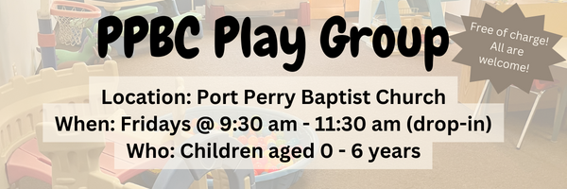




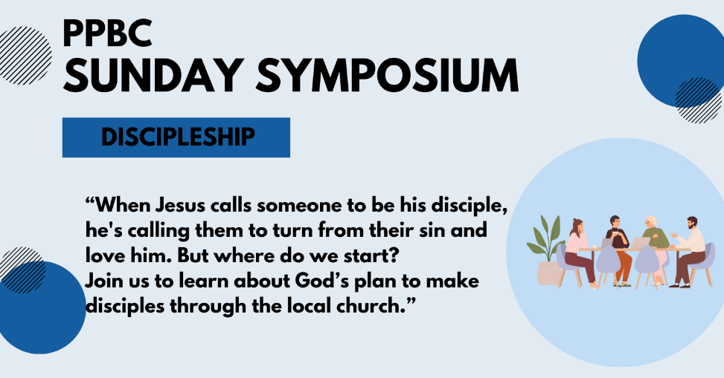

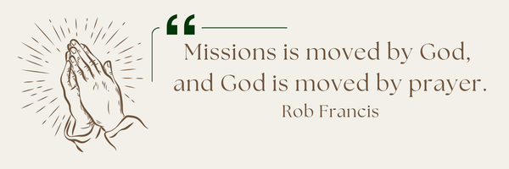
A Prayer Request for Outreach to our Canadian Indigenous: The PPBC Mission Committee continue to seek God’s guidance and provision of an open door to become involved in an outreach to our Canadian Indigenous. Pastor Jim is in contact with r representatives from Rural Life Mission/Round Lake Bible Camp about possible involvement with them. Please pray with us for God’s leading towards this or other opportunities to serve.

Notes

Sunday Ministry Schedules
Nursery
March 1: Kathryn denOuden, Alyssa Summers
March 8: Jan Gerrow, Hannah Colwell
Infant Nursery
March 1: Karen Clemens, Rosalie McLaren
March 8: Lisa Dallas, Elise Anderson
Jr. Church; ages 3 to grade 1
March 1: Ellianne McLaren, Grace Brown
March 8: Christine McLaren, Mikayla Ferguson
Jr. Church; Grades 2 to 6
March 1: Gregg & Karen Anderson, Kim St-Onge
March 8: Kate Anderson, Tiffany Green
Greeters
March 1: Fern & Kim St-Onge
March 8: Graeme & Barb Foster
Ushers
March 1: Leno Araujo, Nick Woytowich
March 8: Matt Saunders, Roy Wilson
Sound & Video
March 1: Sound: Wyatt Werner | Video: Josh Myers
March 8: Sound: | Video: Josh Bolsonello

Morning Service
Song – Crown Him With Many Crowns
Welcome
Song – There is Power in the Blood
Scripture
Song – The Power of the Cross
Communion
Song – There is a Fountain
Prayer
Message – Pastor Jim Clemens
Song – My Wirth is Not in What I Own


Sunday, March 1, 2026
We will be meeting in the sanctuary.
4:00pm – Meeting

Praise & Prayer Highlights
PRAY for Joan Mabley who has been moved to Glen Hill Strathaven in Bowmanville. Please PRAY for Joan’s comfort and peace.
PRAY for John & Joan Mank and their ongoing health concerns.
PRAY for Martin & Tina McCurley and their ongoing health concerns. PRAY for Tina who has some medical tests coming up. PRAY for them as they prepare to move this spring.
PRAY for Bert Faber and the family as the mourn Ada's passing. PRAY that God will give them great comfort in Christ and that the truth of the Gospel will shine through this loss.
PRAY for New Song Church & Port Perry Baptist as they co-host a Christianity Explored outreach at That Place on Queen. Please PRAY for God to prepare the hearts of those who will attend from the community to receive the gospel.
PRAY for the community of Tumbler Ridge BC. PRAY for Pastor George Rowe and Tumbler Ridge Baptist Church as they care for their community.
PRAY for Jordan & Stephanie Anderson. PRAY for Jordan as he goes for basic trainning in Quebec. PRAISE that Stephanie and Alistair made it safely back to Canada on Thursday.
PRAY for Dave and Susie’s nephew Martin and his heart condition. PRAY for the family and the doctors who are caring for them.
PRAY for Betty Collins' friend Vince who is at the doctors with surgery complications. PRAY for his healing and pain relief.

Giving
Just as a reminder, there are several ways you can give:
In Person using the offering box located on the back wall of the sanctuary. Donation envelopes are available at the Welcome Centre. Please contact the church office if you would like a box of donation envelopes (office@portperrybaptist.ca)
Through your online banking, you may send electronic transfers to ppbcdonations@gmail.com.
You can also give through Canada Helps. Donation receipts will be provided by Canada Helps, and transaction fees apply.
***********************************************************************
Weekly Newsletter
The PPBC Newsletter is emailed to the church family every Friday. If you would like to be added to the weekly email list, please contact the office by phone: 905-985-8681 or by email: office@portperrybaptist.ca.
*****************************************************************
Church Information:
Location:
2210 Hwy 7A
Port Perry, ON
L9L 1B4
Office Hours:
Monday: 8:30am – 4:00pm
Tuesday: 8:30am – 4:00pm
Wednesday: Closed
Thursday: 8:30am – 4:00pm
Friday: 8:30 am - 3:00 pm
Contact:
Phone: 905.985.8681
Email: office@portperrybaptist.ca
Website: www.portperrybaptist.ca
Staff:
Sr. Pastor – Rev. Jim Clemens
Administrative Assistant – Madeline Werner
Family Ministries Director – Josh Anderson
Pastoral Intern – Scott McKenzie

PPBC Newsletter
Sunday, March 1, 2026


Sunday Starting Point
Sunday, March 1, 2026 - 9:30 am
“Beginning the day with the Word and prayer”
Adults:
Adults will meet in the sanctuary for a time of study and prayer.
Youth:
Jr High (Grades 7-8) will meet in room 18 with Kate Anderson to study Ecclesiastes.
Children:
Children ages 3 - grade 6 will meet in room 26.
(Please note nursery is unavailable during Starting Point)
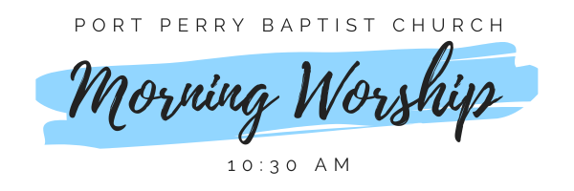Sunday Morning Worship
Sunday, March 1, 2026 - 10:30 am
We are meeting in the sanctuary and will continue to live-stream for those who are unable to attend.
Message: God Makes Things Grow
Scripture: 1 Corinthians 3
Pastor Jim Clemens

