

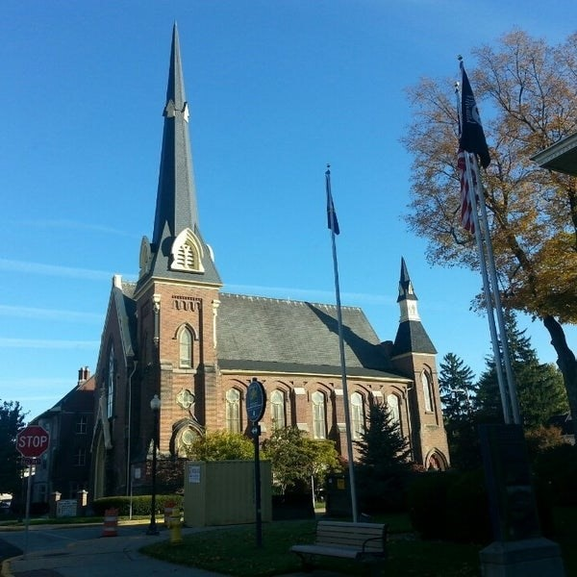
February 25, 2026

A Global Methodist Church
214 S. 5th Street
Goshen, IN 46528
Phone: 574-533-9518
Web Site: goshenfirstgmc.org

Office Hours: Monday-Friday,
8:00 a.m.-12:00 noon
Worship: 9:00 a.m.
Sunday School: 10:30 a.m.
Pastor Jeff & Lisa
Associate Pastor Rich Hull
OUR VISION: “Growing in Faith, Gathering in Community, and Giving in Love”.


The schedule for the 2026 Lenten Breakfasts is finalized. Plan on an 8:30 a.m. start time, and everything will run the same as years past. All are welcome!
February 28 - Faith United Methodist Church
March 7 – New Hope Methodist Church
March 14 – Goshen First Church (in the Garden Room)
March 21 - Dunlap United Methodist Church
March 28 - Jamestown United Methodist Church

On Thursday, March 19, the Primetimers will be visiting Ryan’s Place in Goshen.
More details will be coming later.

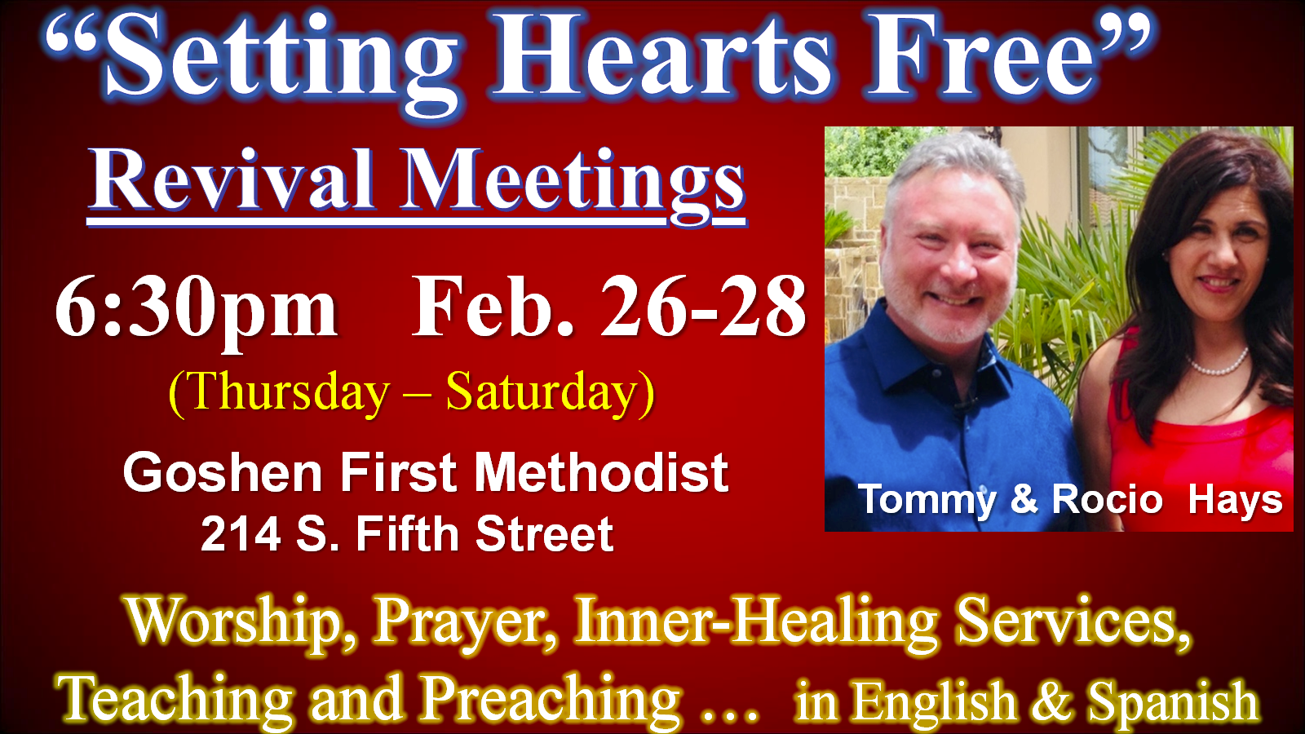

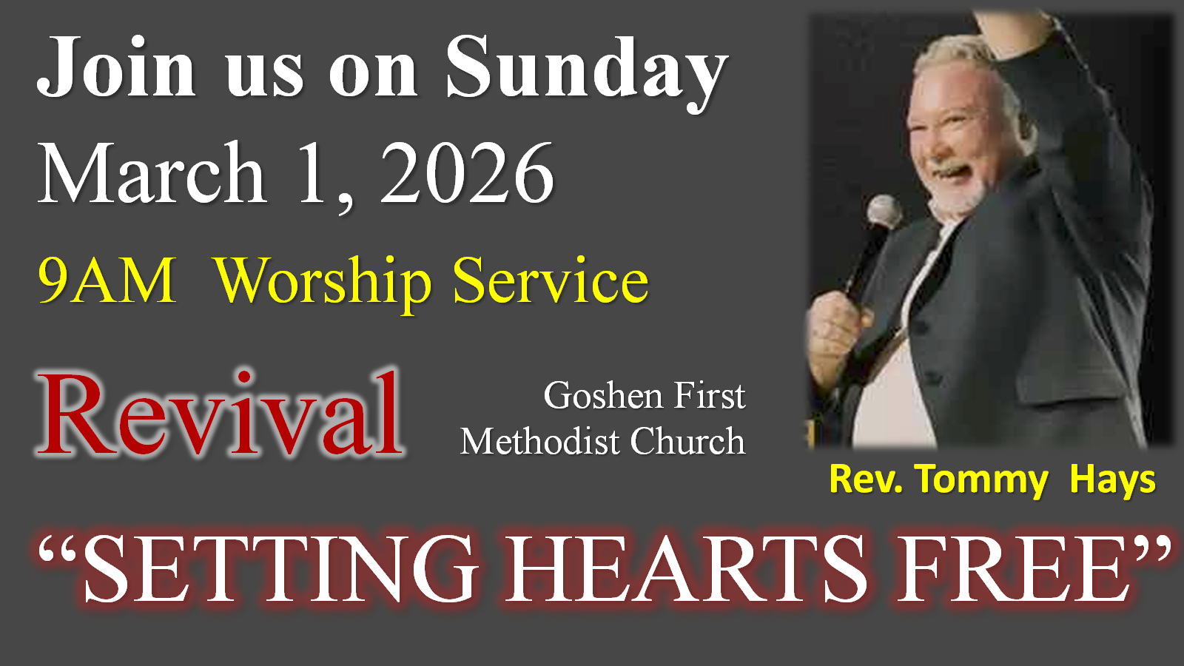

VOLUNTEERS – Thank you for your service! Sunday morning, March 1
Greeters: Jackie Lung VIP: Patty Krebs
Elevator Hosts: Sally Stutsman, Al Eppert
Ushers: Randy Cripe,Pam Lichty, Dan Seltenright, Mateo Tenorio, Williston Tenorio
Scripture Reader: Jeanne Bigler
Elementary Junior Church: Pat Huber, Kelly Leeper
Junior High Church: Jeanne Bigler
Coffee Hour: Sally Stutsman, Al Eppert, Sara Showalter, Betty Jo Morris,
Max Leatherman
Bus Driver: Steve Warner
Communion Servers: Ron & Loraine Troyer, Lenette Burckhart, Susan Wirt
Blood Pressure Clinic: Janice Leek

