
Evening Services
at 7:00pm
2/25, 3/4, 3/11, 3/18, 3/25
Come Experience God’s Unlimited Grace, in a Most Welcoming Place

First Evangelical Lutheran Church
250 W. Decatur St.
Decatur, Illinois
(217) 423-7783
Website: www.felcdecatur.org
Email: felc_decatur@outlook.com

Covenant God made with you in holy baptism:
- live among God’s faithful people;
- hear the word of God and share in the Lord’s Supper;
- proclaim the good news of God in Christ through word and deed;
- serve all people following the example of Jesus; and
- strive for justice and peace in all the earth?”
I will with God’s help

Child of God you have been sealed by the Holy Spirit and marked with the sign of the cross of Christ Forever.

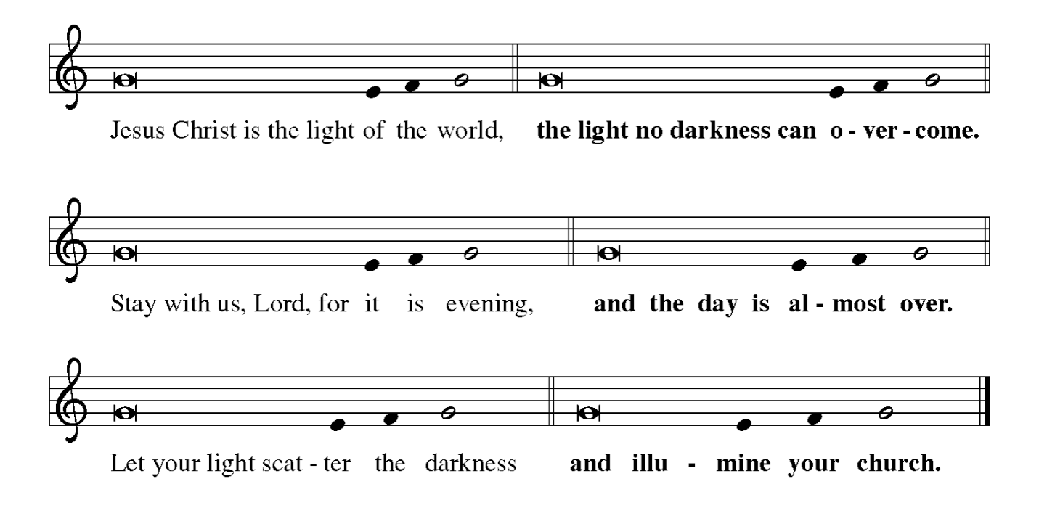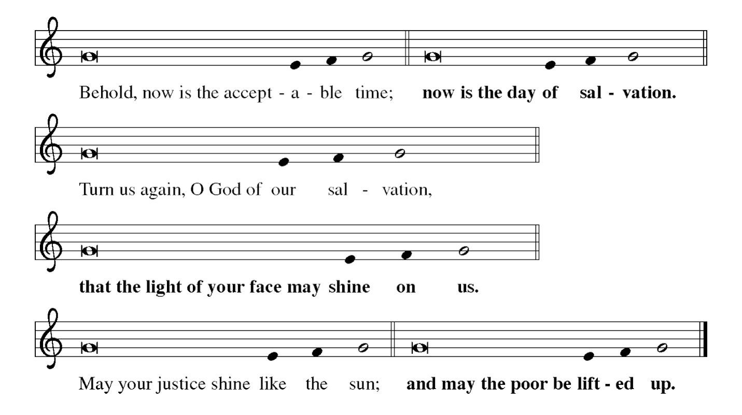

Hymn “Joyous Light of Glory” ELW #229

Psalm
(Please turn to the Psalm in your hymnal)
Feb 25 - Psalm 32
March 4 - Psalm 128
March 11- Psalm 81
March 18 - Psalm 146
March 25 -Psalm 143
Hymn
Feb 25 – ELW #326 “Bless Now, O God the Journey”
March 4 – ELW #322 “Oh, Love, How Deep”
March 11 – ELW #397 “Loving Spirit”
March 18 – ACS #1050 “Sometimes Our only Song is Weeping”
March 25 – ELW #629 “Abide with Me”

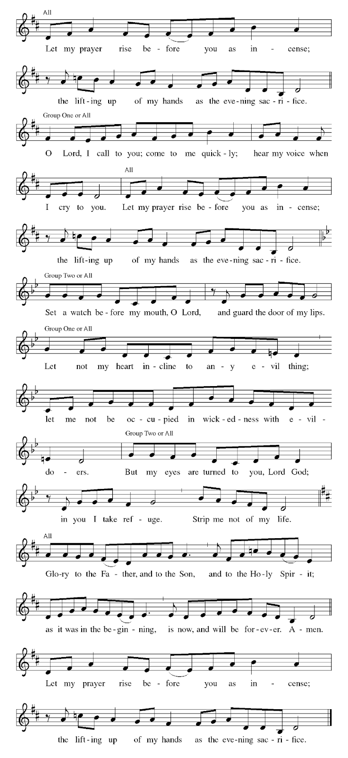

Reading
Feb 25 - Philippians 1: 3-11
March 4 - Philippians 3:7-11
March 11- Philippians 1:12-20
March 18 - Philippians 2: 5-11
March 25 - Philippians 4:8-9

Homily

Silence for reflection

Reflection Prayer-
Feb 25 - Gracious God, we thank you for the gift of the church. We are especially grateful for those who have taught us what it means to be Christian, those who have modeled love, kindness, and mercy. Bless our church and guide us to be a model of faithful living. In the name of Christ, we pray. Amen.

March 4 - Gracious God, we thank you for the gifts of Word and Sacrament. Open our hearts to the Sacrament of Holy Communion. Open our lives to your freeing love; for you alone can feed our hungry spirits through your Word and satisfy our every need. In the name of Christ, we pray. Amen.

March 11- Gracious God, we thank you for the good news of Christ Jesus. Use our lives to boldly proclaim your good news made known in Christ. Use our words and our actions to reflect the goodness of your love. In the name of Christ, we pray. Amen.

March 18 - Gracious God, we thank you for the gift of service. We are recipients of your love made known in Christ. Fill our hearts with compassion, so we might serve out of a spirit of love rather than under the mantle of obligation. In the name of Christ, we pray. Amen.

March 25 -Gracious God, we thank you for the promise of a world of justice and
peace. Your love for your beloved humanity is breathtaking. To send your son Jesus Christ to live among us and die for us is humbling. Allow us to partner with you to bring justice and peace in all the earth. Show us the way. In the name of Christ, we pray. Amen.

Prayers
A brief silence for prayer follows each petition.

Mighty God of mercy, we thank you for the resurrection dawn,
bringing the glory of our risen Lord who makes every day new.
Especially we thank you--
for the sustaining goodness of your creation . . .
for the new creation in Christ and all gifts of healing and forgiveness . . .
for the gifts of relationship with others . . .
for the communion of faith in your church . . .
Other thanksgivings may be added.

Merciful God of might, renew this weary world, heal the hurts of all your children, and bring about your peace for all in Christ Jesus, the living Lord.
Especially we pray--
for those who govern nations of the world . . .
for the people in countries ravaged by strife or warfare . . .
for all who work for peace and international harmony . . .
for all who strive to save the earth from carelessness and destruction . . .
for the church of Jesus Christ in every land . . .
Other intercessions may be added.

Almighty and everlasting God, you have brought us in safety to this new day. Preserve us with your mighty power, that we may not fall into sin nor be overcome in adversity. In all we do, direct us to the fulfilling of your purpose; through Jesus Christ our Lord. Amen.

O God, you have called your servants to ventures of which we cannot see the ending, by paths as yet untrodden, through perils unknown. Give us faith to go out with good courage, not knowing where we go, but only that your hand is leading us and your love supporting us; through Jesus Christ our Lord.
Amen.

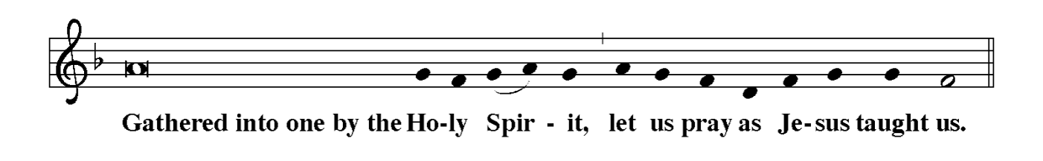
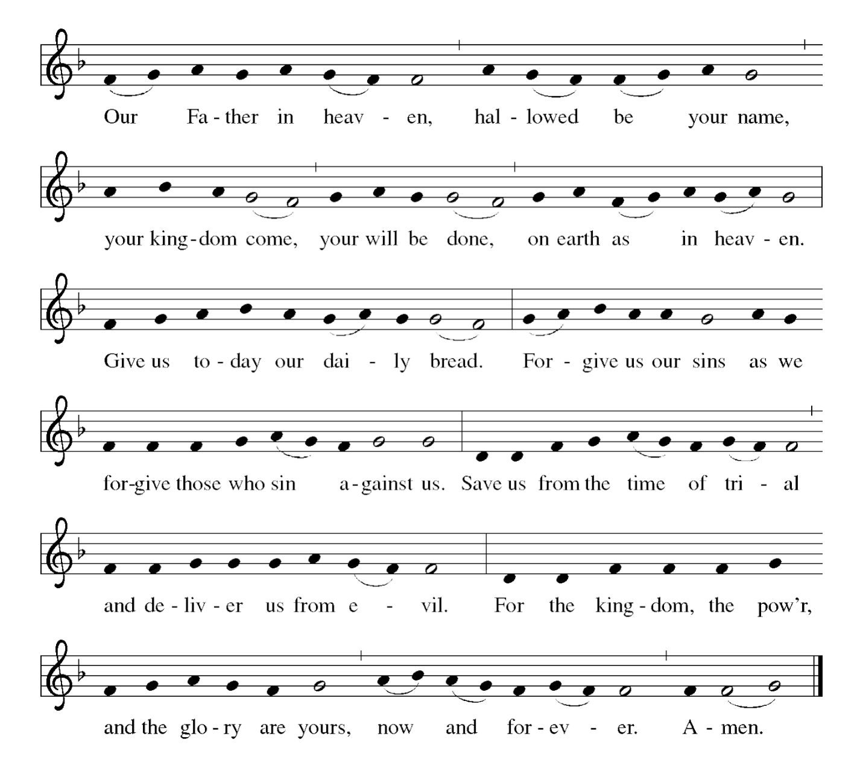

Blessing
Let us bless the Lord.
Thanks be to God.

Almighty God, the Father, the + Son, and the Holy Spirit, bless and preserve us. Amen.

Liturgy from Evangelical Lutheran Worship copyright © 2006. All Rights reserved.
Reprinted by permission of Augsburg Fortress

Lectionary - Copyright © 2026 Augsburg Fortress.
Permission is granted for congregations to reproduce copies for local use only and this copyright notice appears.

All reprints used by permission© John Ylvisaker, Box 321, Waverly, IA 50677
CCLI License # 2368672 | One License #A-734658

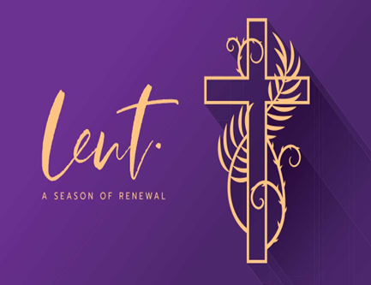

FELC Midweek Lent Services -
Wednesdays at 12:00pm
Soup Supper at 6:00pm
7:00pm Evening Prayer with Short Homily
on February 25, March 4, 11, 18, 25
(Theme: Baptismal Promise)

Five Sundays in Lent
February 22, March 1, 8, 15, 22

